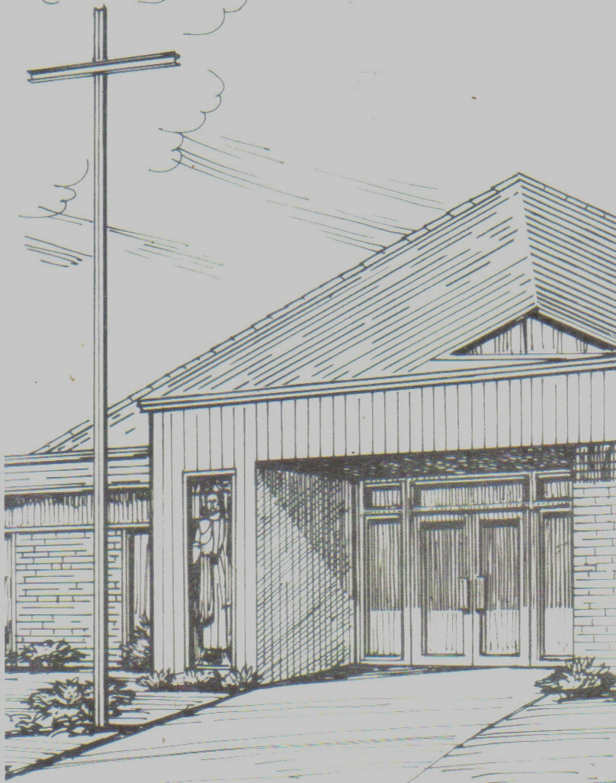

Monthly Newsletter of
BLESSED SAVIOR LUTHERAN CHURCH
2615 Shackelford Road, Florissant, MO 63031-2005 *314- 831-1300
www.blessedsavior-lcms.org * office@blessedsavior-lcms.org
+ + +

“Empowered by God’s Holy Word,
we joyfully share the love of Jesus with all people
through worship, teaching, fellowship, service and witnessing.”

----------------------------------------------------------------------------------------------------
JULY 2017

Dear Family of God at Blessed Savior,

I pray, as always, that this newsletter finds you safe, healthy, faithful, and thankful -- and especially, BLESSED BY THE LORD.
James 1:17 (ESV)
¹⁷ Every good gift and every perfect gift is from above, coming down from the Father of lights with whom there is no variation or shadow due to change.

There sure are a lot of changes that go on in life! And yet we as a people, in general, do not like change. You know the old joke, right? How many Lutherans does it take to change a light bulb? Answer: CHANGE?!?!?

There are some changes taking place at Blessed Savior this month. The main change is that we will be saying “goodbye” to our Vicar, but for the first time in 17 years we will not be saying “Hello” to a new Vicar. We did apply for a Vicar again, but there simply were not enough students going out on Vicarage this year for Blessed Savior to receive one. We hope to be back in the program next year, but we will have to see what the Lord has in store for us. And for this year, things will be a little different. And again, we don’t really like change very much.

Thanks be to God, that He doesn’t change. He loves us from eternity, He provides for us in body and soul, and He forgives us through the life, death, and resurrection of Jesus. And He promises to never leave us, nor forsake us. Knowing all of this, we can face whatever it is that “life” throws our way.

In Service of Christ,
Pastor Matthew D. Roeglin



Dear friends in Christ Jesus, brothers and sisters of the faith, most blessed saints of Blessed Savior Lutheran Church –

It is my final month here at Blessed Savior. I can honestly say that it has snuck up on me. There is still so much more I wanted to do!
There will be a farewell celebration, of sorts, on the 23rd of July (following the late service; see the bulletin in the upcoming weeks for details), at which time I will also be making my final presentation of the website as my evangelism project completes. I’m excited to share with you all of the hard work the committee has done on the website, and all the great features now available for each of you to use as you see fit.
When I arrived here, Pastor Roeglin was sage enough to warn me that vicarage, in some ways, is a dirty trick. You spend a year of your life, a very formative year of your ministry, among people who want nothing more than to help you grow and see you succeed, only to have all of it ripped away from you as they stuff you back into a classroom. While I, unlike many of my classmates, actually relish the opportunity to return to a classroom setting and further my education, I still feel I’m somehow being cheated by being removed from this setting.
Wherever I end up from here, be it a different parish, a more academic setting, or whatever and wherever else God has in store for me, you will always be my vicarage congregation; the love and support you have shown me while I was here will serve to touch the lives of so many others, and all of it because of your dedication and encouragement of the vicarage program. I know there is a not-so-subtle black cloud over my leaving with my being the last of 17 straight vicars here at Blessed Savior, but I pray you take this year as an opportunity to use the gifts God has so graciously given you wisely, and that you return to the vicarage program as soon as may be possible. I have absolutely been blessed by the Lord in my time here, and I’m sure any and all future vicars will be as well.
From the bottom of our hearts, my wife and I extend to you our deepest thanks.
Goodbye, farewell, and amen.

+ Vicar Joseph Hanson +

The Theology of a Beggar - 10
By Walter Mack

"We rejoice in our sufferings. . ." (Rom. 5:3)

Really?

That's St. Paul writing. And, yes, that's what he asserts. "We rejoice in our sufferings."

Well, my life is crammed with pain and suffering. So why am I not rejoicing right now? Or all of the time? Or constantly?

We will never find an answer to these questions that will satisfy the natural mind. That's a reality. Patience, we are told, is a Fruit of the Spirit. And suffering reveals our human impatience. In fact, it shows us exactly what kind of person one really is.

Later in Romans, Paul states, "For I consider that the sufferings of this present time are not worth comparing with the glory that is to be revealed to us." (Rom. 8:18). He goes on to compare all of our pain to the pain of childbirth. And how, in time, that pain is forgotten over the joy of a new life.

God's ways, we must remind ourselves, are not our ways. (Is. 55:8 - 9). The psalmist also notes, "The Lord knows the thoughts of men, that they are vain." (Ps. 94:11)

In his commentary on the Epistle to the Romans, Martin Luther remarks, "When we pray to God for something. . .He hears our prayers and begins to give us what we wish. . .in such a way that He contravenes all of our conceptions."

"He does all this," Luther continues, "because it is the nature of God first to destroy and tear down whatever is in us before He gives us His good things." "We are capable of receiving His works and His counsels only when our own counsels have ceased and our works have stopped and we are made purely passive before God."

Only in our recognized weakness do we learn to depend. Suffering reinforces the truth that we can not make it on our own. To me, that seems why some otherwise very strong personalities suffer so much. Suffering forces us to face the reality of our own inadequacies. God allows us to come against things that are more than we can handle. But they are never more than He can handle! ". . .To do His deed--strange is His deed! And to work His work--alien is His work!" (Is. 28:21)

When we despair, when we hit rock bottom, God awaits us there. That's His promise. As the God Who suffers with us, Jesus Christ is there alongside us: He on the Cross; we at the foot of the Cross, clinging to Him.

That's something to rejoice about. When we know we've nothing left, when we give up struggling, when we throw in the towel or throw up our hands in despair, when we have no other choices left, when all fight is gone out of us, when we finally recognize our inadequacies, when we have no other choice, when we have no other alternative but to trust God, Jesus is there. Not waiting for you at the finish, but with you through the valley. When you have lost it all and exhausted every resource and avenue of relief, your Hope is right there. His name is Jesus Christ. And He has been there, too.

Luther called our cry as a "stark naked" desire for help. That means prayer, the last gasp of one who has given up, the plea of one who has exhausted all "inner strength" of which we so pride ourselves, the call of lost self-confidence. "Those who have the Spirit are helped by Him. Thus they do not lose hope but have confidence, even though they are aware of what goes contrary to what they have so sincerely prayed for." (M. Luther)

Powerless, optionless and with no other idea of what to do or where else to go, we can rest on the promise that ". . .all things work together for good. . ." (Rom.8:28). That is the promise available to all who have been called to be saints however unsaintly we may feel. Because not only are we called to be saints, but we are "called according to His purposes."

Believe it. One suffers for the purposes of God!! His Word says so.

A brief story. Nearly twenty-five years ago, I suffered a heart attack. After catheterization, I went six months before experiencing more heart pain. The only alternative at that time was open-heart surgery. I just didn't want to go through it, through the pain of the procedures, through the stresses of recovery, through the insult to my tissues and the helplessness of the whole experience.

The alternative, according to the imagers, was death in six months to a year. After a full twenty-four hours to consider these, I agreed to the surgery. Surrendering my body and life to the surgeon, to someone who knew a lot more than I did, I felt a calm like never before experienced.

That's a homely illustration, but it rather pitifully illustrates what God wants of us, confidence that He knows best. Best of all, this surrender of self allows Him to mold us for His purposes. Suffering builds the character He wants in us. It is costly in many ways, but it is eternally worth it.

Come, Lord Jesus. Mold me after Your design. Whatever it takes. Amen.


Altar Flowers Needed for:
July 9 & 30
August 6 & 27
Sept. 10 & 17

Blessed Savior
Live Broadcast on KFUO
August 6 – October 29
8:00 a.m. Worship Service

SPONSORS NEEDED!
Blessed Savior will be broadcasting our 8:00 a.m. Worship Services beginning August 6th thru October 29th. If you would like to sponsor a Sunday, please call Paula in the Church Office. The cost to sponsor a Sunday is $150.00.

Available Sunday’s are:
Aug 20
Sept 17 & 24
Oct. 1, 15 & 22



Annual Brick Orders
July 1 – 31, 2017

The cost of the brick is $40.00. You can put 18-21 characters on a line, 3 lines are recommended on a brick, but you can do 4 lines. Brick orders will be taken from July 1 – 31. Order forms will be available on the table in fellowship hall. Please place your order form along with your check in the basket marked “2017 Brick Orders”. If you have any questions, please call Paula in the church office.


Vicar & Julie Hanson
Farewell Luncheon
Sunday, July 23rd, after late service

Please join us Sunday, July 23rd, after late service as we say farewell to Vicar and Julie Hanson. It was certainly a joy and pleasure having Joseph & Julie as part of Blessed Savior’s family. God’s richest blessings to them. A signup sheet is available for attendance and a side dish.

July Greeters
07/02 E – Audrey & Vern Griffey
L – Paula Bossaller
07/09 E – Betty Lipham
L – Mary Bremer
07/16 E – Debbie Haynes
L - Paula Bossaller
07/23 E – Paula Bossaller
L – Paula Bossaller
07/30 E – Mike & Donna Kroehnke
L - Ben Hilderbrand

July Elder Greeter
07/02 E – Mike Kroehnke
L – Terry Bossaller
07/09 E – Ray Ehrhard
L –Dave McDermott
07/16 E – Mike Kroehnke
L – Wade Gergen
07/23 E – Ray Ehrhard
L – Dan Boyd
07/30 E – Ray Ehrhard
L - Dennis Henneman

July Ushers Sunday Services
07/02 E – Team #3
L – Team #4
07/09 E – Team #1
L – Team #2
07/16 E – Team #3
L – Team #4
07/23 E –Team #1
L – Team #2
07/30 E – Team #3
L - Team #4

Anniversary
Thank You!

Thank you all so much for the time and effort you put into the anniversary celebration.

Pictorial
Patti Henneman, Elaine Turner, Linda Martin and Muriel Tosh

Concert Leaders
Karla Roeglin, Retha Taylor and Donna Boyd.

Brass: Pastor Roeglin, Zach & Josh Roeglin. Vicar Hanson Wade & Brendan Gergen and Bradley & Retha Taylor.

Bells: Karla, Abigail, Emily & Josh Roeglin. Tammy & Cassidy Gergen, Alexa Daengsurisri & Jacob McClure.

Choir:
Tenor- Shirley McCabe & Vicar Hanson,
Bass – Pastor Roeglin, Doug Kirk, Ken Butherus, Zachary Roeglin & Wade Gergen.
Soprano – Retha Taylor, Dorothy Wood. Pam Stradtmann & Tina Siemsen.
Alto – Karla Roeglin & Donna Boyd
Piano/Organ (Saturday & Sunday) Donna Boyd
Organ (Sunday) Ken Butherus
Flute – Rachel Legoute’
Processions/Gospel Processions/Recessional:
Brendan Gergen, Cassidy Gergen, Abigail Roeglin, Joshua Roeglin, Zachary Roeglin, Vicar Hanson & Pastor Rawlings.

Altar Guild – Ed, Connie & Peg Steinbruegge, Donna & Mike Kroehnke.
Banner – Retha Taylor, Donna Boyd, Tina Siemsen & Phyllis Maxwell (Retha’s neighbor)
Dinner
Kim, Tracy, & Mike Bossaller, Ed, Connie & Peggy Steinbruegge, Rachel Legoute’, Abigail Roeglin & Cassidy Gergen.

Timeline
Debbie Haynes

Set Up
Terry, Paula, Tracy, Mike & Kim Bossaller, Josh & Zach Roeglin & Ed Steinbruegge

Take Down
Terry & Mike Bossaller, Ken Butherus, Ed Steinbruegge & Todd Mueller.

Homemade Wine
Retha Taylor

Homemade Brew
Ray Ehrhard

Donated Beer
Curtis Wood

Mugs
Rachel Legoute’

Fundraiser’s- Youth Group
Ray & Cheryl Ehrhard
Zach & Abigail Roeglin, Cassidy & Brendan Gergen and Cameron & Zach Helmich
Ornaments
T-shirts, polo’s & fleece

Mugs & Shirts are still on sale if you would like to purchase them. They will be in fellowship hall if you are interested. The shirt fundraiser will help towards the kids going to Higher Things in July.

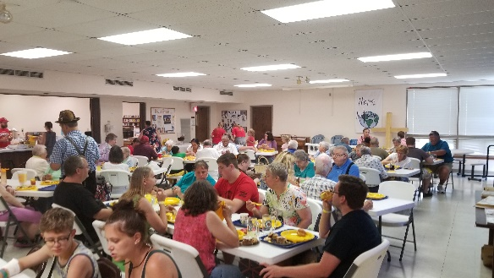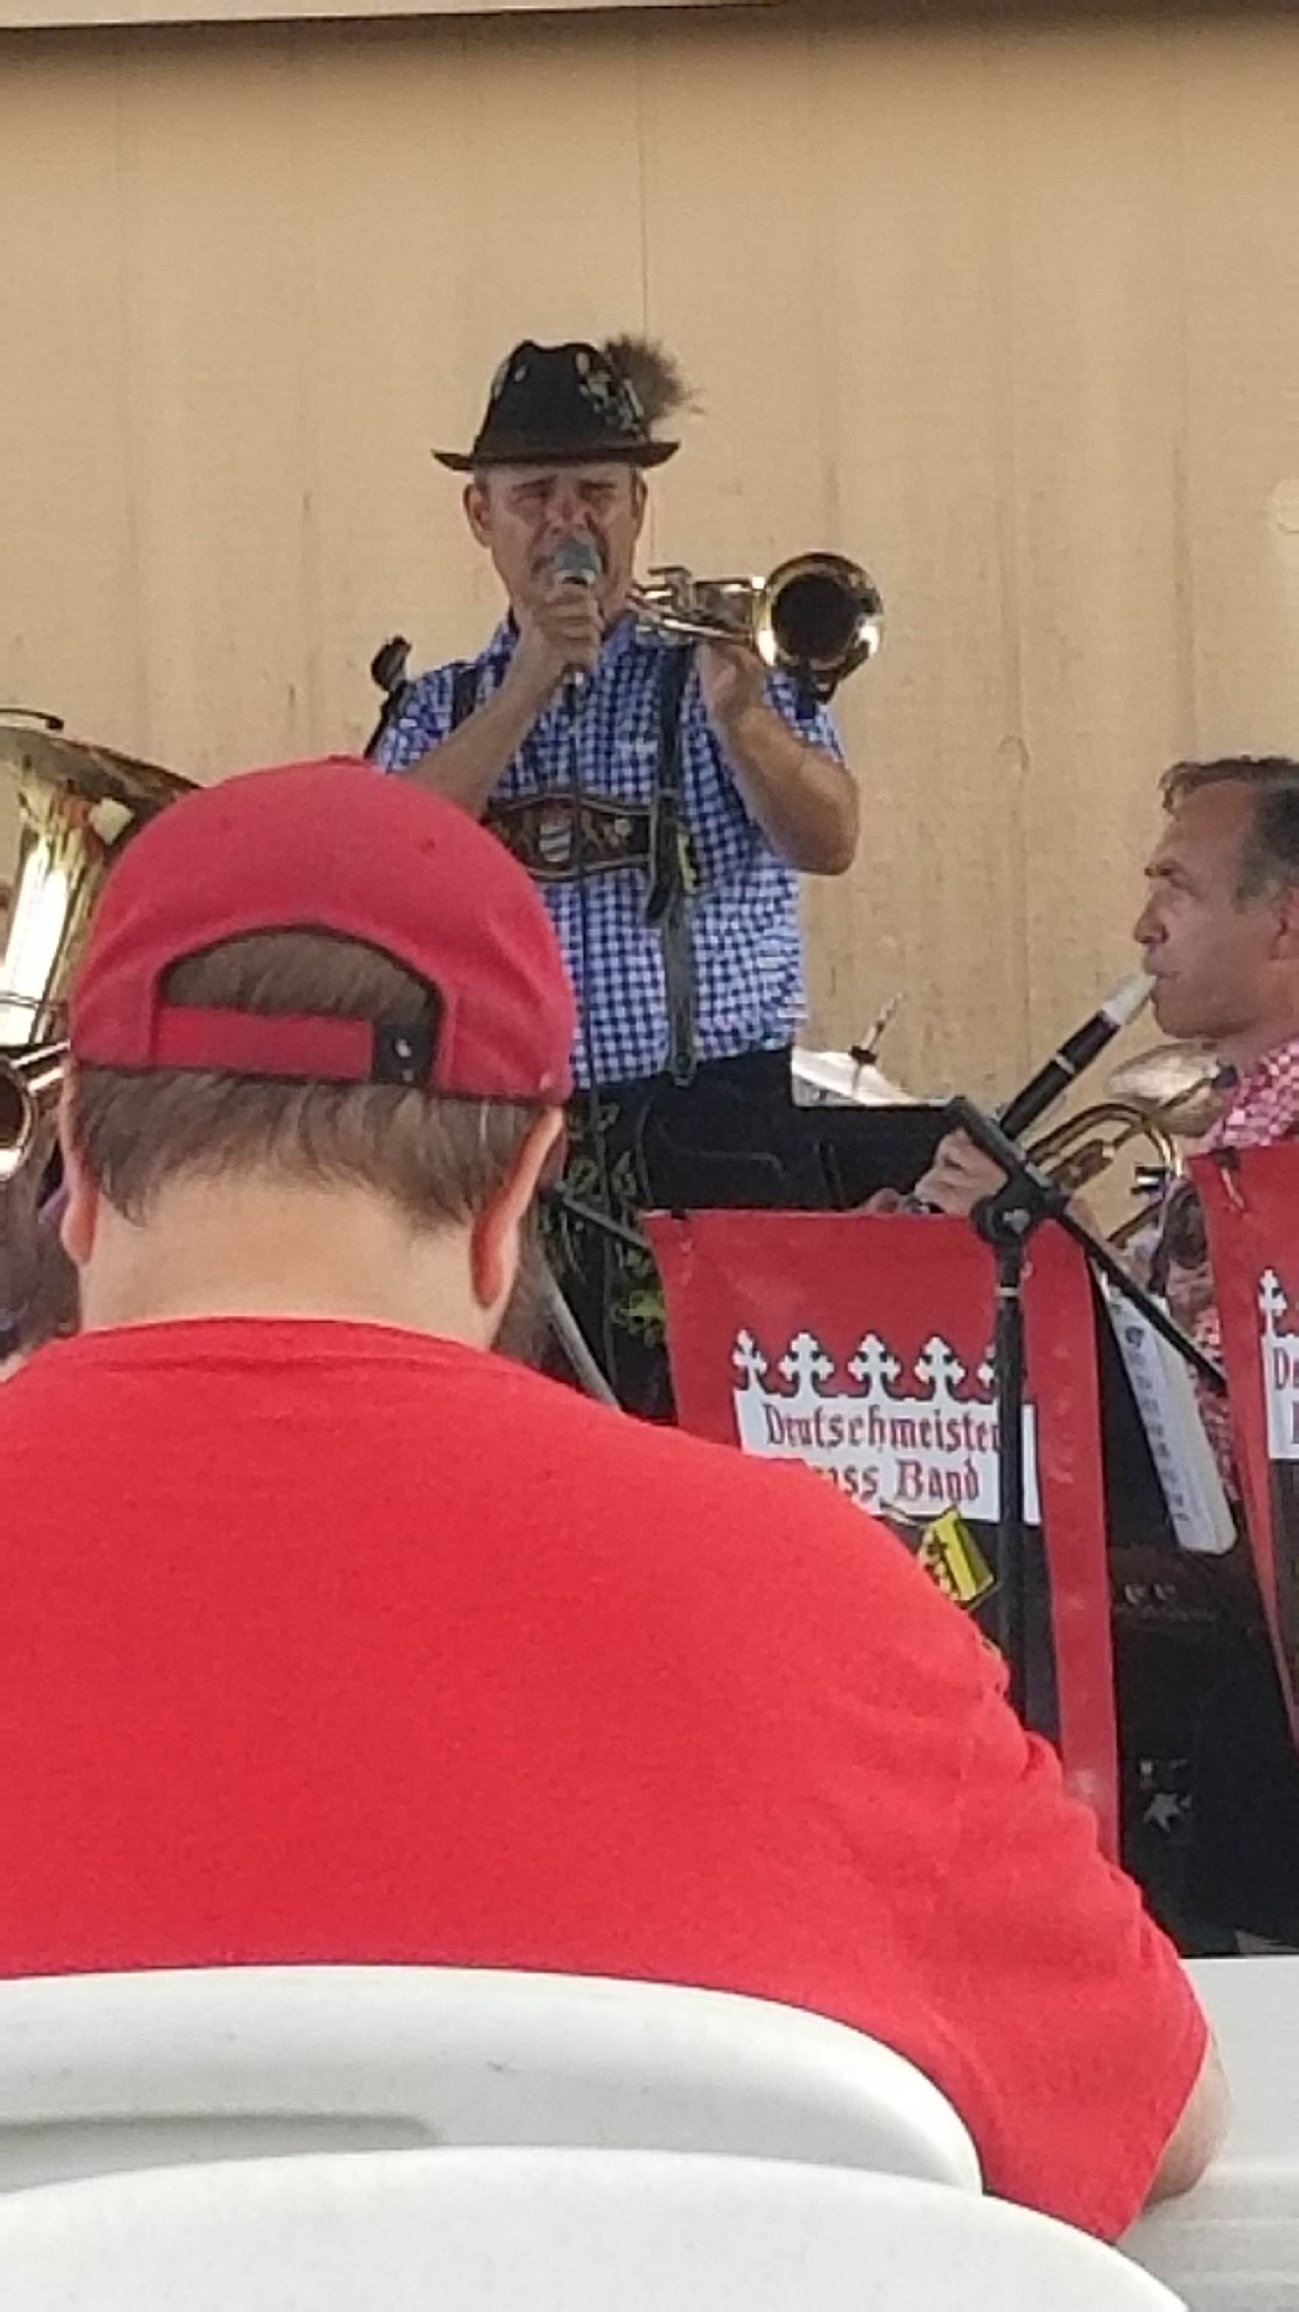

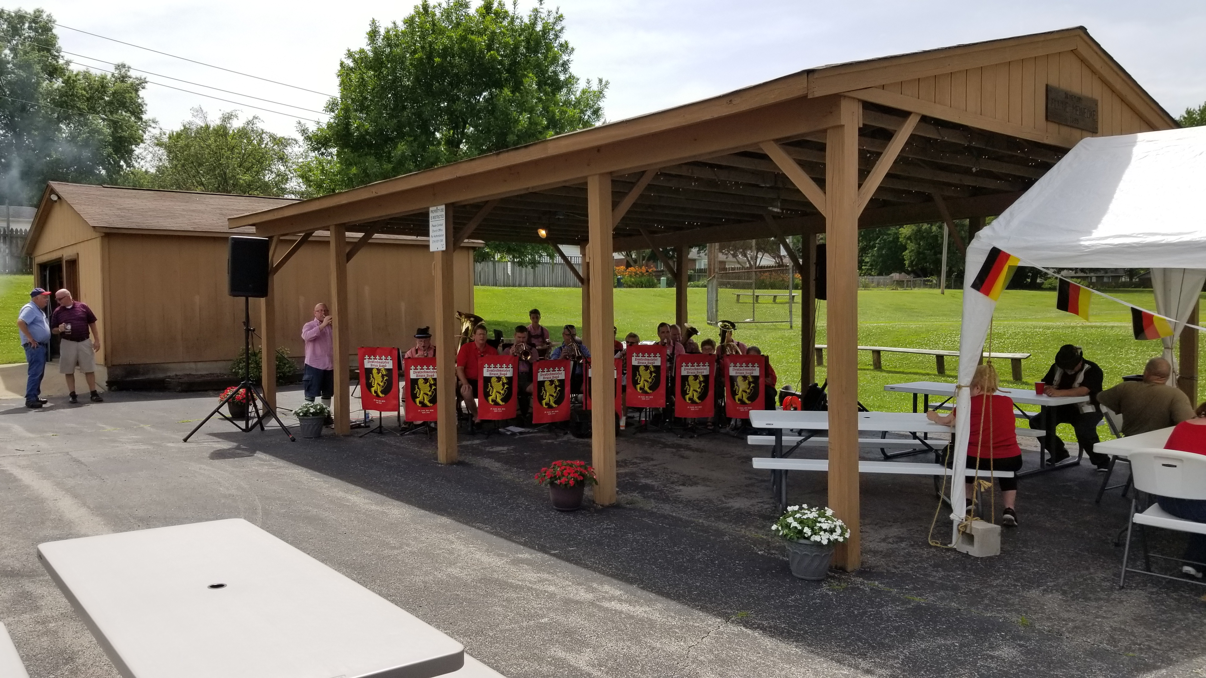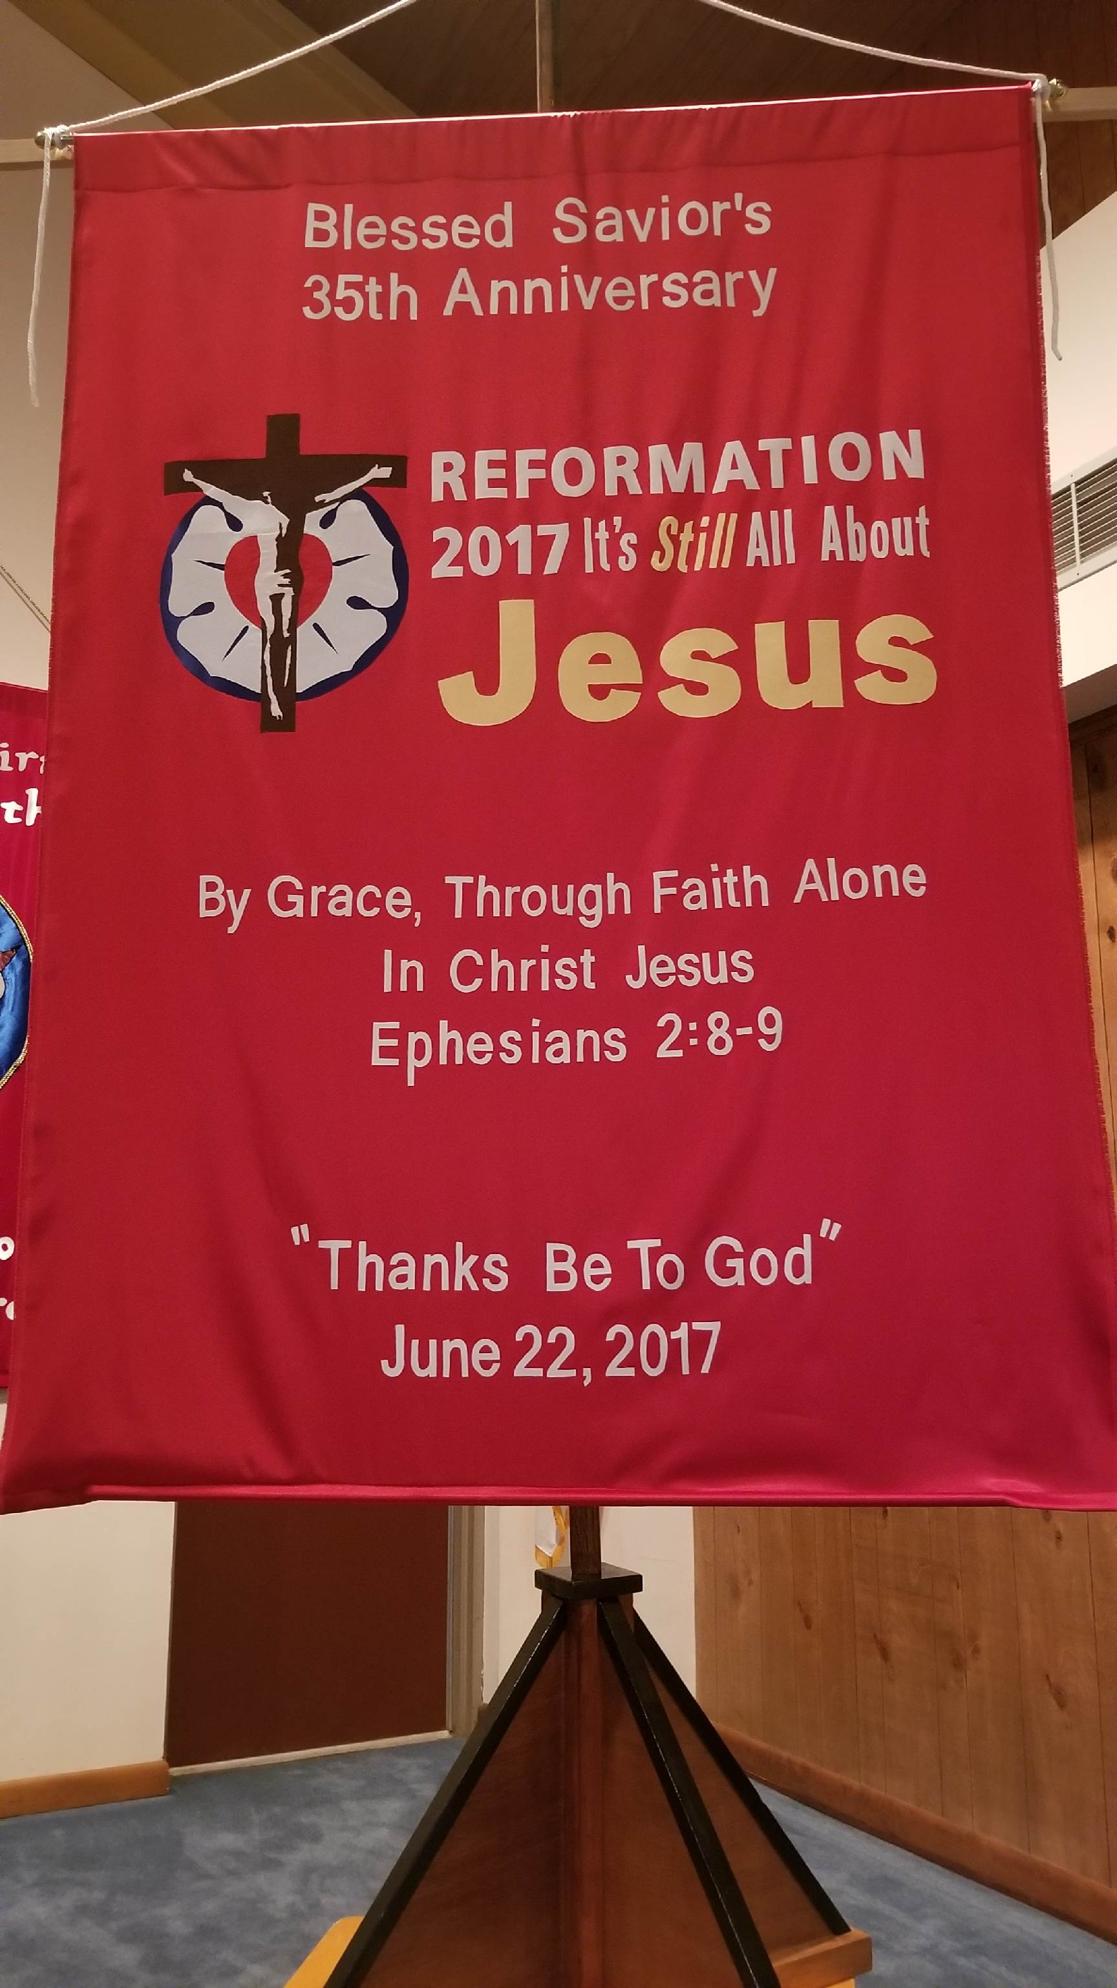

JULY
Birthday’s
7/3 Connie Steinbruegge
7/3 Nancy Dees
7/4 Megan Church
7/5 Brian McKenna
7/6 Walter Mack, Jr.
7/10 Cory Martens
7/12/03 Cassidy Gergen
7/12/98 Haley Caufield
7/13 Arthur Stradtmann
7/15/99 Cameron Helmich
7/17 Helen Stradtmann
7/20 Ray Ehrhard
7/20 Paulita Lowrey
7/23 Paula Bossaller
7/25 Becky Lee
7/25 Jason Lee
7/26 Rebecca Tilley
7/27 David Stupperich
7/27 Jonathan Stupperich
7/28 Rebekah Voss
7/28 Robert Lowrey
7/30 Patti Henneman
7/31 Marcia Loesing


7/7 Ken Butherus
7/8 Pam Walker
7/12/98 Mickayla Kozma
7/12 Connie Steinbruegge
7/12 Cheryl Woodson
7/12/98 Haley Caufield
7/14 Bill Scheer
7/25 David McDermott
7/27 Taylor Rawlings



7/08/78 Donna & Mike Kroehnke
7/11/98 Suzy & Marcel Helmich
7/12/75 Linda & Robert Arras
7/12/46 Jeanette & William Jones
7/18/09 Vicar Joseph & Julie Hanson
7/20/96 Karla & Pastor Matthew Roeglin
7/25/98 Tim & Pam Taylor

July 2017
Sunday | Monday | Tuesday | Wednesday | Thursday | Friday | Saturday
BRICK ORDERS –  JULY 1- 31 |  |  |  |  |  | 1 7AM MOBS BIBLE STUDY @DENNY’S  F.HALL IN USE  6 PM WORSHIP SERVICE W/HOLY COMMUNION
2  8 & 10:30 AM SERVICE W/COMM  9:15 AM SUNDAY SCHOOL/BIBLE CLASSES | 3  7 PM ADULT BIBLE STUDY (MCKENNA)  Pastor & family on vacation – 2 weeks | 4  4TH OF JULY  OFFICE CLOSED | 5  9:30 AM SUNSHINE | 6 | 7  PASTOR & VICAR DAY WITH FAMILY | 8  7AM MOBS BIBLE STUDY @DENNY’S  6 PM WORSHIP SERVICE
9  MITE BOX  8 & 10:30 A.M. WORSHIP SERVICE  9:15 AM SUNDAY SCHOOL/BIBLE CLASSES | 10  7 PM ADULT BIBLE STUDY (MCKENNA) | 11  7:00 PM MOBS | 12  9:30 AM ADULT BIBLE STUDY | 13  7:00 P.M. ELDERS  NEWSLETTER DEADLINE | 14  PASTOR & VICAR DAY WITH FAMILY | 15 7 AM MOBS BIBLE STUDY @DENNY’S  6 PM WORSHIP SER. W/COMMUNION
16 8 & 10:30 AM SERVICE W/HOLY COMM  9:15 AM SUNDAY SCHOOL/BIBLE CLASSES | 17  7 PM ADULT BIBLE STUDY (MCKENNA)  SHUT IN VISITS | 18 | 19  9:30 AM ADULT BIBLE STUDY  SHUT IN VISIT | 20  7:00 PM CHRISTIAN ED  SHUT IN VISITS | 21  PASTOR & VICAR DAY WITH FAMILY | 22  7AM MOBS BIBLE STUDY @DENNY’S  6 PM WORSHIP SERVICE
23 8:00 & 10:30 A.M. WORSHIP SERVICE  9:15 AM SUNDAY SCHOOL/BIBLE CLASSES & CONFIRMATION  12 PM VICAR’S FAREWELL LUNCHEON | 24  7 PM ADULT BIBLE STUDY (MCKENNA)  SHUT IN VISIT | 25 | 26  9:30 AM ADULT BIBLE STUDY | 27  7 PM BD. OF DIRECTORS  SHUT IN VISITS | 28  PASTOR & VICAR DAY WITH FAMILY | 29 7AM MOBS BIBLE STUDY @DENNY’S  6 PM WORSHIP SERVICE
30  8 & 10:30 AM SERVICE W/COMM  9:15 AM SUNDAY SCHOOL/BIBLE CLASSES | 31  7 PM ADULT BIBLE STUDY (MCKENNA) | 1 | 2  9:30 AM SUNSHINE | 3 | 4  PASTOR & VICAR DAY WITH FAMILY | 5 7AM MOBS BIBLE STUDY @DENNY’S  6 PM WORSHIP SER. W/COMMUNION

