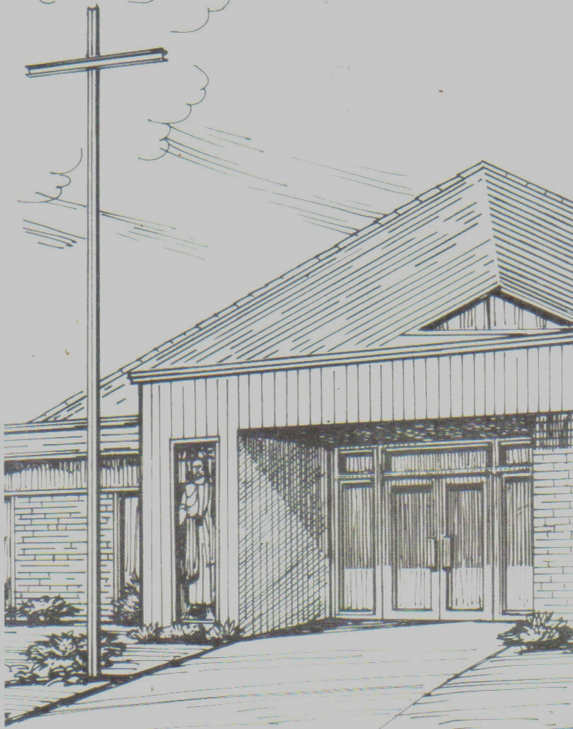
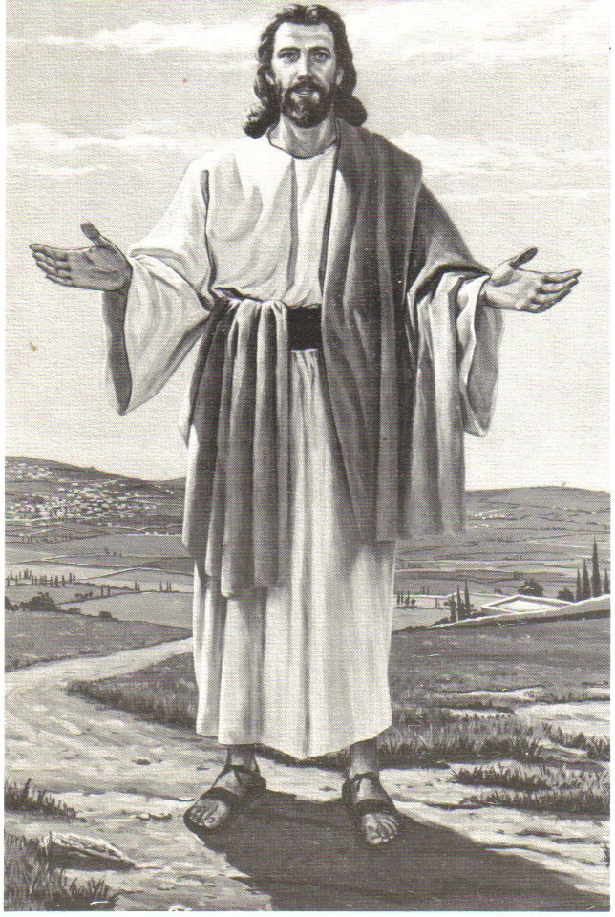
Monthly Newsletter of
BLESSED SAVIOR LUTHERAN CHURCH
2615 Shackelford Road, Florissant, MO 63031-2005 *314- 831-1300
www.blessedsavior-lcms.org * office@blessedsavior-lcms.org
+ + +

“Empowered by God’s Holy Word,
we joyfully share the love of Jesus with all people
through worship, teaching, fellowship, service and witnessing.”

----------------------------------------------------------------------------------------------------
AUGUST 2017

Dear Family of God at Blessed Savior,

I pray, as always, that this newsletter finds you safe, healthy, faithful, and thankful -- and especially, BLESSED BY THE LORD.

Acts 4:19-20
But Peter and John replied, "Judge for yourselves whether it is right in God's sight to obey you rather than God. [20] For we cannot help speaking about what we have seen and heard."

These are the words of Peter and John as they stood before the Sanhedrin. The men of the Sanhedrin had seized Peter and John because they were preaching that Jesus had risen from the dead. They wanted the disciples to stop spreading this story.

Acts 4:18
Then they called them in again and commanded them not to speak or teach at all in the name of Jesus.

And Peter and John’s response?

Acts 4:19-20
But Peter and John replied, "Judge for yourselves whether it is right in God's sight to obey you rather than God. [20] For we cannot help speaking about what we have seen and heard."

Would we be able to be so bold? Would we face even death to proclaim the truth of the Gospel? Thankfully, we in this country don’t have that kind of persecution. We may be ridiculed, but at least at this point in our history, we are not threatened with death if we proclaim what we know to be true.
We have had and continue to have many opportunities to share God’s love. In June, we had our Vacation Bible School. We are reaching out beyond our walls through our Website and our recorded and livestream videos. For the next 3 months, we will be broadcasting our services on AM 850 KFUO. In Spring and in Fall, we canvas the neighborhood with our Prayer walks. Through it all, may we be able to say with Peter and John, “We cannot help speaking about what we have seen and heard.”

In Service of Christ,
Pastor Matthew D. Roeglin



Dear brothers and sisters in Christ at Blessed Savior,
I cannot begin to thank you all nearly enough for the love of Christ you have shared with Joe and me over the last year. Thank you all for your kindness. Thank you for uplifting us and accepting us. Whenever we go somewhere new I'm always afraid that I will be judged for what I do. My job and the shift I work make it difficult to be in church every Sunday and I miss many, many Bible studies and activities I’d like to attend. Thank you for encouraging me, not judging me. We have felt love since we first arrived. Thank you for the gifts of food and household items! I still have not bought laundry detergent! We have been blown away by your generosity throughout the year. We look forward to seeing you occasionally throughout the next year!

In Christ,
Julie Hanson

Pound the Pantry

During August we usually conduct a "Pound the Vicar" campaign to collect household goods and food items for our incoming Vicar and his family. Sadly, we will not have a Vicar for 2017-2018. However, we can still support the seminarians by collecting needed items for the pantry at Concordia Seminary. Therefore, we will hold a "Pound the Pantry" campaign much as we have done for our vicars in the past. A "Food Bank Wish List" for the pantry is provided on the table set up in the back of church. We will collect these needed items throughout the month of August and then donate them to the pantry. Please consider supporting the seminarians and their families.

Youth Luncheon (Higher Things)
August 27, 2017 * After late service

The Youth would like to invite the congregation for a “Thank You” luncheon for your support in helping to get them to Higher Things. The kids will tell you all about the things they did. They look forward to seeing you all on Sunday, August 27th after the late service.

The Theology of a Beggar - 11

A Theological Beggar's View of History – I
Written by: Walter Mack

Its Importance
History has an intensely close relationship to the Christian faith. Anchored on historical events, a faithful record of these is vitally important to what every believer in Jesus Christ claims for himself or herself. For Christians, history has meaning!

Some events have more importance for believers and non-believers alike. Christians, certainly, find the central events of all history to be the Advent of Jesus Christ, His death, and His Resurrection. Nothing Christians experience can be understood well without some knowledge of what led to it. As historian Roy Swanstrom states, "Even the work of the Holy Spirit was done in a historical context." Indeed, the Spirit became critical to the Church's story in the Biblical record.

Its Recording
History is not a study of the past; the past is gone. It is a study of the record of the past as it has come down to us. The surviving records will always reflect the compiler's background, beliefs, methods, and resources. Participation in the event will have particular meaning for the historian. On the other hand, if the historian did not take part, that, too, will be reflected in her or his writing.

The reliability of records and the amount of material -- too little or too much -- will also prove important. Those who wrote the official history of the Army of the United States in World War II reportedly had over seventeen thousand pounds of records to cull and sift through. In contrast, no written accounts of Norse landings in the Western Hemisphere exist other than in Icelandic legends.

Its Recorders
The writers of history must make value judgments regarding the materials they use: what is important, what is not? It seems obvious that the historian must have some standard by which to evaluate the available records. A Christian will have values which differ from those of a non-Christian. A host of other factors will influence the writer's work.

Those who read history expect the historian to have a personal view of things and to make some value judgments of events. They will want to know his or her opinion on the event, its development and its effects. Which side of an issue did the writer favor? Readers will want to know.

Plain and accurate statement must be the historian's first concern. Is the writer's view honest? Does she or he omit certain facts which might alter the reader's view? Is what is offered factual or an opinion? The writer's perspective will be influenced by his or her religious faith or lack of one. Political preferences, nationality, view of history, and personal background are some factors which will be reflected in what is written. Some who have written accurately of Nazi and Soviet history even admitted up front that they detested the regimes and many of the principals within them.

Christian historians have been accused of bias in their view of events. And sometimes this has been true. But such critics often betray their own anti-Christian bias while claiming objectivity. Nazi, Marxist and militant Islamic as well as atheistic historians have shown just such non-objective views.

If the Christian historian possesses the "mind of Christ" as the Apostle urges (ROM. 12:2), she or he should also be a clear and faithful recorder of events.

LUTHERAN SENIOR SERVICES

LSS Aging Answers: Viva La Independencia!
How age-friendly is YOUR house? Slips, trips, and falls can cut short the amount of time older adults can live independently in their own homes.
Tips: Take a look around — does your house have adequate lighting? Clear walkways? Easy access to the phone? If not, some changes may be in order.
To get your questions answered on any aging topic call: 314.446.2475 – a free service offered through Lutheran Senior Services; where older adults live life to the fullest.

Support Seniors with Each Purchase at Hidden Gems Resale
Lutheran Senior Services invites you to explore its Hidden Gems Resale shop, 9051 Watson Rd. in Crestwood, MO. Open Tues. through Sat., Hidden Gems offers fantastic bargains on gently used home furnishings, jewelry, books, toys, clothes, and more. And best of all, each purchase goes to support older adults who have outlived their ability to support themselves. To learn more, visit Hidden Gems on Facebook at Facebook.com/LSSHiddenGems.

Tee Off With LSS: Benevolent Care Golf Tournament
The golf tournament will be on Monday, July 10, 2017 at the prestigious Norwood Hills Country Club. Want to take part in this year’s event? We have a variety of sponsorship opportunities, as well as options for individual golfers. The day includes brunch, 18 holes of golf, competitions, and other donation opportunities. Afterwards, enjoy light appetizers and a silent auction. Proceeds benefit older adults who have outlived their financial resources. Registration information will be available soon! Contact Angie Sutton for more information, including sponsorship and volunteer opportunities. Angie.Sutton@lssliving.org or 314-262-8217.

Save the Date: The Lutheran Prayer Breakfast
Join 400+ area Lutherans at the Lutheran Prayer Breakfast on October 11, 2017. Sponsored by area Lutheran organizations, the breakfast is being held at the Orlando Events & Conference Center in Maryland Heights, MO. More information will be coming soon!

Blessed Savior on
KFUO starting August 6 – October 29, 2017
8:00 a.m. Worship Service

If you are unable to make it to church, please consider listening to KFUO 850AM for the 8:00 a.m. Worship Service.

Thank you to everyone who sponsored a Sunday. Through your generous gift, God’s Word may be heard by our shut-ins and to those who may not know Jesus as their Lord and Savior.


SUNDAY, AUGUST 27TH AT 9:00 A.M.

Pastor will have a short meeting with parents and youth in the sanctuary regarding Confirmation material and starting date. Youth 6th – 8th grade and parents, please plan on attending this meeting. If you cannot attend, please call and let Pastor know.

August Ushers Sunday Services
08/06 E – Team #1
L - Team #2

08/13 E – Team #3
L – Team #4

08/20 E – Team #1
L - Team #2

08/27 E – Team #3
L – Team #4


Lillian Fay Beach
7-20-17
8 lbs * 20 ½ inches
Daughter of: Rachel & Trevor Beach
Granddaughter of: Dan & Donna Boyd

August Greeters
08/06 E – Audrey & Vern Griffey
L – Paula Bossaller

08/13 E – Betty Lipham
L – Mary Bremer

08/20 E – Debbie Haynes
L – Ruth Woodson

08/27 E – Mike & Donna Kroehnke
L – Ben Hilderbrand

August Elder Greeter

08/06 E – Mike Kroehnke
L – Dennis Henneman

08/13 E – Ray Ehrhard
L – Terry Bossaller

08/20 E –Mike Kroehnke
L – Dave McDermott

08/27 E – Ray Ehrhard
L – Wade Gergen

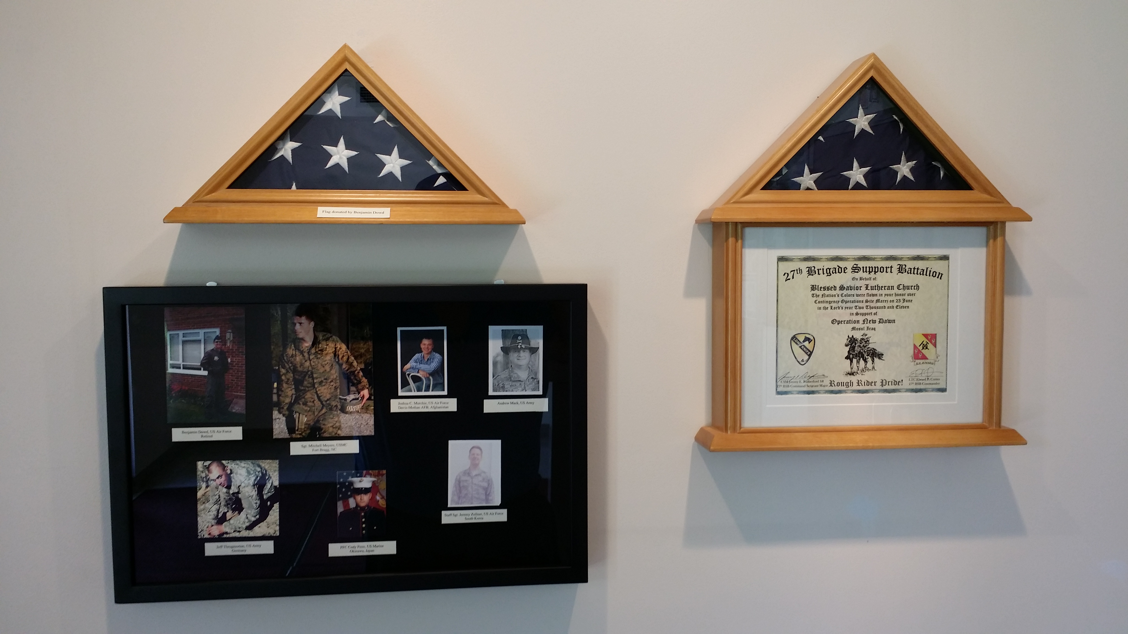
Update to Military Display
Thank you to those members who submitted photos and information to update the military display in the church entry. We still are interested in receiving up to date photos and information regarding our men and women who are serving or have recently left the military service. The display is not only for military personnel who are members of our church but for any members whose family or extended family are in the military. For Veterans Day we will change the display to the veterans from our church. Please drop off a photo and information on the service member with Paula in the church office; be sure to provide your name, contact number and relationship to the individual who is serving. If you have any questions, please contact Debbie Haynes.



September 15 & 16, 2017
7 a.m. – Noon
$15.00
Rainout Date: September 22 & 23, 2017

Table and Tailgate Sale - Mark your calendar for our upcoming Table and Tailgate Sale. All proceeds on donations for indoor tables and outdoor parking lot spaces will benefit our mission outreach programs. We are planning on a two day sales event. On Friday, Sept 15 we will have the first day of our indoor Table Sale. On Saturday, Sept 16 we will have the second day of our indoor Table Sale along with our outdoor Tailgate Sale. Both sale days will run from 7 a.m. to noon. We are asking for a donation of $15 per table indoors (for one day or both days) and $15 will pay for three adjacent parking spaces outdoors (you will have to provide your own table(s) for outdoor sales and set-up on Saturday a.m. only). You will be able to set up your indoor items on Thursday night from 6-9 p.m. or arrive early at 6 a.m. for the sale on Friday. You are not required to do the indoor sale on both days, but if you are interested, you will be able to leave your items overnight from Friday to Saturday. If you only want to do the Saturday sale, you will be able to set up from 6-9 p.m. on Friday night or arrive early at 6 a.m. on Saturday. You will need to remove all of your items immediately following the sale. Indoor table space or outdoor tailgate space must be reserved in advance by either contacting Paula at the church office or sign up in Fellowship Hall. Indoor space is limited.

AUGUST

8/07/04 Pamela & John Walker
8/10/47 Eileen & Dale Montonye
8/13/94 Marlene & Gary Martens
8/18/79 Janet & Bill Lee
8/22/98 Tammy & Wade Gergen
8/24/85 Denise & Curtis Joellenbeck



8/08 Patricia Kneemueller
8/09 Linda Arras
8/10 Thomas Kroehnke
8/12 Gillian Blank
8/12 Ruby Tegarden
8/13 Dawn Steinbruegge
8/13 Linda Martin
8/13 Dawn Steinbruegge
8/14/13 Charlotte Daengsurisri
8/14/13 Isabelle Daengsurisri
8/14 William Woodson
8/15 Alexandria Plack
8/21 Zachary Croghan
8/27 Gilbert Albers
8/27 Joseph Croghan
8/29 Aaron Dietrich
8/31/10 Daniel Roeglin



8/01 Mike Kroehnke
8/06 Helen Stradtmann
8/08/99 Cameron Helmich
8/08 David Stupperich
8/10 Janis Scheer
8/12 Donna Kroehnke
8/12 Mason Kuykendall
8/13 Pam Taylor
8/15 Rebecca Tilley
8/18 Melissa Dudley
8/19 Andy Rawlings
8/21 Linda Arras
8/21 David Meyer
8/23 Jonathan Stupperich
8/28 Paula Bossaller



