
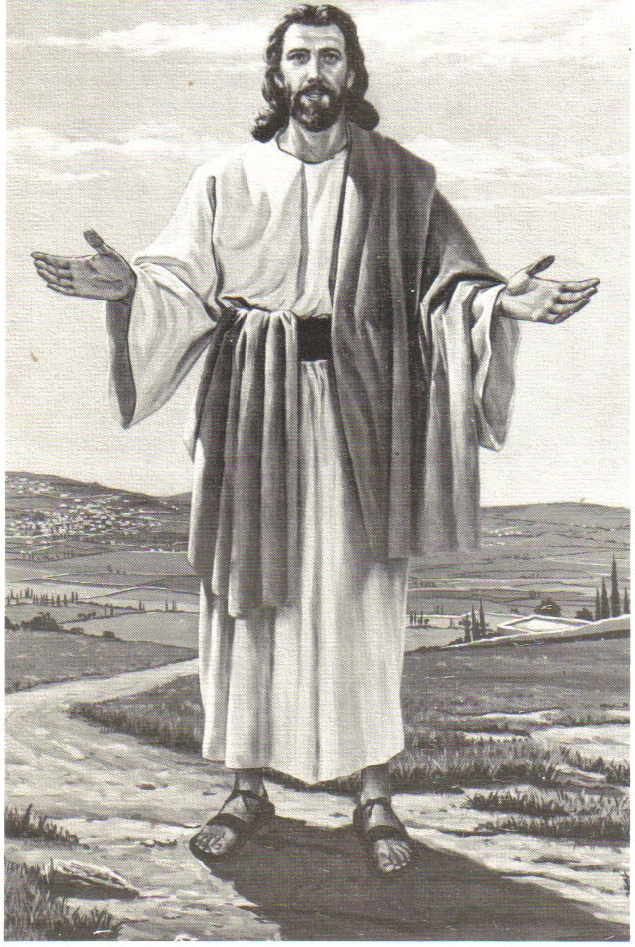
Monthly Newsletter of
BLESSED SAVIOR LUTHERAN CHURCH
2615 Shackelford Road, Florissant, MO 63031-2005 *314- 831-1300
www.blessedsavior-lcms.org * office@blessedsavior-lcms.org
+ + +

“Empowered by God’s Holy Word,
we joyfully share the love of Jesus with all people
through worship, teaching, fellowship, service and witnessing.”

----------------------------------------------------------------------------------------------------
OCTOBER 2017

Dear Family of God at Blessed Savior,
I pray, as always, that this newsletter finds you safe, healthy, faithful, and thankful -- and especially, BLESSED BY THE LORD.
With all the tragedies (Hurricanes, Earthquakes, Wild Fires, Acts of Terror, Mass Shootings… etc.) that have taken place in the last few weeks, I thought I would share the following devotion, written by a man named Chad Bird. I think it is a great reminder that while we don’t have all the answers (especially when tragedy hits), we do have all that matters: Jesus.

In Christ,
Pastor Roeglin

DON'T TELL HURTING PEOPLE THAT GOD'S IN CONTROL – By Chad Bird
As Hurricane Harvey claws its way along south Texas, destroying lives, ripping homes and businesses to shreds, and--even as I write this--transforming Houston streets into rivers, I was reflecting on how often I've heard well-meaning people say, "It's OK. God's in control." I wrote this last year, but it needs repeating now.
We say it to the family who’s standing in a sea of twisted metal and broken dreams that a tornado spit out. We say it to the man who lost his job, can’t find work, and is on the verge of losing his home. We say it to the cancer patient, the pregnant teen, and our sons and daughters as they leave for war.
We mean well. We intend it as good news. We say, “God is in control,” to help them see that God is bigger than their struggles. That he has a grand and wonderful plan for their lives. That he, as the sovereign Lord, has this universe—and them—in the palm of his hand.
And we need to stop saying it.
There are things that are true of God that are not truly the good news people need to hear. There are hidden things about God and there are revealed things about God. The hidden things are of no concern to us;
the revealed are our sole concern. And in those revealed things of God he discloses to us everything we need to know about who he is and what he does for us.
We want to know how God rules this world, how he is present in all things, how he exerts his control over the course of world events. We want
to know why some get cancer and some don’t, why terrible things happen to the best of people, why volcanoes erupt and hurricanes strike and fires consume. We want to know whose side God is on when there are wars, why he waits so long to answer our prayers, how he’s going to sort out the ups and downs of our day-to-day lives.
Yet these questions are none of our concern. They are wrong questions that seek imperfect answers that give unstable hope. These deal with the hidden things of God. And even if the Lord gave us an answer, it would sound like Einstein lecturing on the theory of relativity to a bawling infant. The hidden things of God are hidden for a reason. They are none of our concern, none of our hope, none of our life.
What God wants us to know about him is that everything there is to know about him is Jesus. He is the sole means to the Father, the only revealer of the Spirit. He is the exact representation of God. In him all the fullness of the deity dwells in bodily form. In other words, the only God we know is Christ. And, equally important, the only Christ we know is the crucified one. Thus Paul says, “I determined to know nothing among you except Jesus Christ and him crucified,” (1 Cor 2:2).
God does have a wonderful plan for your life, but it’s not what you think. His merciful plan is to crucify you with Christ, bury you with Christ, and raise you to new life in Christ. All this he does in baptism. Baptism unites you with the only God we know. And in that God—the crucified and resurrected Christ—God reveals who he is.
He is the God who will never leave you in your sickness, never forsake you in your brokenness, for you have been washed into his body, blooded into his veins, grafted into the limbs of his flesh.
He is the God who goes with grieving spouses to the graveside, and will one day go with you as you are carried to the place of your burial, for he is the God who is the resurrection and the life, the one in whom we live, even though we die.
Jesus is the crucified and resurrected God who gave his cheek to those who struck him, his hands to those who pierced him, his ear to those who mocked him, his body and blood to those who crucified him. And in so doing, he secured absolution for us for the most evil acts imaginable. He reconciled us to the Father by building a bridge from him to us that’s constructed out of the wood and nails of his cross. He gave us something better than answers to our questions; he gave us life for our death, heaven for our hell, forgiveness for our sin.
These are the revealed things of God—his revealed gifts to us. These gifts are not only all that matters, they are also all that satisfies. Here is hope for the hurting. Here is adoption for the rejected. Here is the God you can see and taste and touch and smell—the God whose name is Jesus Christ.
To those of you who are hurting, know that there is a God who loves you, who has always loved you and always will. Jesus Christ will not answer all your questions, but he will give you all of himself. And in the end, that’s all any of us need.

In Service of Christ,
Pastor Matthew D. Roeglin

The Theology of a Beggar – 15
By Walter Mack

Social media.

Here is a term that a decade or two ago likely meant writing cards and letters or making a phone call. Today, and too many people, it has become an all-consuming internet passion. And to a number of users, pretty much a disease. For all the time spent on it, I wonder, sometimes, if some people get anything else done.

Because of what has been placed on it, social media has raised hopes, subsequently dashed those hopes, and even, at times, destroyed all hope. People reportedly have been bullied by it to the point of taking their own lives. Tragic. It has complicated routines in offices, schools, businesses and homes.

The main attraction of social media seems to be the opportunity to talk about oneself. On it, people mostly present themselves very flatteringly. "Wow," the reader thinks. "Here's a person who really has it all together." Or, "Here's someone whose life and accomplishments really make mine look rather pitiful."

What you see on social media largely shows what a person or family wants you to see. Here is how Lutheran theologian R. J. Grunewald puts it: "This is the unwritten rule of social media: show the best version of your life and hide the mess." (Reading Romans with Luther, R. J. Grunewald, p. 12.)

The truth is that all of us work to hide "the mess" in our lives. There are things we just do not want exposed. We enter relationships with half of the chapters in the story of our lives secreted. That was the problem with Adam and Eve when they tried to hide from God. The whole truth was more than they could bear to have exposed. Honestly, we work hard not to be honest with ourselves or others. Like Adam, we cannot bear to be seen as we truly are. So we work to make light of the sin in our lives. Or we rationalize it as something other than sin.

In the introduction to his comments on the Epistle to the Romans, Martin Luther addresses this very human problem. The reformer puts it like this: "The chief purpose of this letter is to break down, to pluck up, and to destroy all wisdom and righteousness of the flesh. . . .this letter is to affirm and state and magnify sin."

God wants to redeem us. He does this through Law and Gospel as Luther famously preached.

When we see ourselves for what and who we really are through the Word of God's Law, then the Gospel can show us Him Who is outside of us, Him Who gives Himself to us and for us. The unrighteousness which the Law exposes is covered by that
Continued…..
righteousness which is foreign to us, which is outside us, the righteousness of Jesus, the Christ of God.
Of humankind, St. Paul writes that the Law is ". . .written on their hearts." (Romans 2:15). This Law joins our love of God with the love of our fellow humans. And, oh, how we fail both Him and them. The Law exposes that failure.

When we see ourselves, then, as the Law does, it is easy to be defeated in spirit, to see our sins looming over us. Despite our obvious moral failures, God loves us. Jesus loves us. He came to rescue hopeless sinners. He came for all who try to hide "the mess" they have made of their lives, for all who are ashamed of what they are and what they have done. He came for all ashamed of themselves. That is the Gospel.

In his Roman commentary, Luther expresses it well. It cannot be improved upon: "If the heart of a believer in Christ accuses him and reprimands him and witnesses against him that he has done evil, he will immediately turn away from evil and will take his refuge in Christ and say, 'Christ has done enough for me. He is just. He is my defense. He has died for me. He has made His righteousness my righteousness, and my sin His sin. If He has made my sin to be His sin, then I do not have it, and I am free. If He has made His righteousness my righteousness, then I am righteous now with the same righteousness as He. My sin cannot devour Him, but it is engulfed in the unfathomable depths of His righteousness, for He himself is God, who is blessed forever. The Defender is greater than the accuser, immeasurably greater.' "

What could be greater? Christ has done this for us. He makes us righteous. As righteous as He. Remember the Scriptural command, "Be holy even as I am holy?" Christ has made it possible for you, for me. Unbelievable, but true. And the gift of faith makes it believable. Jesus Christ has taken care of "the mess." Alleluia!

- It's still all about Jesus!

Sola Gratia – Grace Alone
Sola Fide – Faith Alone
Sola Scriptura – Scripture Alone
Solus Christus – Christ Alone
Sola Deo Gloria –
To the Glory of God Alone

Friday, October 27th
5:30 p.m. Decorate your Trunk
6:00 p.m. Treat



Do you have a car? Do you like to dress up? Blessed Savior will once again have our Trunk or Treat night on Friday, October 27th.

Kids will be able to trunk or treat in the parking lot starting at 6 p.m. and adults, you can show off that stylish costume or trunk as well

Members can sign up to decorate their cars. Sign up will be available October 1st. The more cars we have, the more fun it will be!

This event provides a safe and fun trunk or treat experience for the kids and a great chance to socialize for adults.

This event is open to the community, so tell your family, friends and neighbors!

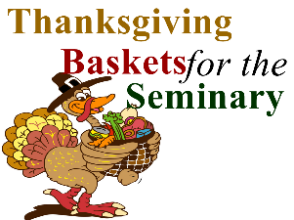

The Turkey is ready to be plucked!
Oct.1– Nov. 12, 2017

Listed on each feather are items that are needed for the baskets. Please take feathers only if you will be able to fulfill the obligation. If you are unable to purchase food, cash donations will be taken. The ladies will need your items turned in by November 12th.
Thank you all for your support to the men and their families at the Seminary.

Please note Reformation Weekend
Will be as follows:

Sat. Oct 28th at 6 pm Worship Service w/Holy Communion

and One Service Only on Sunday
Sun. Oct 29th 8 a.m. (KFUO) Worship Service w/Holy Communion
followed by:
9:15 a.m. Adult Bible Study – we will be watching the movie “Martin Luther” that was just aired on PBS.

Following the movie, please join us for our Reformation/Pastor Appreciation & Chili Cook-off Luncheon

2:00 p.m. Salem Lutheran Church will have the Circuit Wide Reformation Worship Service with District President Rev. Dr. Lee Hagan as guest preacher and Dr. Jim Marriot of Concordia Seminary will direct the music.

Please plan to come if you can.



We give thanks to the Lord for sending us faithful pastors and would like to show our appreciation to Pastor Roeglin for preaching and teaching faithfully God’s Word to us. Last year’s Chili Cook-off winner was Cheryl Ehrhard, with Rachel Legoute’ falling to second place. Can she regain 1st place or will someone else knock them both out? Come and find out! Please sign up in fellowship hall, if you plan to attend and if you plan to make chili.

-----------------------------------------------------------------------------------------------------------------

Tuesday, October 31, Concordia Seminary 500th Anniversary Reformation Service at 7:00 p.m. Chapel of St. Timothy and St. Titus – The “three solas” of the Reformation will be in the spotlight as Concordia Seminary, St. Louis, hosts the 500th Anniversary Reformation Service. Seminary President Dr. Dale Meyer will give the closing meditation. Attendees will receive a commemorative 500th Anniversary Reformation Service program that will include the meditations on each of the solas – Latin for “alone.”

October Greeters
10/01 E – Audrey & Vern Griffey
L – Paula Bossaller
10/08 E – Betty Lipham
L – Mary Bremer

10/15 E – Debbie Haynes
L – Ruth Woodson

10/22 E – Paula Bossaller
L – Paula Bossaller

10/29 E – Mike & Donna Kroehnke
L – Ben Hilderbrand

October Elder Greeter
10/01 E – Ray Ehrhard
L – Wade Gergen

10/08 E – Mike Kroehnke
L – Dan Boyd

10/15 E –Ray Ehrhard
L – Dennis Henneman

10/22 E – Mike Kroehnke
L – Terry Bossaller

10/29 E – Mike Kroehnke
L – Dave McDermott

October Acolyters
10/01 L – Joshua Roeglin

10/08 L – Abigail Gayfield

10/15 L – Emily Roeglin

10/22 L – Caitlin Gayfield

10/29 L – Meaghan Helmich

October Ushers Sunday Services
10/01 E – Team #1
L - Team #2

10/08 E – Team #3
L – Team #4

10/15 E – Team #1
L - Team #2

10/22 E – Team #3
L – Team #4

10/29 E – Team #1
L – Team #2

OCTOBER


10/2 Tina Siemsen
10/2 Doug Kirk
10/7 Dennis Henneman
10/9 Janet Lee
10/10 Rachel Legoute’
10/11 Terry Bossaller
10/14 Kristen Meyer
10/15 Michael Haynes
10/17 Diane Pavlik
10/19 Tim Taylor
10/22 Lydia Legoute’
10/22 Joel Vogel
10/24/96 Mickayla Kozma
10/25 Todd Mueller
10/25 Paula Plack
10/26 John Walker
10/27/87 Kelsey Martens
10/31 Jim Steinbruegge

10/1 Donna Boyd
10/5 Lisa Meyer
10/6 Eugene Beach
10/7/07 Ashley Koop
10/8/95 Bradley Taylor
10/22 Dennis Henneman
10/23 Curt Joellenbeck
10/23 Daniel Lipham
10/23 Muriel Tosh
10/24/93 Karly Guetersloh
10/25/92 Kelsey Martens
10/28/07 Robert Lowrey
10/31 Michael Haynes


10/01/88 David & Elizabeth Guetersloh
10/03/42 June & William Emde
10/06/73 Martha & Lynn Oth
10/11/08 Melissa & Joshua Dudley
10/11 Daniel & Bethany Sanderson

10/18/74 Ted & Nancy Stocker
10/22/11 Les & Jennifer Eyman
10/22/62 Dennis & Patti Henneman

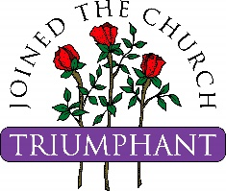
Mary Jo McCutcheon
June 5, 1928 – August 23, 2017

Mary Jo was called to God’s heavenly rest from her earthly home on Wednesday, August 23, 2017. We remember her family and friends in our prayers as we extend our Christian sympathy.

Dale Edward Randall
November 22, 1935 – September 30, 2017

Dale was called to God’s heavenly rest from his earthly home on Saturday, September 30, 2017. We remember Dale’s family and friends in our prayers as we extend our Christian sympathy.



