Blessed Savior Lutheran Church
Florissant, Missouri

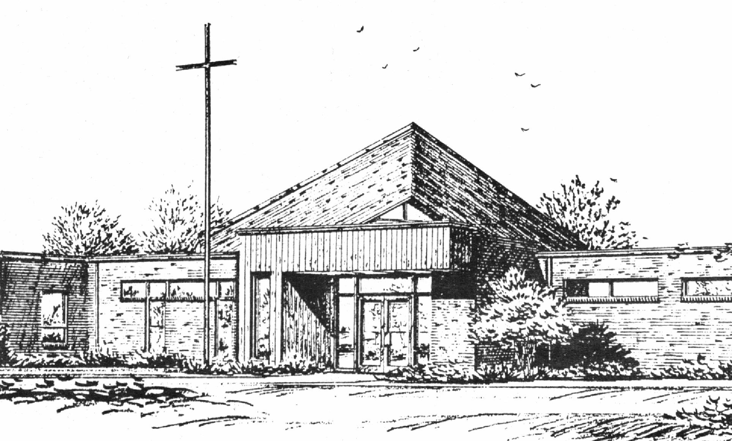

“Empowered by God’s Holy Word,
we joyfully share the love of Jesus with all people;
through worship, teaching, fellowship,
service and witnessing.”

Eleventh Sunday after Pentecost
August 20, 2017

The Lutheran Church-Missouri Synod

BLESSED SAVIOR LUTHERAN CHURCH
2615 Shackelford Road
Florissant, Missouri 63031-2005
Telephone: 831-1300
www.blessedsavior-lcms.org
Pastor Matthew Roeglin

+ + + + + + + + + + + +
Eleventh Sunday after Pentecost
Saturday, August 19 and Sunday, August 20, 2017

WE WELCOME YOU to our worship service this morning. We pray God’s rich blessings upon you as you hear His Word and praise His holy name. We ask our members and visitors to please use the friendship pad found on the pew. Kindly hand the friendship pad to the person sitting next to you. The Ushers will collect them after the service. Thank You.
HOLY COMMUNION will be offered during our worship services this week. You are encouraged to prepare for communion by meditating on the Christian Questions and Answers located on pages 329 & 330 in the front of the hymnal.
We rejoice in this celebration of the LORD’S Supper as the Lord Jesus indeed comes to us in a very intimate manner, giving to us His true Body & Blood in and with the bread and wine in this sacred meal. St. Paul writes, “A man ought to examine himself before he eats of the bread and drinks of the cup. For anyone who eats and drinks without recognizing the body of the Lord eats and drinks judgment on himself.” (1 Corinthians 11:28-29) It is out of love and care for every individual that comes to the Lord’s Supper that we ask those who are not instructed in the faith and/or doubt the presence of the Body and Blood of Jesus in this Sacrament to speak to the pastor before attending the Lord’s Supper. Members of churches that belong to the Lutheran Church- Missouri Synod, believing and confessing as we do, are invited to partake in the Lord’s Supper with us. We practice close communion and ask that ALL guests who desire to commune, kindly speak to the Pastor before the service. Please respect our position of love in this matter of pastoral care, BSLC.

THIS WORSHIP FOLDER / CHURCH BULLETIN is prepared for your convenience and contains the entire order of worship with all spoken and sung responses. However, if you are more comfortable using the hymnal, you may use the order of worship found in the front pages of Lutheran Service Book where all the melodies are shown for the sung responses of the congregation.

Divine Service 1 p.151
Greeting of Peace The people may greet one another in the name of the Lord, saying, “Peace be with you,” as a sign of reconciliation and of the unity of the Spirit in the bond of peace (Matt. 5:22-24; Eph. 4:1-3).

Opening Hymn
“Open Now Thy Gates of Beauty” #901

Stand
Confession and Absolution p.151
The sign of the cross may be made by all in remembrance of their baptism.

P | In the name of the Father and of the T Son and of the Holy Spirit.
C | Amen.

P | If we say we have no sin, we deceive ourselves, and the truth is not in us.
C | But if we confess our sins, God, who is faithful and just, will forgive our sins and cleanse us from all unrighteousness.

Silence for reflection on God's Word and for self-examination.

P | Let us then confess our sins to God our Father.
C | Most merciful God, we confess that we are by nature sinful and unclean. We have sinned against You in thought, word, and deed, by what we have done and by what we have left undone. We have not loved You with our whole heart; we have not loved our neighbors as ourselves. We justly deserve Your present and eternal punishment. For the sake of Your Son, Jesus Christ, have mercy on us. Forgive us, renew us, and lead us, so that we may delight in Your will and walk in Your ways to the glory of Your holy name. Amen.

P | Almighty God in His mercy has given His Son to die for you and for His sake forgives you all your sins. As a called and ordained servant of Christ, and by His authority, I therefore forgive you all your sins in the name of the Father and of the T Son and of the Holy Spirit.
C | Amen.

Service of the Word
Introit Ps. 28:1–2, 6–7; antiphon: Ps. 28:8

The Lord is the strength of his | people;*
he is the saving refuge of his a- | nointed.
To you, O Lord, I call; my rock, be not | deaf to me,*
lest, if you be silent to me, I become like those who go down | to the pit.
Hear the voice of my pleas for mercy, when I cry to | you for help,*
when I lift up my hands toward your most holy sanctu- | ary.
Blessèd | be the Lord!*
for he has heard the voice of my pleas for | mercy.
The Lord is my strength and my shield; in him my heart trusts, and | I am helped;*
my heart exults, and with my song I give | thanks to him.
Glory be to the Father and | to the Son
and to the Holy | Spirit;
as it was in the be- | ginning,
is now, and will be forever. | Amen.
The Lord is the strength of his | people;*
he is the saving refuge of his a- | nointed.

Kyrie p.152
P | In peace let us pray to the Lord.
C | Lord, have mercy.
P | For the peace from above and for our salvation let us pray to the Lord.
C | Lord, have mercy.
P | For the peace of the whole world, for the well-being of the Church of God, and for the unity of all let us pray to the Lord.
C | Lord, have mercy.
P | For this holy house and for all who offer here their worship and praise let us pray to the Lord.
C | Lord, have mercy.
P | Help, save, comfort, and defend us, gracious Lord.
C | Amen.

Hymn of Praise “This Is the Feast” p.155
C | This is the feast of victory for our God.  Alleluia, alleluia, alleluia.  Worthy is Christ, the Lamb who was slain,  whose blood set us free to be people of God.  This is the feast of victory for our God.  Alleluia, alleluia, alleluia.  Power, riches, wisdom and strength, and honor, blessing, and glory are His.  This is the feast of victory for our God.  Alleluia, alleluia, alleluia.  Sing with all the people of God, and join in the hymn of all creation. Blessing, honor, glory, and might be to God and the Lamb forever. Amen.  This is the feast of victory for our God.  Alleluia, alleluia, alleluia.  For the Lamb who was slain has begun His reign. Alleluia. This is the feast of victory for our God.  Alleluia, alleluia, alleluia.

Salutation and Collect of the Day p.156

P | The Lord be with you.
C | - And also with you.

P | Let us pray.

C | Almighty and everlasting Father, You give Your children many blessings even though we are undeserving. In every trial and temptation grant us steadfast confidence in Your loving-kindness and mercy; through Jesus Christ, Your Son, our Lord, who lives and reigns with You and the Holy Spirit, one God, now and forever. Amen.

Sit
Old Testament Reading Isaiah 56:1, 6–8
¹Thus says the Lord:
“Keep justice, and do righteousness,
for soon my salvation will come,
and my deliverance be revealed.
⁶“And the foreigners who join themselves to the Lord,
to minister to him, to love the name of the Lord,
and to be his servants,
everyone who keeps the Sabbath and does not profane it,
and holds fast my covenant—
⁷these I will bring to my holy mountain,
and make them joyful in my house of prayer;
their burnt offerings and their sacrifices
will be accepted on my altar;
for my house shall be called a house of prayer
for all peoples.”
⁸The Lord God,
who gathers the outcasts of Israel, declares,
“I will gather yet others to him
besides those already gathered.”

A | This is the Word of the Lord.
C | Thanks be to God.

Gradual Ps. 34:9, 19, alt.
C Fear the Lord, you his saints, for those who fear him lack nothing! Many are the afflictions of the righteous, but the Lord delivers him out of them all.
Epistle Romans 11:1–2a, 13–15, 28–32
¹I ask, then, has God rejected his people? By no means! For I myself am an Israelite, a descendant of Abraham, a member of the tribe of Benjamin. ²God has not rejected his people whom he foreknew. . .
¹³Now I am speaking to you Gentiles. Inasmuch then as I am an apostle to the Gentiles, I magnify my ministry ¹⁴in order somehow to make my fellow Jews jealous, and thus save some of them. ¹⁵For if their rejection means the reconciliation of the world, what will their acceptance mean but life from the dead? . . .
²⁸As regards the gospel, they are enemies of God for your sake. But as regards election, they are beloved for the sake of their forefathers. ²⁹For the gifts and the calling of God are irrevocable. ³⁰Just as you were at one time disobedient to God but now have received mercy because of their disobedience, ³¹so they too have now been disobedient in order that by the mercy shown to you they also may now receive mercy. ³²For God has consigned all to disobedience, that he may have mercy on all.

A | This is the Word of the Lord.
C | Thanks be to God.

Stand
Alleluia and Verse p.156

C | Alleluia.  Lord, to whom shall we go?  You have the words of eternal life.  Alleluia, alleluia.

Holy Gospel Matthew 15:21–28
P | The Holy Gospel according to St. Matthew, the fifteenth chapter.
C | - Glory to You, O Lord.

²¹Jesus went away from there and withdrew to the district of Tyre and Sidon. ²²And behold, a Canaanite woman from that region came out and was crying, “Have mercy on me, O Lord, Son of David; my daughter is severely oppressed by a demon.” ²³But he did not answer her a word. And his disciples came and begged him, saying, “Send her away, for she is crying out after us.” ²⁴He answered, “I was sent only to the lost sheep of the house of Israel.” ²⁵But she came and knelt before him, saying, “Lord, help me.” ²⁶And he answered, “It is not right to take the children’s bread and throw it to the dogs.” ²⁷She said, “Yes, Lord, yet even the dogs eat the crumbs that fall from their masters’ table.” ²⁸Then Jesus answered her, “O woman, great is your faith! Be it done for you as you desire.” And her daughter was healed instantly.

P | This is the Gospel of the Lord.
C | - Praise to You, O Christ.

Nicene Creed p.158
C | I believe in one God,  the Father Almighty,  maker of heaven and earth  and of all things visible and invisible.  And in one Lord Jesus Christ,  the only-begotten Son of God,  begotten of His Father before all worlds,  God of God, Light of Light,  very God of very God,  begotten, not made,  being of one substance with the Father,  by whom all things were made;  who for us men and for our salvation came down from heaven  and was incarnate by the Holy Spirit of the virgin Mary  and was made man;  and was crucified also for us under Pontius Pilate.  He suffered and was buried.  And the third day He rose again according to the Scriptures  and ascended into heaven  and sits at the right hand of the Father.  And He will come again with glory to judge both the living and the dead,  whose kingdom will have no end.  And I believe in the Holy Spirit,  the Lord and giver of life,  who proceeds from the Father and the Son,  who with the Father and the Son together is worshiped and glorified,  who spoke by the prophets.  And I believe in one holy Christian and apostolic Church,  I acknowledge one Baptism for the remission of sins,  and I look for the resurrection of the dead  and the life T of the world to come. Amen.

Sit
Children's Message
Sermon Hymn “When in the Hour of Deepest Need” #615
Sermon
Offering
Stand
Offertory p.159
C | What shall I render to the Lord for all His benefits to me? I will offer the sacrifice of thanksgiving and will call on the name of the Lord. I will take the cup of salvation and will call on the name of the Lord.  I will pay my vows to the Lord now in the presence of all His people, in the courts of the Lord's house, in the midst of you, O Jerusalem.

Prayer of the Church
After each petition of the prayers:
P | P Let us pray to the Lord.
C | C Lord, have mercy.
After the final petition:
P | P Holy Spirit, One God, now and forever.
C | C Amen.

Service of the Sacrament p.160
Preface
P | The Lord be with you.
C | And also with you.
P | Lift up your hearts.
C | We lift them to the Lord.
P | Let us give thanks to the Lord our God.
C | It is right to give Him thanks and praise.

P | It is truly good, right, and salutary that we should at all times and in all places give thanks to You, holy Lord, almighty Father, everlasting God, through Jesus Christ, our Lord, who on this day overcame death and the grave and by His glorious resurrection opened to us the way of everlasting life. Therefore with angels and archangels and with all the company of heaven we laud and magnify Your glorious name, evermore praising You and saying:

Sanctus p.161
C | Holy, holy, holy Lord, God of pow'r and might:  Heaven and earth are full of your glory.  Hosanna. Hosanna.  Hosanna in the highest.  Blessed is He who comes in the name of the Lord.  Hosanna in the highest.

Prayer of Thanksgiving
P | Blessed are You, Lord of heaven and earth, for You have had mercy on those whom You created and sent Your only-begotten Son into our flesh to bear our sin and be our Savior. With repentant joy we receive the salvation accomplished for us by the all-availing sacrifice of His body and His blood on the cross.  Gathered in the name and the remembrance of Jesus, we beg You, O Lord, to forgive, renew, and strengthen us with Your Word and Spirit. Grant us faithfully to eat His body and drink His blood as He bids us do in His own testament. Gather us together, we pray, from the ends of the earth to celebrate with all the faithful the marriage feast of the Lamb in His kingdom, which has no end. Graciously receive our prayers; deliver and preserve us. To You alone, O Father, be all glory, honor, and worship, with the Son and the Holy Spirit, one God, now and forever.
C | Amen.

Lord's Prayer p.162
P | Lord, remember us in Your kingdom and teach us to pray:
C | Our Father who art in heaven,  hallowed be Thy name,  Thy kingdom come,  Thy will be done on earth  as it is in heaven;  give us this day our daily bread;  and forgive us our trespasses  as we forgive those  who trespass against us;  and lead us not into temptation,  but deliver us from evil.  For Thine is the kingdom  and the power and the glory  forever and ever. Amen.

The Words of Our Lord
P | Our Lord Jesus Christ, on the night when He was betrayed, took bread, and when He had given thanks, He broke it and gave it to the disciples and said: “Take, eat; this is My T body, which is given for you. This do in remembrance of Me.”
P | In the same way also He took the cup after supper, and when He had given thanks, He gave it to them, saying: “Drink of it, all of you; this cup is the new testament in My T blood, which is shed for you for the forgiveness of sins. This do, as often as you drink it, in remembrance of Me.”

Pax Domini p.163
P | The peace of the Lord be with you always.
C | - Amen.

Agnus Dei
C | Lamb of God, You take away the sin of the world; have mercy on us.  Lamb of God, You take away the sin of the world; have mercy on us.  Lamb of God, You take away the sin of the world; grant us peace.

Sit
Distribution
Distribution Hymns
“Blest Be the Tie That Binds” # 649
“What a Friend We Have in Jesus” # 770
“Jesus Shall Reign” # 832

Stand
Post-Communion Canticlem “Thank the Lord” p.164
C | Thank the Lord and sing His praise; tell ev'ryone what He has done.  Let all who seek the Lord rejoice and proudly bear His name.  He recalls His promises and leads His people forth in joy  with shouts of thanksgiving. Alleluia, alleluia.

Post-Communion Collect
A | Let us pray.
A | We give thanks to You, almighty God, that You have refreshed us through this salutary gift, and we implore You that of Your mercy You would strengthen us through the same in faith toward You and in fervent love toward one another; through Jesus Christ, Your Son, our Lord, who lives and reigns with You and the Holy Spirit, one God, now and forever.
C | - Amen.
Benediction
P | The Lord bless you and keep you.  The Lord make His face shine on you  and be gracious to you.  The Lord look upon you with favor and T give you peace.
C | - Amen.

Closing Hymn “Go, My Children, with My Blessing” # 922

Sit
Announcements
After the announcements, please stand for the closing Doxology.
Doxology #805
Praise God, from whom all blessings flow;
Praise Him, all creatures here below;
Praise Him above, ye heav’nly host:
Praise Father, Son, and Holy Ghost. Amen
Go and Serve the Lord
Acknowledgments Unless otherwise indicated, all scripture quotations are from The Holy Bible, English Standard Version, copyright © 2001 by Crossway Bibles, a division of Good News Publishers. Used by permission. All rights reserved. Created by Lutheran Service Builder © 2006 Concordia Publishing House.

The Preacher: Pastor Matthew Roeglin
The Liturgist: Pastor Matthew Roeglin
The Organist: Mr. Kenneth Butherus
Greeters: E – Debbie Haynes & L- Ruth Woodson
Elder Greeters: Saturday: Ed Steinbruegge
E- Ray Ehrhard & L- Dave McDermott
Acolytes: Sunday 8:00 a.m.-
Sunday10:30am:
Christian Education: Sunday 9:15 a.m. Adults, Young Adults, Youth,
and Sunday School
Wednesday morning Bible Class 9:30 a.m.

Altar Flowers – are placed by Tom & Samantha Kroehnke in celebration of their marriage on August 19th and for the many blessings God has bestowed upon them.

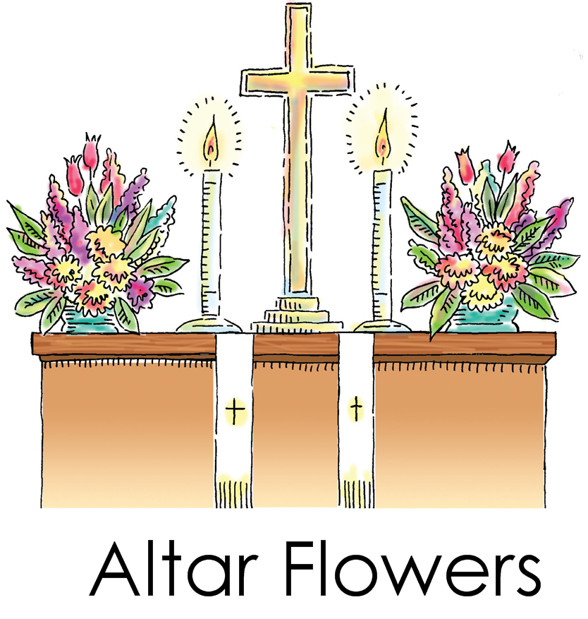

KFUO Sponsor week of August 20, 2017
+ + +
Norma Masters
In honor of what would have been Norma & Nelson’s
47th wedding anniversary

Announcer: Ray Ehrhard

BLESSED SAVIOR’S CALENDAR
August 20, 2017 – August 27, 2017

TODAY: 8:00 a.m. (KFUO) & 10:30 a.m. Worship
SUNDAY with Holy Communion
9:15 a.m. Sunday School & Bible Classes
Aug. 20 12:00 p.m. Youth

MONDAY: 6:00 p.m. Adult Bible Study (McKenna)
Aug. 21

TUESDAY:
Aug. 22

WEDNESDAY: 9:30 a.m. Adult Bible Study
Aug. 23

THURSDAY: Secretary on vacation thru Sept 3
Aug. 24

FRIDAY: Pastor – Day with family
Aug. 25

SATURDAY: 7:00 a.m. MOBS Bible Study @ Denny’s
9:00 a.m. Clean up/ Fix up Day
Aug. 26 6:00 p.m. Worship Service

NEXT 8:00 a.m. (KFUO) & 10:30 a.m. Worship Services
SUNDAY 9:15 a.m. Sunday School & Bible Classes
Aug. 27 12:00 p.m. Youth Luncheon- Higher Things

August 26th “Clean Up/Fix Up Day” from 9 a.m. – 1 p.m. Lunch will be provided – There is a sign up sheet for those who would like to help the Property Committee in getting some things done. If you have any questions, please call Dennis @395-9417.

August 27th at 9:00 a.m. Youth/Adult Confirmation Meeting - Pastor will have a short meeting with parents and youth in the sanctuary regarding Confirmation material and starting date. Youth 6th – 8th grade and parents, please plan on attending this meeting. If you cannot attend, please call and let Pastor know.

August 27th after late service – Youth Luncheon- The youth are hosting a luncheon to share their experience with you regarding Higher Things”. A sign up sheet is available in fellowship hall. Please sign up so they know how many will be attending. We hope you will be able to join us. Once again, thanks for your support!

Blessed Savior Youth Group “Buy a Mile” Fundraiser -
Please support the youth who have attended Higher Things by “Buying a Mile”. You can buy 5 miles for $25.00 or any number times $5.00. To Buy A Mile (or multiple miles!) please write your check to Blessed Savior Lutheran Church and note “Buy A Mile” in the memo of your check. If you would like, you may place cash in the envelope as well. Donations will be accepted through August 31, 2017. We appreciate all that you do for us!

Aug 1-31 Pound the Pantry – A “Food Bank Wish List” for the pantry is provided on the table set up in the back of church. We will collect these needed items throughout the month of August and then donate them to the pantry. Please consider supporting the seminarians and their families. Thank you.

LWML
Our zone president, Barb Edwards, would like to get a group together to go to the Westport Plaza Playhouse to see the Church Basement Ladies. This is a “hilarious musical celebration of the church basement kitchen, and the women who work there” and is inspired by the best seller “Growing up Lutheran”.

Date: Saturday, September 16th, 2017
Time: 4:00 PM
What: Church Basement Ladies – The Musical
Where: Westport Plaza Playhouse
Questions: Please email Barb Edwards at buffyjo610@gmail.com

Tickets are regularly $50, but groups of 10+, are ½ price - $25. Barb already has 6 ladies attending from Hope and welcomes all the ladies from our zone to join them. Please email Barb at buffyjo610@gmail.com if interested in attending.

Table & Tailgate Sale - Friday, September 15 from 7 a.m. to Noon (Indoor) & Sat. Sept. 16 from 7 a.m. to Noon (Indoor & Outdoor) – Cost is $15.00. Rain Date: Sept 22 & 23. Please sign up on the table in fellowship hall.

Sept 23 A Day with Katie Luther, 8:30 a.m. – 2:00 p.m. Laclede Groves Auditorium. Sponsored by the LWML South St. Louis Zone. Continental Breakfast and Lunch are included. Forms are available in fellowship hall, if you would like to attend.

Kids divine

Aug. 20 11th Sun. after Pentecost Matthew 15:27 “Yes, Lord, yet even the dogs eat the crumbs that fall from their masters’ table.” These are the words of faith, for faith means receiving what God gives. And God has given us so much more than just the crumbs that fall from the table – He has given us life, salvation, body and soul, eyes and ears, possessions and income. That’s where our stewardship starts: with faith in the God who is the greatest Giver.

+ + +
Our Response to God’s Love – Week of August 13, 2017
Saturday………………. 18
Sunday (8:00)……….... 31
Sunday (10:30)……….. 51
Sem Students/family..... 0
Visitors……………… 2
Communed….
Total………… 102
Sunday School……… 10
Sun. School/Bible Staff.... 7
Bible Study/Youth…….... 2
Bible Study I …………. 13
Bible Study II ……… 3
Adult/Confirm…….
Wednesday Morning ……
M.O.B.S. Bible Study…… 2

Stewardship means a partnership with God, a ministry of love for God, a shower of blessings from God.

Our Special Prayers and Intercessions
Steven Pavlik – renewal of faith
Marty Geringer – cancer
Parker Kolb – 3 yr. old with cancer
Kyle – renewal of faith
Heather – strengthening of faith
Haily – 8 yrs. old - rare heart disease
Pastor Struve- home recovering
Emma Warren – epileptic seizures
Walter Coble – young child, health issues
Craig Tudor- health
Jim & Joan Aubushon – health issues
Ken Fahrman – health issues
Virginia Hauck- Breast Cancer
Tim Taylor – fibromyalgia
Pam Kraemer – cancer
Tracy Pavlik – health issues
Jay Vogelsang – health
Alberta Vogel – hospice
Nancy Stocker – back problems
Nick Glass – health
Ben Hilderbrand – health issues
Inez Hanson – vascular dementia
Dawn – health issues
Katie Brown – health issues
Pastor Charles Schultz- rec. surgery
Charlotte Taggart – health issues
Dian Jonas - cancer
Adikas – 2 yr. old – upcoming heart
Surgery on Aug 17
Lynne Scheer – stage 4 cancer
Joanne Knaus – health issues
Jessica Parish – diagnoised with MS
Dave Stupperich – health

Donovan Spence – 5 yr. old spinal surgery
Jerry – recovering from heart surgery
Glen Schaper – St. Sophia
Joyce Meyer – Village of St. Peters
Marlene Martens – home
Pastor Stephen Fair – stints in heart
Kathy Ehrhard – breast cancer

Serving in our Armed Forces – Christopher Bushart, Scott Burleigh, Andrew Mack, Paul Hackett, Jay Warren, Gary Wood, Michael Rice, Caleb McElyea, Andrew LaToure, Jeff Throgmorton,
Dan Patrick, Jeremy Zollner, Joshua Murchie, Mitchell Meyers, Adam Guercio, Chance Glover and Cody Guercio.

*Please note: Those who are named in our special prayers and intercessions list are placed there by members of our congregation. St. Paul tells us in 1Timothy 2:1-2: “I urge, then, first of all, that requests, prayers, intercessions and thanksgivings be made for everyone – for kings and all those in authority, that we may live peaceful and quiet lives in all godliness and holiness. This is good, and pleases God our Savior.” Those named remain joyfully in our prayers until the person who requested our prayers removes them or until the Lord resolves their need. Therefore, as St. Paul tells us in Philippians 4:6 “Do not be anxious about anything, but in everything, by prayer and petition, with thanksgiving, present your requests to God.

