Blessed Savior Lutheran Church
Florissant, Missouri

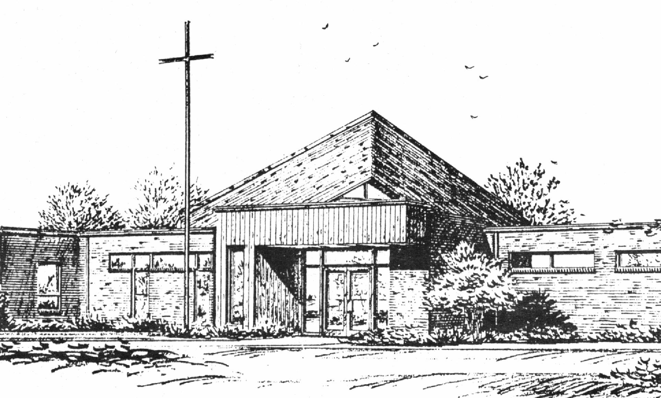

“Empowered by God’s Holy Word,
we joyfully share the love of Jesus with all people;
through worship, teaching, fellowship,
service and witnessing.”

Fourteenth Sunday after Pentecost
September 10, 2017

The Lutheran Church-Missouri Synod

BLESSED SAVIOR LUTHERAN CHURCH
2615 Shackelford Road
Florissant, Missouri 63031-2005
Telephone: 831-1300
www.blessedsavior-lcms.org
Pastor Matthew Roeglin

+ + + + + + + + + + + +
The Fourteenth Sunday after Pentecost
Saturday, September 9 and Sunday, September 10, 2017

WE WELCOME YOU to our worship service this morning. We pray God’s rich blessings upon you as you hear His Word and praise His holy name. We ask our members and visitors to please use the friendship pad found on the pew. Kindly hand the friendship pad to the person sitting next to you. The Ushers will collect them after the service. Thank You.

THIS WORSHIP FOLDER / CHURCH BULLETIN is prepared for your convenience and contains the entire order of worship with all spoken and sung responses. However, if you are more comfortable using the hymnal, you may use the order of worship found in the front pages of Lutheran Service Book where all the melodies are shown for the sung responses of the congregation

Divine Service 1 p.151

Greeting of Peace The people may greet one another in the name of the Lord, saying, “Peace be with you,” as a sign of reconciliation and of the unity of the Spirit in the bond of peace (Matt. 5:22-24; Eph. 4:1-3).

Opening Hymn
“Children of the Heavenly Father” #725

Stand
Confession and Absolution p.151
The sign of the cross may be made by all in remembrance of their Baptism.

P | In the name of the Father and of the T Son and of the Holy Spirit.
C | Amen.

P | If we say we have no sin, we deceive ourselves, and the truth is not in us.
C | But if we confess our sins, God, who is faithful and just, will forgive our sins and cleanse us from all unrighteousness.

Silence for reflection on God's Word and for self-examination.

P | Let us then confess our sins to God our Father.
C | Most merciful God, we confess that we are by nature sinful and unclean. We have sinned against You in thought, word, and deed, by what we have done and by what we have left undone. We have not loved You with our whole heart; we have not loved our neighbors as ourselves. We justly deserve Your present and eternal punishment. For the sake of Your Son, Jesus Christ, have mercy on us. Forgive us, renew us, and lead us, so that we may delight in Your will and walk in Your ways to the glory of Your holy name. Amen.

P | Almighty God in His mercy has given His Son to die for you and for His sake forgives you all your sins. As a called and ordained servant of Christ, and by His authority, I therefore forgive you all your sins in the name of the Father and of the T Son and of the Holy Spirit.
C | Amen.

Service of the Word p.152
Introit Ps. 92:1–4; antiphon: Ps. 92:5

How great are your works, | O Lord!*
Your thoughts are | very deep!
It is good to give thanks | to the Lord,*
to sing praises to your name, | O Most High;
to declare your steadfast love in the | morning,*
and your faithful- | ness by night,
to the music of the lute | and the harp,*
to the melody | of the lyre.
For you, O Lord, have made me glad | by your work;*
at the works of your hands I | sing for joy.
Glory be to the Father and | to the Son
and to the Holy | Spirit;
as it was in the be- | ginning,
is now, and will be forever. | Amen.
How great are your works, | O Lord!*
Your thoughts are | very deep!

Kyrie p.152
P | In peace let us pray to the Lord.
C | Lord, have mercy.
P | For the peace from above and for our salvation let us pray to the Lord.
C | Lord, have mercy.
P | For the peace of the whole world, for the well-being of the Church of God, and for the unity of all let us pray to the Lord.
C | Lord, have mercy.
P | For this holy house and for all who offer here their worship and praise let us pray to the Lord.
C | Lord, have mercy.
P | Help, save, comfort, and defend us, gracious Lord.
C | Amen.

Hymn of Praise “Gloria in Excelsis” p.154
A | Glory to God in the highest, and peace to his people on earth.
C | Lord God, heavenly King, almighty God and Father:  We worship You, we give You thanks, we praise You for Your glory.  Lord Jesus Christ, only Son of the Father, Lord God, Lamb of God:  You take away the sin of the world; have mercy on us.  You are seated at the right hand of the Father; receive our prayer.  For You alone are the Holy One, You alone are the Lord,  You alone are the Most High, Jesus Christ, with the Holy Spirit,  in the glory of God the Father. Amen.

Salutation and Collect of the Day p.156

P | The Lord be with you.
C | - And also with you.

P | Let us pray.

C | O God, from whom all good proceeds, grant to us, Your humble servants, Your holy inspiration, that we may set our minds on the things that are right and, by Your merciful guiding, accomplish them; through Jesus Christ, Your Son, our Lord, who lives and reigns with You and the Holy Spirit, one God, now and forever. Amen.

Sit
Old Testament Reading Ezekiel 33:7–9
⁷“So you, son of man, I have made a watchman for the house of Israel. Whenever you hear a word from my mouth, you shall give them warning from me. ⁸If I say to the wicked, O wicked one, you shall surely die, and you do not speak to warn the wicked to turn from his way, that wicked person shall die in his iniquity, but his blood I will require at your hand. ⁹But if you warn the wicked to turn from his way, and he does not turn from his way, that person shall die in his iniquity, but you will have delivered your soul.

A | This is the Word of the Lord.
C | Thanks be to God.

Gradual Ps. 34:9, 19, alt.
C Fear the Lord, you his saints,
for those who fear him lack nothing!
Many are the afflictions of the righteous,
but the Lord delivers him out of them all.

Epistle Romans 13:1–10
¹Let every person be subject to the governing authorities. For there is no authority except from God, and those that exist have been instituted by God. ²Therefore whoever resists the authorities resists what God has appointed, and those who resist will incur judgment. ³For rulers are not a terror to good conduct, but to bad. Would you have no fear of the one who is in authority? Then do what is good, and you will receive his approval, ⁴for he is God’s servant for your good. But if you do wrong, be afraid, for he does not bear the sword in vain. For he is the servant of God, an avenger who carries out God’s wrath on the wrongdoer. ⁵Therefore one must be in subjection, not only to avoid God’s wrath but also for the sake of conscience. ⁶For the same reason you also pay taxes, for the authorities are ministers of God, attending to this very thing. ⁷Pay to all what is owed to them: taxes to whom taxes are owed, revenue to whom revenue is owed, respect to whom respect is owed, honor to whom honor is owed.
⁸Owe no one anything, except to love each other, for the one who loves another has fulfilled the law. ⁹The commandments, “You shall not commit adultery, You shall not murder, You shall not steal, You shall not covet,” and any other commandment, are summed up in this word: “You shall love your neighbor as yourself.” ¹⁰Love does no wrong to a neighbor; therefore love is the fulfilling of the law.

A | This is the Word of the Lord.
C | Thanks be to God.
Stand
Alleluia and Verse p.156

C | Alleluia.  Lord, to whom shall we go?  You have the words of eternal life.  Alleluia, alleluia.

Holy Gospel Matthew 18:1–20
P | The Holy Gospel according to St. Matthew, the eighteenth chapter.
C | - Glory to You, O Lord.

¹At that time the disciples came to Jesus, saying, “Who is the greatest in the kingdom of heaven?” ²And calling to him a child, he put him in the midst of them ³and said, “Truly, I say to you, unless you turn and become like children, you will never enter the kingdom of heaven. ⁴Whoever humbles himself like this child is the greatest in the kingdom of heaven.
⁵“Whoever receives one such child in my name receives me, ⁶but whoever causes one of these little ones who believe in me to sin, it would be better for him to have a great millstone fastened around his neck and to be drowned in the depth of the sea.
⁷“Woe to the world for temptations to sin! For it is necessary that temptations come, but woe to the one by whom the temptation comes! ⁸And if your hand or your foot causes you to sin, cut it off and throw it away. It is better for you to enter life crippled or lame than with two hands or two feet to be thrown into the eternal fire. ⁹And if your eye causes you to sin, tear it out and throw it away. It is better for you to enter life with one eye than with two eyes to be thrown into the hell of fire.
¹⁰“See that you do not despise one of these little ones. For I tell you that in heaven their angels always see the face of my Father who is in heaven. ¹²What do you think? If a man has a hundred sheep and one of them has gone astray, does he not leave the ninety-nine on the mountains and go in search of the one that went astray? ¹³And if he finds it, truly, I say to you, he rejoices over it more than over the ninety-nine that never went astray. ¹⁴So it is not the will of my Father who is in heaven that one of these little ones should perish.
¹⁵“If your brother sins against you, go and tell him his fault, between you and him alone. If he listens to you, you have gained your brother. ¹⁶But if he does not listen, take one or two others along with you, that every charge may be established by the evidence of two or three witnesses. ¹⁷If he refuses to listen to them, tell it to the church. And if he refuses to listen even to the church, let him be to you as a Gentile and a tax collector. ¹⁸Truly, I say to you, whatever you bind on earth shall be bound in heaven, and whatever you loose on earth shall be loosed in heaven. ¹⁹Again I say to you, if two of you agree on earth about anything they ask, it will be done for them by my Father in heaven. ²⁰For where two or three are gathered in my name, there am I among them.”

P | This is the Gospel of the Lord.
C | - Praise to You, O Christ.

Apostles' Creed p.159
C | I believe in God, the Father Almighty,  maker of heaven and earth.  And in Jesus Christ, His only Son, our Lord,  who was conceived by the Holy Spirit,  born of the virgin Mary,  suffered under Pontius Pilate,  was crucified, died and was buried.  He descended into hell.  The third day He rose again from the dead.  He ascended into heaven  and sits at the right hand of God the Father Almighty.  From thence He will come to judge the living and the dead.  I believe in the Holy Spirit,  the holy Christian Church,  the communion of saints,  the forgiveness of sins,  the resurrection of the body,  and the life T everlasting. Amen.
Sit
Mite Box
Children's Message
Sermon Hymn “My Soul, Now Praise Your Maker” # 820
Sermon
Offering
Stand
Offertory p.159
C | What shall I render to the Lord for all His benefits to me?  I will offer the sacrifice of thanksgiving and will call on the name of the Lord.  I will take the cup of salvation and will call on the name of the Lord.  I will pay my vows to the Lord now in the presence of all His people,  in the courts of the Lord's house, in the midst of you, O Jerusalem.

Prayer of the Church
After each petition of the prayers:
P | P Lord, in Your mercy.
C | C Hear our prayer.
After the final petition:
P | P One God, now and forever.
C | C Amen.

Lord's Prayer p.162
P | Lord, remember us in Your kingdom and teach us to pray:
C | Our Father who art in heaven,  hallowed be Thy name,  Thy kingdom come,  Thy will be done on earth  as it is in heaven;  give us this day our daily bread;  and forgive us our trespasses  as we forgive those  who trespass against us;  and lead us not into temptation,  but deliver us from evil.  For Thine is the kingdom  and the power and the glory  forever and ever. Amen.

Benediction p.166
P | The Lord bless you and keep you.  The Lord make His face shine on you and be gracious to you.  The Lord look upon you with favor and T give you peace.
C | - Amen.

Closing Hymn “Thy Strong Word” # 578

Sit
Announcements
After the announcements, please stand for the closing Doxology.
Doxology #805
Praise God, from whom all blessings flow;
Praise Him, all creatures here below;
Praise Him above, ye heav’nly host:
Praise Father, Son, and Holy Ghost. Amen

Go and Serve the Lord
Acknowledgments Unless otherwise indicated, all scripture quotations are from The Holy Bible, English Standard Version, copyright © 2001 by Crossway Bibles, a division of Good News Publishers. Used by permission. All rights reserved. Created by Lutheran Service Builder © 2006 Concordia Publishing House.

The Preacher: Pastor Matthew Roeglin
The Liturgist: Pastor Matthew Roeglin
The Organist: Mr. Kenneth Butherus
Greeters: E – Betty Lipham & L- Mary Bremer
Elder Greeters: Saturday: Ed Steinbruegge
E- Mike Kroehnke & L- Dennis Henneman
Acolytes: Sunday 8:00 a.m.-
Sunday10:30am:
Christian Education: Sunday 9:15 a.m. Adults, Young Adults, Youth,
and Sunday School
Wednesday morning Bible Class 9:30 a.m.

Altar Flowers – are placed by Susan Johnston in celebration of her mother, Wanda Johnston’s 80th birthday and for the many blessings God has bestowed upon her.

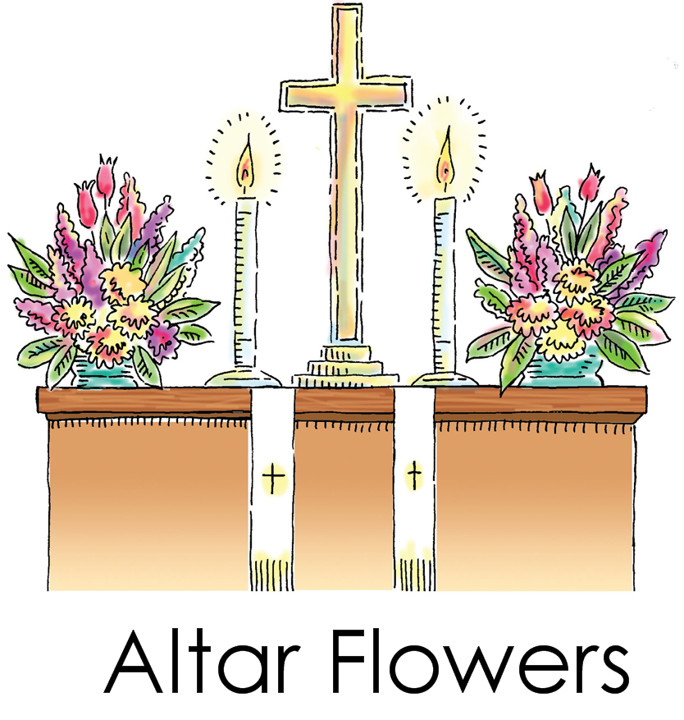

KFUO Sponsor week of September 10, 2017
+ + +
Doris Hewkin
In loving memory of her parents, Ernest & Jeannette Young and her brother, Donald Young

Announcer: Brian McKenna

Table & Tailgate Sale - Friday, September 15 from 7 a.m. to Noon (Indoor) & Sat. Sept. 16 from 7 a.m. to Noon (Indoor & Outdoor) – Cost is $15.00. Rain Date: Sept 22 & 23. Please sign up on the table in fellowship hall.

Thank You – to all who helped with our Clean Up/ Fix Up Day:
Dan & Donna Boyd, Dennis Mullen, Ed Steinbruegge, Connie & Peg Steinbruegge (baked cookies for the crew), Wade Gergen & Trevor Beach. Your help was very much appreciated. God Bless

Thank You – to all of you who helped support Concordia Seminary’s Food Bank. They were truly grateful for your donation.

Thank You – to all who helped with the funeral luncheon. The family was very appreciative of the work done by the congregation. Thanks again.

BLESSED SAVIOR’S CALENDAR
September 10, 2017 – September 17, 2017

TODAY: 8:00 a.m. (KFUO) & 10:30 a.m. Worship
SUNDAY 9:15 a.m. Sunday School & Bible Classes
Mite Box 9:15 a.m. 6th grade Confirmation
Sep. 10 12:00 p.m. Voter’s Assembly

MONDAY: 7:00 p.m. MOBS
Sep. 11

TUESDAY:
Sep. 12

WEDNESDAY: 9:30 a.m. Adult Bible Study
Sep. 13 6:00 p.m. Youth Confirmation Class

THURSDAY: 10:00 a.m. Bible Study (Brian McKenna’s)
7:00 p.m. Elders
Sep. 14 Newsletter Deadline

FRIDAY: Pastor – Day with family
Sep. 15 7:00 a.m. Table & Tailgate Sale

SATURDAY: 7:00 a.m. MOBS Bible Study @ Denny’s
7:00 a.m. Table & Tailgate Sale
Sep. 16 6:00 p.m. Worship Service

NEXT 8:00 a.m. (KFUO) & 10:30 a.m. Worship Services
SUNDAY 9:15 a.m. Sunday School & Bible Classes
Sep. 17 Communion will be on the 24th

HOMEMADE APPLEBUTTER, made by Salem Lutheran Church, may be ordered by calling Judy at 839-2157 or Kathy at 839--0823. Cost is Regular quart $7. Regular pint $4. Splenda quart $8. Splenda pint $5. Orders will be available for pick up across the street from the church beginning October 1. Thank you! God Bless! Mary

Fun 4 Purpose Community Carnival
Saturday, Sept. 16
10am-3pm
Lutheran High School North
5401 Lucas & Hunt Road

Kingdom State University, in partnership with Lutheran High School North and the Lutheran Hope Center, is sponsoring a community carnival saluting education. Everyone is invited to this family fun-filled day! Come and enjoy free admission and free food, along with carnival games, prizes, inflatables, vendors, raffles, and more.

In addition, two scholarships will be presented to Lutheran North seniors who entered an essay competition on the importance of understanding “Purpose.”

Kingdom State University (KSU) is a faith-based nonprofit organization purposed to RAISE AWARENESS, EDUCATE, and INSPIRE youth and young adults to value their faith and live their life with God woven into every aspect. KSU operates from the premise that 60-75% of graduating high school seniors disconnect from the Church once they begin to live life independently. This 2nd annual Fun 4 Purpose event is designed to galvanize the community and celebrate the importance of education.

For more information, to be a vendor, or to volunteer, contact: INFO@KINGDOMSU.ORG, or call 314-384-9960.

+ + +
Our Response to God’s Love – Week of August 27, 2017
Saturday………………. 10
Sunday (8:00)……….... 34
Sunday (10:30)……….. 46
Sem Students/family..... 0
Visitors……………… 4
Communed….
Total………… 94
Sunday School……… 10
Sun. School/Bible Staff.... 8
Bible Study/Youth…….... 5
Bible Study I …………. 12
Bible Study II ……… 4
Adult/Confirm…….
Wednesday Morning …… 11
M.O.B.S. Bible Study…… 2

Stewardship means a partnership with God, a ministry of love for God, a shower of blessings from God.

Sep. 10 14th Sun. after Pentecost Matthew 18:4 “Whoever humbles himself like this child is the greatest in the kingdom of heaven.” What does it mean to have childlike faith? Certainly Jesus does not want us to have a faith that is childish: we are not called to ignorance or silliness. Rather, we are called to trust the way a child trusts: with complete confidence in the Father. We show that confidence in our lives when we follow His directives for our life: Father knows best, so we’ll take His advice!

+ + +
Our Response to God’s Love – Week of September 3, 2017
Saturday………………. 19
Sunday (8:00)……….... 30
Sunday (10:30)……….. 45
Sem Students/family..... 2
Visitors……………… 0
Communed….84
Total………… 96
Sunday School……… 8
Sun. School/Bible Staff.... 5
Bible Study/Youth…….... 1
Bible Study I …………. 13
Bible Study II ……… 5
Adult/Confirm…….
Wednesday Morning ……
M.O.B.S. Bible Study…… 2

Stewardship means a partnership with God, a ministry of love for God, a shower of blessings from God.

Our Special Prayers and Intercessions
Steven Pavlik – renewal of faith
Marty Geringer – cancer
Parker Kolb – 3 yr. old with cancer
Kyle – renewal of faith
Heather – strengthening of faith
Haily – 8 yrs. old - rare heart disease
Pastor Struve- home recovering
Emma Warren – epileptic seizures
Walter Coble – young child, health issues
Craig Tudor- health
Jim & Joan Aubushon – health issues
Ken Fahrman – health issues
Virginia Hauck- Breast Cancer
Tim Taylor – fibromyalgia
Pam Kraemer – cancer
Tracy Pavlik – health issues
Jay Vogelsang – health
Alberta Vogel – hospice
Nancy Stocker – back problems
Nick Glass – health
Ben Hilderbrand – health issues
Inez Hanson – vascular dementia
Dawn – health issues
Katie Brown – health issues
Pastor Charles Schultz- rec. surgery
Charlotte Taggart – health issues
Dian Jonas - cancer
Adikas – 2 yr. old – upcoming heart
Surgery on Aug 17
Lynne Scheer – stage 4 cancer
Joanne Knaus – health issues
Jessica Parish – diagnoised with MS
Dave Stupperich – health

Donovan Spence – 5 yr. old spinal surgery
Glen Schaper – St. Sophia
Marlene Martens – home
Pastor Stephen Fair – home
Kathy Ehrhard – breast cancer
Bill Woodson – recovery from surgery
Aaron Dietrich – recovery from surgery

Serving in our Armed Forces – Christopher Bushart, Scott Burleigh, Andrew Mack, Paul Hackett, Jay Warren, Gary Wood, Michael Rice, Caleb McElyea, Andrew LaToure, Jeff Throgmorton,
Dan Patrick, Jeremy Zollner, Joshua Murchie, Mitchell Meyers, Adam Guercio, Chance Glover and Cody Guercio.

*Please note: Those who are named in our special prayers and intercessions list are placed there by members of our congregation. St. Paul tells us in 1Timothy 2:1-2: “I urge, then, first of all, that requests, prayers, intercessions and thanksgivings be made for everyone – for kings and all those in authority, that we may live peaceful and quiet lives in all godliness and holiness. This is good, and pleases God our Savior.” Those named remain joyfully in our prayers until the person who requested our prayers removes them or until the Lord resolves their need. Therefore, as St. Paul tells us in Philippians 4:6 “Do not be anxious about anything, but in everything, by prayer and petition, with thanksgiving, present your requests to God.

