Blessed Savior Lutheran Church
Florissant, Missouri

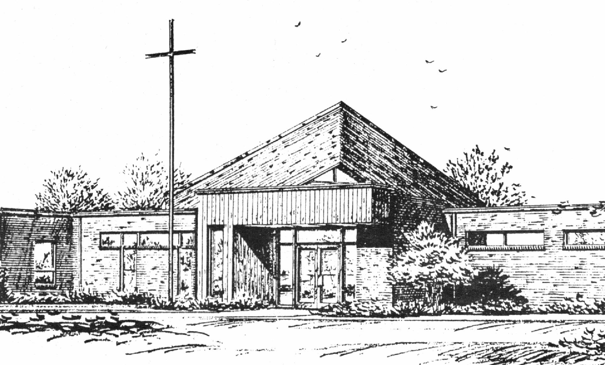

“Empowered by God’s Holy Word,
we joyfully share the love of Jesus with all people;
through worship, teaching, fellowship,
service and witnessing.”

Twentieth Sunday after Pentecost
October 22, 2017

The Lutheran Church-Missouri Synod

BLESSED SAVIOR LUTHERAN CHURCH
2615 Shackelford Road
Florissant, Missouri 63031-2005
Telephone: 831-1300
www.blessedsavior-lcms.org
Pastor Matthew Roeglin

+ + + + + + + + + + + +
Twentieth Sunday after Pentecost
Saturday, October 21 and Sunday, October 22, 2017

WE WELCOME YOU to our worship service this morning. We pray God’s rich blessings upon you as you hear His Word and praise His holy name. We ask our members and visitors to please use the friendship pad found on the pew. Kindly hand the friendship pad to the person sitting next to you. The Ushers will collect them after the service. Thank You.

THIS WORSHIP FOLDER / CHURCH BULLETIN is prepared for your convenience and contains the entire order of worship with all spoken and sung responses. However, if you are more comfortable using the hymnal, you may use the order of worship found in the front pages of Lutheran Service Book where all the melodies are shown for the sung responses of the congregation

Divine Service 1 p.151

Greeting of Peace The people may greet one another in the name of the Lord, saying, “Peace be with you,” as a sign of reconciliation and of the unity of the Spirit in the bond of peace (Matt. 5:22-24; Eph. 4:1-3).

Opening Hymn
“Lord of Glory, You Have Bought Us” #851

Stand
Confession and Absolution p.151
The sign of the cross may be made by all in remembrance of their Baptism.

P | In the name of the Father and of the T Son and of the Holy Spirit.
C | Amen.

P | If we say we have no sin, we deceive ourselves, and the truth is not in us.
C | But if we confess our sins, God, who is faithful and just, will forgive our sins and cleanse us from all unrighteousness.

Silence for reflection on God's Word and for self-examination.

P | Let us then confess our sins to God our Father.
C | Most merciful God, we confess that we are by nature sinful and unclean. We have sinned against You in thought, word, and deed, by what we have done and by what we have left undone. We have not loved You with our whole heart; we have not loved our neighbors as ourselves. We justly deserve Your present and eternal punishment. For the sake of Your Son, Jesus Christ, have mercy on us. Forgive us, renew us, and lead us, so that we may delight in Your will and walk in Your ways to the glory of Your holy name. Amen.

P | Almighty God in His mercy has given His Son to die for you and for His sake forgives you all your sins. As a called and ordained servant of Christ, and by His authority, I therefore forgive you all your sins in the name of the Father and of the T Son and of the Holy Spirit.
C | Amen.

Service of the Word
Introit Ps. 121:1–4, 7–8; antiphon: Ps. 121:5


The Lord is your | keeper;*
the Lord is your shade on your | right hand.
I lift up my eyes | to the hills.*
From where does my | help come?
My help comes | from the Lord,*
who made | heaven and earth.
He will not let your | foot be moved;*
he who keeps you will not | slumber.
Behold, he who keeps | Israel*
will neither slum- | ber nor sleep.
The Lord will keep you from all | evil;*
he will | keep your life.
The Lord will keep your going out and your | coming in*
from this time forth and for- | evermore.
Glory be to the Father and | to the Son*
and to the Holy | Spirit;
as it was in the be- | ginning,*
is now, and will be forever. | Amen.
The Lord is your | keeper;*
the Lord is your shade on your | right hand.

Kyrie p.152
P | In peace let us pray to the Lord.
C | Lord, have mercy.
P | For the peace from above and for our salvation let us pray to the Lord.
C | Lord, have mercy.
P | For the peace of the whole world, for the well-being of the Church of God, and for the unity of all let us pray to the Lord.
C | Lord, have mercy.
P | For this holy house and for all who offer here their worship and praise let us pray to the Lord.
C | Lord, have mercy.
P | Help, save, comfort, and defend us, gracious Lord.
C | Amen.

Hymn of Praise “Gloria in Excelsis” p.154
A | Glory to God in the highest, and peace to his people on earth.
C | Lord God, heavenly King, almighty God and Father:  We worship You, we give You thanks, we praise You for Your glory.  Lord Jesus Christ, only Son of the Father, Lord God, Lamb of God:  You take away the sin of the world; have mercy on us.  You are seated at the right hand of the Father; receive our prayer.  For You alone are the Holy One, You alone are the Lord,  You alone are the Most High, Jesus Christ, with the Holy Spirit,  in the glory of God the Father. Amen.

Salutation and Collect of the Day p.156

P | The Lord be with you.
C | - And also with you.

P | Let us pray.

C | O God, the protector of all who trust in You, have mercy on us that with You as our ruler and guide we may so pass through things temporal that we lose not the things eternal; through Jesus Christ, Your Son, our Lord, who lives and reigns with You and the Holy Spirit, one God, now and forever. Amen.

Sit

Old Testament Reading Isaiah 45:1–7
¹Thus says the Lord to his anointed, to Cyrus,
whose right hand I have grasped,
to subdue nations before him
and to loose the belts of kings,
to open doors before him
that gates may not be closed:
²“I will go before you
and level the exalted places,
I will break in pieces the doors of bronze
and cut through the bars of iron,
³I will give you the treasures of darkness
and the hoards in secret places,
that you may know that it is I, the Lord,
the God of Israel, who call you by your name.
⁴For the sake of my servant Jacob,
and Israel my chosen,
I call you by your name,
I name you, though you do not know me.
⁵I am the Lord, and there is no other,
besides me there is no God;
I equip you, though you do not know me,
⁶that people may know, from the rising of the sun
and from the west, that there is none besides me;
I am the Lord, and there is no other.
⁷I form light and create darkness,
I make well-being and create calamity,
I am the Lord, who does all these things.

A | This is the Word of the Lord.
C | Thanks be to God.

Gradual Ps. 91:11; 103:1
C He will command his angels concerning you
to guard you in all your ways.
Bless the Lord, O my soul,
and all that is within me, bless his holy name!

Epistle 1 Thessalonians 1:1–10
¹Paul, Silvanus, and Timothy,
To the church of the Thessalonians in God the Father and the Lord Jesus Christ:
Grace to you and peace.
²We give thanks to God always for all of you, constantly mentioning you in our prayers, ³remembering before our God and Father your work of faith and labor of love and steadfastness of hope in our Lord Jesus Christ. ⁴For we know, brothers loved by God, that he has chosen you, ⁵because our gospel came to you not only in word, but also in power and in the Holy Spirit and with full conviction. You know what kind of men we proved to be among you for your sake. ⁶And you became imitators of us and of the Lord, for you received the word in much affliction, with the joy of the Holy Spirit, ⁷so that you became an example to all the believers in Macedonia and in Achaia. ⁸For not only has the word of the Lord sounded forth from you in Macedonia and Achaia, but your faith in God has gone forth everywhere, so that we need not say anything. ⁹For they themselves report concerning us the kind of reception we had among you, and how you turned to God from idols to serve the living and true God, ¹⁰and to wait for his Son from heaven, whom he raised from the dead, Jesus who delivers us from the wrath to come.

A | This is the Word of the Lord.
C | Thanks be to God.

Stand
Alleluia and Verse p.156

C | Alleluia.  Lord, to whom shall we go?  You have the words of eternal life.  Alleluia, alleluia.

Holy Gospel Matthew 22:15–22
P | The Holy Gospel according to St. Matthew, the twenty-second chapter.
C | - Glory to You, O Lord.

¹⁵Then the Pharisees went and plotted how to entangle Jesus in his talk. ¹⁶And they sent their disciples to him, along with the Herodians, saying, “Teacher, we know that you are true and teach the way of God truthfully, and you do not care about anyone’s opinion, for you are not swayed by appearances. ¹⁷Tell us, then, what you think. Is it lawful to pay taxes to Caesar, or not?” ¹⁸But Jesus, aware of their malice, said, “Why put me to the test, you hypocrites? ¹⁹Show me the coin for the tax.” And they brought him a denarius. ²⁰And Jesus said to them, “Whose likeness and inscription is this?” ²¹They said, “Caesar’s.” Then he said to them, “Therefore render to Caesar the things that are Caesar’s, and to God the things that are God’s.” ²²When they heard it, they marveled. And they left him and went away.

P | This is the Gospel of the Lord.
C | - Praise to You, O Christ.

Apostles' Creed p.159
C | I believe in God, the Father Almighty,  maker of heaven and earth.  And in Jesus Christ, His only Son, our Lord,  who was conceived by the Holy Spirit,  born of the virgin Mary,  suffered under Pontius Pilate,  was crucified, died and was buried.  He descended into hell.  The third day He rose again from the dead.  He ascended into heaven  and sits at the right hand of God the Father Almighty.  From thence He will come to judge the living and the dead.  I believe in the Holy Spirit,  the holy Christian Church,  the communion of saints,  the forgiveness of sins,  the resurrection of the body,  and the life T everlasting. Amen.
Sit
Children's Message
Sermon Hymn “Holy God, We Praise Thy Name” # 940
Sermon
Offering
Stand
Offertory p.159
C | What shall I render to the Lord for all His benefits to me? I will offer the sacrifice of thanksgiving and will call on the name of the Lord. I will take the cup of salvation and will call on the name of the Lord.  I will pay my vows to the Lord now in the presence of all His people, in the courts of the Lord's house, in the midst of you, O Jerusalem.

Prayer of the Church
After each petition of the prayers:
P | P Let us pray to the Lord.
C | C Lord, have mercy.
After the final petition:
P | P Through Jesus Christ, our Lord.
C | C Amen.

Lord's Prayer p.162
P | Lord, remember us in Your kingdom and teach us to pray:
C | Our Father who art in heaven, hallowed be Thy  name, Thy kingdom come,  Thy will be done on earth  as it is in heaven;  give us this day our daily bread;  and forgive us our trespasses  as we forgive those  who trespass against us;  and lead us not into temptation,  but deliver us from evil.  For Thine is the kingdom  and the power and the glory  forever and ever. Amen.
Benediction p.166
P | The Lord bless you and keep you.  The Lord make His face shine on you and be gracious to you.  The Lord look upon you with favor and T give you peace.
C | - Amen.

Closing Hymn “Crown Him with Many Crowns” # 525

Sit
Announcements
After the announcements, please stand for the closing Doxology.
Doxology # 805
Praise God, from whom all blessings flow;
Praise Him, all creatures here below;
Praise Him above, ye heav’nly host:
Praise Father, Son, and Holy Ghost. Amen

Go and Serve the Lord
Acknowledgments Unless otherwise indicated, all scripture quotations are from The Holy Bible, English Standard Version, copyright © 2001 by Crossway Bibles, a division of Good News Publishers. Used by permission. All rights reserved. Created by Lutheran Service Builder © 2006 Concordia Publishing House.

The Preacher: Sem. Joseph Hanson
The Liturgist: Pastor Matthew Roeglin
The Organist: Mr. Kenneth Butherus
Greeters: E – Paula Bossaller & L- Debbie Haynes
Elder Greeters: Saturday: Ed Steinbruegge
E- Mike Kroehnke & L- Terry Bossaller
Acolytes: Sunday 8:00 a.m.-
Sunday10:30am: Caitlin Gayfield
Christian Education: Sunday 9:15 a.m. Adults, Young Adults, Youth,
and Sunday School
Wednesday morning Bible Class 9:30 a.m.

Altar Flowers – are placed by the Bossaller family and Doris Glatz in celebration of Terry’s birthday and for the many blessings God has bestowed on him.


KFUO Sponsor week of October 22, 2017
+ + +
Ken Butherus
In loving memory of his wife, Effie and his mother, Anita

Announcer: Michael Haynes
-----------------------------------------------------------------------

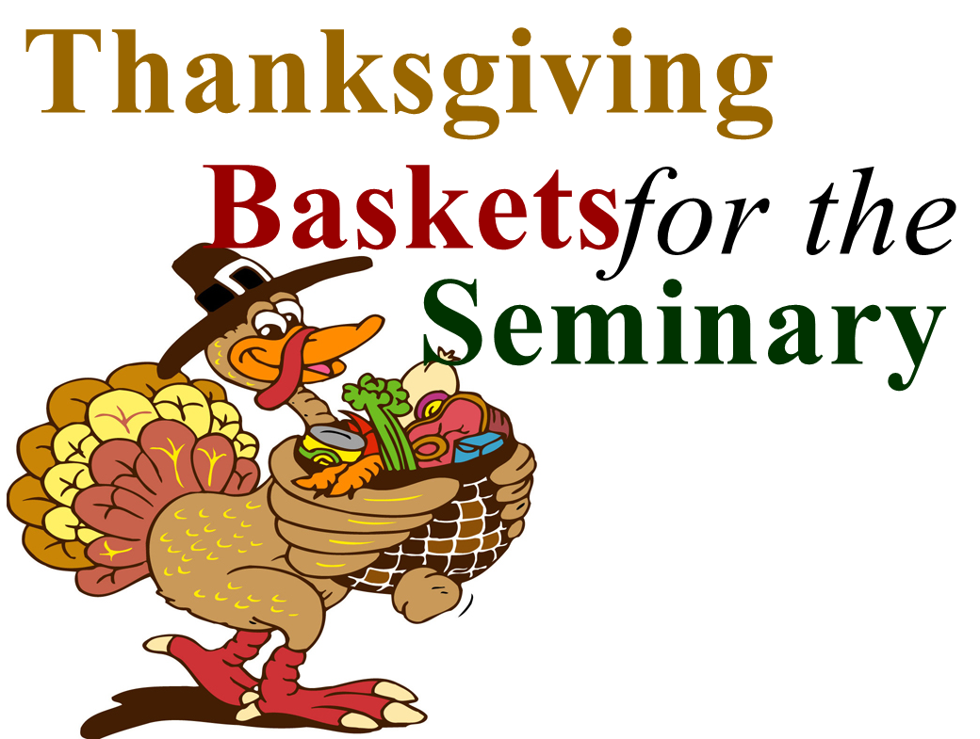

The Turkey is ready to be plucked!
Oct. 7 – Nov. 12, 2017

Listed on each feather are items that are needed for the baskets. Please take feathers only if you will be able to fulfill the obligation. If you are unable to purchase food, cash donations will be taken. The ladies will need your items turned in by November 12th.
Thank you all for your support to the men and their families at the Seminary.
----------------------------------------------------------------

Friday, October 27th Trunk r Treat – Please sign up in fellowship hall if you will be decorating your trunk. In the past, we have had between 100-150 kids & parents come. We would really like to have a nice turn out from our congregation in decorating their trunk. Thank you so much! Paula

BLESSED SAVIOR’S CALENDAR
October 22, 2017 – October 29, 2017

TODAY: 8:00 a.m. (KFUO) & 10:30 a.m. Worship
SUNDAY 9:15 a.m. Sunday School & Bible Classes
9:15 a.m. 6th grade Confirmation
Oct. 22 5:00 p.m. Choir, 6 pm Hand Bells & 7:30 pm Brass

MONDAY: 7:00 p.m. Bd. Of Directors
Oct. 23

TUESDAY:
Oct. 24

WEDNESDAY: 9:30 a.m. Adult Bible Class
Oct. 25

THURSDAY: 10:00 a.m. Bible Study (Brian McKenna’s)
Oct. 26

FRIDAY: Pastor – Day with family
Oct. 27 5:30 p.m. Decorate Trunk & 6:00 p.m. Treat

SATURDAY: 7:00 a.m. MOBS Bible Study @ Denny’s
Oct. 28 6:00 p.m. Worship Service w/ Holy Communion

NEXT 8:00 a.m. (KFUO) “1 worship service only”
SUNDAY 9:15 a.m. Sunday School & Bible Classes & 6th
Grade Confirmation
11:15 a.m. Pastor Appreciation/Reformation & Chili Cook-Off!
2:00 p.m. Salem –Black Jack, Circuit Wide
Oct. 29 Reformation Service

Reformation Weekend Services
Saturday, October 28th
6:00 p.m. with Holy Communion
and
Sunday, October 29th – “One Service Only”
8:00 a.m. (KFUO) with Holy Communion
9:15 a.m. Movie “Martin Luther” (all are welcome)
11:00 a.m. Pastor Appreciation/Reformation
& Chili Cook-off
At 2:00 p.m. – Salem Lutheran Church for a circuit wide Reformation Worship Service

Our District President, Rev. Dr. Lee Hagan will preach and Dr. Jim Marriott of Concordia Seminary will direct the music.

Sign up sheets are available for those who will be attending the Reformation Luncheon and for those who would like to enter their “Chili”.
-----------------------------------------------------------------------

October 31 – Concordia Seminary 500th Anniversary Reformation Service @ 7:00 p.m. Chapel of St. Timothy and St. Titus – The “three solas” of the Reformation will be in the spotlight.

Nov. 4th Craft Bazaar and Luncheon – Immanuel Lutheran –Olive Rd. from 10:00 a.m. – 2:00 p.m. More information on the bulletin board in the Narthex.

Nov. 5 Sausage Supper – Salem Black Jack from 12:30 p.m. – 6:00 p.m. “Carry Out Only”. Adults $11.00 and Children under 12 $8.00.

Thrivent Choice Dollars – are ready to be designated. This will be done through the end of the year.

Nov. 18th - Lutheran High School Association Dinner Auction - Join us Under the Big Top for the 39th annual Lutheran High School Association Dinner Auction on November 18th at the DoubleTree Westport. The event will be a fun night of celebration with jugglers, stilt walkers, fire breathers and more! Enjoy a cotton candy cocktail, bid on some great items, and stay for the after-party with live music and dancing. There is something for everyone! For more information and tickets, please visit lhsastl.org/auction2017. If you would like to donate or help sponsor the auction, please contact Cheryl Ehrhard at cehrhard@lhsastl.org. Thank you for your support!

Blessed Savior College Students - We are looking for pen pals for our college students. It will be great to keep them in touch with our caring church community. Anyone who would like to send a short note of encouragement to our college student during the school year can find a list of their addresses on the bright yellow paper on the table in fellowship hall. We will also be taking some goodie box donations near the end of the semester to send them each a care package before finals. If you have any questions, please call Suzy Helmich @314-608-4892. Thank you and God bless.

The Lutheran North Theater Department invites you to join them for an evening of drama and laughter as they present Strange Boarders. What happens when a naïve but kindhearted boarding home proprietor, her two adopted daughters, an absent-minded professor, an aging sea captain and a handful of mobsters-in-hiding are all living under one roof? Find out on Oct. 26, 27, or 28 at LHSN, 5401 Lucas & Hunt Road. The show begins at 7:00 p.m. Tickets are $5 for adults, $3 for students, no charge for children 5 and under. This is a good way for Lutheran elementary school students to get Crusader Coins!

Oct. 22 20th Sunday after Pentecost Matthew 22:21
Then he said to them, "Therefore render to Caesar the things that are Caesar's, and to God the things that are God's." So what is Jesus saying? Doesn’t everything belong to God? Yes – and God has a place for everything. Some of what He gives us goes to Caesar. Some must come back to the work of His Church. And some goes to support the families He has given us. All belongs to God – and he has work for us to do with what He has given us in the Home, in the Church, and in Society.
+ + +
Our Response to God’s Love – Week of October 15, 2017
Saturday………………. 19
Sunday (8:00)……….... 29
Sunday (10:30)……….. 42
Sem Students/family...... 2
Visitors……………….. 1
Communed….85
Total………….…. 93
Sunday School……….. 4
Sun. School/Bible Staff... 8
Bible Study/Youth……... 1
Bible Study I …………. 11
Bible Study II ………… 8
Adult/Confirm…….
Wednesday Morning …… 9
M.O.B.S. Bible Study…… 2

Stewardship means a partnership with God, a ministry of love for God, a shower of blessings from God.

Our Special Prayers and Intercessions
Steven Pavlik – renewal of faith
Marty Geringer – cancer
Parker Kolb – 3 yr. old with cancer
Kyle – renewal of faith
Heather – strengthening of faith
Haily – 8 yrs. old - rare heart disease
Pastor Struve- home recovering
Emma Warren – epileptic seizures
Walter Coble – young child, health issues
Craig Tudor- health
Jim & Joan Aubushon – health issues
Ken Fahrman – health issues
Virginia Hauck- Breast Cancer
Tim Taylor – fibromyalgia
Pam Kraemer – cancer
Tracy Pavlik – health issues
Alberta Vogel – hospice
Nancy Stocker – recovering from back
surgery
Nick Glass – health
Ben Hilderbrand – health issues
Inez Hanson – vascular dementia
Dawn – health issues
Katie Brown – health issues
Charlotte Taggart – health issues
Dian Jonas - cancer
Adikas – 2 yr. old – recovering from heart
Surgery on Aug 17
Lynne Scheer – stage 4 cancer
Joanne Knaus – health issues
Jessica Parish – diagnoised with MS
Dave Stupperich – health
Donovan Spence – 5 yr. old spinal surgery
Glen Schaper – St. Sophia

Kathy Ehrhard – cancer treatments
Rev. Tormoehlen – home from hospital
Mille Henke – hospitalized with broken leg
Miracle – 14 yr. old hospitalized severe
seizures – ICU unresponsive
Pam – health issues
Mike Stewart – having heart surgery &
will be in recovery for the next several
weeks.
Larry Crews – heart issues
Sandy - cancer

Serving in our Armed Forces – Christopher Bushart, Scott Burleigh, Andrew Mack, Paul Hackett, Jay Warren, Gary Wood, Michael Rice, Caleb McElyea, Andrew LaToure, Jeff Throgmorton,
Dan Patrick, Jeremy Zollner, Joshua Murchie, Mitchell Meyers, Adam Guercio, Chance Glover and Cody Guercio.

*Please note: Those who are named in our special prayers and intercessions list are placed there by members of our congregation. St. Paul tells us in 1Timothy 2:1-2: “I urge, then, first of all, that requests, prayers, intercessions and thanksgivings be made for everyone – for kings and all those in authority, that we may live peaceful and quiet lives in all godliness and holiness. This is good, and pleases God our Savior.” Those named remain joyfully in our prayers until the person who requested our prayers removes them or until the Lord resolves their need. Therefore, as St. Paul tells us in Philippians 4:6 “Do not be anxious about anything, but in everything, by prayer and petition, with thanksgiving, present your requests to God.

