Opening Hymn “When Morning Gilds the Skies” # 807
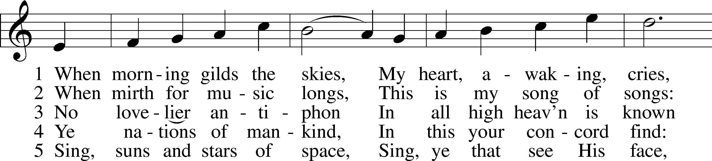
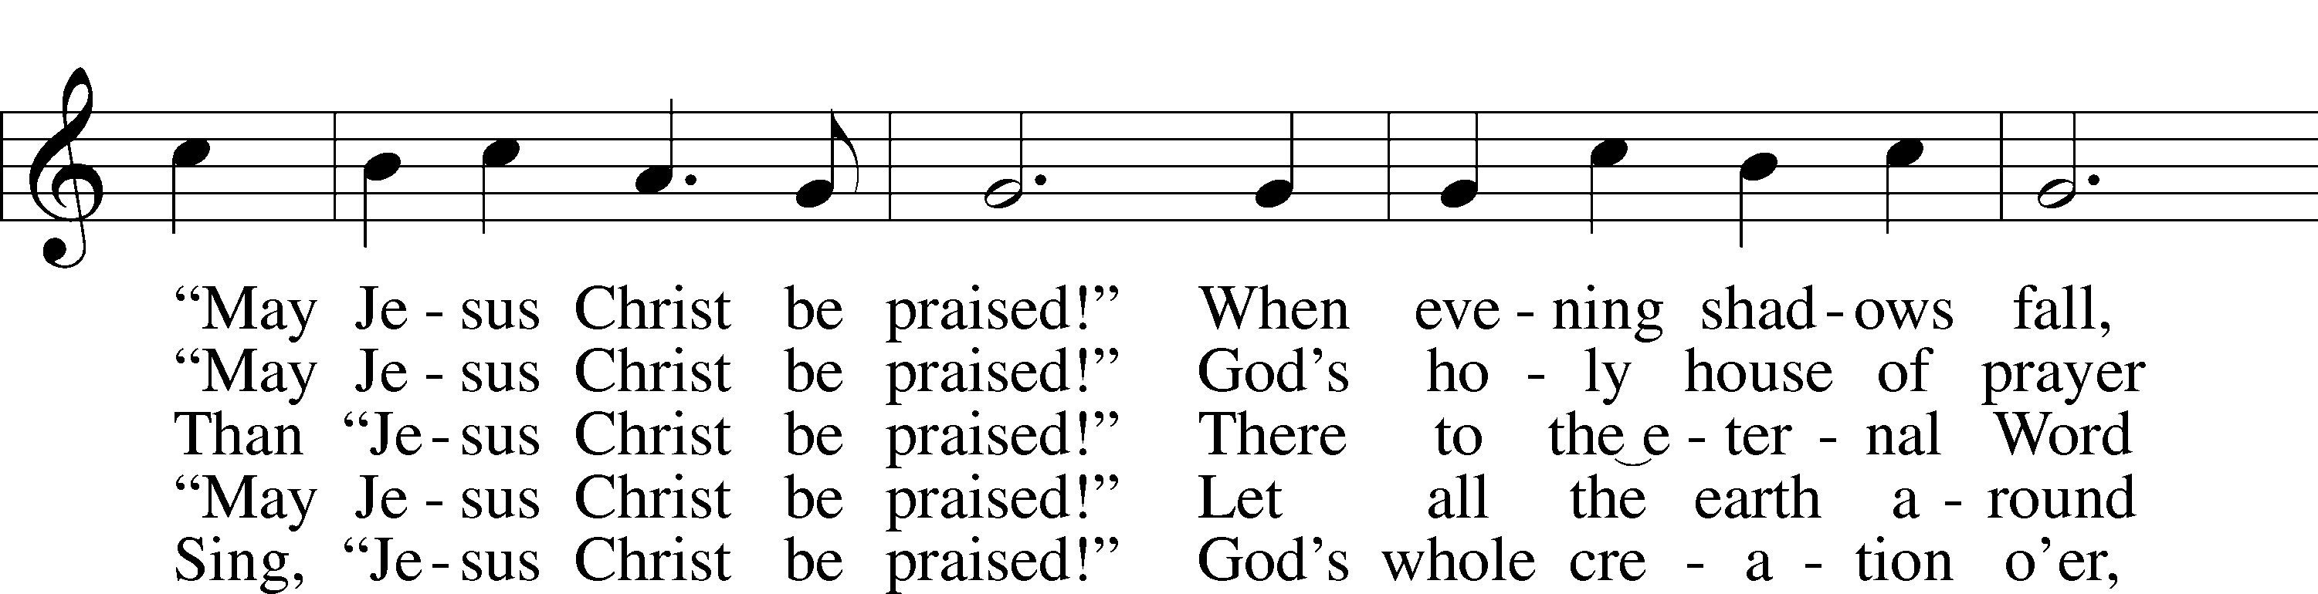
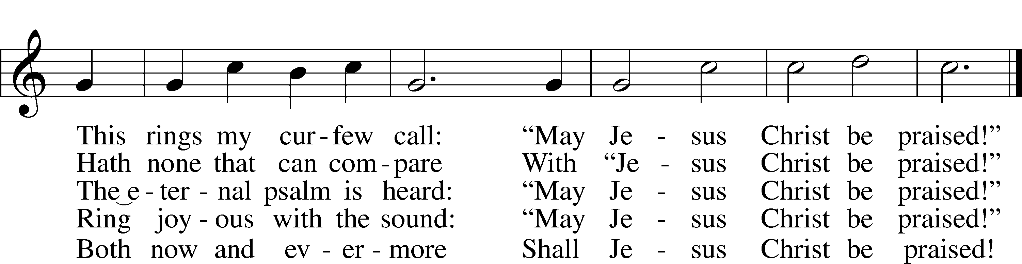
Text: Katholisches Gesangbuch, 1828, Würzburg; tr. Robert S. Bridges, 1844–1930, alt.
Tune: Joseph Barnby, 1838–96
Text and tune: Public domain

Sermon Hymn “The Only Son from Heaven” # 402
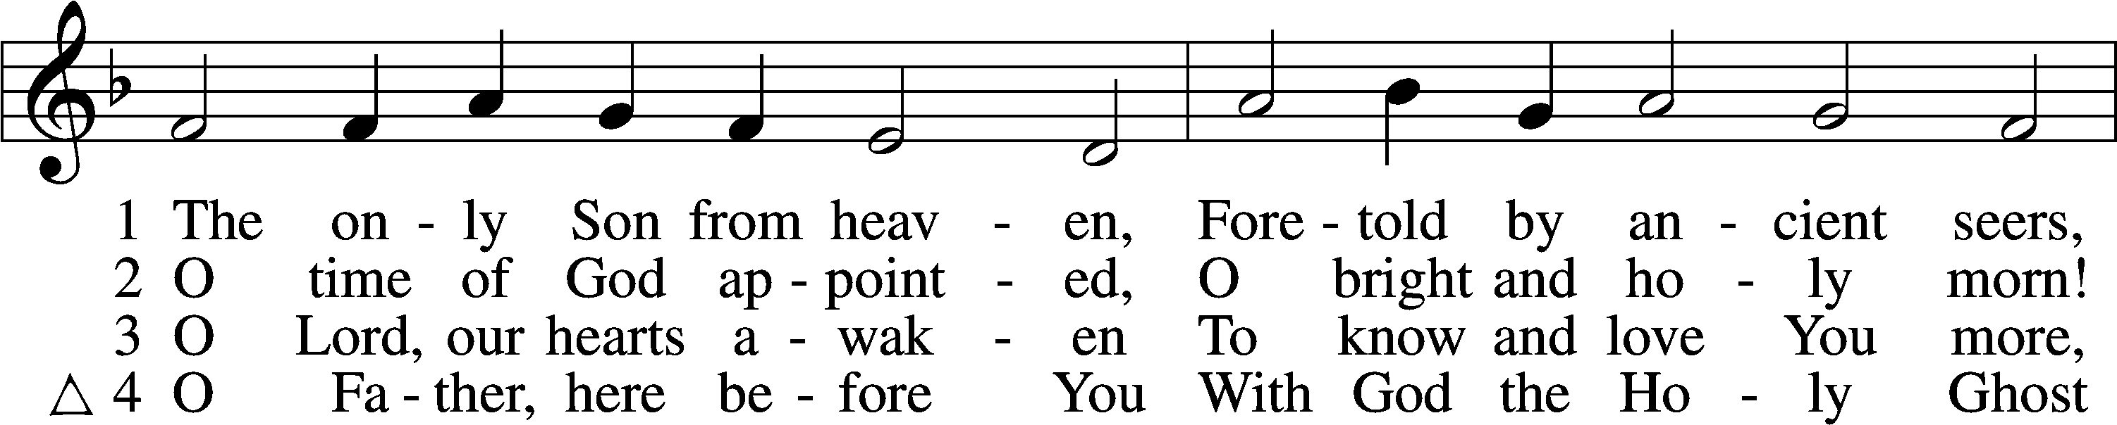
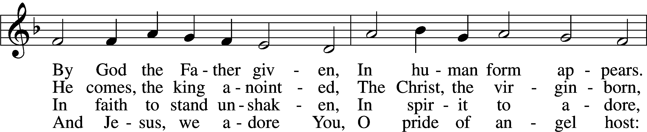
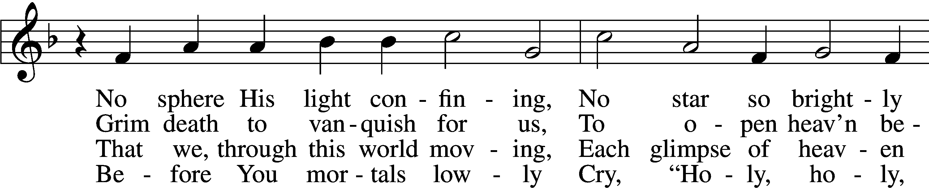
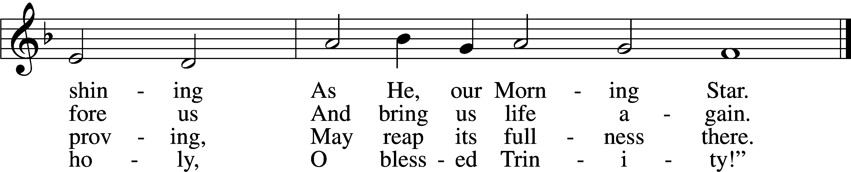
Text (sts. 1–3): Elisabeth Cruciger, c. 1500–1535; (sts. 1–3): tr. Arthur T. Russell, 1806–74, alt.; (st. 4): Lutheran Book of Worship, 1978
Tune: Eyn Enchiridion oder Handbüchlein, 1524, Erfurt
Text and tune: Public domain

Closing Hymn “Take My Life and Let It Be” # 783
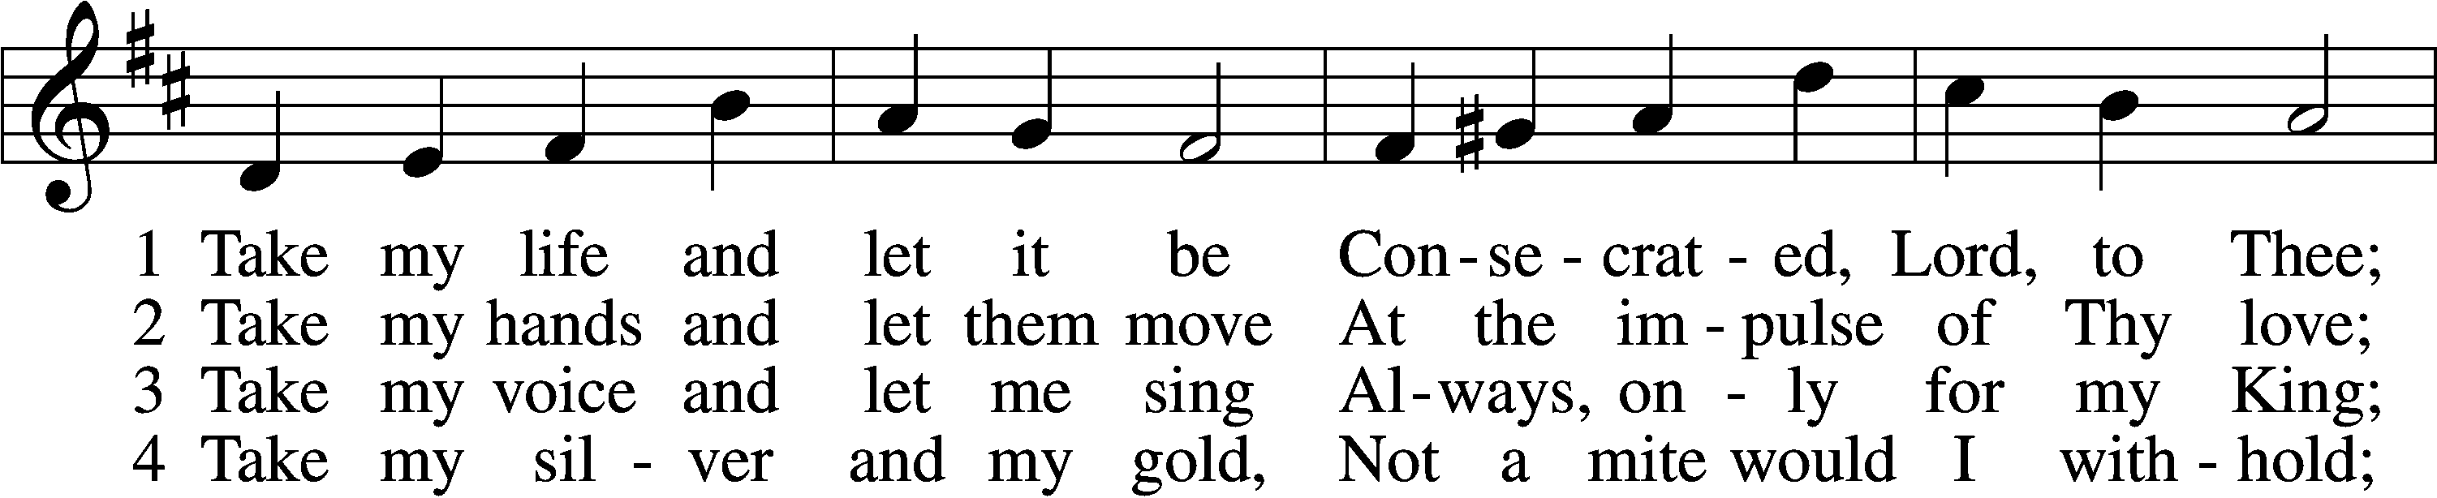
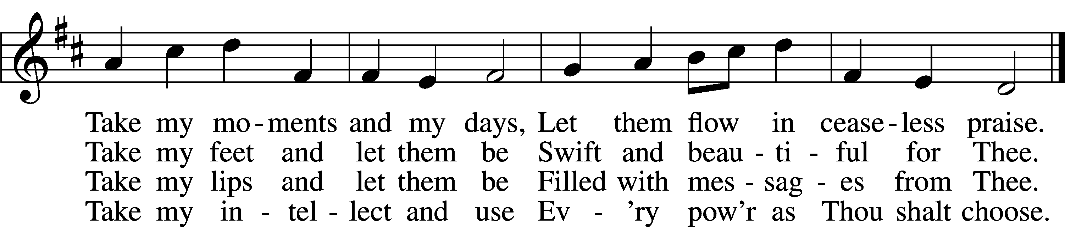

5 Take my will and make it Thine,
It shall be no longer mine;
Take my heart, it is Thine own,
It shall be Thy royal throne.

6 Take my love, my Lord, I pour
At Thy feet its treasure store;
Take myself, and I will be
Ever, only, all for Thee.
Text: Frances R. Havergal, 1836–79
Tune: William H. Havergal, 1793–1870
Text and tune: Public domain

