Opening Hymn “Let Us Ever Walk with Jesus” # 685
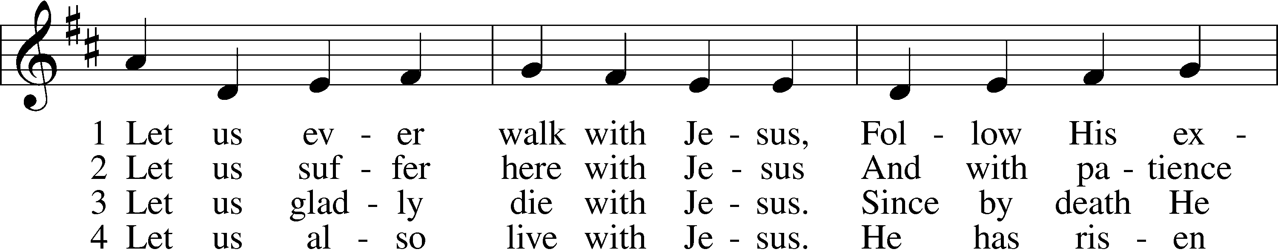
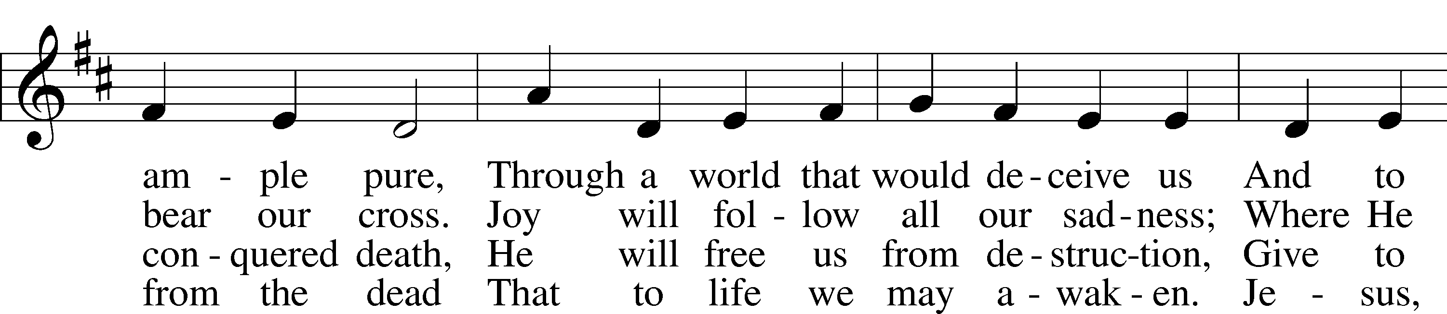
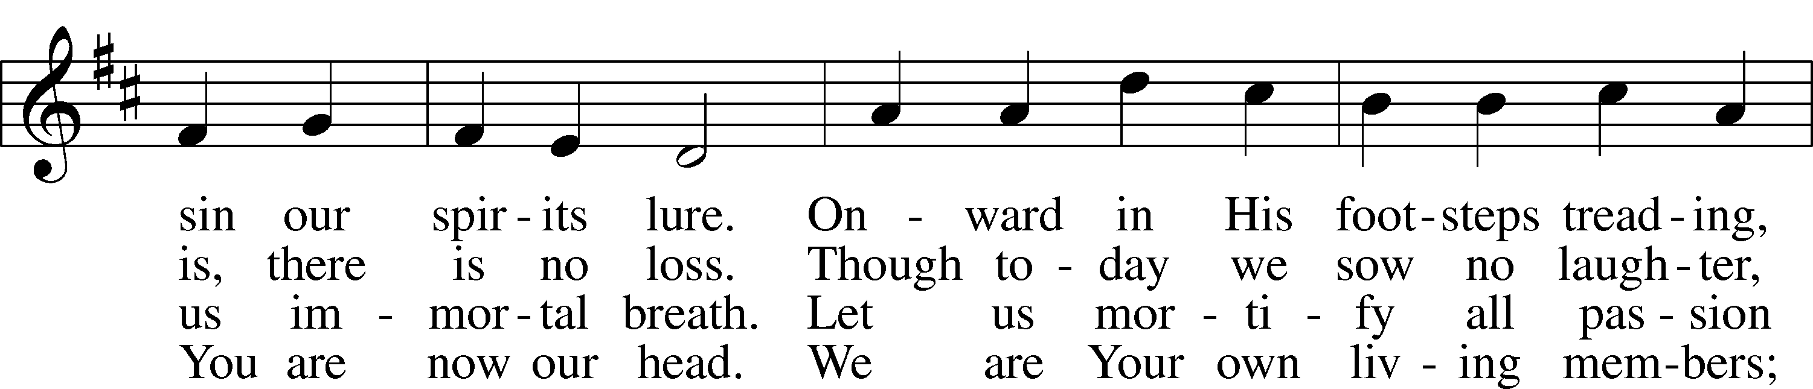
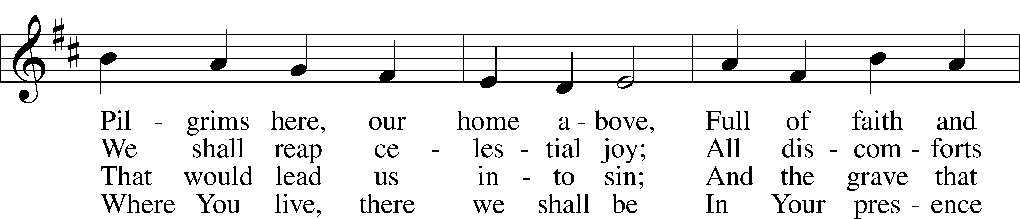
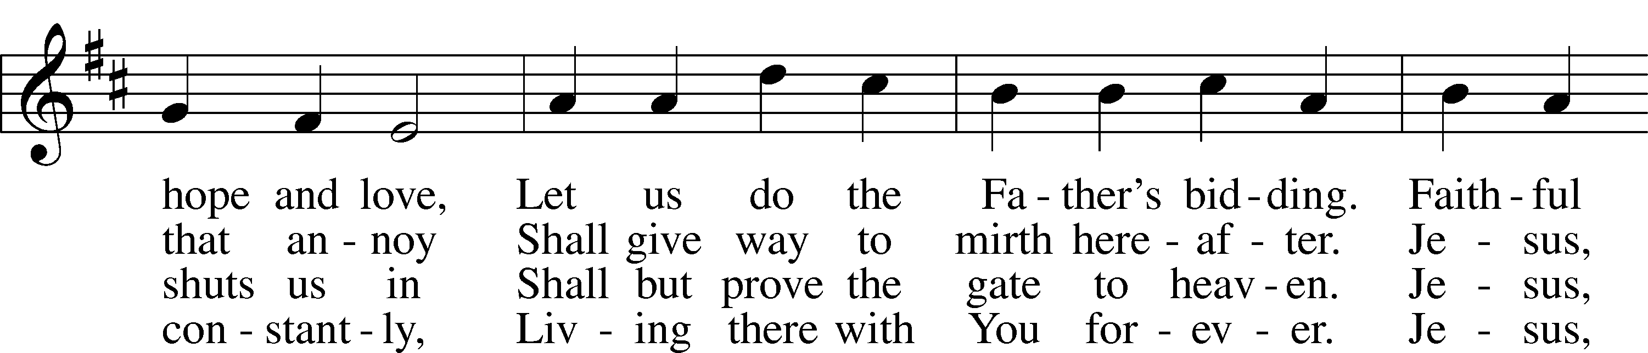
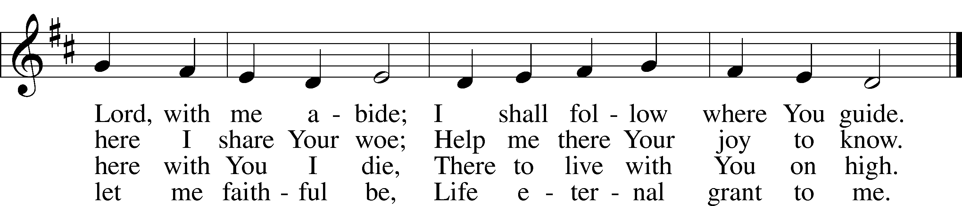
Text: Sigismund von Birken, 1626–81; tr. Lutheran Book of Worship, 1978, alt.
Tune: Georg G. Boltze, 18th cent.
Text: © 1978 Lutheran Book of Worship. Used by permission: LSB Hymn License no. 110003344
Tune: Public domain

Sermon Hymn “O Christ, Our True and Only Light” # 839
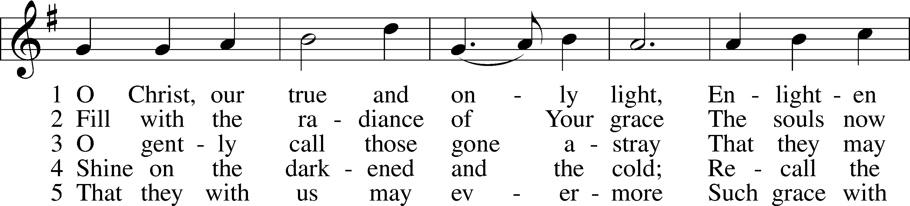
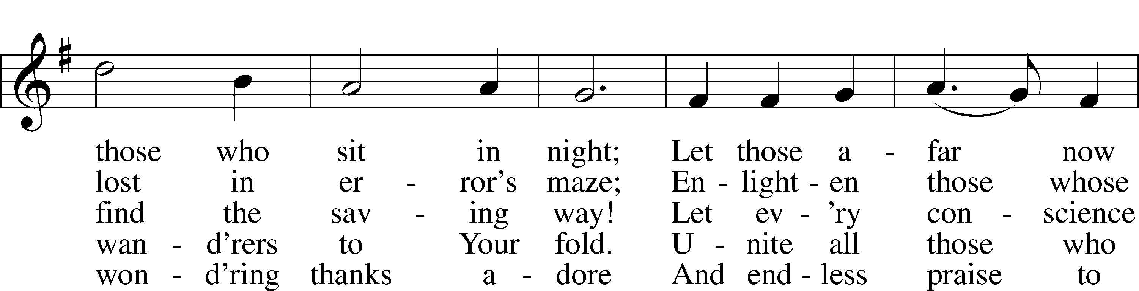
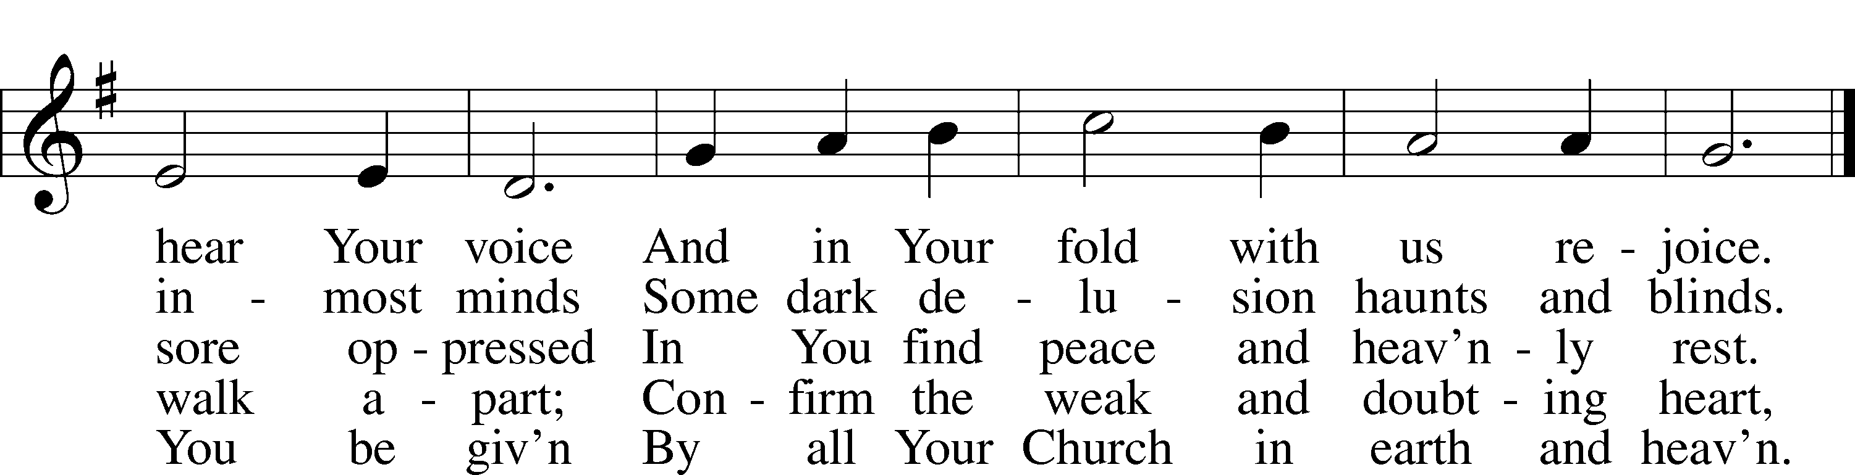
Text: Johann Heermann, 1585–1647; tr. Catherine Winkworth, 1827–78, alt.
Tune: Andächtige Haus-Kirche, 1676, Nürnberg
Text and tune: Public domain

Distribution Hymn “O God of God, O Light of Light” # 810

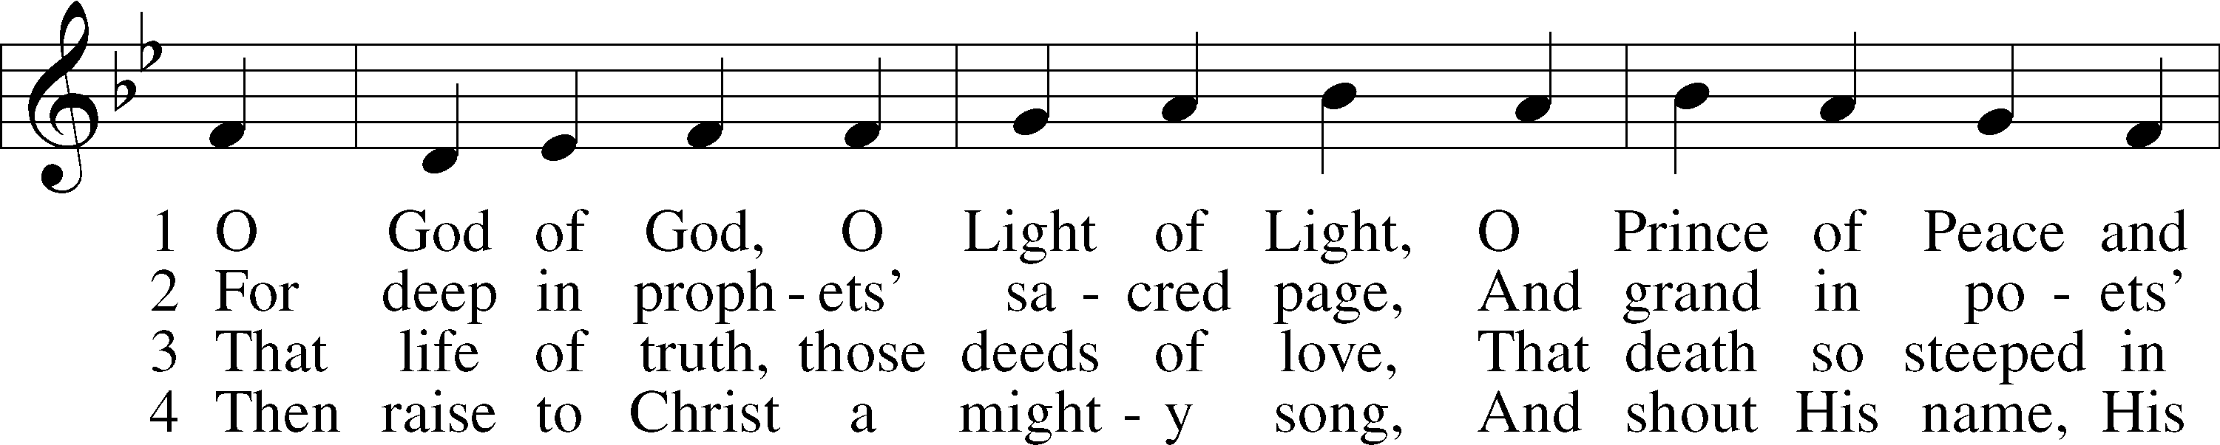

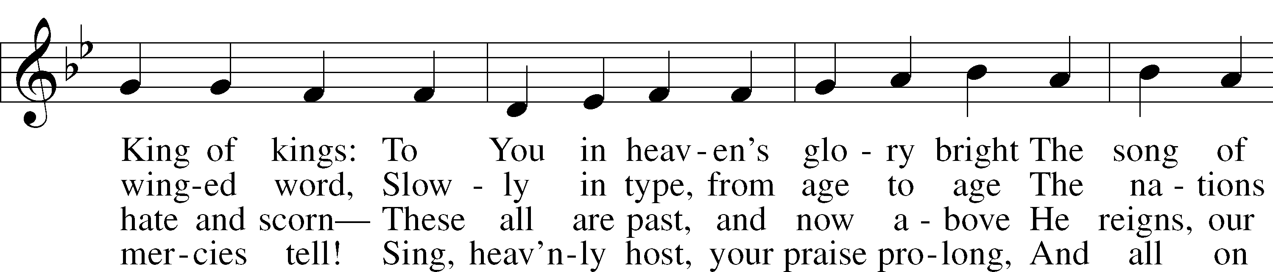

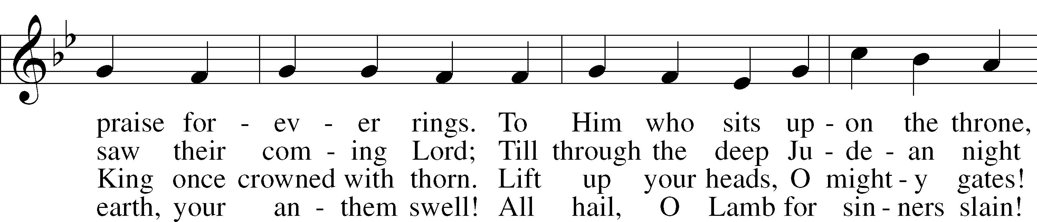

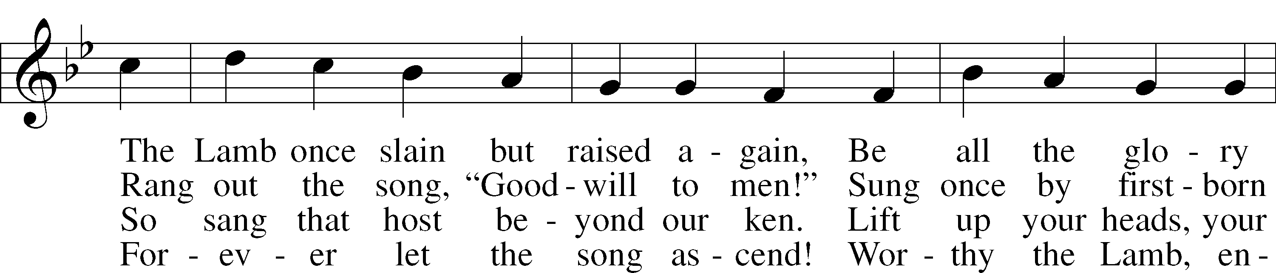

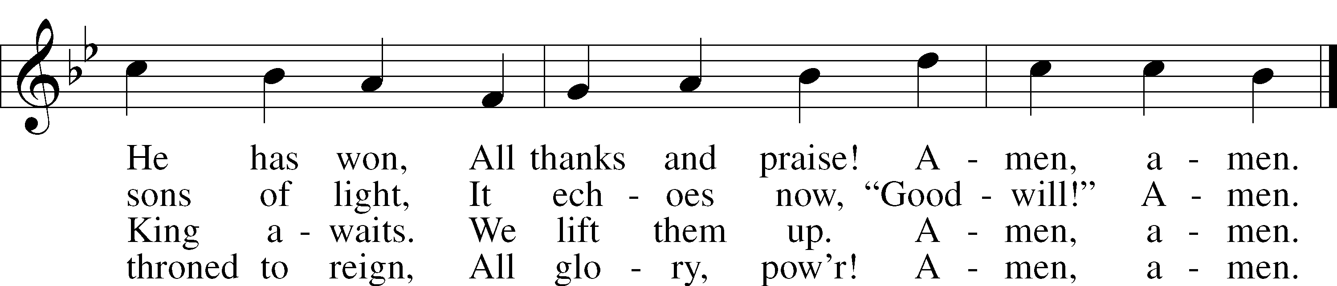

Text: John Julian, 1839–1913, alt.
Tune: Johann Störls . . . Schlag- Gesang- Und Noten-Buch, 1744, Stuttgart
Text and tune: Public domain

Distribution Hymn “Come, Follow Me,” the Savior Spake” # 688
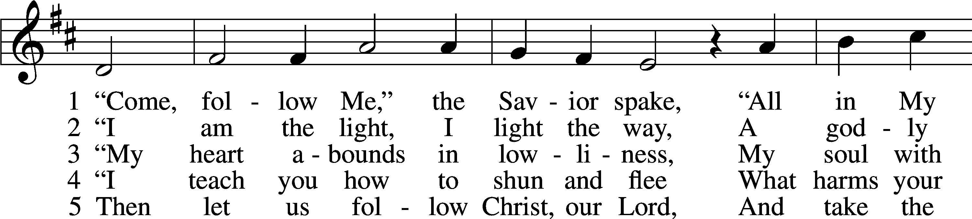
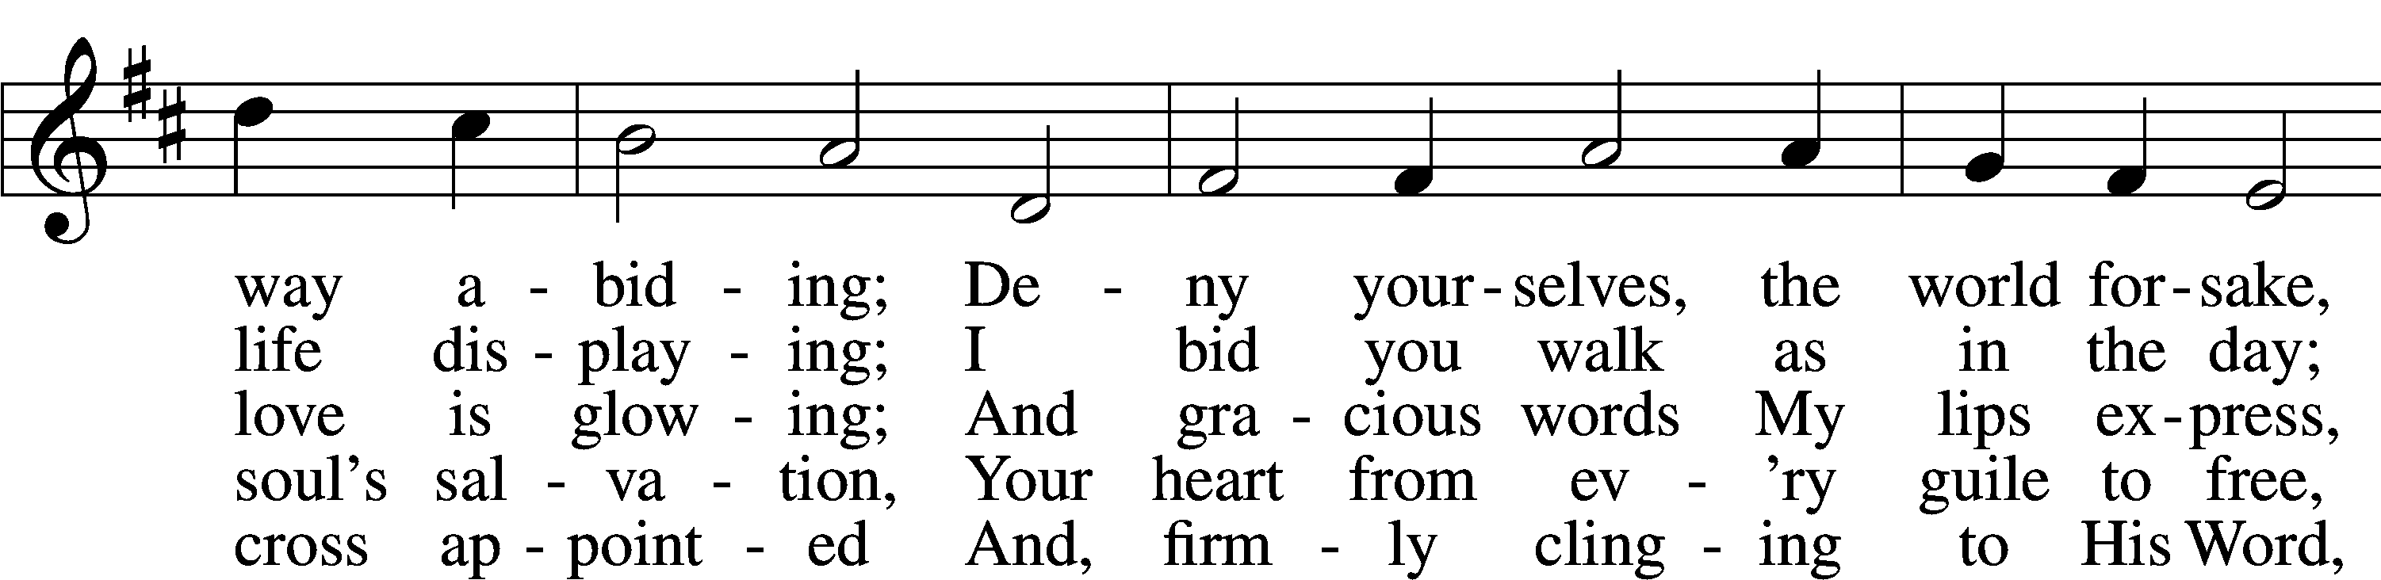
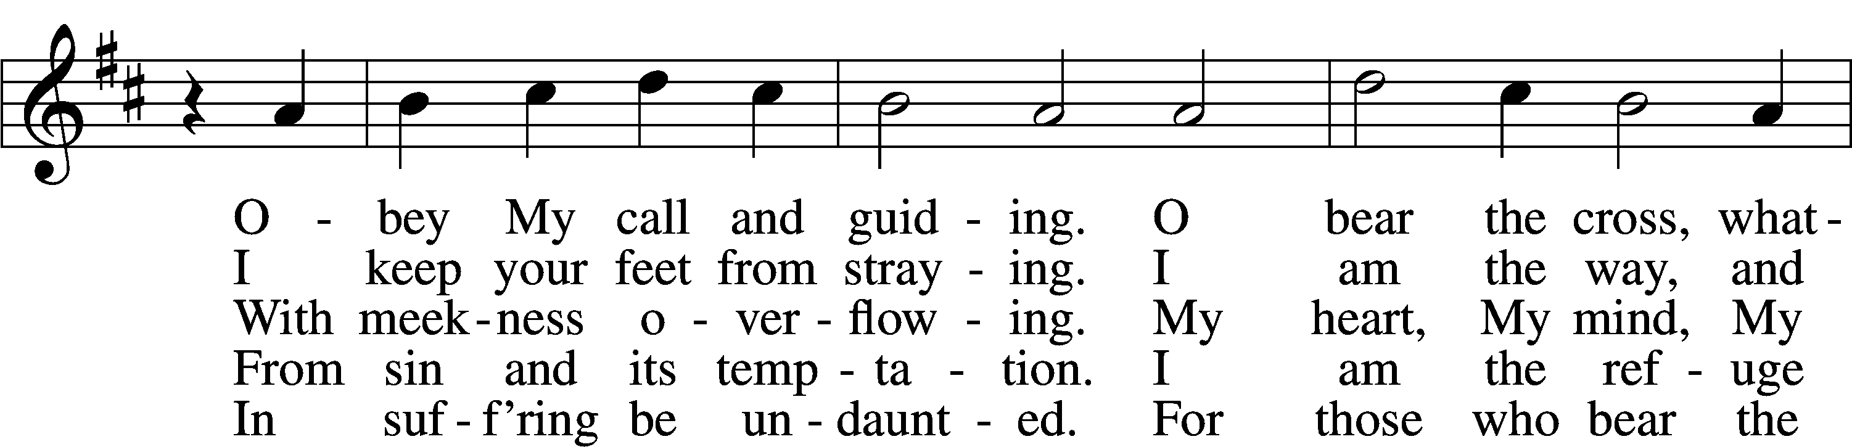
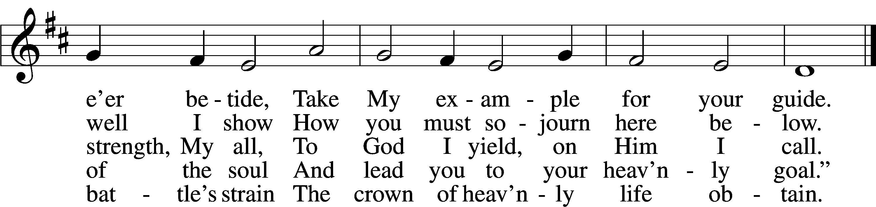
Text: tr. Charles W. Schaeffer, 1813–96; (sts. 1–3, 5): Johann Scheffler, 1624–77; (st. 4): Geistliche Lieder und Lobgesänge, 1695
Tune: Bartholomäus Gesius, c. 1555–1613, adapt.
Text and tune: Public domain

Distribution Hymn “Have No Fear, Little Flock” # 735
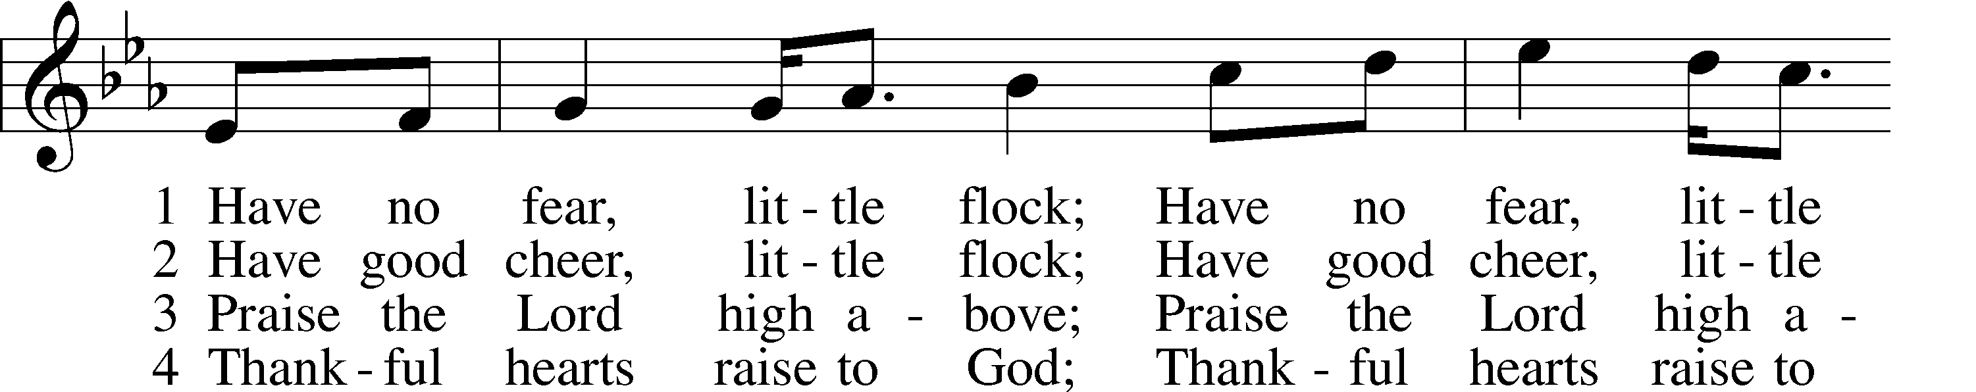
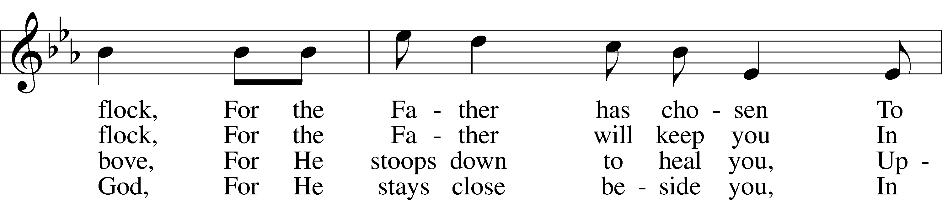
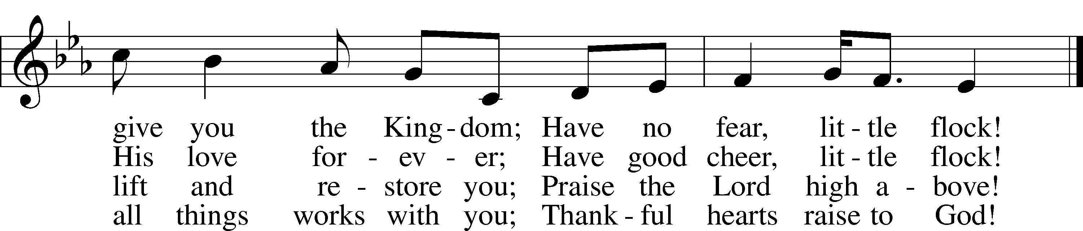
Text (sts. 2–4): Marjorie A. Jillson, 1931–2010
Text (st. 1) and tune: Heinz Werner Zimmermann, 1930
Text and tune: © 1973 Concordia Publishing House. Used by permission: LSB Hymn License no. 110003344

Closing Hymn “What Is the World to Me” # 730
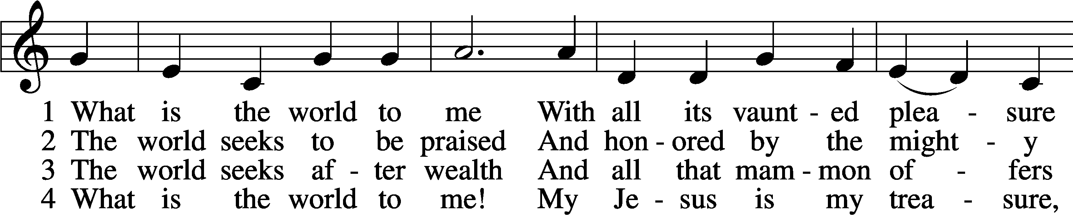
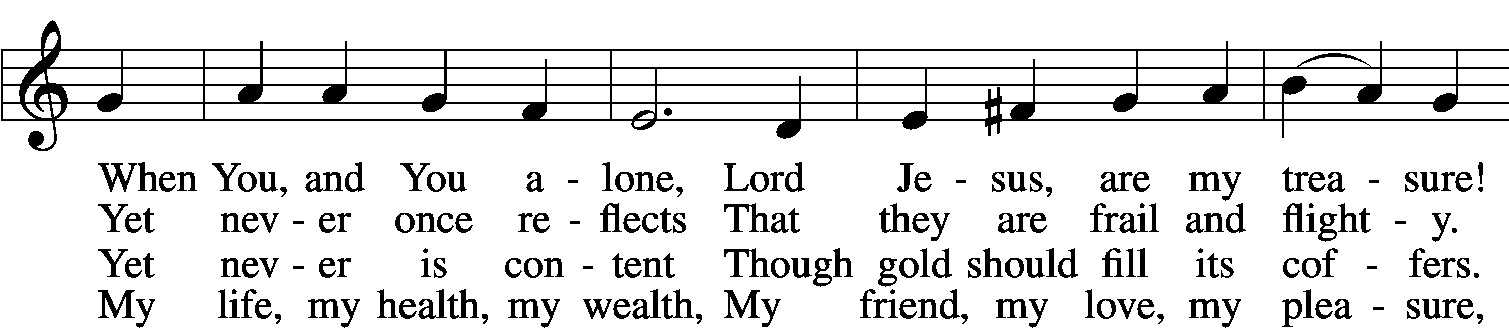
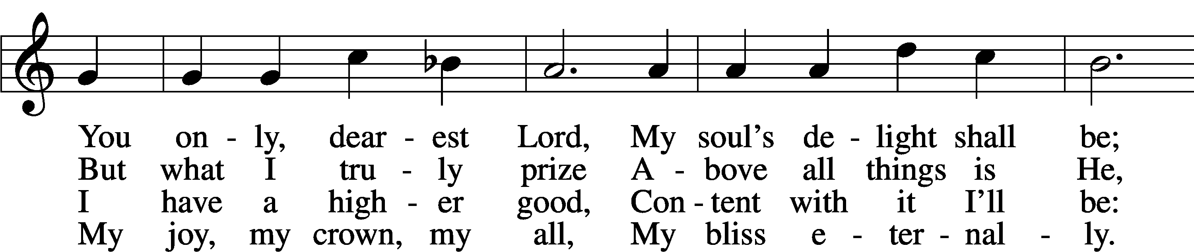

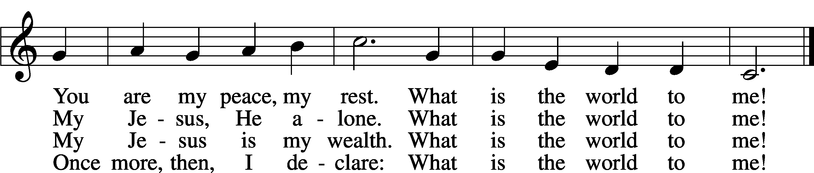

Text: Georg Michael Pfefferkorn, 1645–1732; tr. August Crull, 1845–1923, alt.
Tune: Ahasverus Fritsch, 1629–1701
Text and tune: Public domain

