Opening Hymn ’Tis Good, Lord, to Be Here # 414
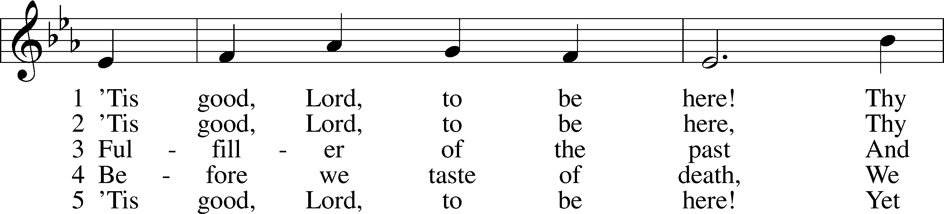
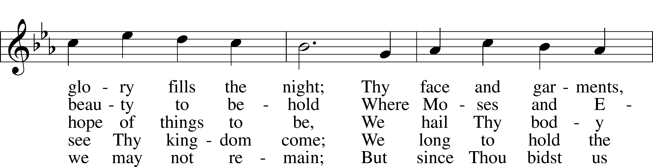
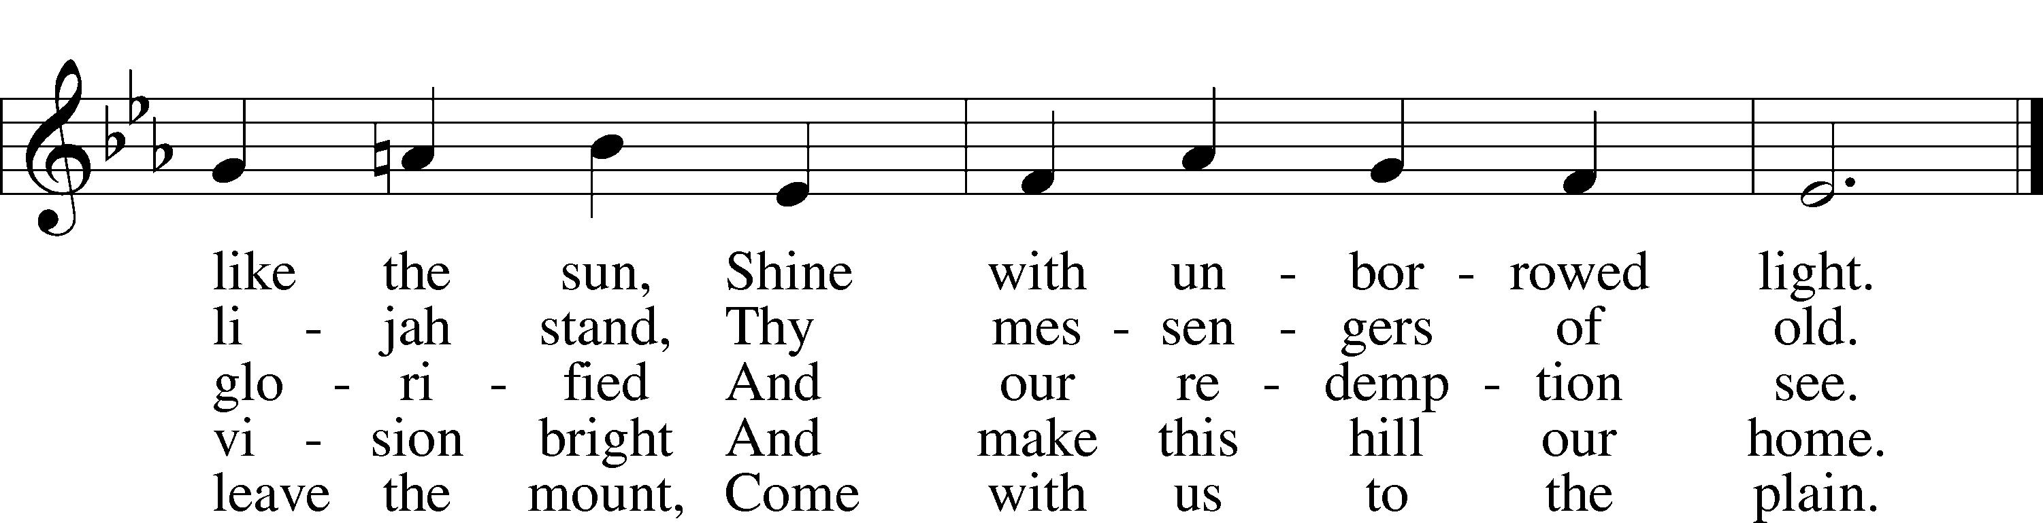
Text: Joseph A. Robinson, 1858–1933, alt.
Tune: Johann Sebastian Bach, 1685–1750, adapt.
Text and tune: Public domain

Sermon Hymn “O Wondrous Type! O Vision Fair” # 413
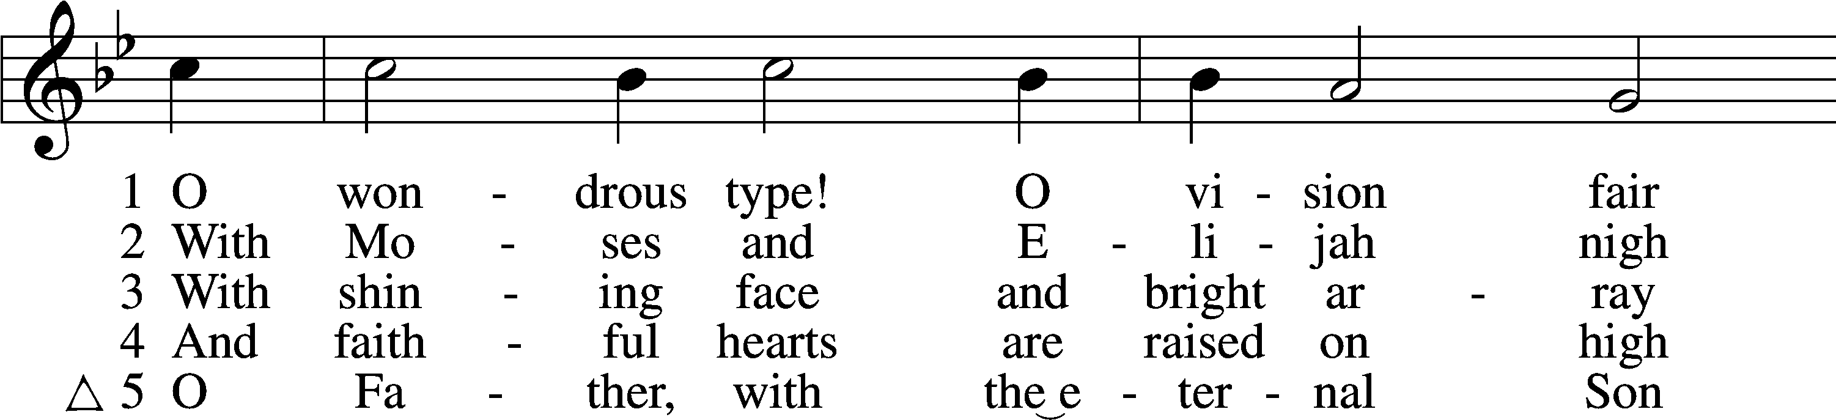
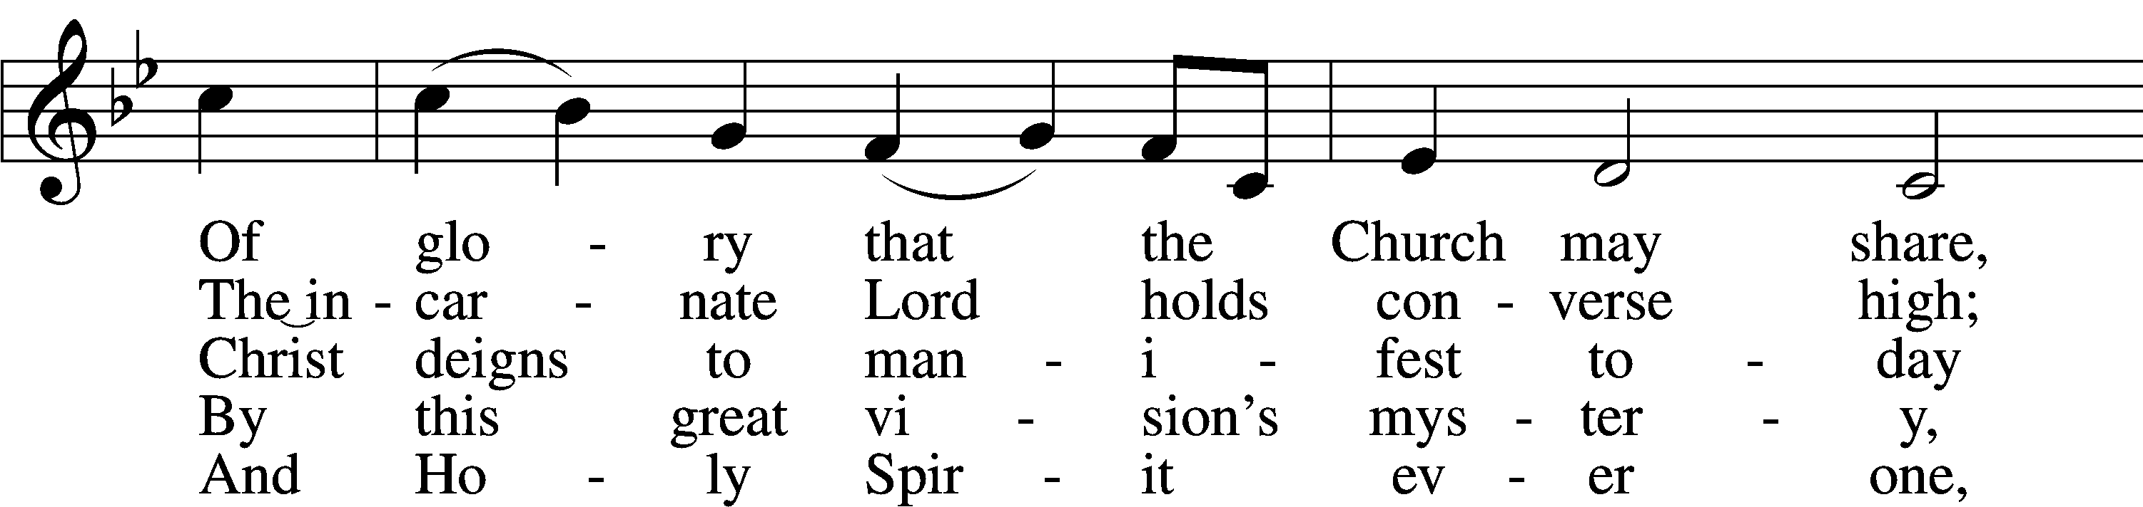
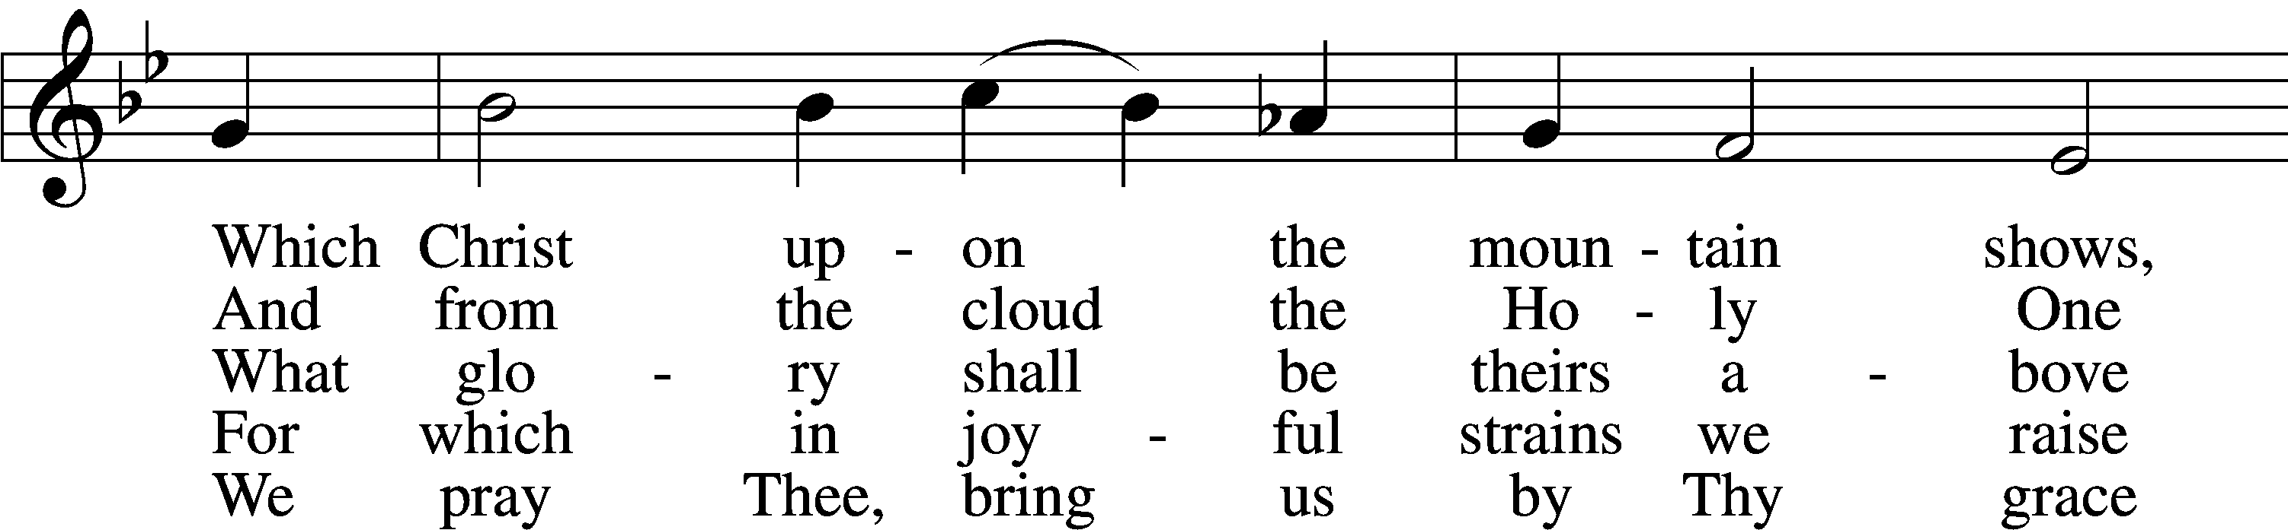
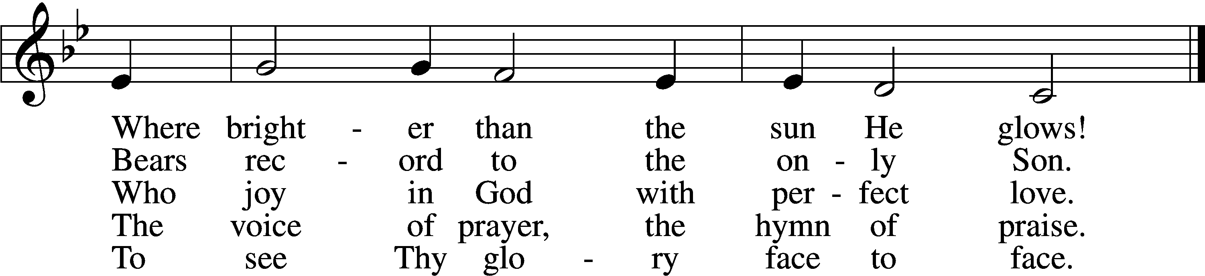
Text: Sarum Breviary, 1495, Salisbury; tr. John Mason Neale, 1818–66, alt.
Tune: English, 15th cent.
Text and tune: Public domain

Closing Hymn “Alleluia, Song of Gladness” # 417
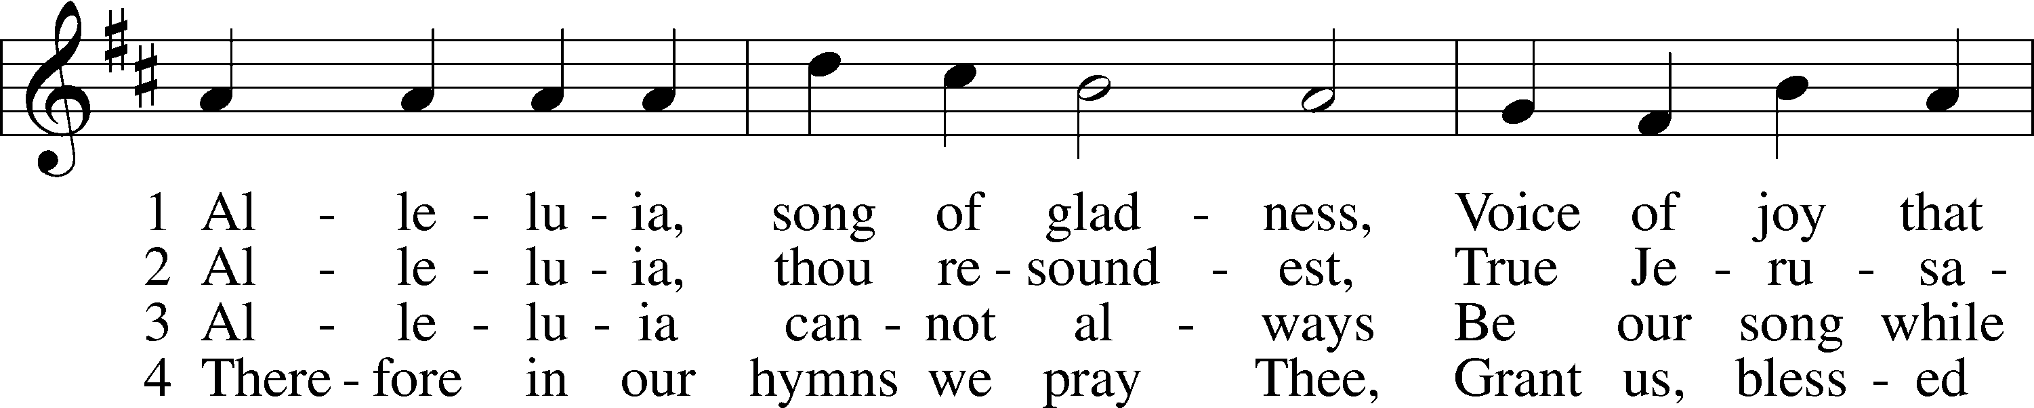
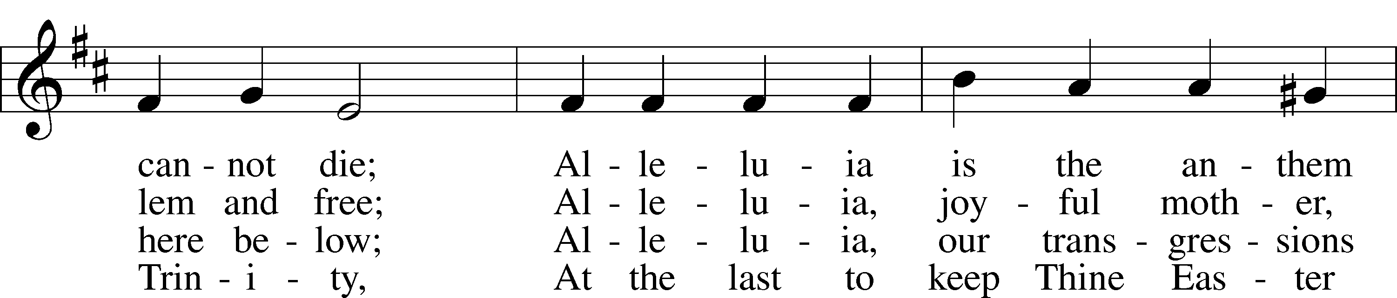
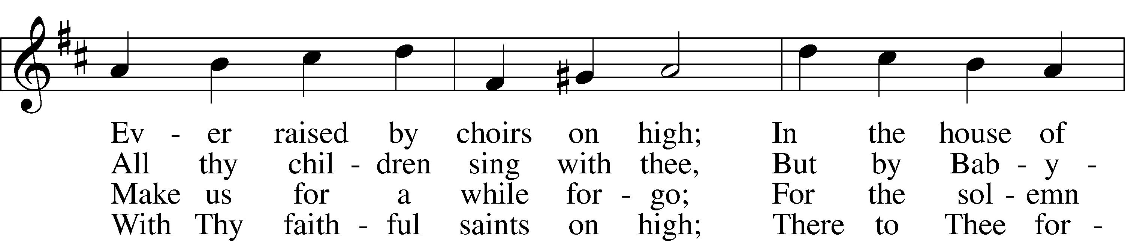
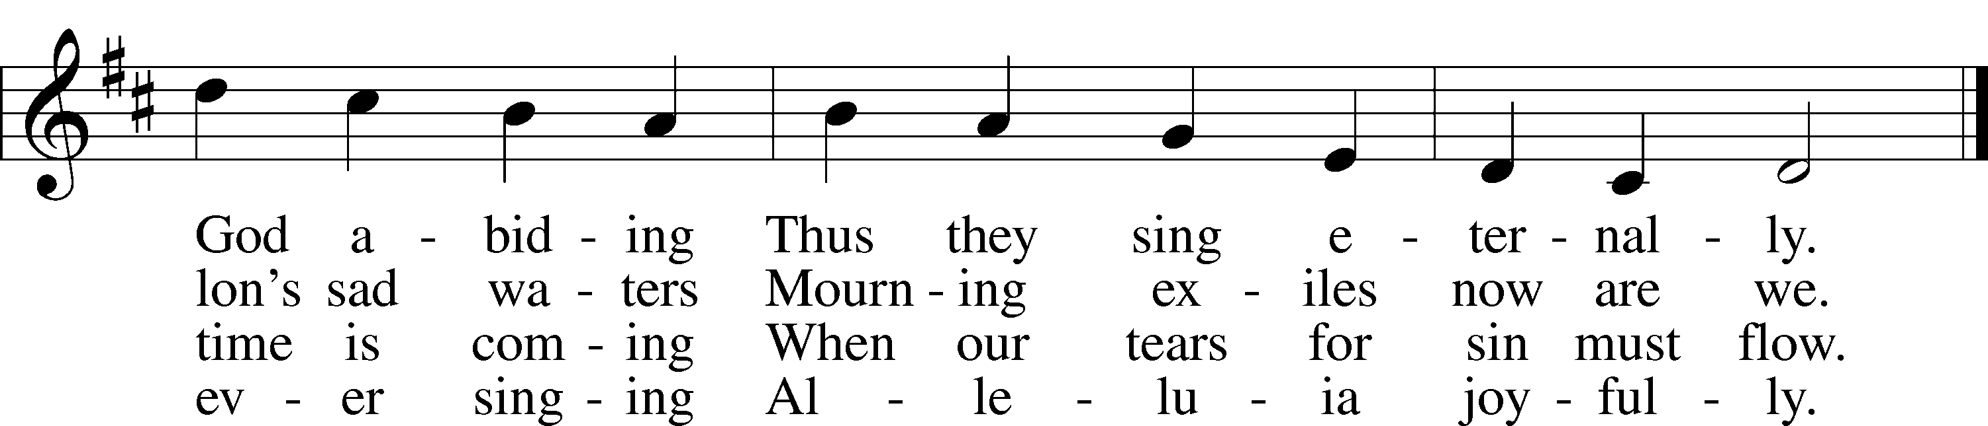
Text: Latin, c. 11th cent.; tr. John Mason Neale, 1818–66, alt.
Tune: John Goss, 1800–80
Text and tune: Public domain

