Opening Hymn “Oh, That the Lord would guide my ways” # 707
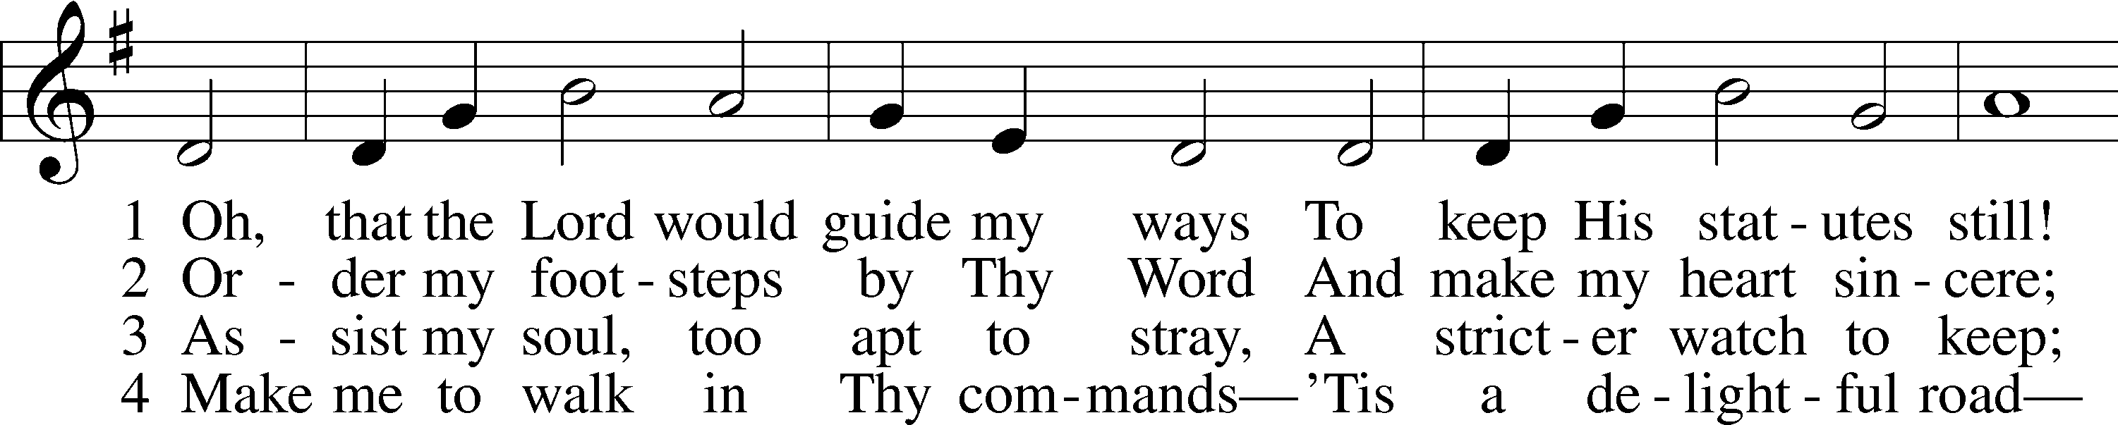
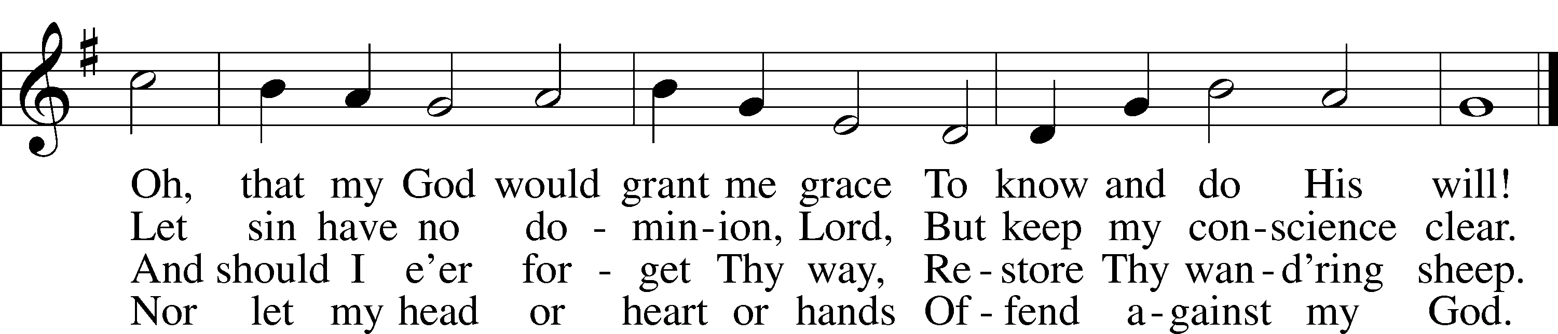
Text: Isaac Watts, 1674–1748, alt.
Tune: William H. Havergal, 1793–1870
Text and tune: Public domain

Sermon Hymn “A Mighty Fortress Is Our God” # 656
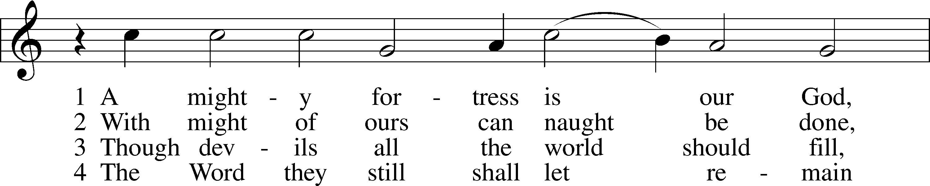
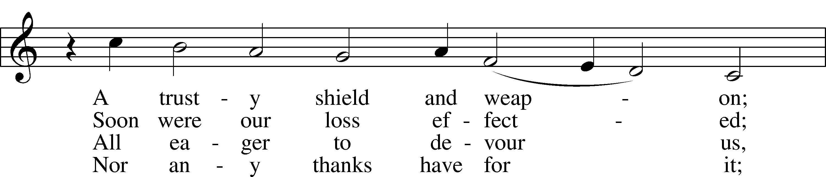
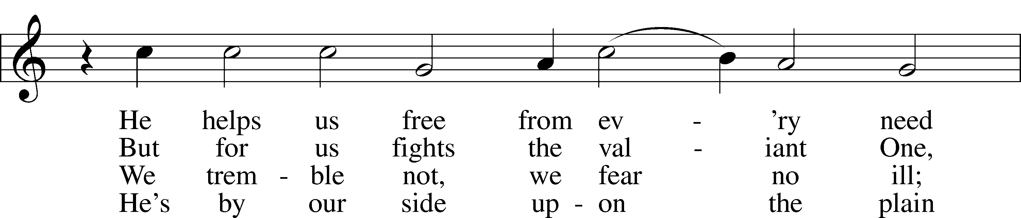
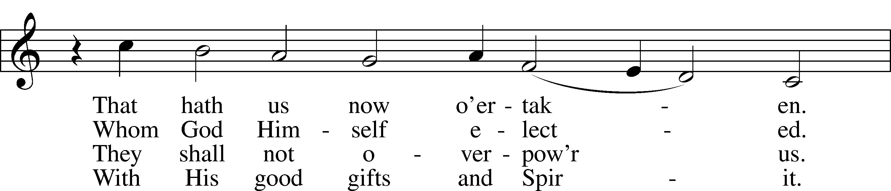
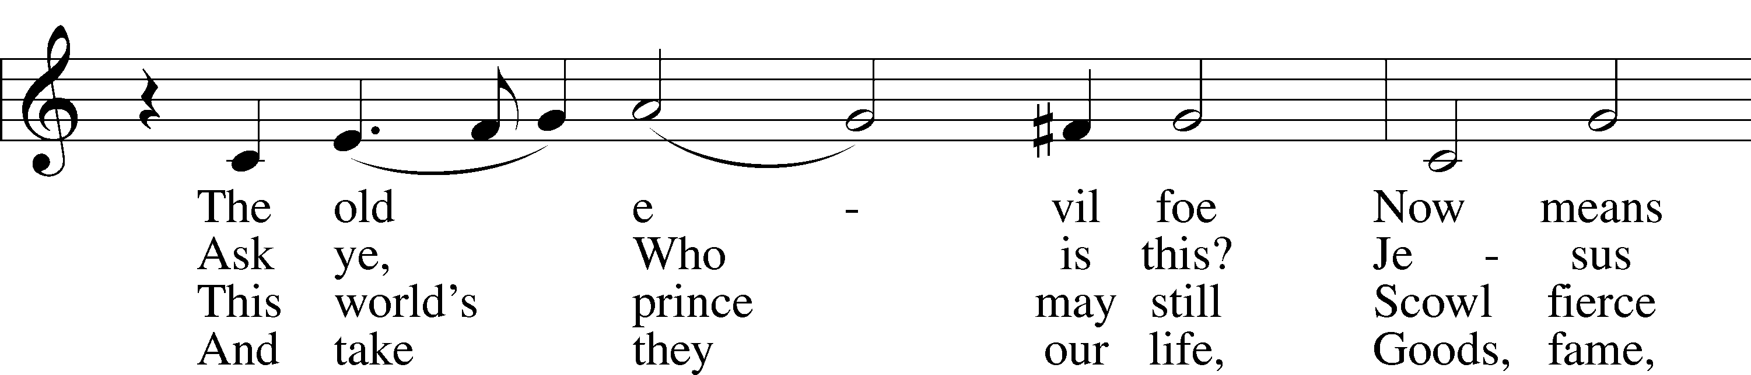
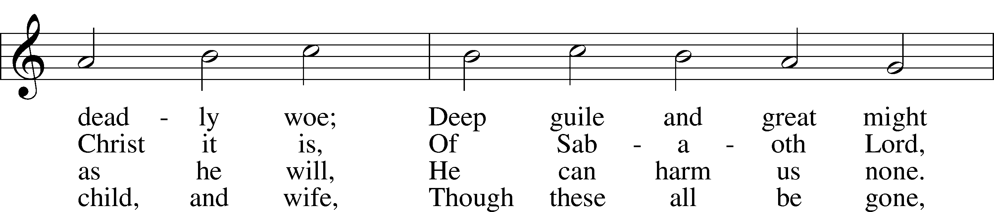
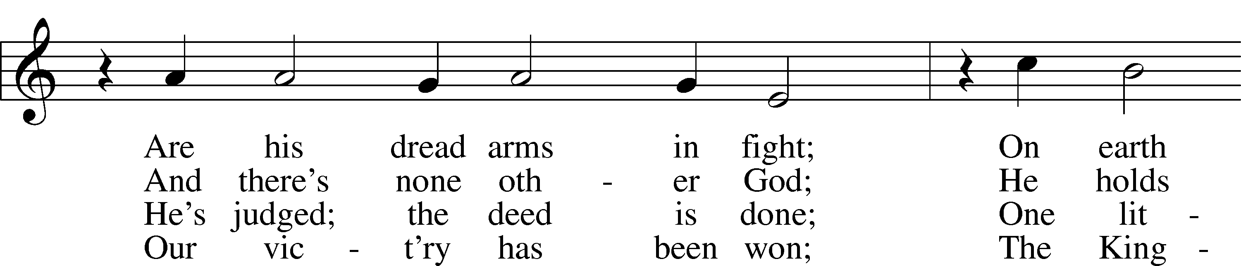
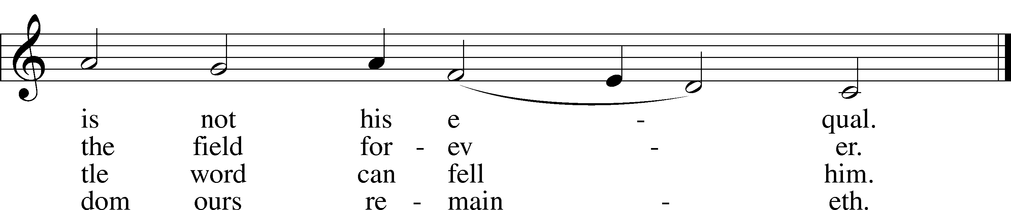
Text: tr. composite
Text and tune: Martin Luther, 1483–1546
Text and tune: Public domain

Distribution Hymn “The Lamb” # 547
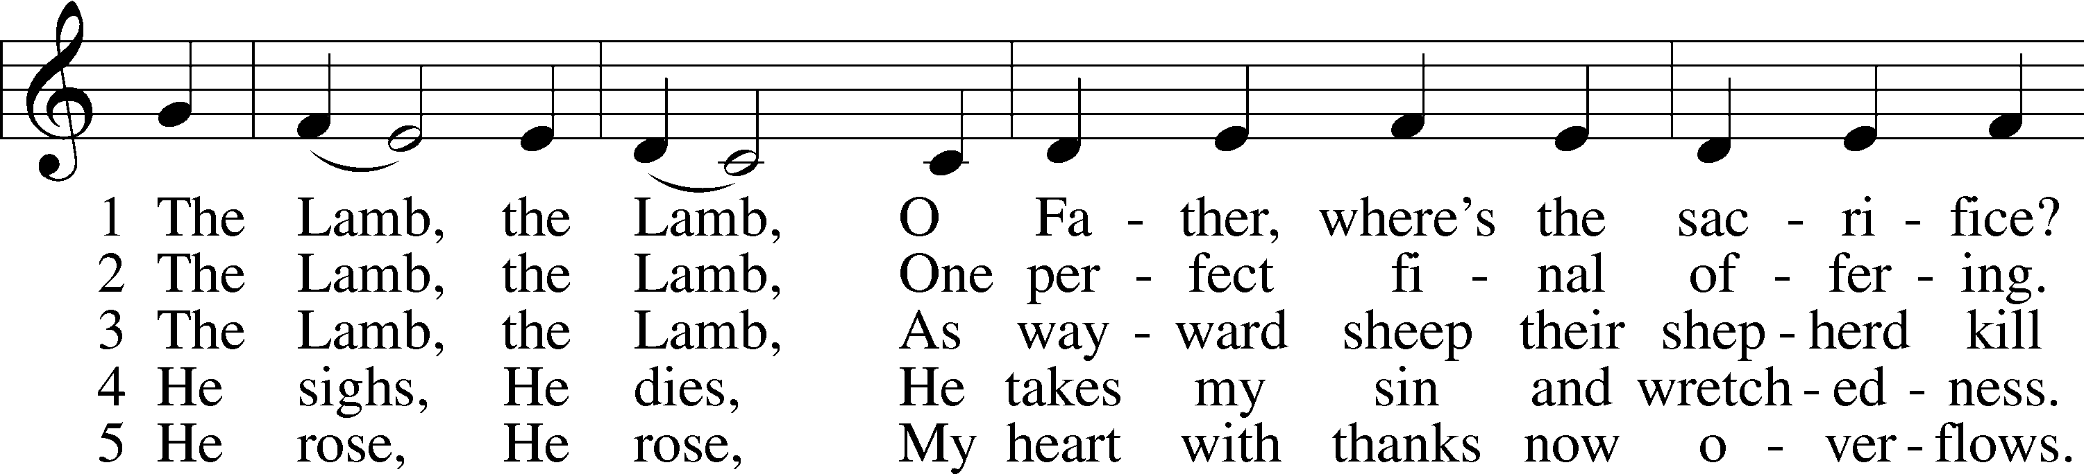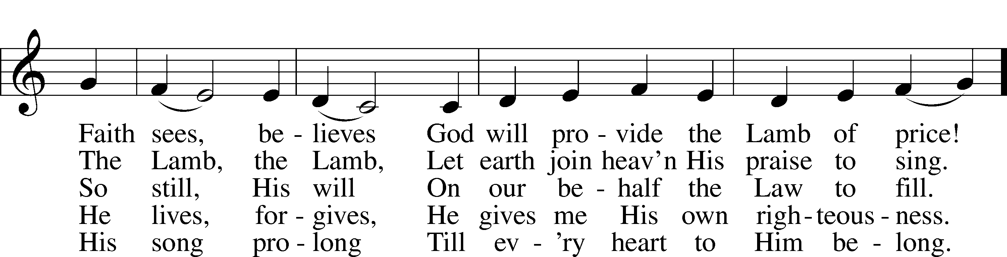
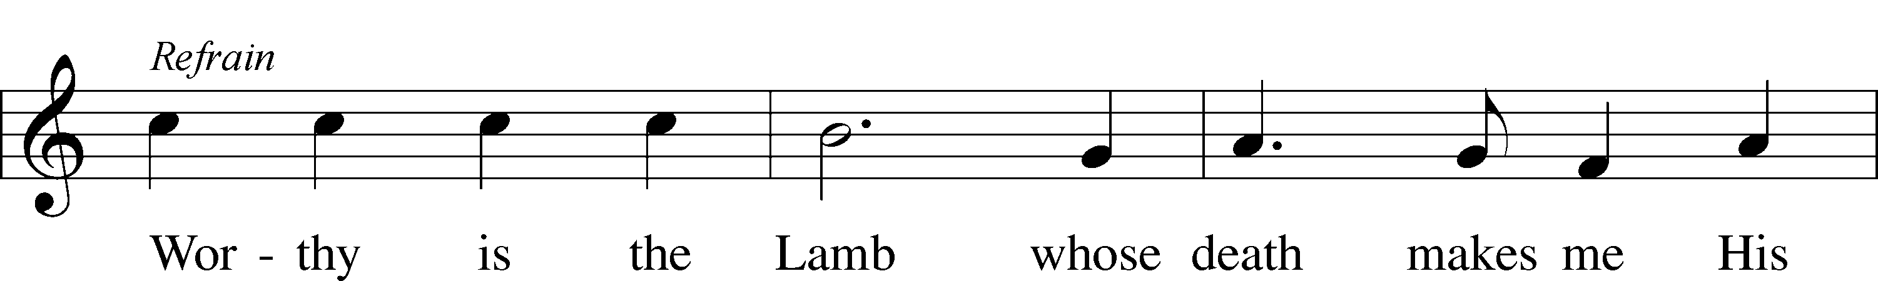
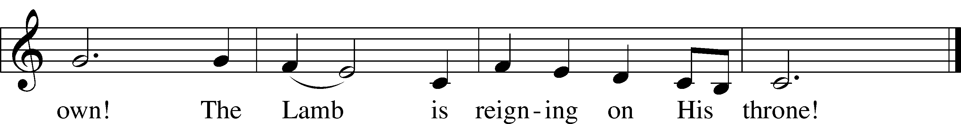
Text and tune: Gerald P. Coleman, 1953
Text and tune: © 1987 and 1997 MorningStar Music Publishers. Used by permission: LSB Hymn License no. 110003344

Distribution Hymn “Great Is Thy Faithfulness” # 809
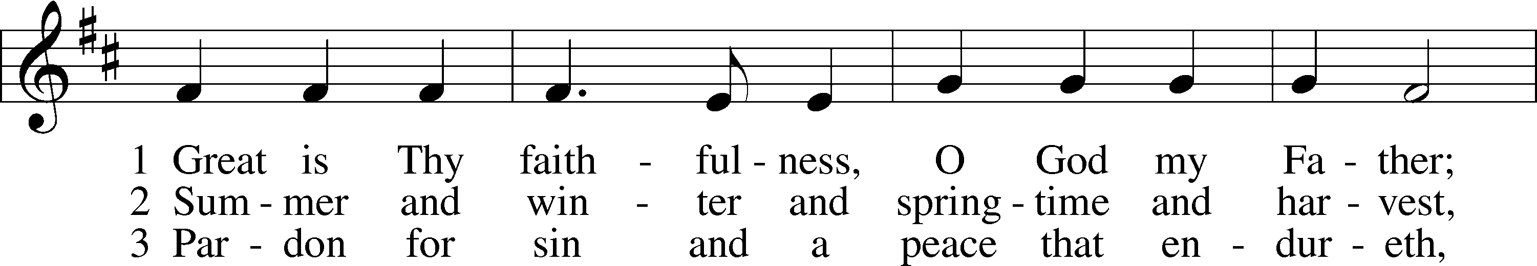
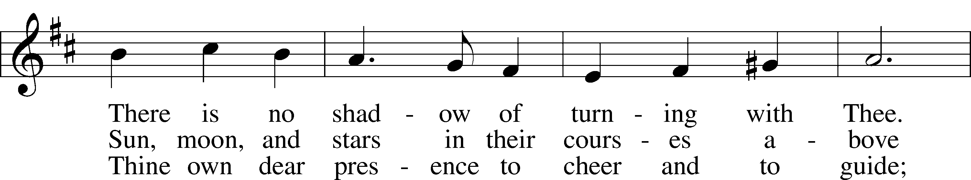
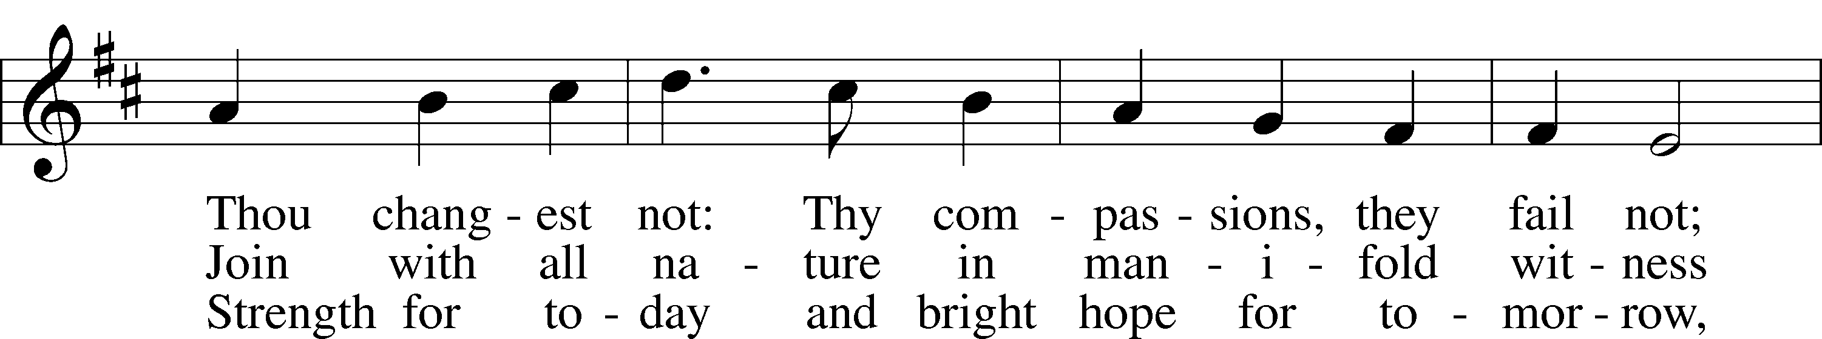
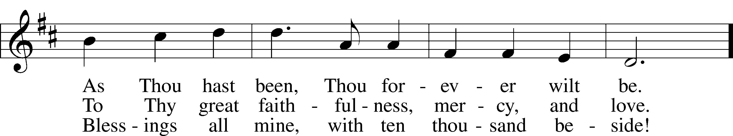
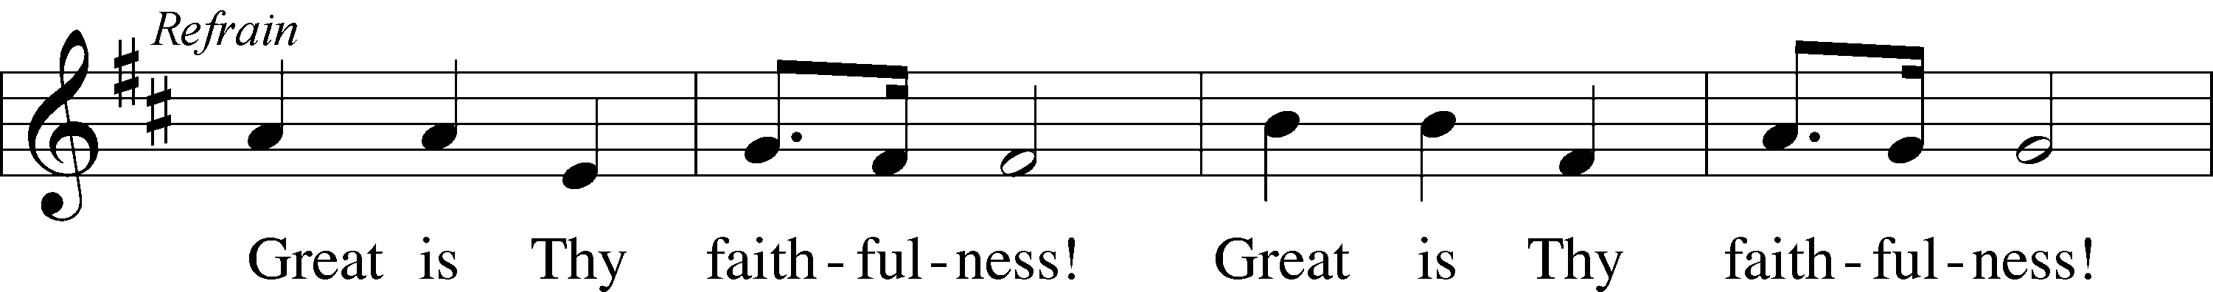
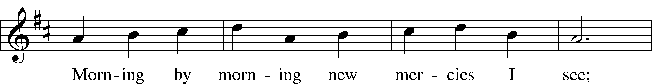
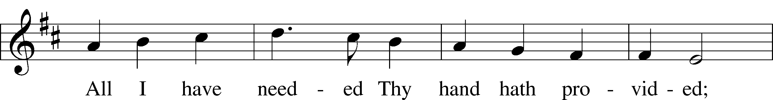

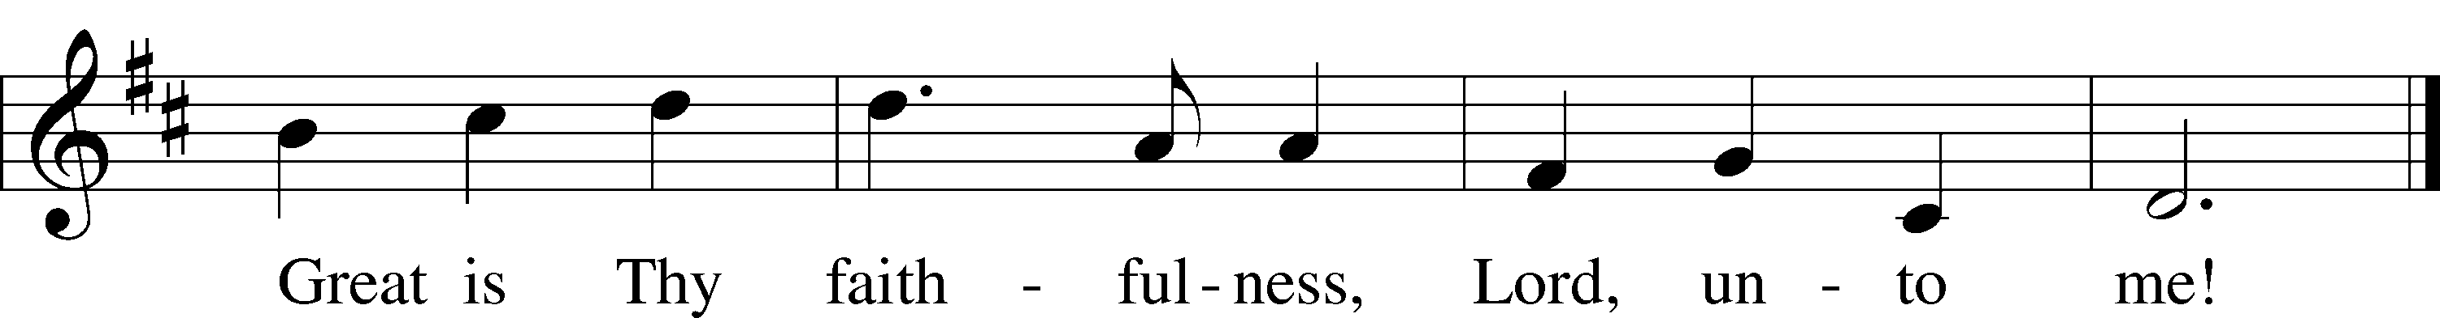

Text: Thomas O. Chisholm, 1866–1960
Tune: William M. Runyan, 1870–1957
Text: Public domain
Tune: Public domain

Distribution Hymn “Christ Be My Leader” # 861
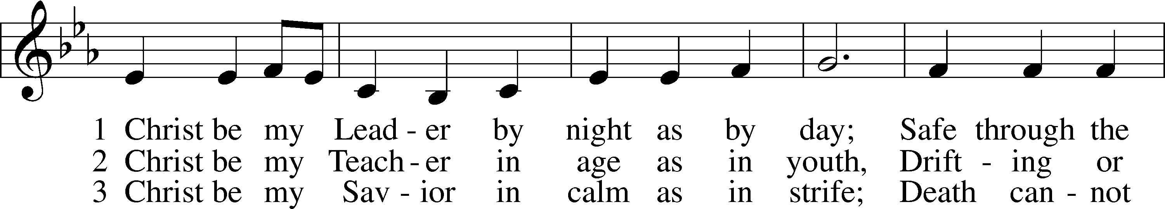
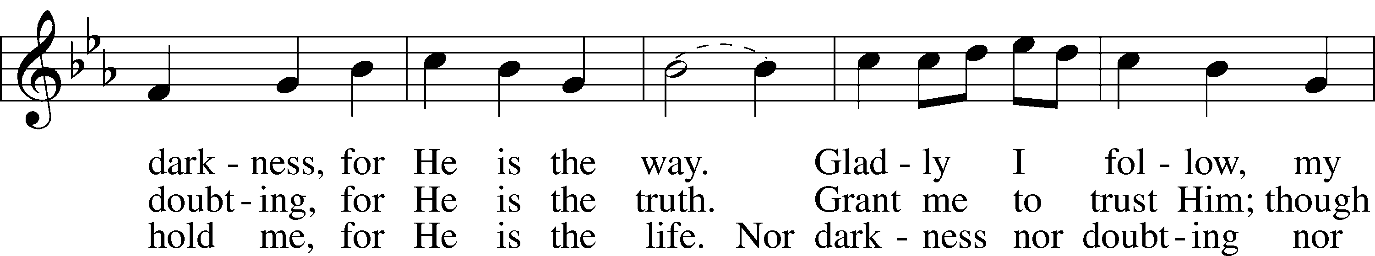
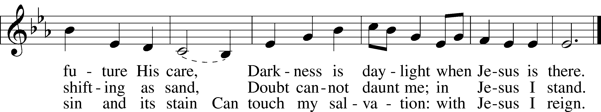
Text: Timothy Dudley-Smith, 1926
Tune: Irish
Text: © 1964, renewed 1992 Hope Publishing Co. Used by permission: LSB Hymn License no. 110003344
Tune: Public domain

Closing Hymn “O Lord, throughout These Forty Days” # 418
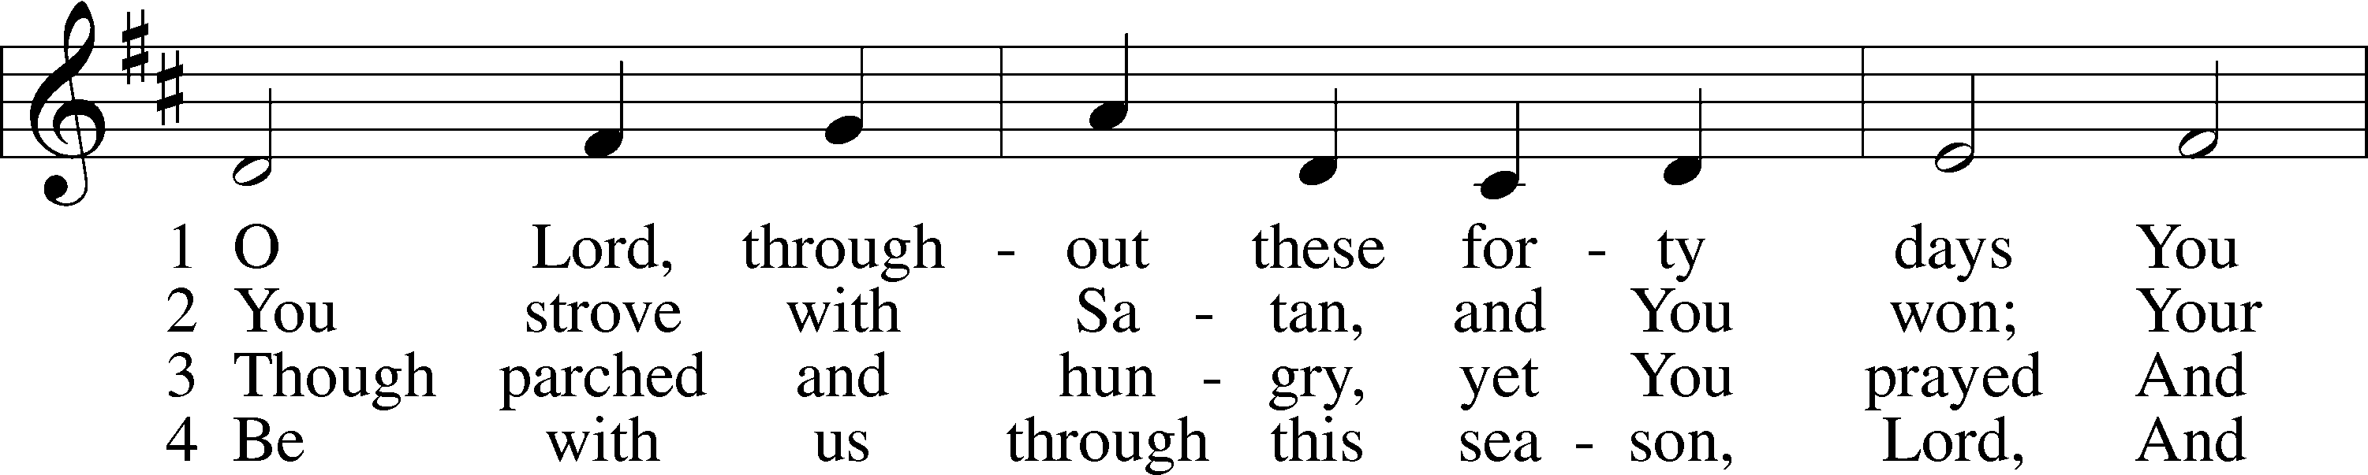
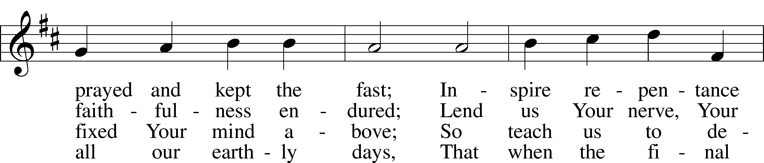
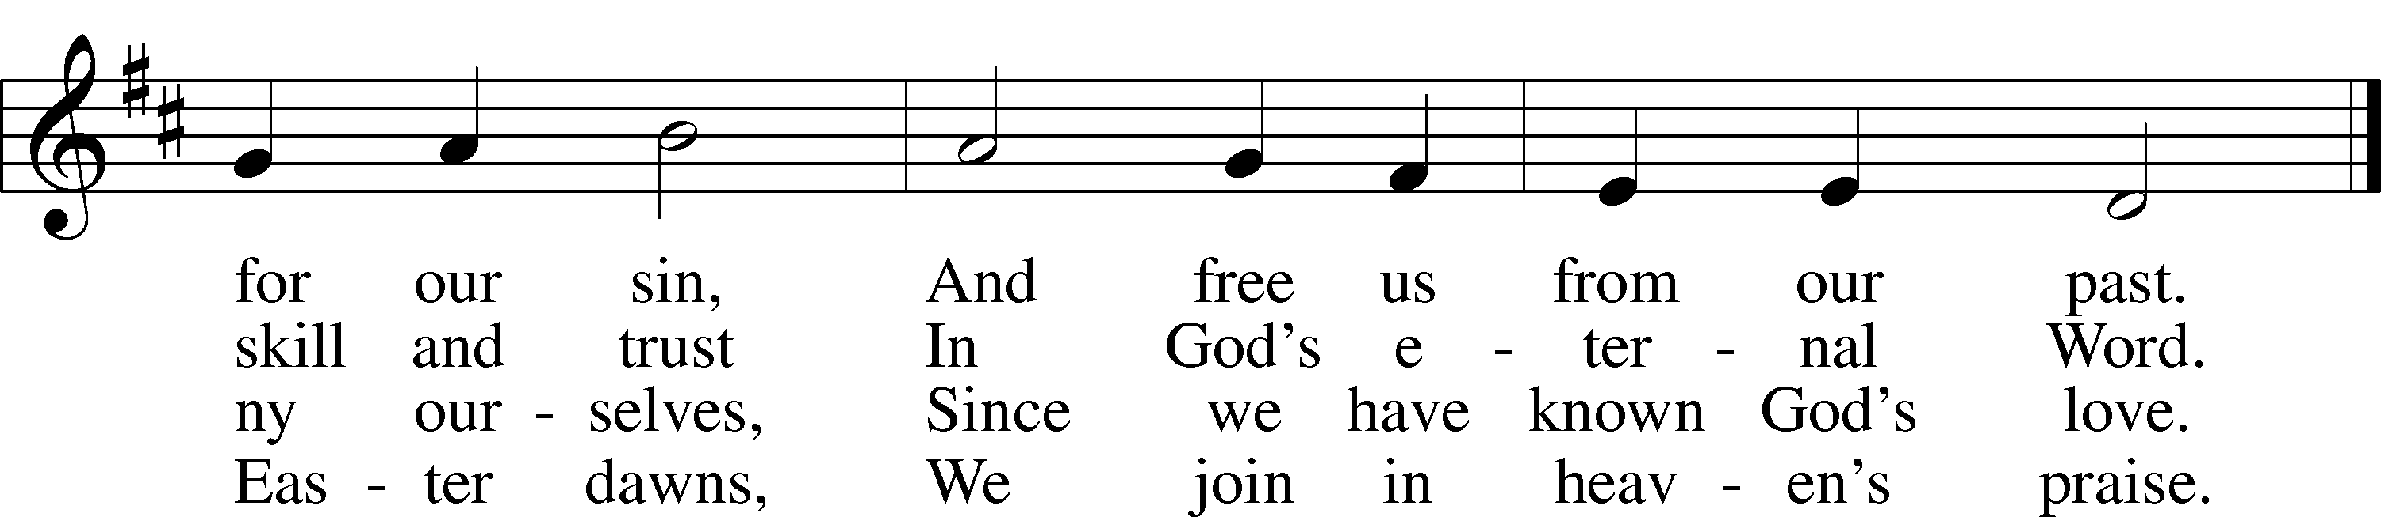
Text: based on Claudia F. Hernaman, 1838–98; para. Gilbert E. Doan, 1930
Tune: The Psalmes of David in Prose and Meeter, 1635, Edinburgh
Text: © 1978 Lutheran Book of Worship. Used by permission: LSB Hymn License no. 110003344
Tune: Public domain

