Opening Hymn “Chief of Sinners Though I Be” # 611
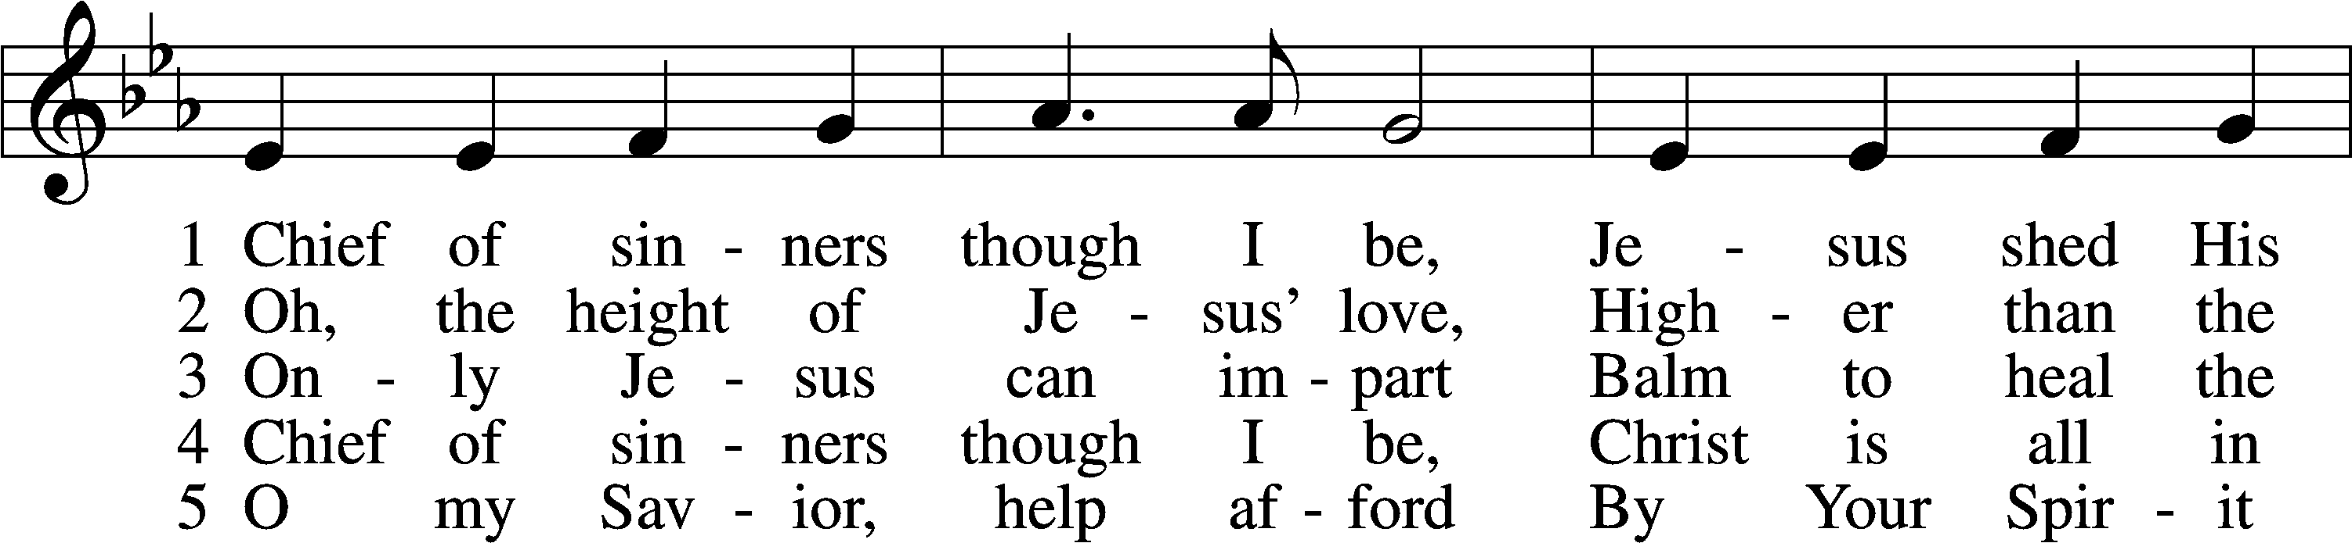
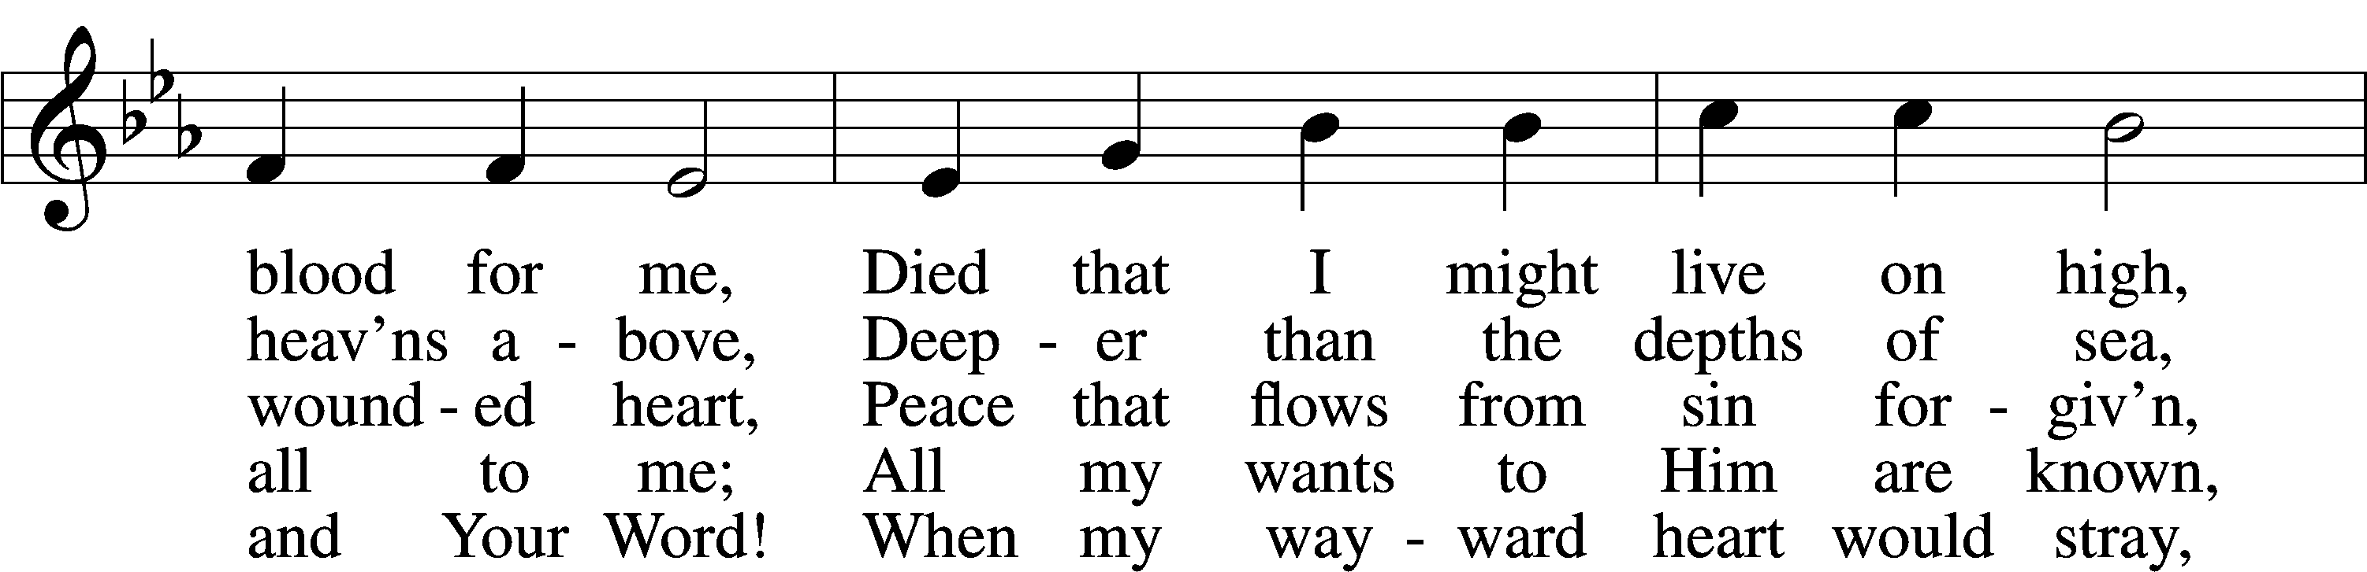
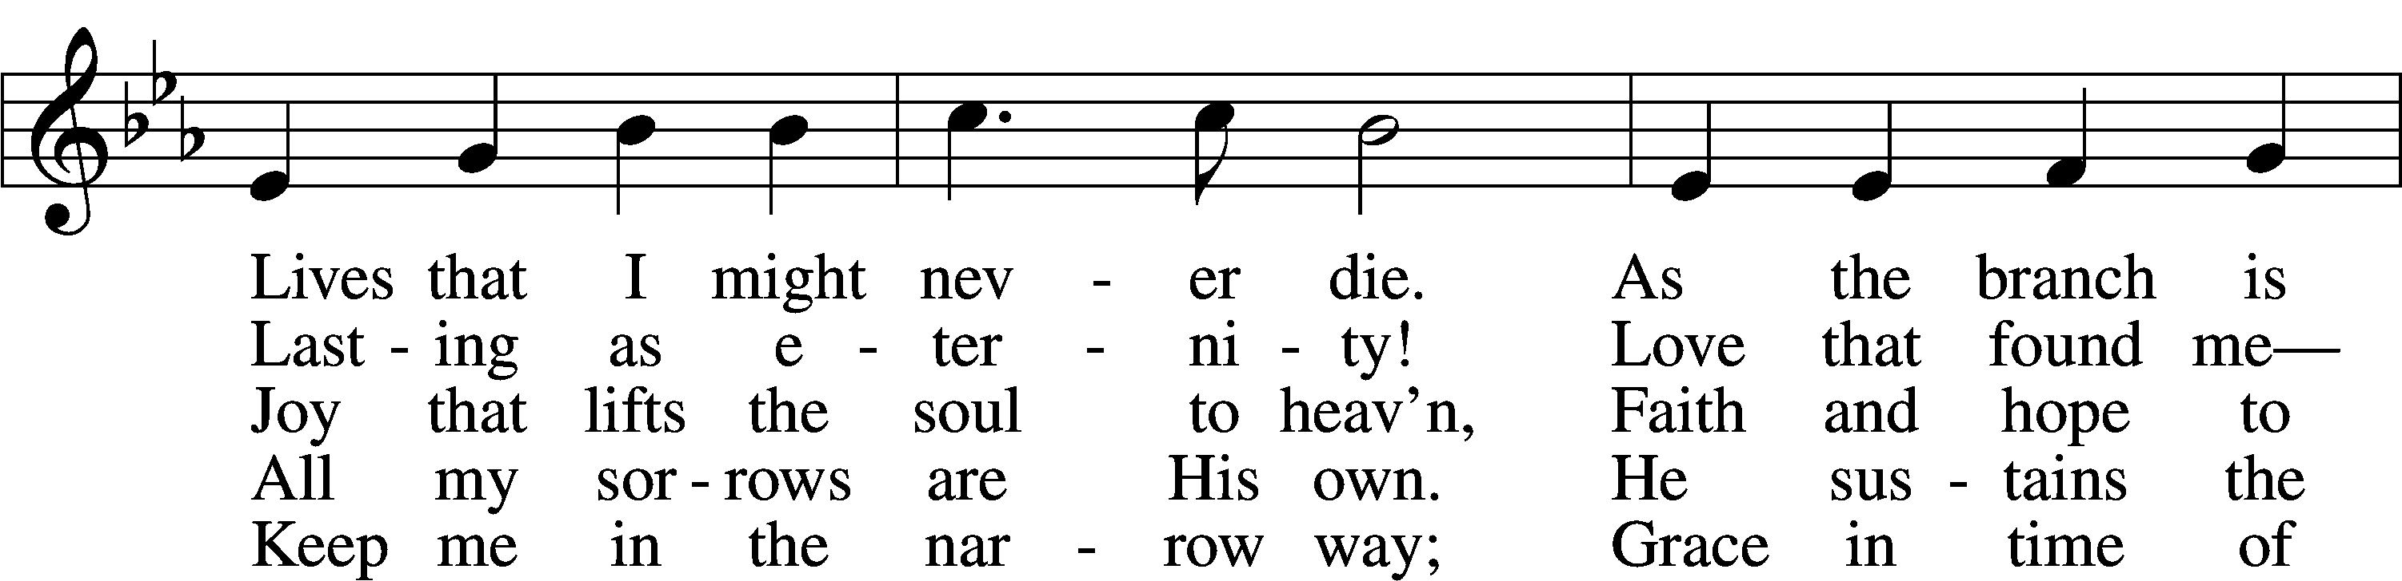
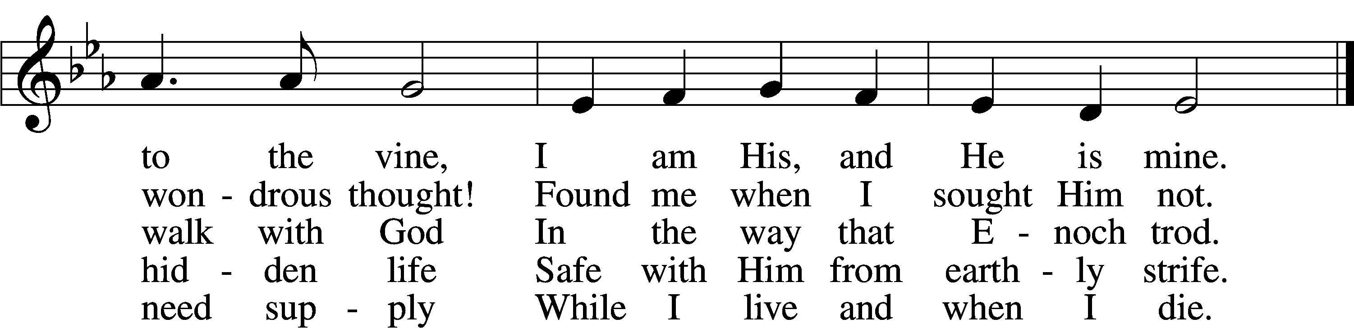
Text: William McComb, 1793–1873, alt.
Tune: Richard Redhead, 1820–1901
Text and tune: Public domain

Sermon Hymn “Lord, Thee I Love with All My Heart” # 708
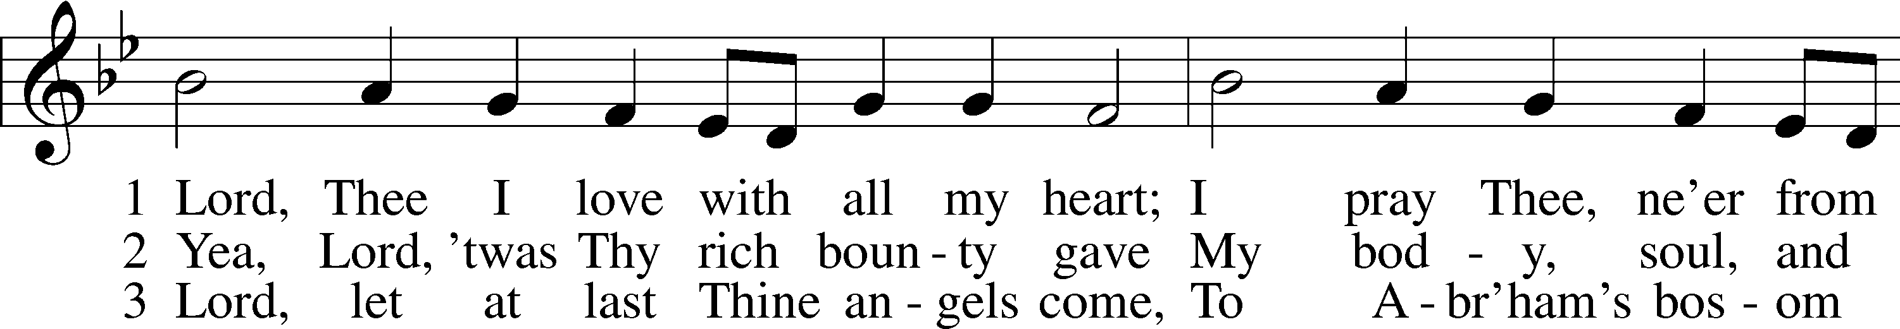
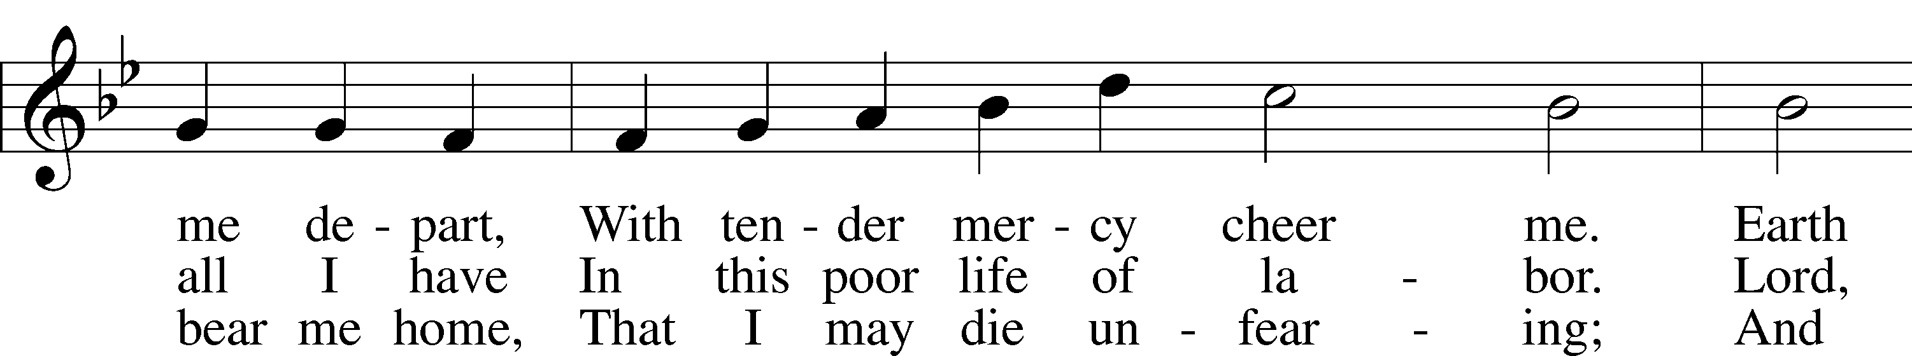
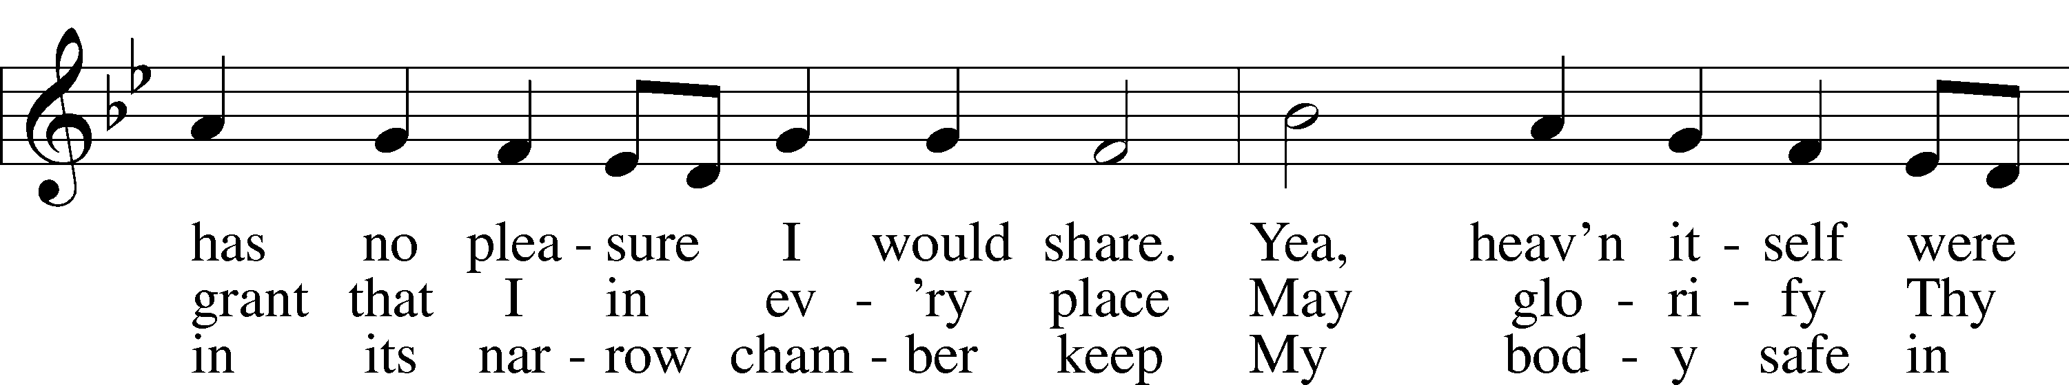
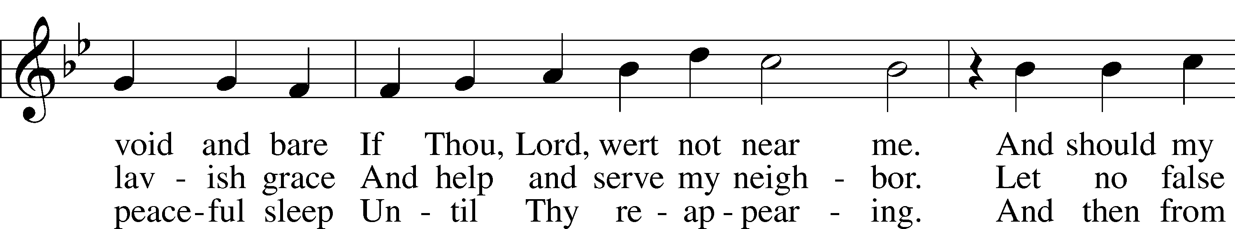
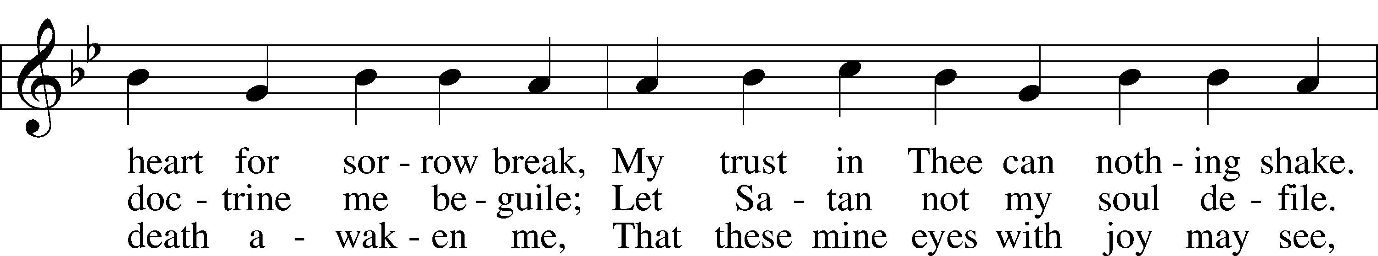
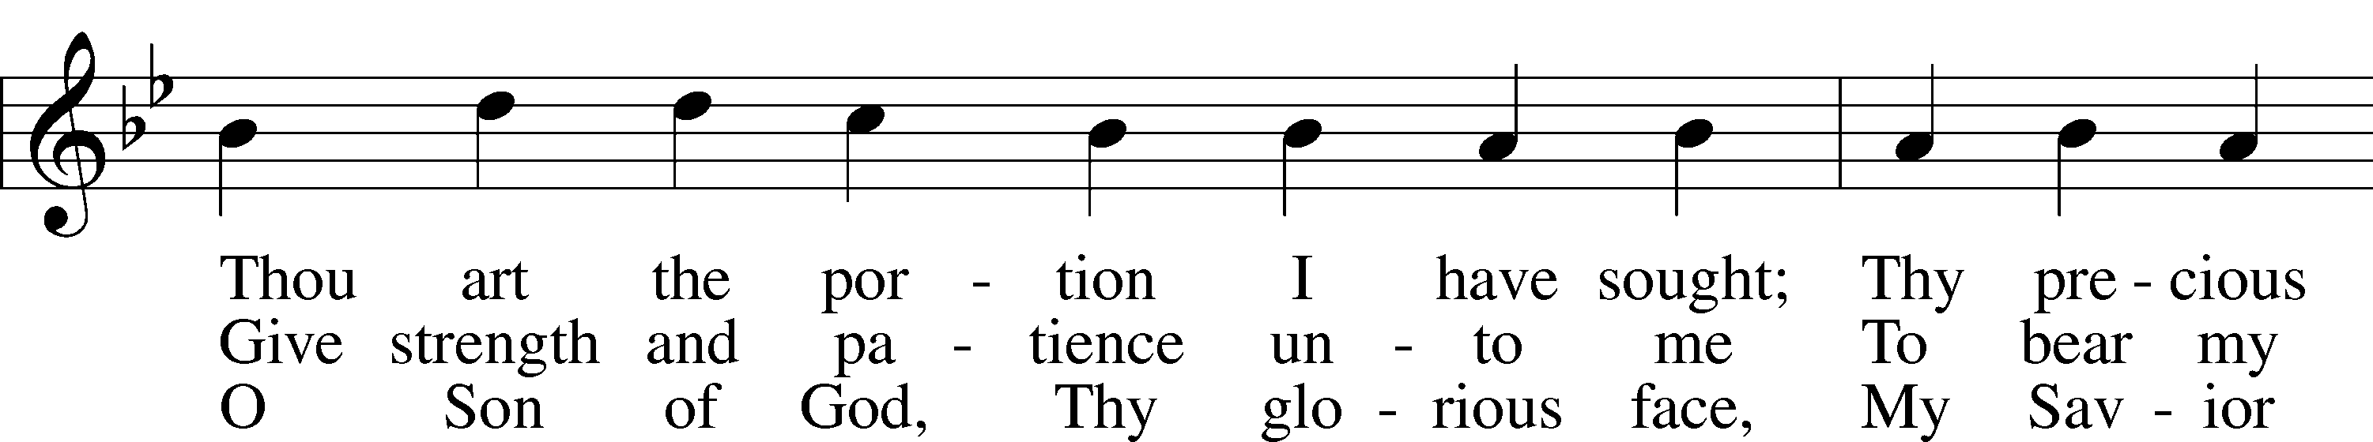
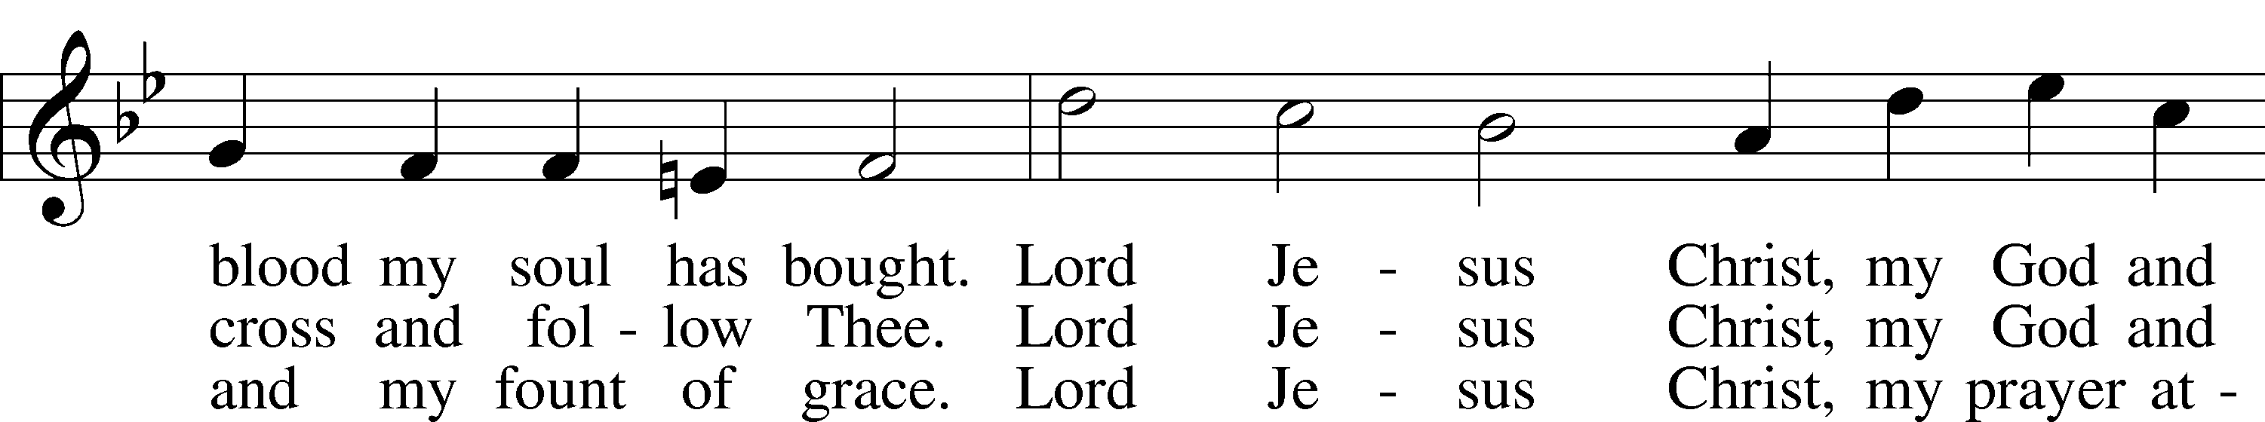
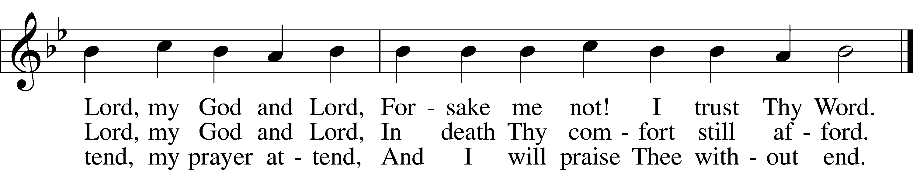
Text: Martin Schalling, 1532–1608; tr. Catherine Winkworth, 1827–78, alt.
Tune: Zwey Bücher . . . Tabulatur, 1577, Strassburg
Text and tune: Public domain

Closing Hymn “My Song Is Love Unknown” # 430
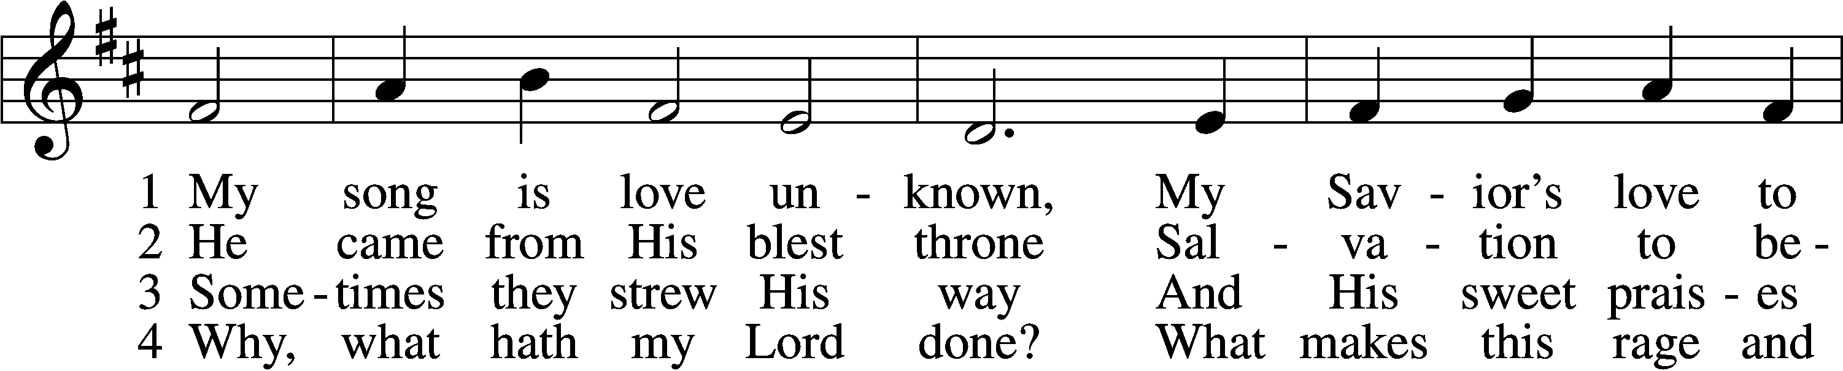
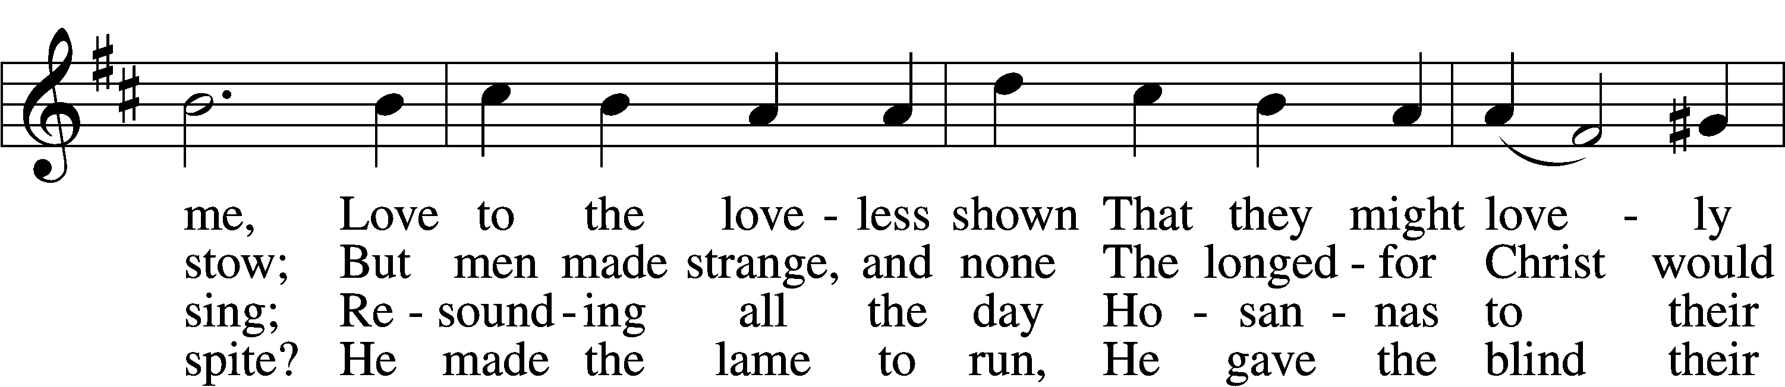
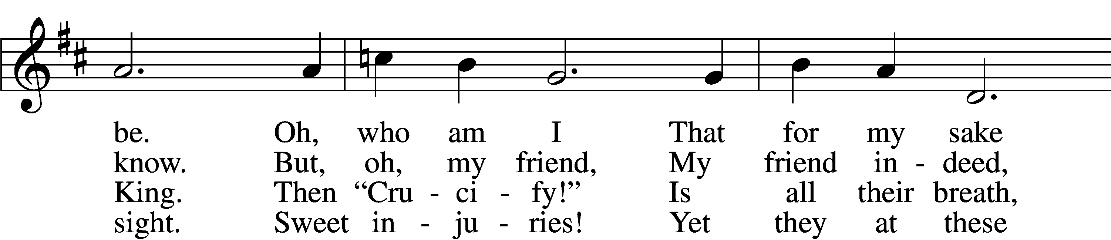
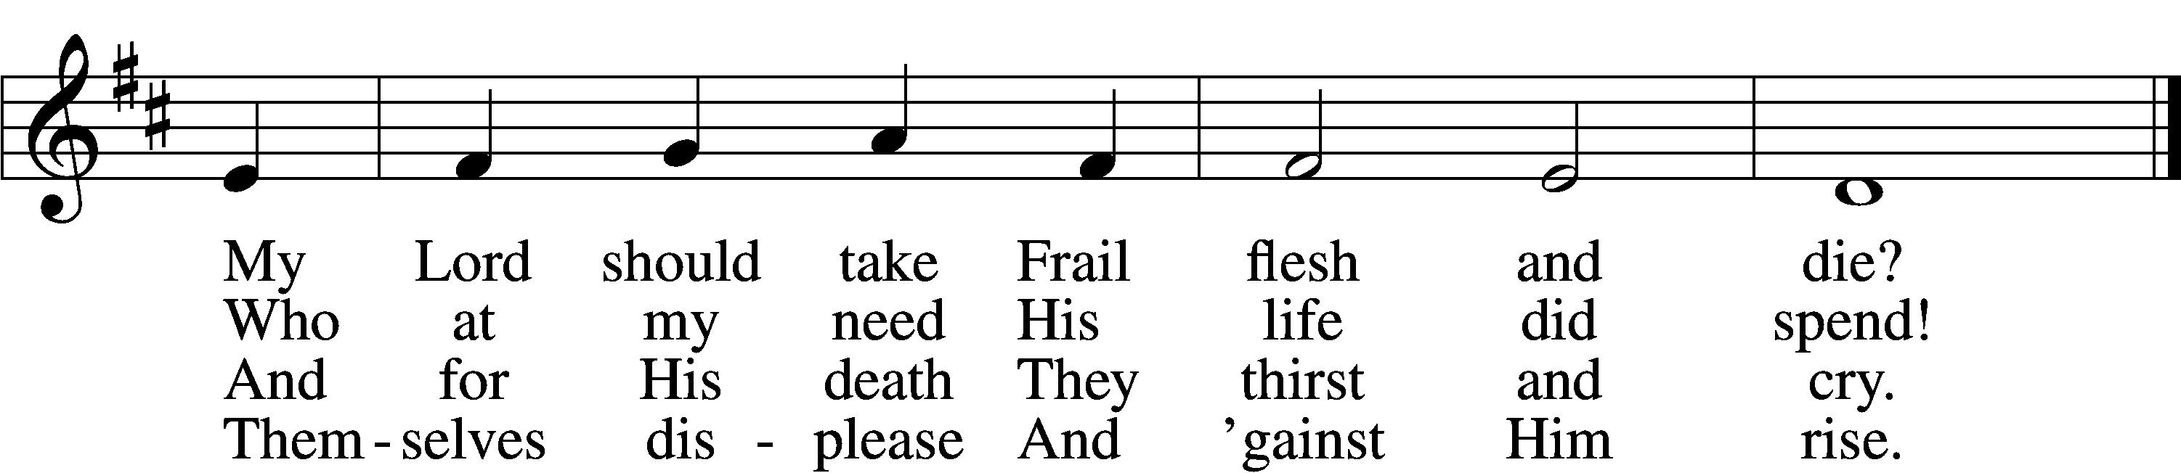

5 They rise and needs will have
My dear Lord made away;
A murderer they save,
The Prince of Life they slay.
Yet cheerful He
To suff’ring goes
That He His foes
From thence might free.

6 In life no house, no home
My Lord on earth might have;
In death no friendly tomb
But what a stranger gave.
What may I say?
Heav’n was His home
But mine the tomb
Wherein He lay.

7 Here might I stay and sing,
No story so divine!
Never was love, dear King,
Never was grief like Thine.
This is my friend,
In whose sweet praise
I all my days
Could gladly spend!
Text: Samuel Crossman, c. 1624–1683
Tune: John N. Ireland, 1879–1962
Text: Public domain
Tune: © John Ireland Trust. Used by permission: LSB Hymn License no. 110003344

