### Blessed Savior Lutheran Church

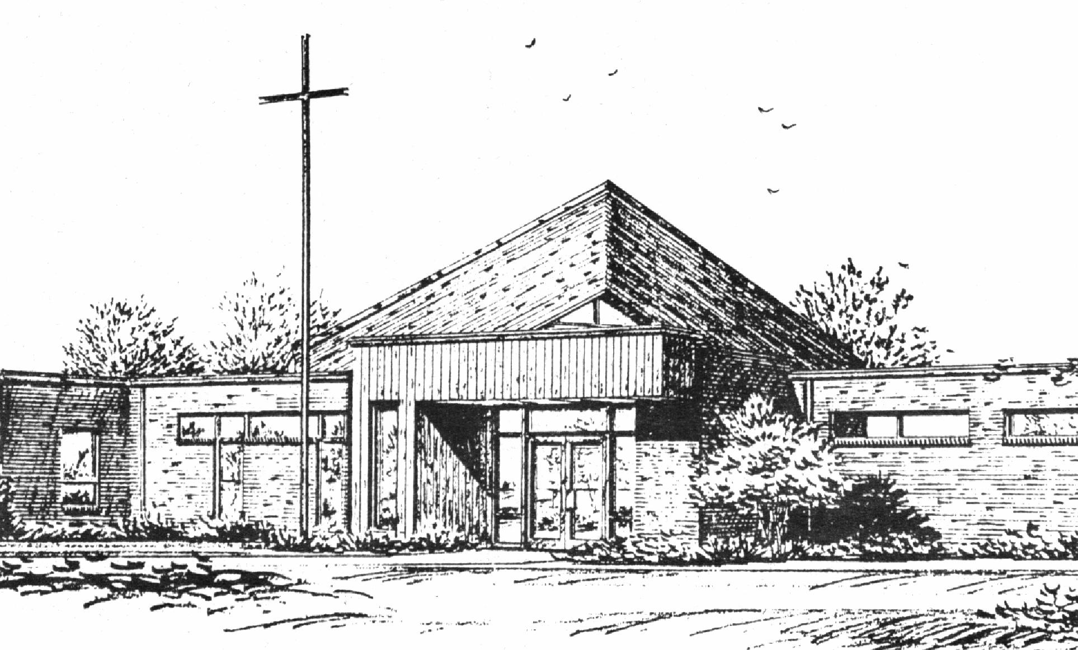

*“Empowered by God’s Holy Word,*

*we joyfully share the love of Jesus with all people;*

*through worship, teaching, fellowship,*

*service and witnessing.”*

**You Meant it for Evil,**

**But God Meant it for Good**

**February 28, 2024**

That Day, and Today

***(Luke 23:26-43)***



Lutheran Church Missouri Synod

Rev. Matthew Roeglin, Pastor 314-479-1470

pastor@blessedsavior-lcms.org

Church Office: 7:30 AM – 11:30 AM Monday-Friday 314-831-1300

2615 Shackelford Rd. Florissant, MO Fax 314-831-3444

Website: www.blessedsavior-lcms.org

Church Email: office@blessedsavior-lcms.org

Divine Services: Sunday 9:30 AM; Wednesday 6:30 PM

**WE WELCOME YOU** to our worship service this evening. We pray God’s rich blessings upon you as you hear His Word and praise His holy name. We ask our members and visitors to please use the friendship pad found on the pew. Kindly hand the friendship pad to the person sitting next to you. The Ushers will collect them after the service. Thank You.

**THIS WORSHIP FOLDER / CHURCH BULLETIN** is prepared for your convenience and contains the entire order of worship with all spoken and sung responses. However, if you are more comfortable using the hymnal, you may use the order of worship found in the front pages of Lutheran Service Book where all the melodies are shown for the sung responses of the congregation.

**INDIVIDUAL HEARING ASSISTANCE SETS** are available for those with impaired hearing. Please ask an usher for assistance.

**LARGE PRINT BULLETINS** are available in the narthex.

**THANK YOU FOR YOUR SERVICE**

Preacher: Pastor Roeglin – Blessed Savior

Organist/Pianist: Mrs. Donna Boyd

*(Please silence your cell phones)*

Service of Prayer and Preaching *p.260*

*Opening Hymn*

*“O Christ, You Walked the Road* # 424

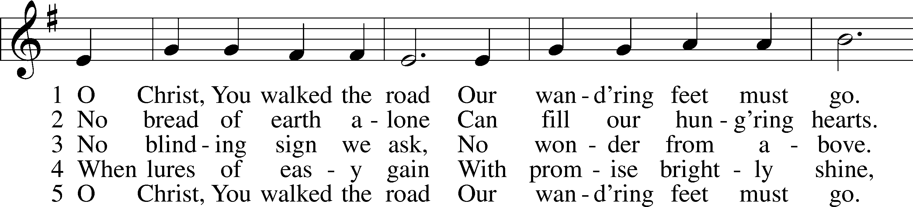

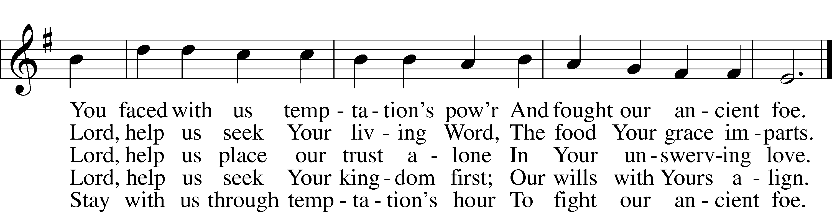

Text: Herman G. Stuempfle, Jr., 1923–2007  
Tune: William Daman, c. 1540–1591  
Text: © 1997 GIA Publications, Inc. Used by permission: LSB Hymn License no. 110003344  
Tune: Public domain

Stand

*Opening Versicles p.260*

L This is the day which the Lord has made;

C **let us rejoice and be glad in it.**

L From the rising of the sun to its setting,

C **the name of the Lord is to be praised.**

L Return to the Lord, your God, for He is gracious and merciful,

C **slow to anger, and abounding in steadfast love, and repents of evil.**

L Jesus said: If any man would come after Me,

C **let him deny himself and take up his cross and follow Me.**

L Christ was wounded for our transgressions.

C **He was bruised for our iniquities.**

L From the rising of the sun to its setting,

C **the name of the Lord is to be praised.**

C **Glory be to the Father and to the Son and to the Holy Spirit;**  
**as it was in the beginning, is now, and will be forever. Amen.**

*Hymn* # 528 sts. 1–2, 6–7

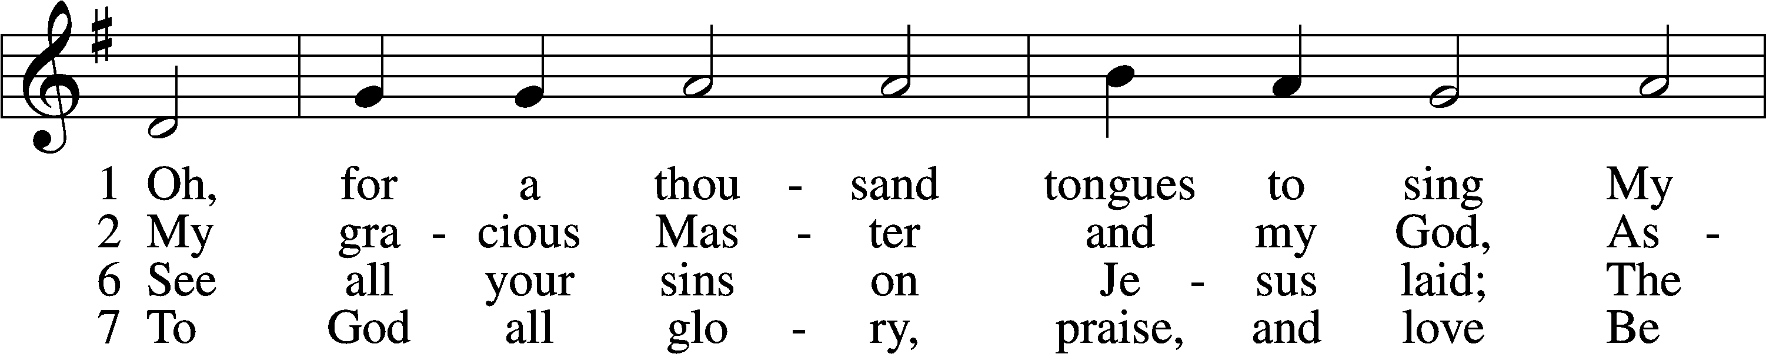

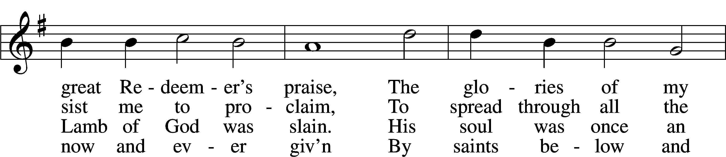

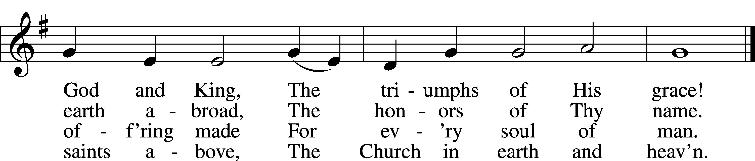

Text: Charles Wesley, 1707–88, alt.  
Tune: Carl G. Gläser, 1784–1829  
Text and tune: Public domain

Sit

Readings From Holy Scripture

*Reading* Micah 7:18–20

L A reading from Micah, the seventh chapter.

18Who is a God like you, pardoning iniquity  
 and passing over transgression  
 for the remnant of his inheritance?  
He does not retain his anger forever,  
 because he delights in steadfast love.  
19He will again have compassion on us;  
 he will tread our iniquities under foot.  
You will cast all our sins  
 into the depths of the sea.  
20You will show faithfulness to Jacob  
 and steadfast love to Abraham,  
as you have sworn to our fathers  
 from the days of old.

L This is the Word of the Lord.

C **Thanks be to God.**

*Reading* 1 Timothy 1:12–17

12I thank him who has given me strength, Christ Jesus our Lord, because he judged me faithful, appointing me to his service, 13though formerly I was a blasphemer, persecutor, and insolent opponent. But I received mercy because I had acted ignorantly in unbelief, 14and the grace of our Lord overflowed for me with the faith and love that are in Christ Jesus. 15The saying is trustworthy and deserving of full acceptance, that Christ Jesus came into the world to save sinners, of whom I am the foremost. 16But I received mercy for this reason, that in me, as the foremost, Jesus Christ might display his perfect patience as an example to those who were to believe in him for eternal life. 17To the King of ages, immortal, invisible, the only God, be honor and glory forever and ever. Amen.

*Reading* Luke 23:26–43

26And as they led him away, they seized one Simon of Cyrene, who was coming in from the country, and laid on him the cross, to carry it behind Jesus. 27And there followed him a great multitude of the people and of women who were mourning and lamenting for him. 28But turning to them Jesus said, “Daughters of Jerusalem, do not weep for me, but weep for yourselves and for your children. 29For behold, the days are coming when they will say, ‘Blessed are the barren and the wombs that never bore and the breasts that never nursed!’ 30Then they will begin to say to the mountains, ‘Fall on us,’ and to the hills, ‘Cover us.’ 31For if they do these things when the wood is green, what will happen when it is dry?”

32Two others, who were criminals, were led away to be put to death with him. 33And when they came to the place that is called The Skull, there they crucified him, and the criminals, one on his right and one on his left. 34And Jesus said, “Father, forgive them, for they know not what they do.” And they cast lots to divide his garments. 35And the people stood by, watching, but the rulers scoffed at him, saying, “He saved others; let him save himself, if he is the Christ of God, his Chosen One!” 36The soldiers also mocked him, coming up and offering him sour wine 37and saying, “If you are the King of the Jews, save yourself!” 38There was also an inscription over him, “This is the King of the Jews.”

39One of the criminals who were hanged railed at him, saying, “Are you not the Christ? Save yourself and us!” 40But the other rebuked him, saying, “Do you not fear God, since you are under the same sentence of condemnation? 41And we indeed justly, for we are receiving the due reward of our deeds; but this man has done nothing wrong.” 42And he said, “Jesus, remember me when you come into your kingdom.” 43And he said to him, “Truly, I say to you, today you will be with me in Paradise.”

*Responsory p.263*

L We have an advocate with the Father; Jesus Christ, the Righteous One.

C **He was delivered up to death; He was delivered for the sins of the people.**

L Blessed is the one whose transgression is forgiven, whose sin is covered.

C **He was delivered up to death; He was delivered for the sins of the people.**

L We have an advocate with the Father; Jesus Christ, the Righteous One.

C **He was delivered up to death; He was delivered for the sins of the people.**

Stand

*Ten Commandments p.264*

C **You shall have no other gods.**

**You shall not misuse the name of the Lord your God.**

**Remember the Sabbath day by keeping it holy.**

**Honor your father and your mother.**

**You shall not murder.**

**You shall not commit adultery.**

**You shall not steal.**

**You shall not give false testimony against your neighbor.**

**You shall not covet your neighbor’s house.**

**You shall not covet your neighbor’s wife, or his manservant or maidservant, his ox or donkey, or anything that belongs to your neighbor.**

*Apostles’ Creed p.264*

C **I believe in God, the Father Almighty,**

**maker of heaven and earth.**

**And in Jesus Christ, His only Son, our Lord,** **who was conceived by the Holy Spirit,** **born of the virgin Mary,** **suffered under Pontius Pilate,** **was crucified, died and was buried.** **He descended into hell.** **The third day He rose again from the dead.** **He ascended into heaven** **and sits at the right hand of God the Father Almighty.** **From thence He will come to judge the living and the dead.**

**I believe in the Holy Spirit,** **the holy Christian Church,** **the communion of saints,** **the forgiveness of sins,** **the resurrection of the body,** **and the life** T **everlasting. Amen.**

*Lord’s Prayer*

C **Our Father who art in heaven, hallowed be Thy name, Thy kingdom come, Thy will be done on earth as it is in heaven; give us this day our daily bread; and forgive us our trespasses as we forgive those who trespass against us; and lead us not into temptation, but deliver us from evil. For Thine is the kingdom and the power and the glory**

**forever and ever. Amen.**

Sit

*Sermon*

*Hymn* *“Jesus, Thy Blood and Righteousness”* # 563

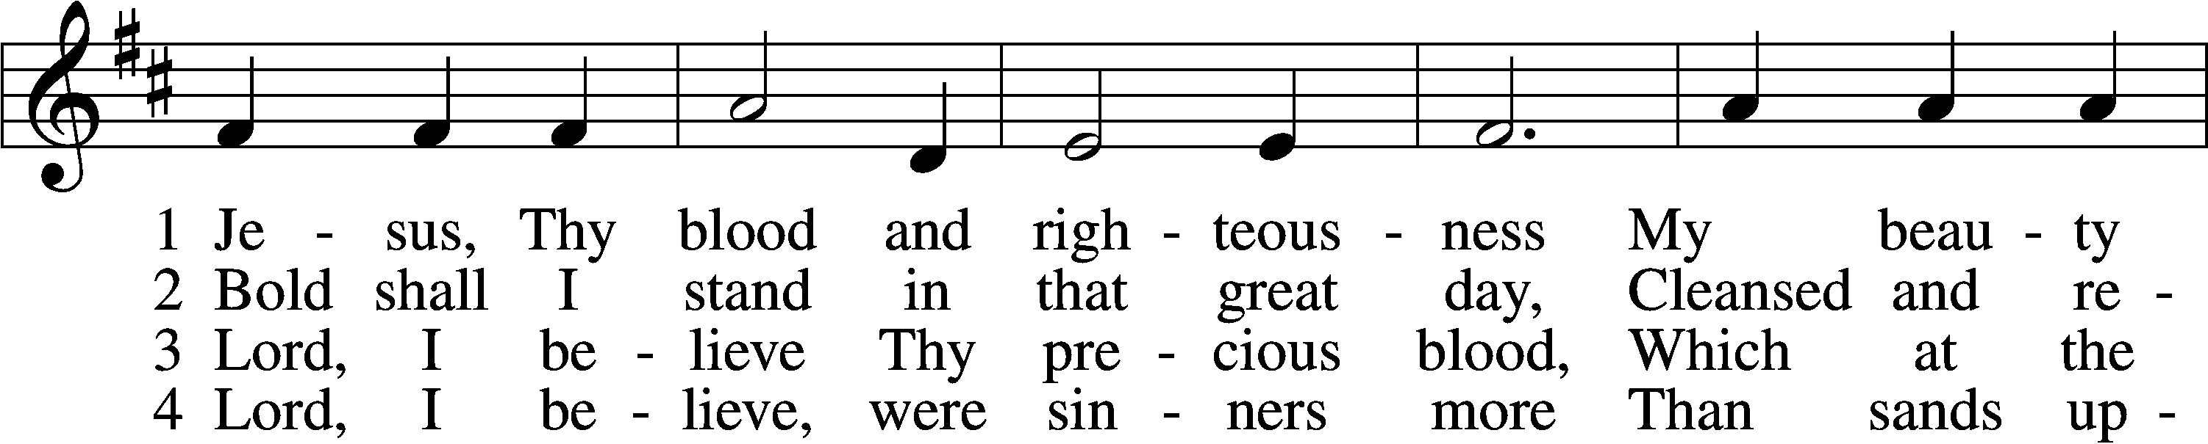

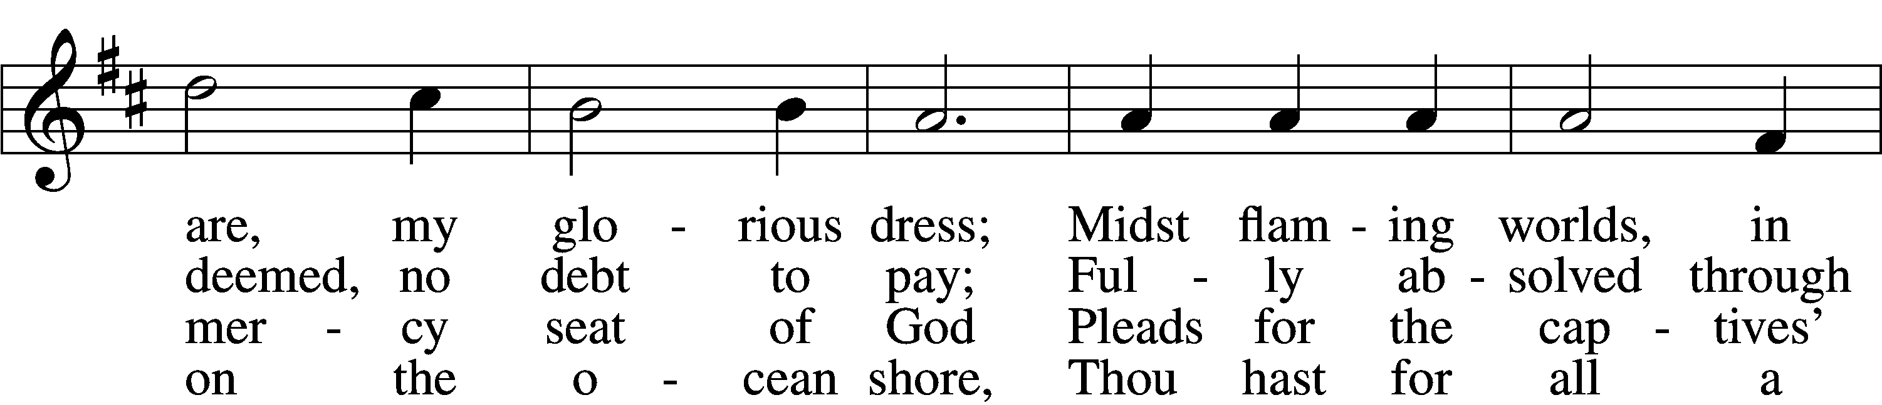

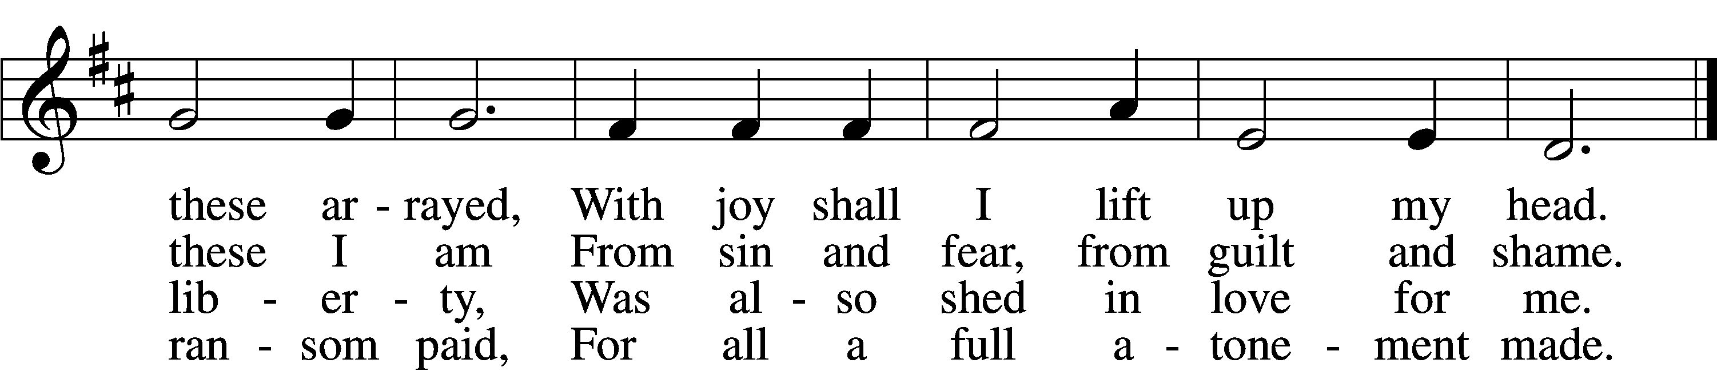

5 When from the dust of death I rise  
To claim my mansion in the skies,  
This then shall be my only plea:  
Jesus hath lived and died for me.

6 Jesus, be endless praise to Thee,  
Whose boundless mercy hath for me,  
For me, and all Thy hands have made,  
An everlasting ransom paid.

Text: Nicolaus Ludwig von Zinzendorf, 1700–60; tr. John B. Wesley, 1703–91, alt.  
Tune: George J. Elvey, 1816–93  
Text and tune: Public domain

*Offering*

Stand

*Prayer p.265*

L In peace let us pray to the Lord:

C **Lord, have mercy.**

L For the gift of divine peace and of pardon, with all our heart and with all our mind, let us pray to the Lord:

C **Lord, have mercy.**

L For the holy Christian Church, here and scattered throughout the world, and for the proclamation of the Gospel and the calling of all to faith, let us pray to the Lord:

C **Lord, have mercy.**

L For this nation, for our cities and communities, and for the common welfare of us all, let us pray to the Lord:

C **Lord, have mercy.**

L For seasonable weather and for the fruitfulness of the earth, let us pray to the Lord:

C **Lord, have mercy.**

L For those who labor, for those whose work is difficult or dangerous, and for all who travel, let us pray to the Lord:

C **Lord, have mercy.**

L For all those in need, for the hungry and homeless, for the widowed and orphaned, and for all those in prison, let us pray to the Lord:

C **Lord, have mercy.**

L For the sick and dying and for all those who care for them, let us pray to the Lord:

C **Lord, have mercy.**

L Finally, for these and for all our needs of body and soul, let us pray to the Lord:

C **Lord, have mercy. Christ, have mercy. Lord, have mercy.**

*Collect of the Day*

L O God, You see that of ourselves we have no strength. By Your mighty power defend us from all adversities that may happen to the body and from all evil thoughts that may assault and hurt the soul; through Jesus Christ, Your Son, our Lord, who lives and reigns with You and the Holy Spirit, one God, now and forever.

C **Amen.**

*Collect for the Word*

L Blessed Lord, You have caused all Holy Scriptures to be written for our learning. Grant that we may so hear them, read, mark, learn, and take them to heart that, by the patience and comfort of Your holy Word, we may embrace and ever hold fast the blessed hope of everlasting life; through Jesus Christ, Your Son, our Lord, who lives and reigns with You and the Holy Spirit, one God, now and forever.

C **Amen.**

*Hymn* *“Lamb of God”* # 550

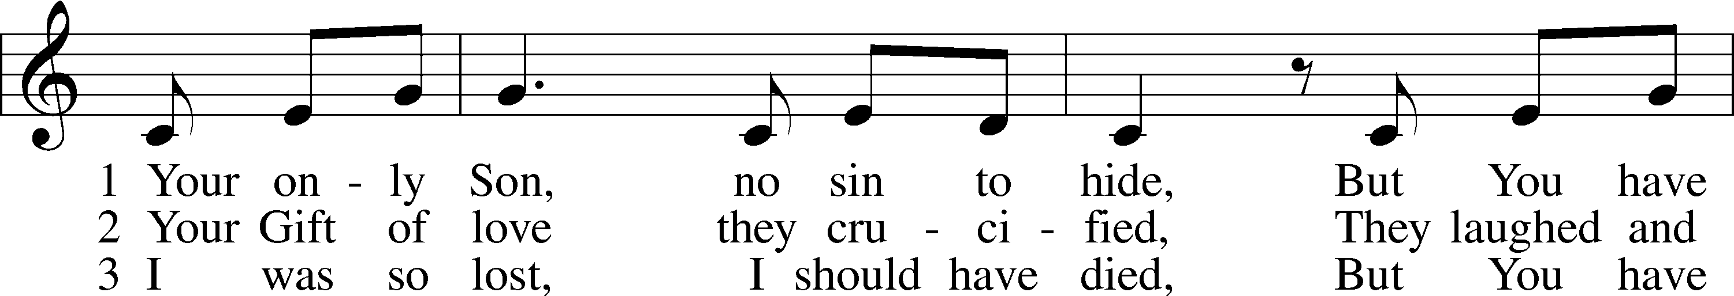

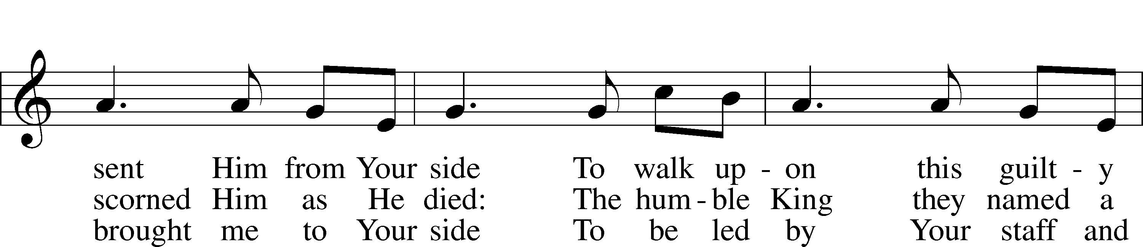

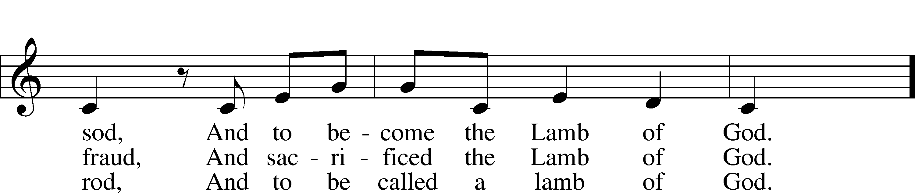

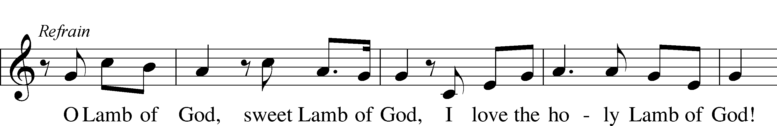

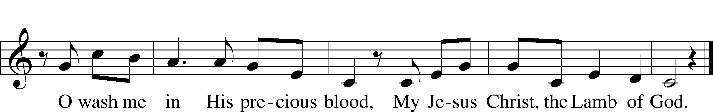

Text and tune: Twila Paris, 1958  
Text and tune: © 1985 Straightway Music, admin. EMI. Used by permission: LSB Hymn License no. 110003344

*Evening Prayer p.266*

C **I thank You, my heavenly Father, through Jesus Christ, Your dear Son, that You have graciously kept me this day; and I pray that You would forgive me all my sins where I have done wrong, and graciously keep me this night. For into Your hands I commend myself, my body and soul, and all things. Let Your holy angel be with me, that the evil foe may have no power over me.**

*Blessing*

L Let us bless the Lord.

C **Thanks be to God.**

L The almighty and merciful Lord, the Father, the T Son, and the Holy Spirit, bless and preserve us.

C **Amen.**

*Closing Hymn* *“The Day Thou Gavest”* # 886

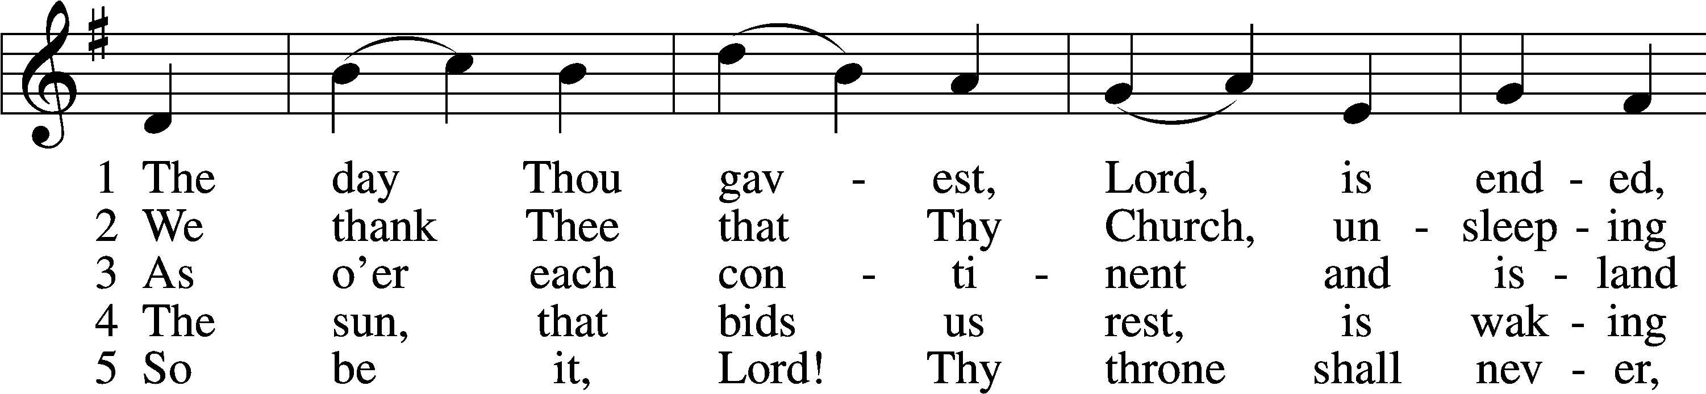

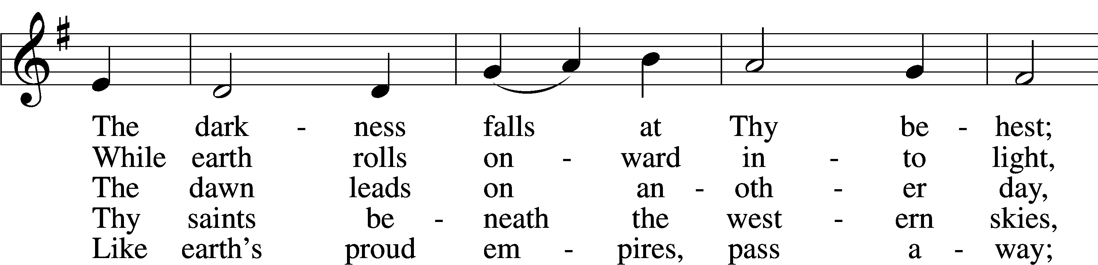

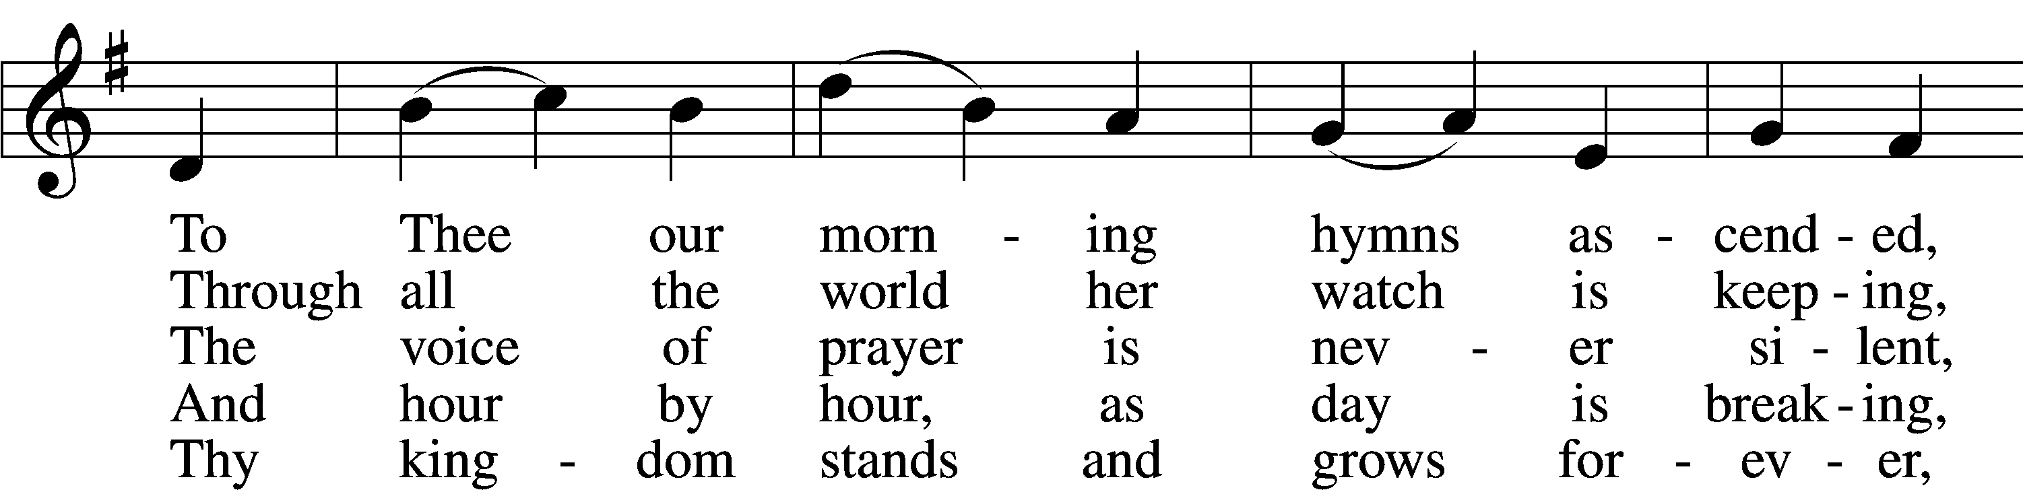

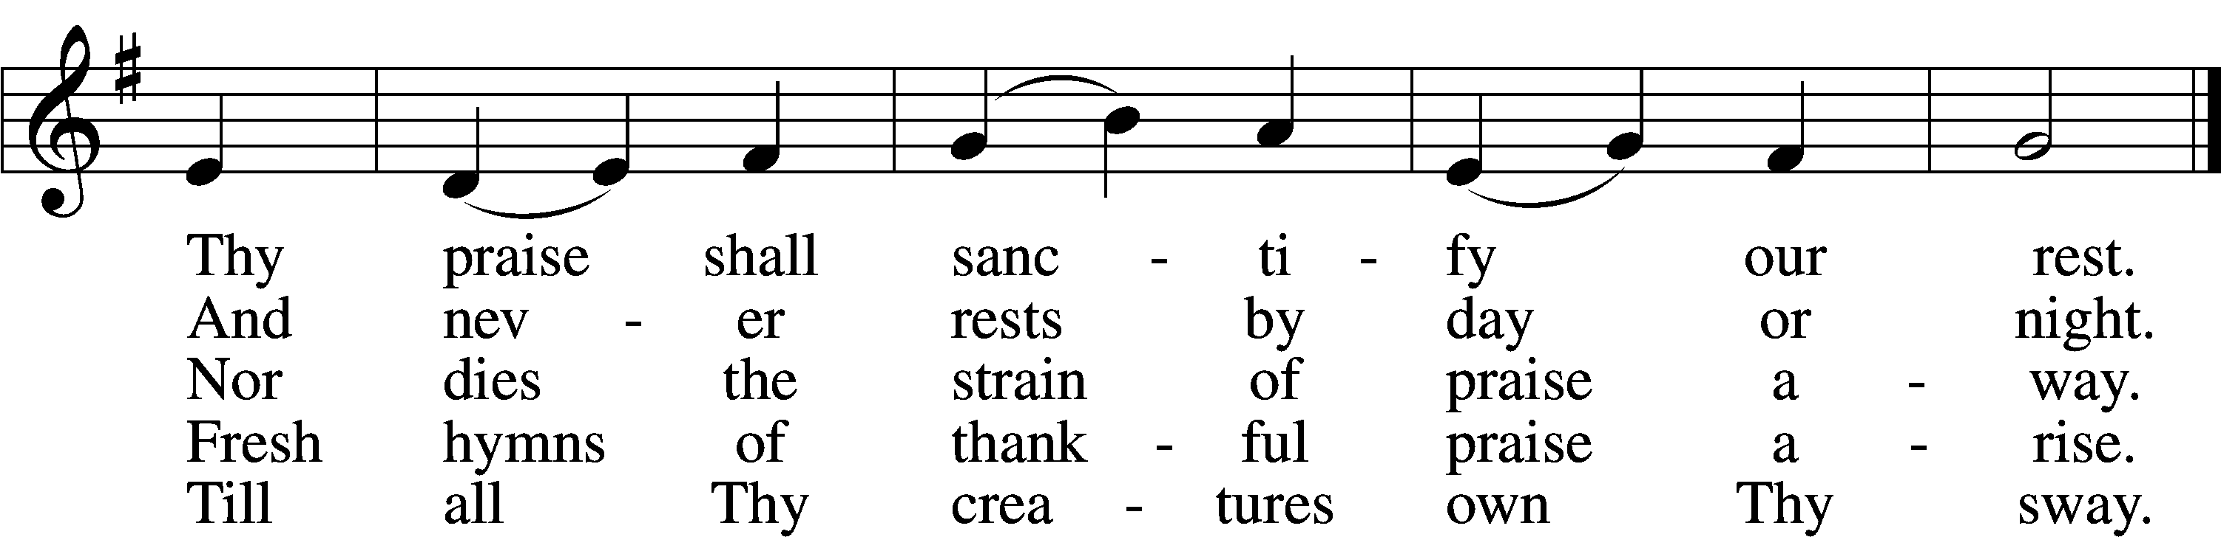

Text: John Ellerton, 1826–93, alt.  
Tune: Clement C. Scholefield, 1839–1904  
Text and tune: Public domain

Acknowledgments

Service of Prayer and Preaching from Lutheran Service Book

Unless otherwise indicated, Scripture quotations are from the ESV® Bible (The Holy Bible, English Standard Version®), copyright © 2001 by Crossway, a publishing ministry of Good News Publishers. Used by permission. All rights reserved.

Created by Lutheran Service Builder © 2024 Concordia Publishing House.