### Blessed Savior Lutheran Church

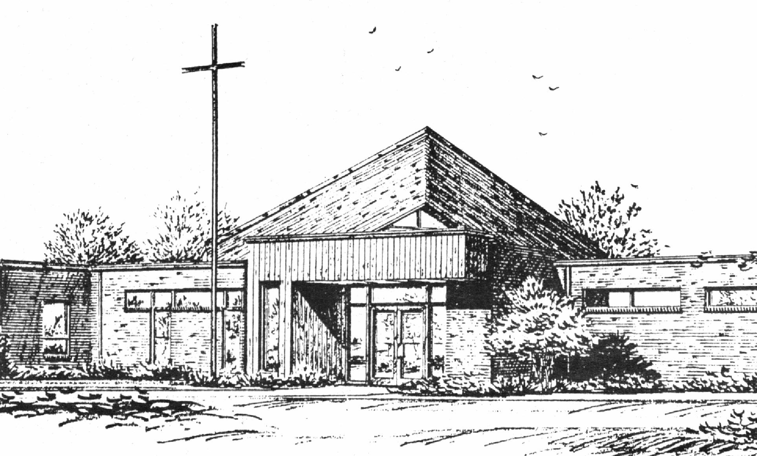

*“Empowered by God’s Holy Word,*

*we joyfully share the love of Jesus with all people;*

*through worship, teaching, fellowship,*

*service and witnessing.”*

**You Meant it for Evil,**

**But God Meant it for Good**

**March 6, 2024**

He was Numbered Among the Transgressors

***(Luke 22:14, 24-38)***



Lutheran Church Missouri Synod

Rev. Matthew Roeglin, Pastor 314-479-1470

pastor@blessedsavior-lcms.org

Church Office: 7:30 AM – 11:30 AM Monday-Friday 314-831-1300

2615 Shackelford Rd. Florissant, MO Fax 314-831-3444

Website: www.blessedsavior-lcms.org

Church Email: office@blessedsavior-lcms.org

Divine Services: Sunday 9:30 AM; Wednesday 6:30 PM

**WE WELCOME YOU** to our worship service this evening. We pray God’s rich blessings upon you as you hear His Word and praise His holy name. We ask our members and visitors to please use the friendship pad found on the pew. Kindly hand the friendship pad to the person sitting next to you. The Ushers will collect them after the service. Thank You.

**THIS WORSHIP FOLDER / CHURCH BULLETIN** is prepared for your convenience and contains the entire order of worship with all spoken and sung responses. However, if you are more comfortable using the hymnal, you may use the order of worship found in the front pages of Lutheran Service Book where all the melodies are shown for the sung responses of the congregation.

**INDIVIDUAL HEARING ASSISTANCE SETS** are available for those with impaired hearing. Please ask an usher for assistance.

**LARGE PRINT BULLETINS** are available in the narthex.

**THANK YOU FOR YOUR SERVICE**

Preacher: Pastor Ellory Glenn – Chapel of the Cross

Organist/Pianist: Substitute Organist Service

*(Please silence your cell phones)*

Service of Prayer and Preaching *p.260*

*Opening Hymn*

*“God Himself is Present”*  *#907*

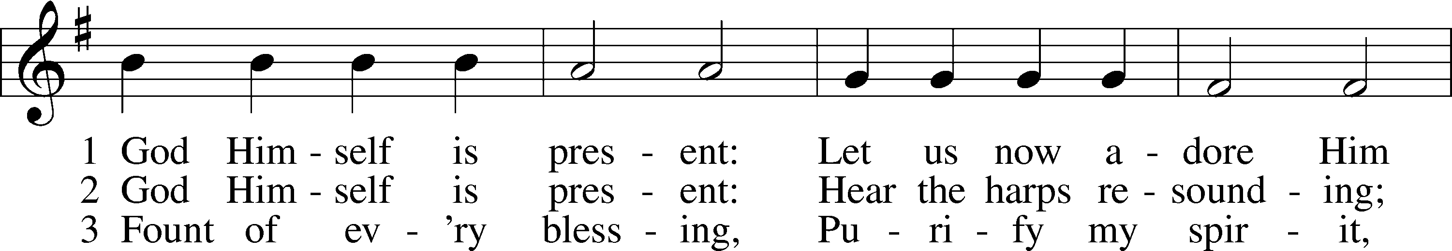

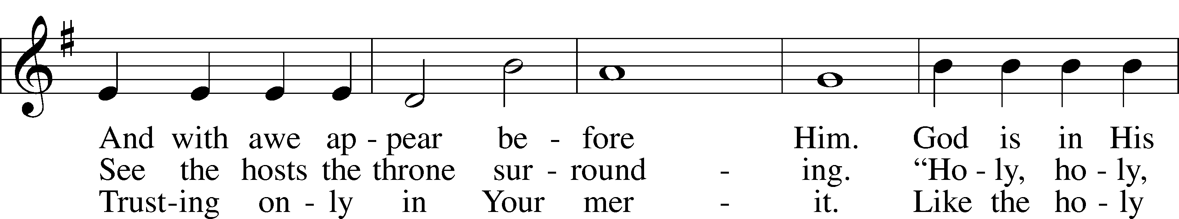

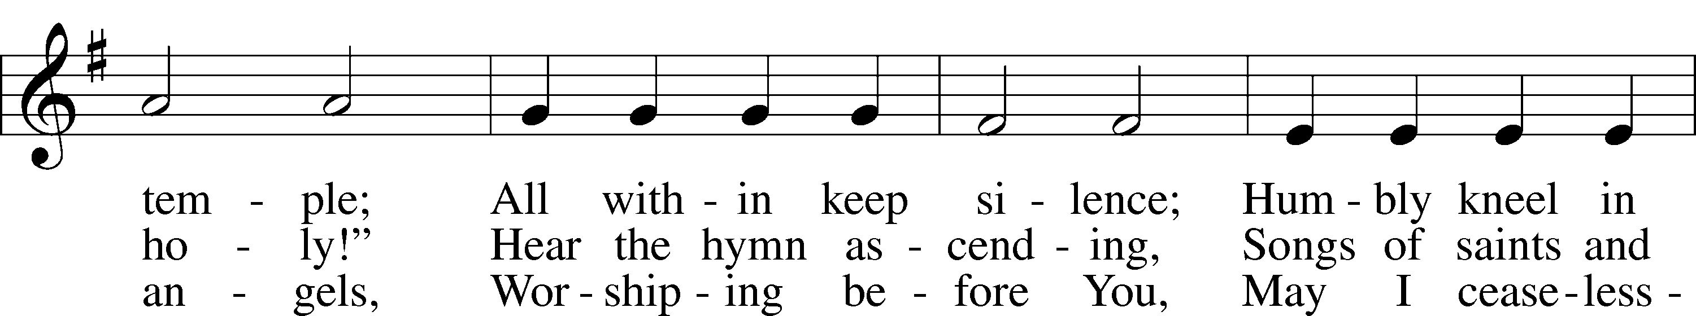

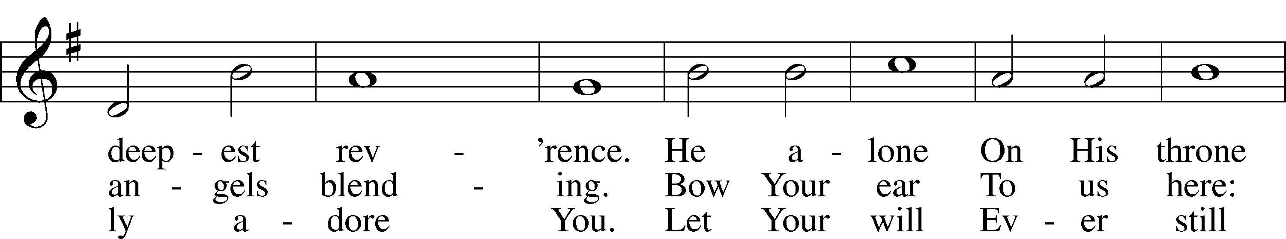

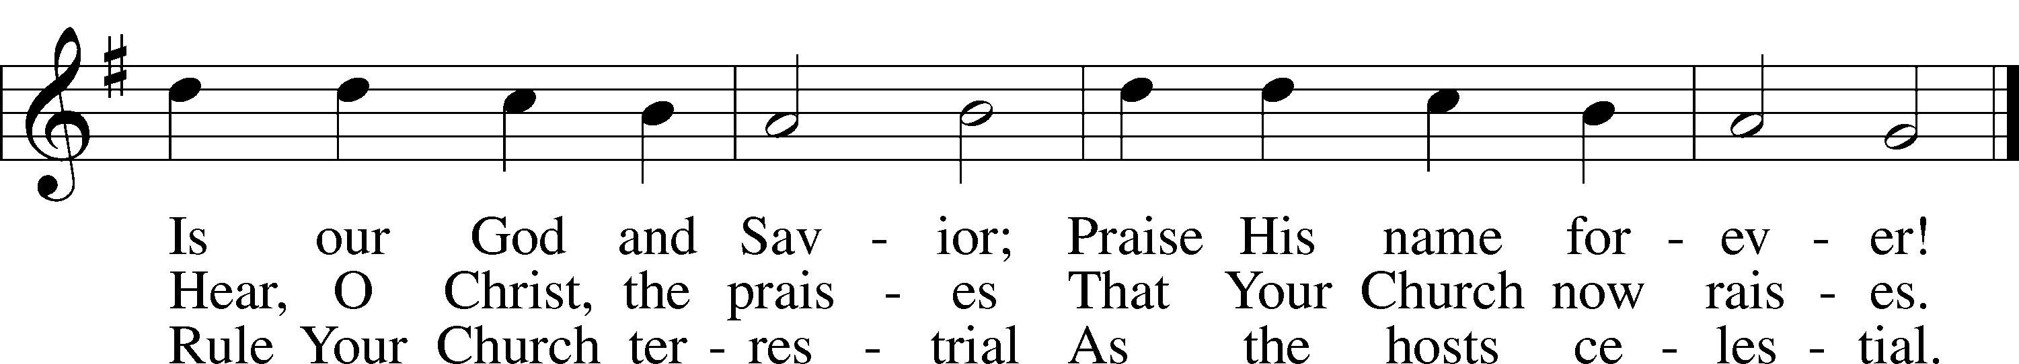

Text: Gerhard Tersteegen, 1697–1769, abr.; tr. Frederick W. Foster, 1760–1835, alt.; tr. John Miller, 1756–90, alt.  
Tune: Joachim Neander, 1650–80  
Text and tune: Public domain

Stand

*Opening Versicles p.260*

L This is the day which the Lord has made;

C **let us rejoice and be glad in it.**

L From the rising of the sun to its setting,

C **the name of the Lord is to be praised.**

L Return to the Lord, your God, for He is gracious and merciful,

C **slow to anger, and abounding in steadfast love, and repents of evil.**

L Jesus said: If any man would come after Me,

C **let him deny himself and take up his cross and follow Me.**

L Christ was wounded for our transgressions.

C **He was bruised for our iniquities.**

L From the rising of the sun to its setting,

C **the name of the Lord is to be praised.**

C **Glory be to the Father and to the Son and to the Holy Spirit;**  
**as it was in the beginning, is now, and will be forever. Amen.**

*Hymn* # 528 sts. 1–2, 6–7

*“Oh, for a Thousand Tongues to Sing”*

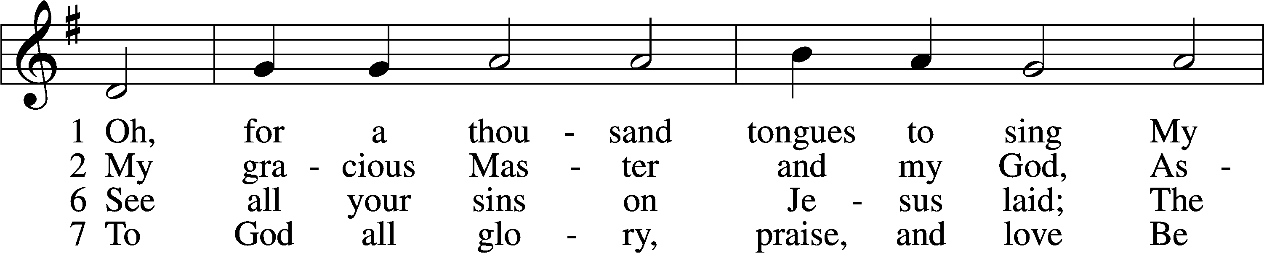

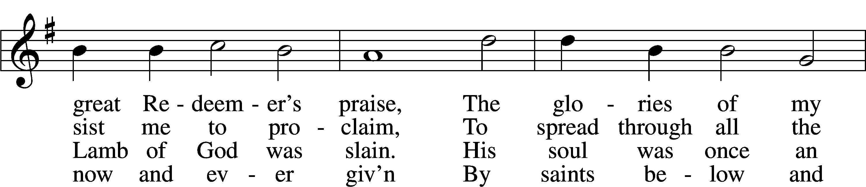

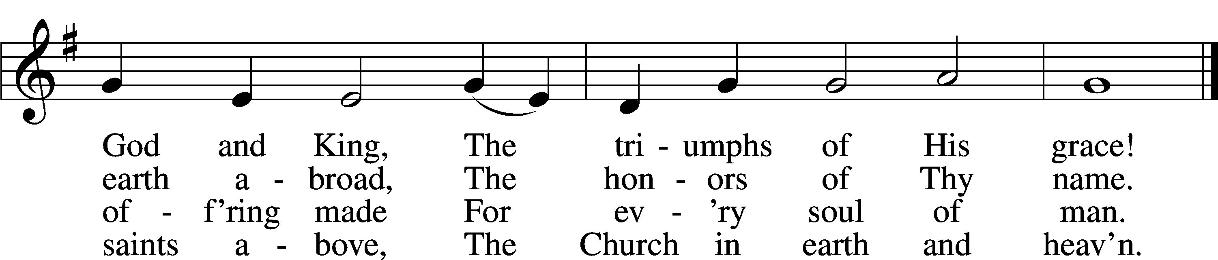

Text: Charles Wesley, 1707–88, alt.  
Tune: Carl G. Gläser, 1784–1829  
Text and tune: Public domain

Sit

Readings From Holy Scripture

*Reading* Isaiah 53:7–12

L A reading from Isaiah, the fifty-third chapter.

7He was oppressed, and he was afflicted,  
 yet he opened not his mouth;  
like a lamb that is led to the slaughter,  
 and like a sheep that before its shearers is silent,  
 so he opened not his mouth.  
8By oppression and judgment he was taken away;  
 and as for his generation, who considered  
that he was cut off out of the land of the living,  
 stricken for the transgression of my people?  
9And they made his grave with the wicked  
 and with a rich man in his death,  
although he had done no violence,  
 and there was no deceit in his mouth.  
10Yet it was the will of the Lord to crush him;  
 he has put him to grief;  
when his soul makes an offering for sin,  
 he shall see his offspring; he shall prolong his days;  
the will of the Lord shall prosper in his hand.  
11Out of the anguish of his soul he shall see and be satisfied;  
by his knowledge shall the righteous one, my servant,  
 make many to be accounted righteous,  
 and he shall bear their iniquities.  
12Therefore I will divide him a portion with the many,  
 and he shall divide the spoil with the strong,  
because he poured out his soul to death  
 and was numbered with the transgressors;  
yet he bore the sin of many,  
 and makes intercession for the transgressors.

L This is the Word of the Lord.

C **Thanks be to God.**

*Reading* 2 Corinthians 5:16–21

16From now on, therefore, we regard no one according to the flesh. Even though we once regarded Christ according to the flesh, we regard him thus no longer. 17Therefore, if anyone is in Christ, he is a new creation. The old has passed away; behold, the new has come. 18All this is from God, who through Christ reconciled us to himself and gave us the ministry of reconciliation; 19that is, in Christ God was reconciling the world to himself, not counting their trespasses against them, and entrusting to us the message of reconciliation. 20Therefore, we are ambassadors for Christ, God making his appeal through us. We implore you on behalf of Christ, be reconciled to God. 21For our sake he made him to be sin who knew no sin, so that in him we might become the righteousness of God.

*Reading* Luke 22:14, 24–38

14And when the hour came, he reclined at table, and the apostles with him.

24A dispute also arose among them, as to which of them was to be regarded as the greatest. 25And he said to them, “The kings of the Gentiles exercise lordship over them, and those in authority over them are called benefactors. 26But not so with you. Rather, let the greatest among you become as the youngest, and the leader as one who serves. 27For who is the greater, one who reclines at table or one who serves? Is it not the one who reclines at table? But I am among you as the one who serves.

28“You are those who have stayed with me in my trials, 29and I assign to you, as my Father assigned to me, a kingdom, 30that you may eat and drink at my table in my kingdom and sit on thrones judging the twelve tribes of Israel.

31“Simon, Simon, behold, Satan demanded to have you, that he might sift you like wheat, 32but I have prayed for you that your faith may not fail. And when you have turned again, strengthen your brothers.” 33Peter said to him, “Lord, I am ready to go with you both to prison and to death.” 34Jesus said, “I tell you, Peter, the rooster will not crow this day, until you deny three times that you know me.”

35And he said to them, “When I sent you out with no moneybag or knapsack or sandals, did you lack anything?” They said, “Nothing.” 36He said to them, “But now let the one who has a moneybag take it, and likewise a knapsack. And let the one who has no sword sell his cloak and buy one. 37For I tell you that this Scripture must be fulfilled in me: ‘And he was numbered with the transgressors.’ For what is written about me has its fulfillment.” 38And they said, “Look, Lord, here are two swords.” And he said to them, “It is enough.”

*Responsory*

L We have an advocate with the Father; Jesus Christ, the Righteous One.

C **He was delivered up to death; He was delivered for the sins of the people.**

L Blessed is the one whose transgression is forgiven, whose sin is covered.

C **He was delivered up to death; He was delivered for the sins of the people.**

L We have an advocate with the Father; Jesus Christ, the Righteous One.

C **He was delivered up to death; He was delivered for the sins of the people.**

Stand

*Ten Commandments p.264*

C **You shall have no other gods.**

**You shall not misuse the name of the Lord your God.**

**Remember the Sabbath day by keeping it holy.**

**Honor your father and your mother.**

**You shall not murder.**

**You shall not commit adultery.**

**You shall not steal.**

**You shall not give false testimony against your neighbor.**

**You shall not covet your neighbor’s house.**

**You shall not covet your neighbor’s wife, or his manservant or maidservant, his ox or donkey, or anything that belongs to your neighbor.**

*Apostles’ Creed*

C **I believe in God, the Father Almighty,**

**maker of heaven and earth.**

**And in Jesus Christ, His only Son, our Lord,**

**who was conceived by the Holy Spirit,**

**born of the virgin Mary,**

**suffered under Pontius Pilate,**

**was crucified, died and was buried.**

**He descended into hell.**

**The third day He rose again from the dead.**

**He ascended into heaven**

**and sits at the right hand of God the Father Almighty.**

**From thence He will come to judge the living and the dead.**

**I believe in the Holy Spirit,**

**the holy Christian Church,**

**the communion of saints,**

**the forgiveness of sins,**

**the resurrection of the body,**

**and the life** T **everlasting. Amen.**

*Lord’s Prayer*

C **Our Father who art in heaven,**

**hallowed be Thy name,**

**Thy kingdom come,**

**Thy will be done on earth**

**as it is in heaven;**

**give us this day our daily bread;**

**and forgive us our trespasses**

**as we forgive those**

**who trespass against us;**

**and lead us not into temptation,**

**but deliver us from evil.**

**For Thine is the kingdom**

**and the power and the glory**

**forever and ever. Amen.**

Sit

Sermon

*Hymn* *“O Love, How Deep”* # 544

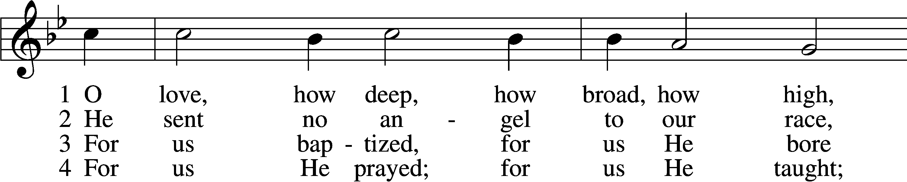

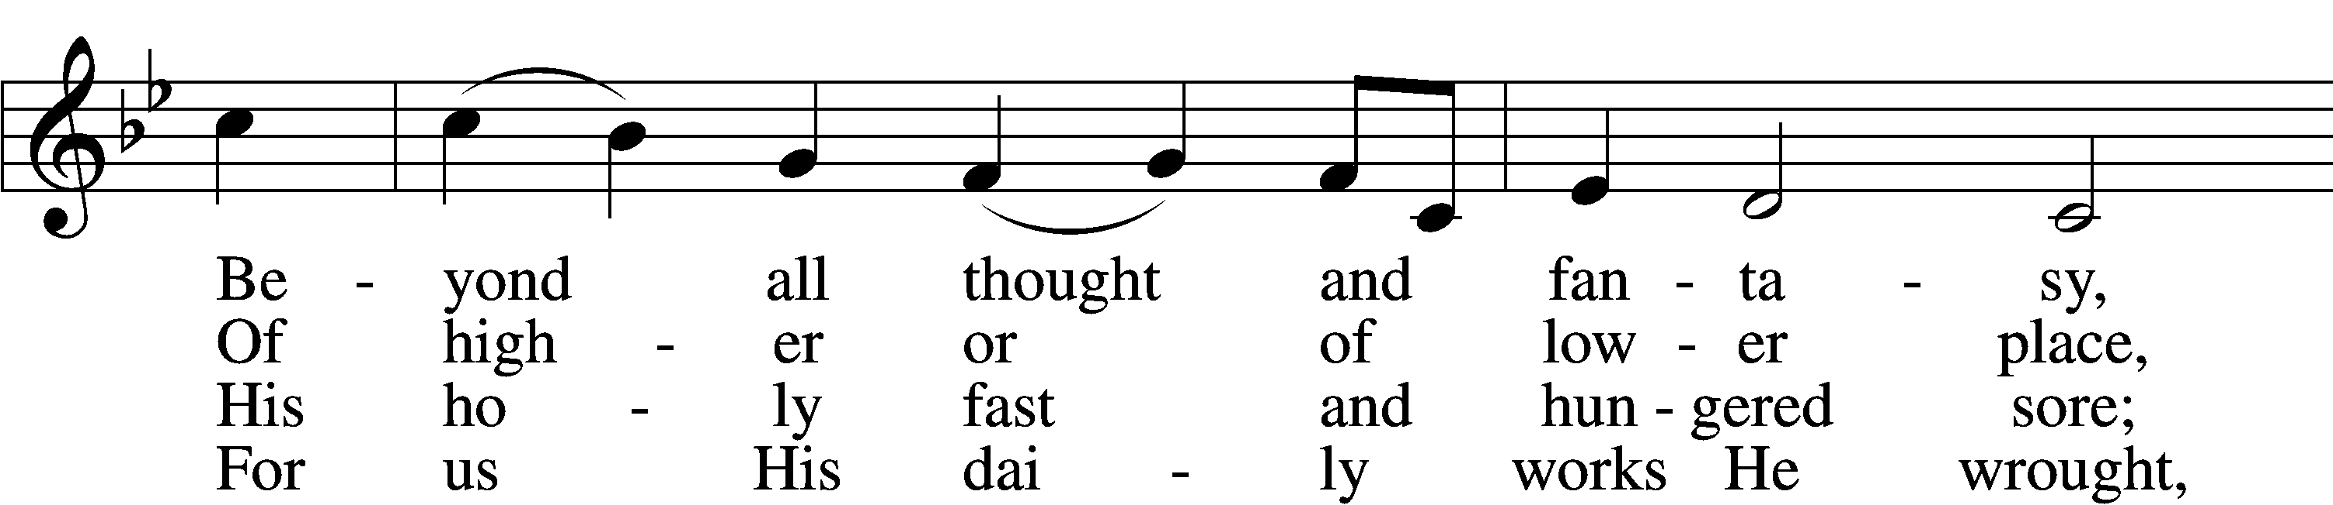

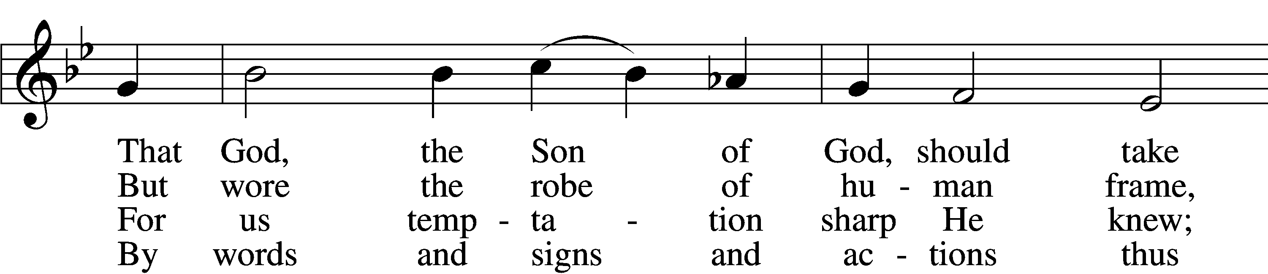

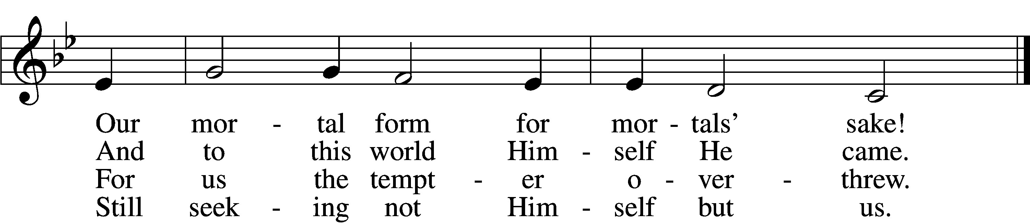

5 For us by wickedness betrayed,  
For us, in crown of thorns arrayed,  
He bore the shameful cross and death;  
For us He gave His dying breath.

6 For us He rose from death again;  
For us He went on high to reign;  
For us He sent His Spirit here  
To guide, to strengthen, and to cheer.

D 7 All glory to our Lord and God  
For love so deep, so high, so broad;  
The Trinity whom we adore  
Forever and forevermore.

Text: attr. Thomas à Kempis, 1380–1471; tr. Benjamin Webb, 1819–85, alt.  
Tune: English, 15th cent.  
Text: Public domain

*Offering*

Stand

*Prayer*

L In peace let us pray to the Lord:

C **Lord, have mercy.**

L For the gift of divine peace and of pardon, with all our heart and with all our mind, let us pray to the Lord:

C **Lord, have mercy.**

L For the holy Christian Church, here and scattered throughout the world, and for the proclamation of the Gospel and the calling of all to faith, let us pray to the Lord:

C **Lord, have mercy.**

L For this nation, for our cities and communities, and for the common welfare of us all, let us pray to the Lord:

C **Lord, have mercy.**

L For seasonable weather and for the fruitfulness of the earth, let us pray to the Lord:

C **Lord, have mercy.**

L For those who labor, for those whose work is difficult or dangerous, and for all who travel, let us pray to the Lord:

C **Lord, have mercy.**

L For all those in need, for the hungry and homeless, for the widowed and orphaned, and for all those in prison, let us pray to the Lord:

C **Lord, have mercy.**

L For the sick and dying and for all those who care for them, let us pray to the Lord:

C **Lord, have mercy.**

L Finally, for these and for all our needs of body and soul, let us pray to the Lord:

C **Lord, have mercy. Christ, have mercy. Lord, have mercy.**

*Collect of the Day*

L Almighty God, our heavenly Father, Your mercies are new every morning; and though we deserve only punishment, You receive us as Your children and provide for all our needs of body and soul. Grant that we may heartily acknowledge Your merciful goodness, give thanks for all Your benefits, and serve You in willing obedience; through Jesus Christ, Your Son, our Lord, who lives and reigns with You and the Holy Spirit, one God, now and forever.

C **Amen.**

*Collect for the Word*

L Blessed Lord, You have caused all Holy Scriptures to be written for our learning. Grant that we may so hear them, read, mark, learn, and take them to heart that, by the patience and comfort of Your holy Word, we may embrace and ever hold fast the blessed hope of everlasting life; through Jesus Christ, Your Son, our Lord, who lives and reigns with You and the Holy Spirit, one God, now and forever.

C **Amen.**

*Evening Prayer*

C **I thank You, my heavenly Father, through Jesus Christ, Your dear Son, that You have graciously kept me this day; and I pray that You would forgive me all my sins where I have done wrong, and graciously keep me this night. For into Your hands I commend myself, my body and soul, and all things. Let Your holy angel be with me, that the evil foe may have no power over me. Amen.**

*Hymn “Lamb of God”* # 550

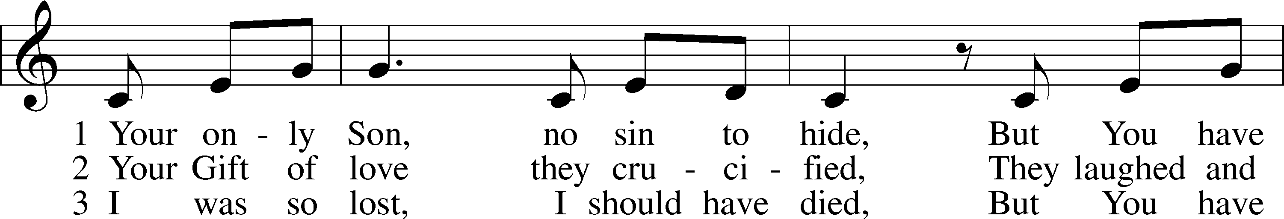

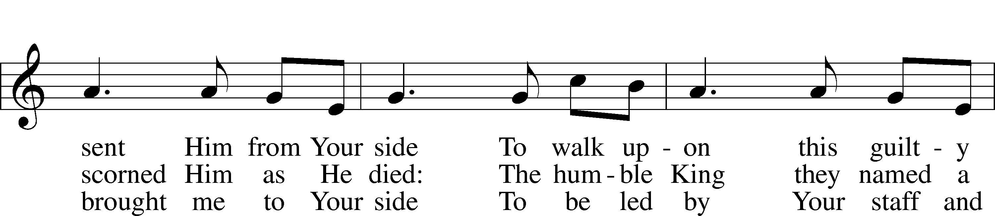

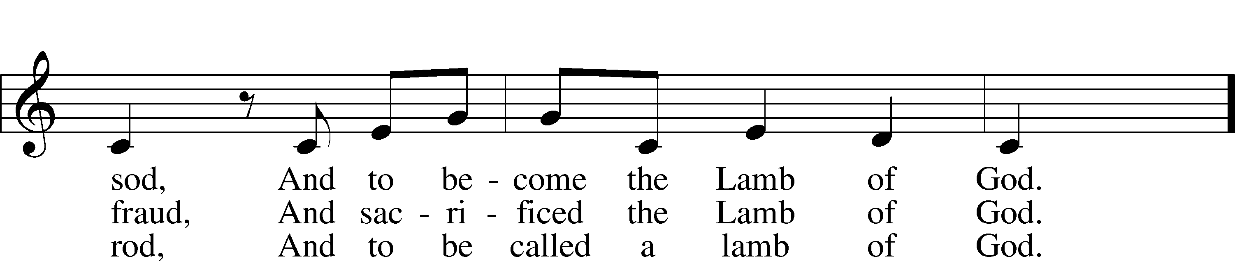

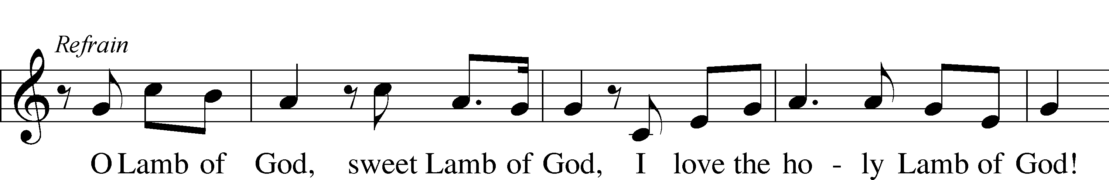

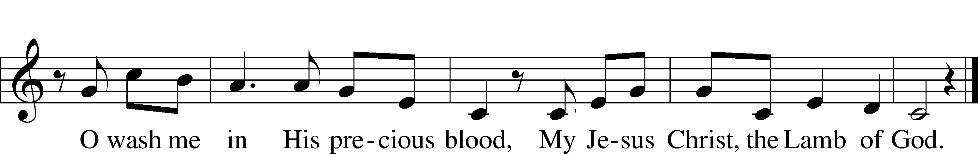

Text and tune: Twila Paris, 1958  
Text and tune: © 1985 Straightway Music, admin. EMI. Used by permission: LSB Hymn License no. 110003344

*Blessing*

L Let us bless the Lord.

C **Thanks be to God.**

L The almighty and merciful Lord, the Father, the T Son, and the Holy Spirit, bless and preserve us.

C **Amen.**

*Hymn* *“Stay with Us”* # 879

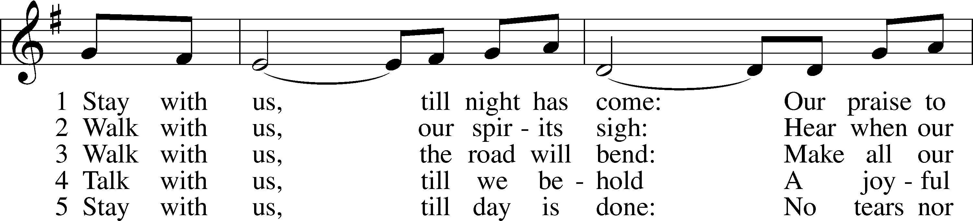

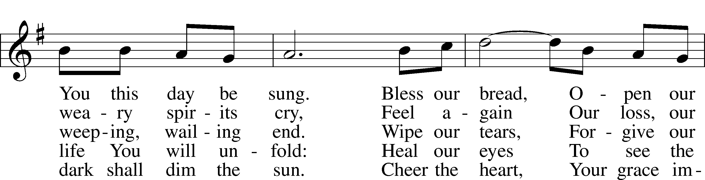

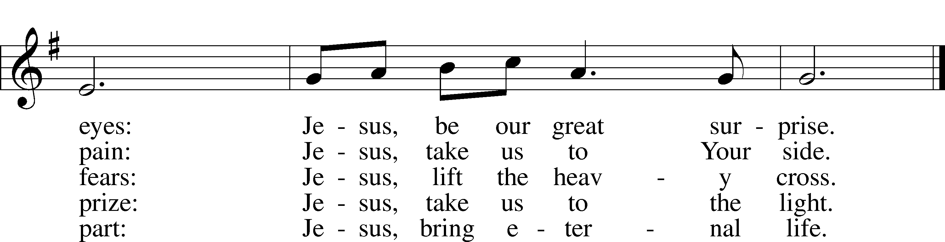

Text: Herbert F. Brokering, 1926–2009  
Tune: Walter L. Pelz, 1926  
Text and tune: © 1990 Concordia Publishing House. Used by permission: LSB Hymn License no. 110003344

Acknowledgments

Service of Prayer and Preaching from Lutheran Service Book

Unless otherwise indicated, Scripture quotations are from the ESV® Bible (The Holy Bible, English Standard Version®), copyright © 2001 by Crossway, a publishing ministry of Good News Publishers. Used by permission. All rights reserved.

Created by Lutheran Service Builder © 2024 Concordia Publishing House.

Lenten Theme

+++

You Meant it for Evil,

But God Meant it for Good

2/14 Ash Wednesday

Pastor Roeglin

Blessed Savior Lutheran

2/21 Faith for a Complicated World

Pastor Ruback

Grace Chapel Lutheran

2/28 That Day, and Today

Pastor Roeglin – Blessed Savior Lutheran Church

3/06 He was Numbered Among the Transgressors

Pastor Glenn

Chapel of the Cross

3/13 The Real Battle

Pastor Dressler

Salem Lutheran Church

3/20 When you See such Blind Ignorance, What do you

Think?

Rev. Briggs –Lutheran Senior Services

Acknowledgments

Service of Prayer and Preaching from Lutheran Service Book

Unless otherwise indicated, Scripture quotations are from the ESV® Bible (The Holy Bible, English Standard Version®), copyright © 2001 by Crossway, a publishing ministry of Good News Publishers. Used by permission. All rights reserved.

Created by Lutheran Service Builder © 2024 Concordia Publishing House.