Opening Hymn “By Grace I’m Saved” # 566
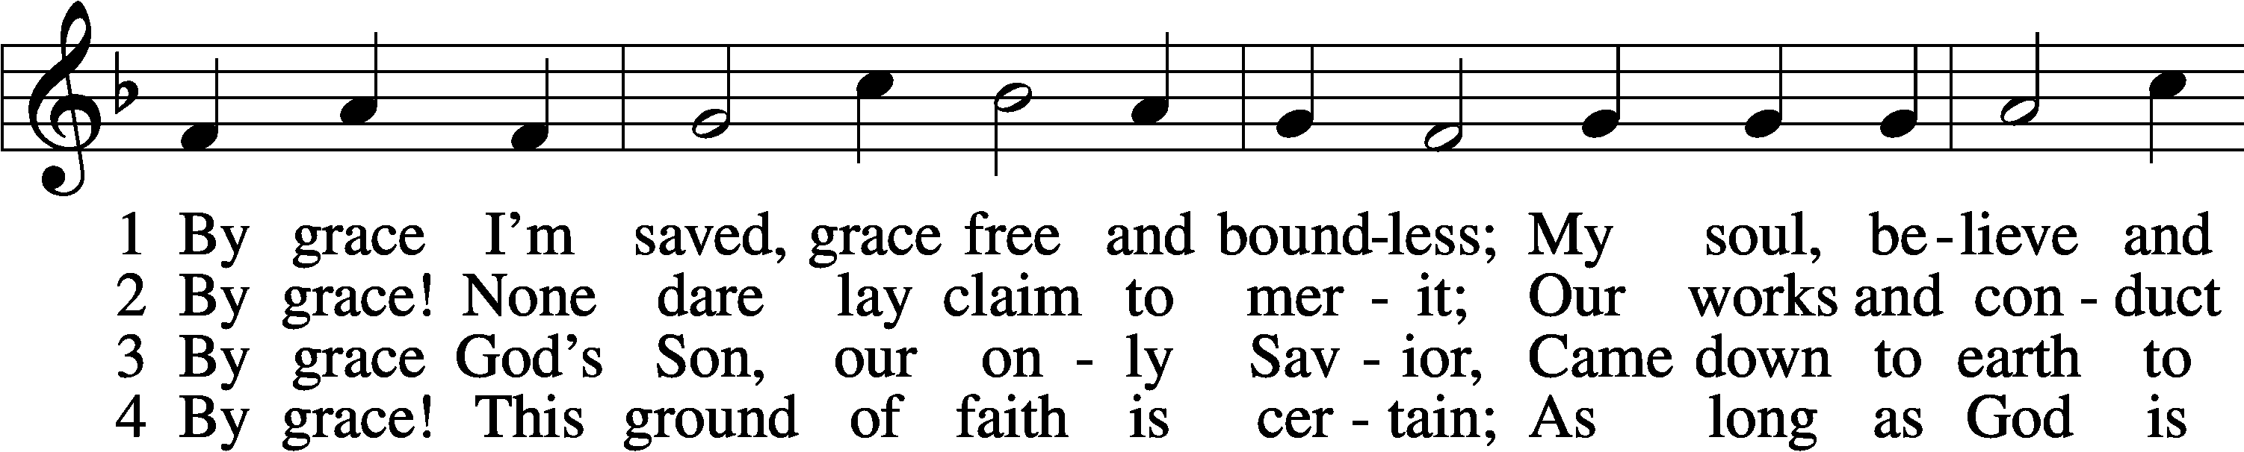
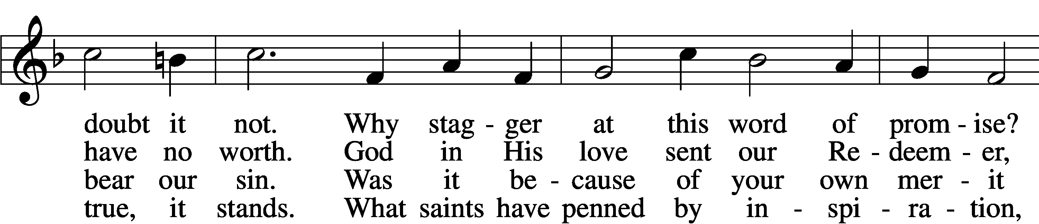
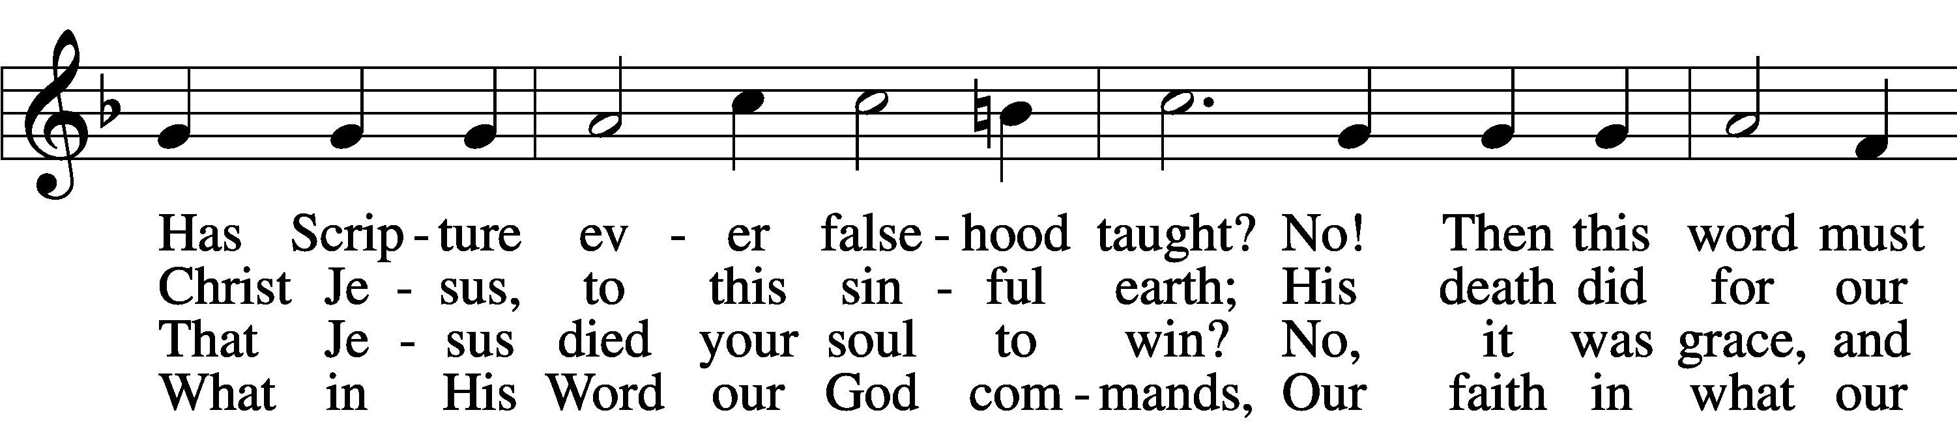
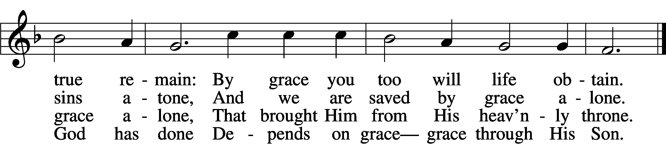

5 By grace to timid hearts that tremble,
In tribulation’s furnace tried,
By grace, in spite of fear and trouble,
The Father’s heart is open wide.
Where could I help and strength secure
If grace were not my anchor sure?

6 By grace! On this I’ll rest when dying;
In Jesus’ promise I rejoice;
For though I know my heart’s condition,
I also know my Savior’s voice.
My heart is glad, all grief has flown
Since I am saved by grace alone.
Text: Christian Ludwig Scheidt, 1709–61; tr. The Lutheran Hymnal, 1941, alt.
Tune: Cornelius Heinrich Dretzel, 1697–1775
Text and tune: Public domain

Sermon Hymn “God Loved the World So That He Gave” # 571
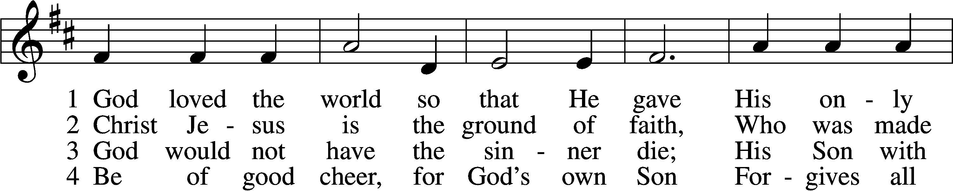
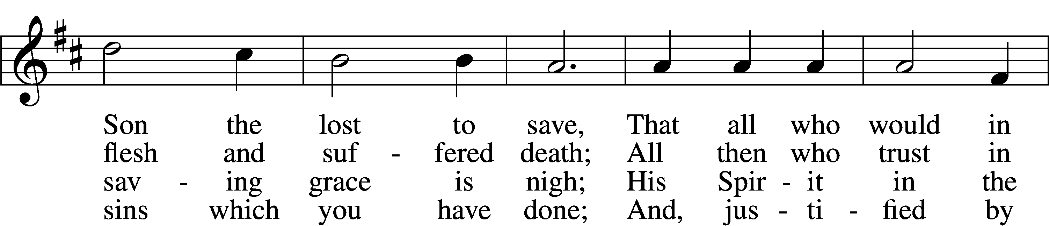
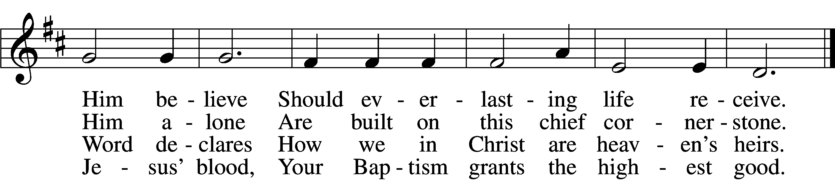

5 If you are sick, if death is near,
This truth your troubled heart can cheer:
Christ Jesus saves your soul from death;
That is the firmest ground of faith.

D 6 Glory to God the Father, Son,
And Holy Spirit, Three in One!
To You, O blessèd Trinity,
Be praise now and eternally!
Text: Heiliges Lippen- und Hertzens-Opffer, c. 1778, Stettin; tr. August Crull, 1845–1923, alt.
Tune: George J. Elvey, 1816–93
Text and tune: Public domain

Closing Hymn “My Faith Looks Up to Thee” # 702
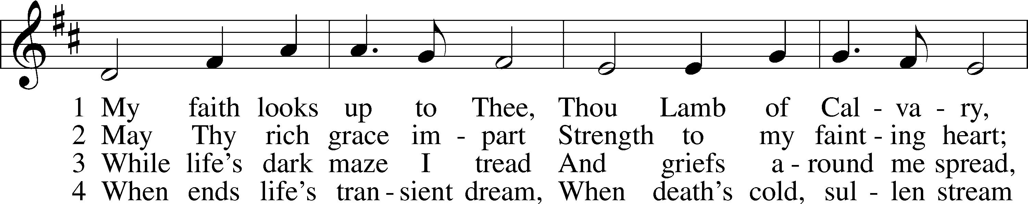
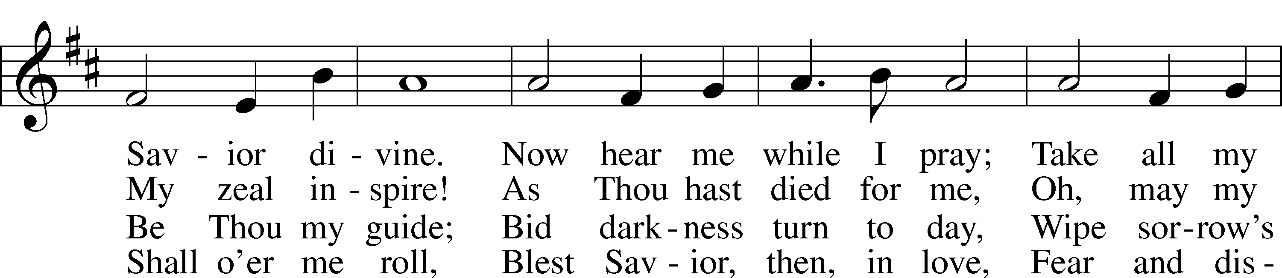
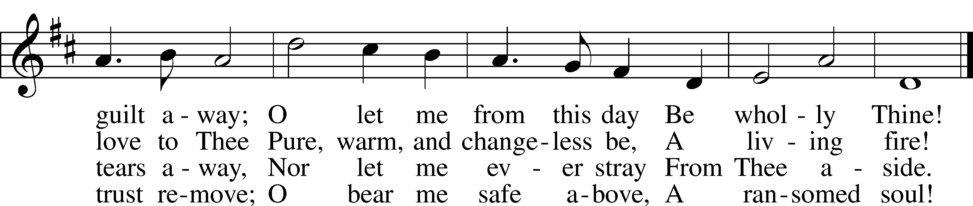
Text: Ray Palmer, 1808–87
Tune: Lowell Mason, 1792–1872
Text and tune: Public domain

