### Blessed Savior Lutheran Church

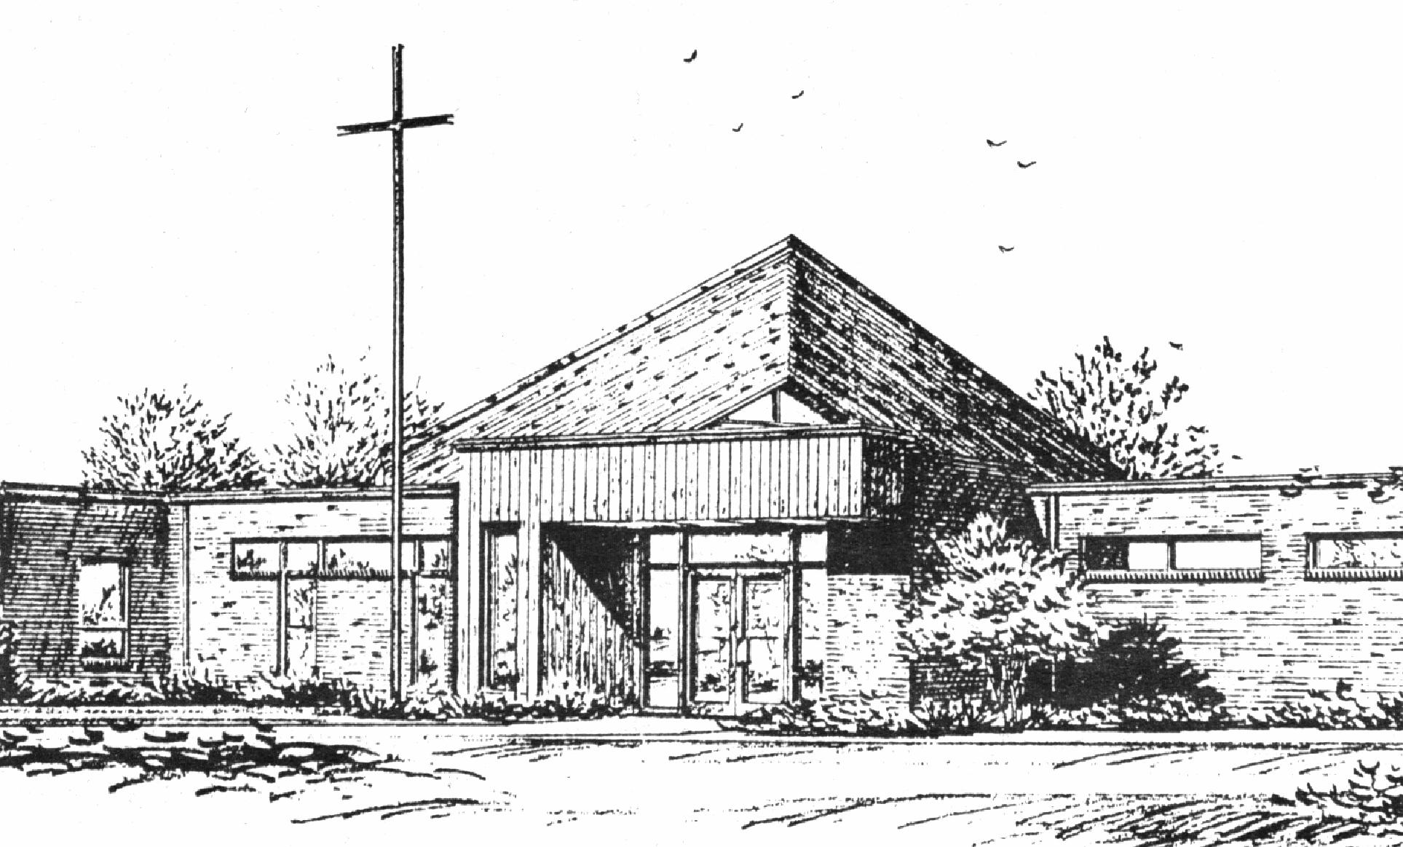

*“Empowered by God’s Holy Word,*

*we joyfully share the love of Jesus with all people;*

*through worship, teaching, fellowship,*

*service and witnessing.”*

**You Meant it for Evil,**

**But God Meant it for Good**

**March 13, 2024**

The Real Battle

***(Luke 22:39-62)***



Lutheran Church Missouri Synod

Rev. Matthew Roeglin, Pastor 314-479-1470

pastor@blessedsavior-lcms.org

Church Office: 7:30 AM – 11:30 AM Monday-Friday 314-831-1300

2615 Shackelford Rd. Florissant, MO Fax 314-831-3444

Website: www.blessedsavior-lcms.org

Church Email: office@blessedsavior-lcms.org

Divine Services: Sunday 9:30 AM; Wednesday 6:30 PM

**WE WELCOME YOU** to our worship service this evening. We pray God’s rich blessings upon you as you hear His Word and praise His holy name. We ask our members and visitors to please use the friendship pad found on the pew. Kindly hand the friendship pad to the person sitting next to you. The Ushers will collect them after the service. Thank You.

**THIS WORSHIP FOLDER / CHURCH BULLETIN** is prepared for your convenience and contains the entire order of worship with all spoken and sung responses. However, if you are more comfortable using the hymnal, you may use the order of worship found in the front pages of Lutheran Service Book where all the melodies are shown for the sung responses of the congregation.

**INDIVIDUAL HEARING ASSISTANCE SETS** are available for those with impaired hearing. Please ask an usher for assistance.

**LARGE PRINT BULLETINS** are available in the narthex.

**THANK YOU FOR YOUR SERVICE**

Preacher: Pastor Dressler – Salem Lutheran Church

Organist/Pianist: Mrs. Donna Boyd

*(Please silence your cell phones)*

Service of Prayer and Preaching *p.260*

*Opening Hymn*

*“Jesus, Grant That Balm and Healing”*  *#421*

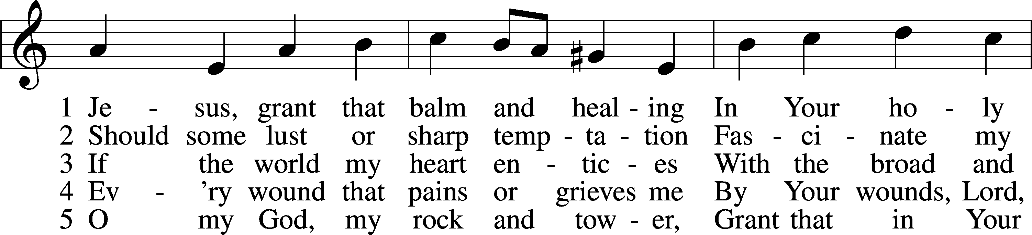

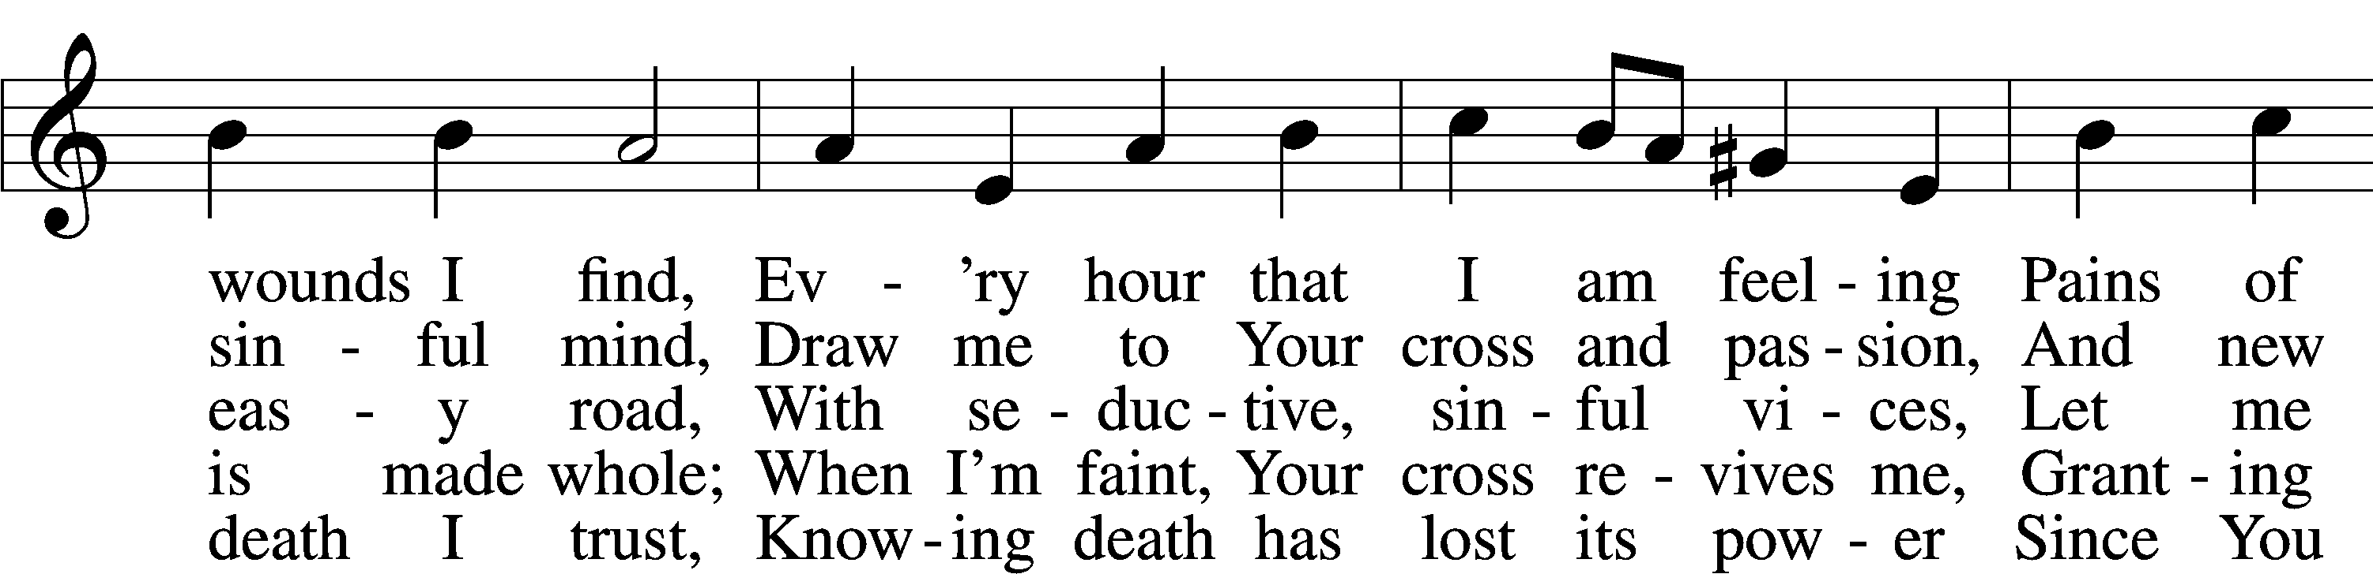

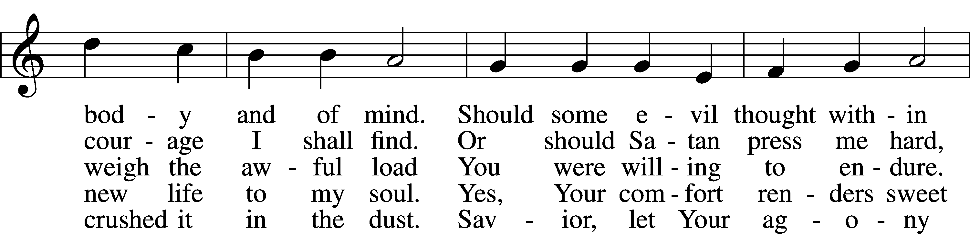

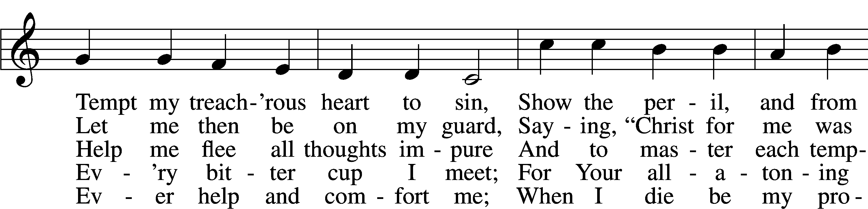

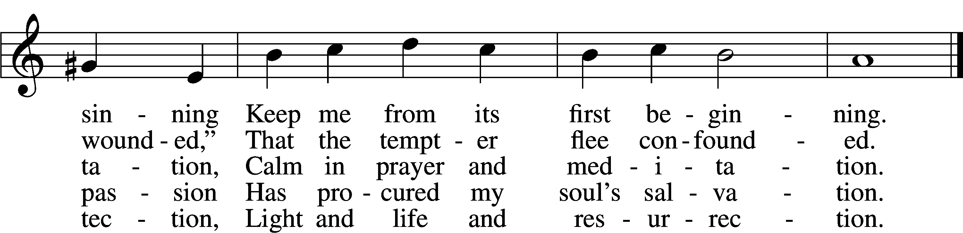

Text: Johann Heermann, 1585–1647; tr. composite, alt.  
Tune: Johann Balthasar König, 1691–1758  
Text and tune: Public domain

Stand

*Opening Versicles*

L This is the day which the Lord has made;

C **let us rejoice and be glad in it.**

L From the rising of the sun to its setting,

C **the name of the Lord is to be praised.**

L Return to the Lord, your God, for He is gracious and merciful,

C **slow to anger, and abounding in steadfast love, and repents of evil.**

L Jesus said: If any man would come after Me,

C **let him deny himself and take up his cross and follow Me.**

L Christ was wounded for our transgressions.

C **He was bruised for our iniquities.**

L From the rising of the sun to its setting,

C **the name of the Lord is to be praised.**

C **Glory be to the Father and to the Son and to the Holy Spirit;**  
**as it was in the beginning, is now, and will be forever. Amen.**

*Hymn*

*“Oh, for a Thousand Tongues to Sing”* # 528 sts. 1–2, 6–7

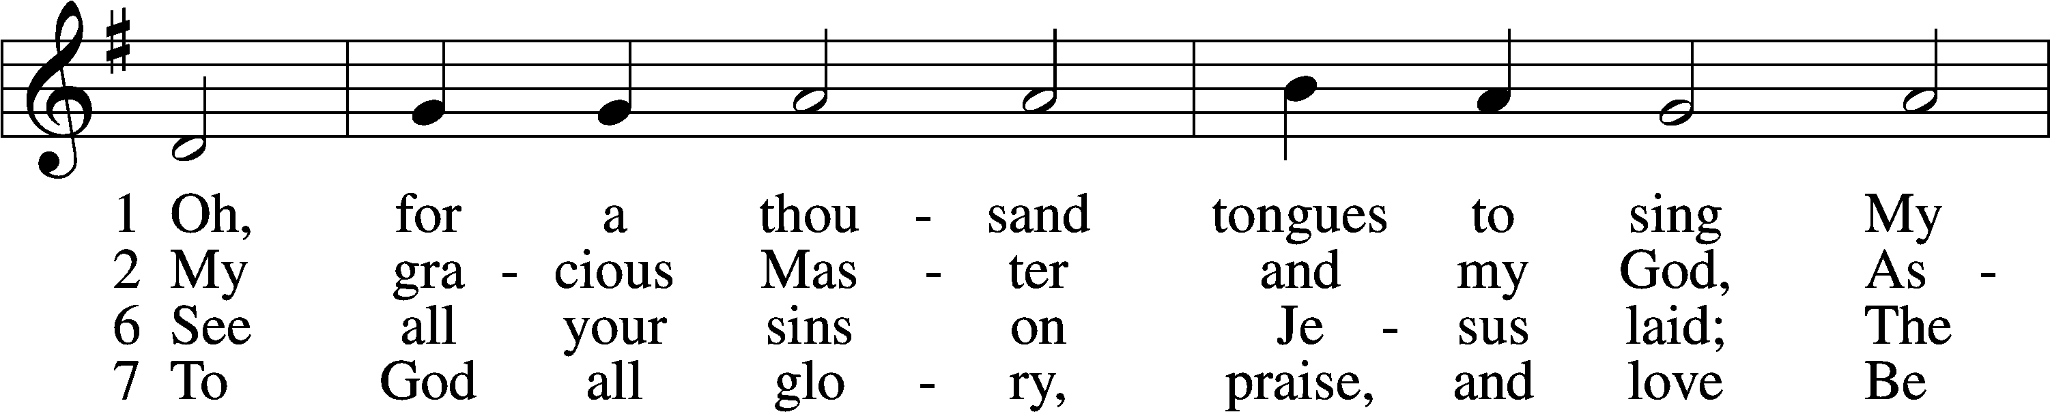

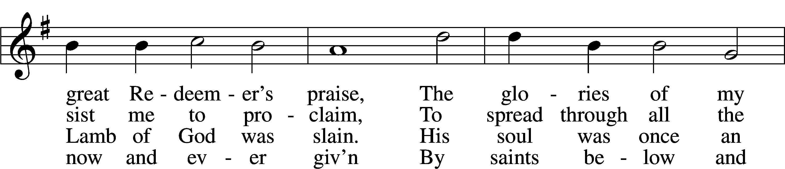

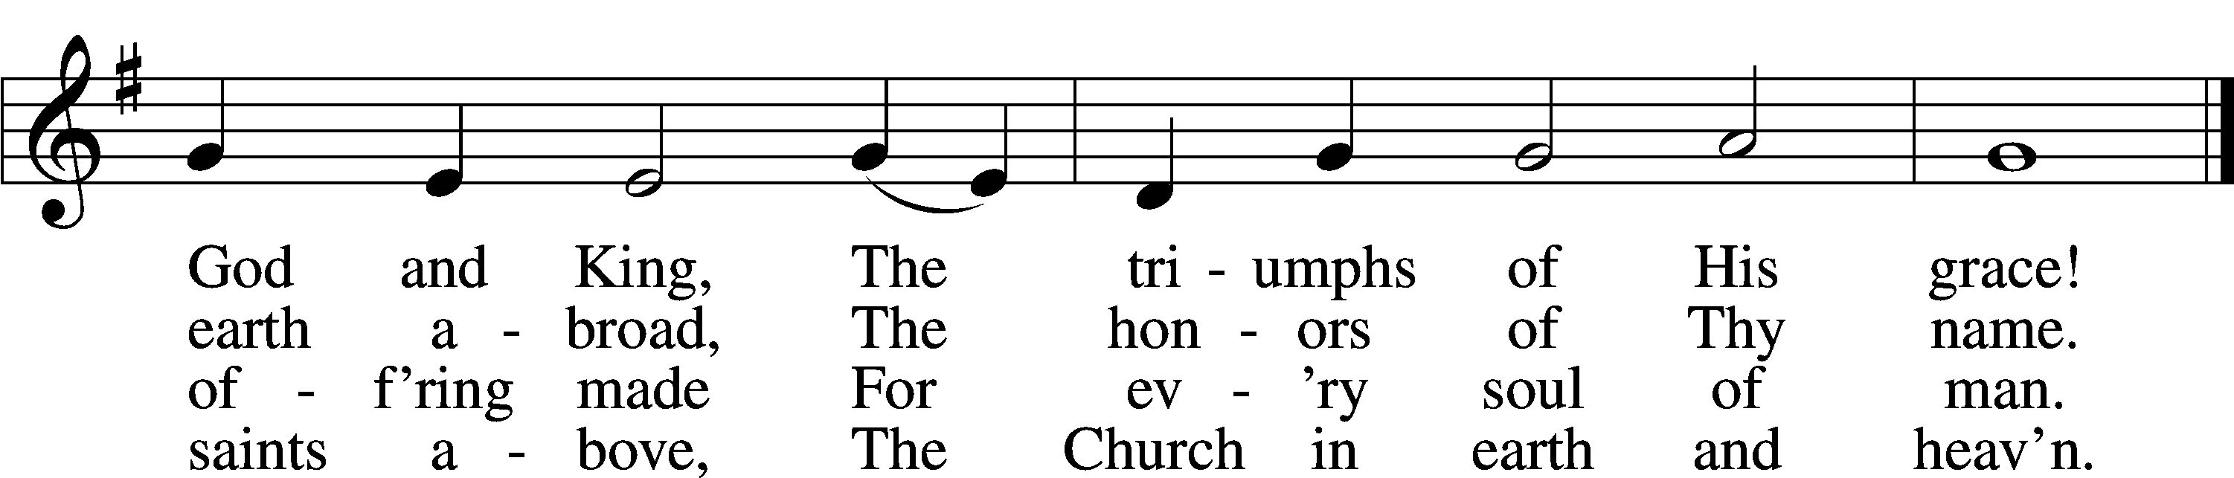

Text: Charles Wesley, 1707–88, alt.  
Tune: Carl G. Gläser, 1784–1829  
Text and tune: Public domain

Sit

Readings From Holy Scripture

*Reading* Genesis 3:1–7

L A reading from Genesis, the third chapter.

1Now the serpent was more crafty than any other beast of the field that the Lord God had made.

He said to the woman, “Did God actually say, ‘You shall not eat of any tree in the garden’?” 2And the woman said to the serpent, “We may eat of the fruit of the trees in the garden, 3but God said, ‘You shall not eat of the fruit of the tree that is in the midst of the garden, neither shall you touch it, lest you die.’” 4But the serpent said to the woman, “You will not surely die. 5For God knows that when you eat of it your eyes will be opened, and you will be like God, knowing good and evil.” 6So when the woman saw that the tree was good for food, and that it was a delight to the eyes, and that the tree was to be desired to make one wise, she took of its fruit and ate, and she also gave some to her husband who was with her, and he ate. 7Then the eyes of both were opened, and they knew that they were naked. And they sewed fig leaves together and made themselves loincloths.

L This is the Word of the Lord.

C **Thanks be to God.**

*Reading* 1 Peter 5:6–11

6Humble yourselves, therefore, under the mighty hand of God so that at the proper time he may exalt you, 7casting all your anxieties on him, because he cares for you. 8Be sober-minded; be watchful. Your adversary the devil prowls around like a roaring lion, seeking someone to devour. 9Resist him, firm in your faith, knowing that the same kinds of suffering are being experienced by your brotherhood throughout the world. 10And after you have suffered a little while, the God of all grace, who has called you to his eternal glory in Christ, will himself restore, confirm, strengthen, and establish you. 11To him be the dominion forever and ever. Amen.

A This is the Word of the Lord.

C **Thanks be to God.**

Stand

*Reading* Luke 22:39–62

39And he came out and went, as was his custom, to the Mount of Olives, and the disciples followed him. 40And when he came to the place, he said to them, “Pray that you may not enter into temptation.” 41And he withdrew from them about a stone’s throw, and knelt down and prayed, 42saying, “Father, if you are willing, remove this cup from me. Nevertheless, not my will, but yours, be done.” 43And there appeared to him an angel from heaven, strengthening him. 44And being in an agony he prayed more earnestly; and his sweat became like great drops of blood falling down to the ground. 45And when he rose from prayer, he came to the disciples and found them sleeping for sorrow, 46and he said to them, “Why are you sleeping? Rise and pray that you may not enter into temptation.”

47While he was still speaking, there came a crowd, and the man called Judas, one of the twelve, was leading them. He drew near to Jesus to kiss him, 48but Jesus said to him, “Judas, would you betray the Son of Man with a kiss?” 49And when those who were around him saw what would follow, they said, “Lord, shall we strike with the sword?” 50And one of them struck the servant of the high priest and cut off his right ear. 51But Jesus said, “No more of this!” And he touched his ear and healed him. 52Then Jesus said to the chief priests and officers of the temple and elders, who had come out against him, “Have you come out as against a robber, with swords and clubs? 53When I was with you day after day in the temple, you did not lay hands on me. But this is your hour, and the power of darkness.”

54Then they seized him and led him away, bringing him into the high priest’s house, and Peter was following at a distance. 55And when they had kindled a fire in the middle of the courtyard and sat down together, Peter sat down among them. 56Then a servant girl, seeing him as he sat in the light and looking closely at him, said, “This man also was with him.” 57But he denied it, saying, “Woman, I do not know him.” 58And a little later someone else saw him and said, “You also are one of them.” But Peter said, “Man, I am not.” 59And after an interval of about an hour still another insisted, saying, “Certainly this man also was with him, for he too is a Galilean.” 60But Peter said, “Man, I do not know what you are talking about.” And immediately, while he was still speaking, the rooster crowed. 61And the Lord turned and looked at Peter. And Peter remembered the saying of the Lord, how he had said to him, “Before the rooster crows today, you will deny me three times.” 62And he went out and wept bitterly.

A This is the Word of the Lord.

C **Thanks be to God.**

*Responsory p.263*

L We have an advocate with the Father; Jesus Christ, the Righteous One.

C **He was delivered up to death; He was delivered for the sins of the people.**

L Blessed is the one whose transgression is forgiven, whose sin is covered.

C **He was delivered up to death; He was delivered for the sins of the people.**

L We have an advocate with the Father; Jesus Christ, the Righteous One.

C **He was delivered up to death; He was delivered for the sins of the people.**

Catechism *p.264*

*Ten Commandments*

C **You shall have no other gods.**

**You shall not misuse the name of the Lord your God.**

**Remember the Sabbath day by keeping it holy.**

**Honor your father and your mother.**

**You shall not murder.**

**You shall not commit adultery.**

**You shall not steal.**

**You shall not give false testimony against your neighbor.**

**You shall not covet your neighbor’s house.**

**You shall not covet your neighbor’s wife, or his manservant or maidservant, his ox or donkey, or anything that belongs to your neighbor.**

*Apostles’ Creed*

C **I believe in God, the Father Almighty,**

**maker of heaven and earth.**

**And in Jesus Christ, His only Son, our Lord,**

**who was conceived by the Holy Spirit,**

**born of the virgin Mary,**

**suffered under Pontius Pilate,**

**was crucified, died and was buried.**

**He descended into hell.**

**The third day He rose again from the dead.**

**He ascended into heaven**

**and sits at the right hand of God the Father Almighty.**

**From thence He will come to judge the living and the dead.**

**I believe in the Holy Spirit,**

**the holy Christian Church,**

**the communion of saints,**

**the forgiveness of sins,**

**the resurrection of the body,**

**and the life** T **everlasting. Amen.**

*Lord’s Prayer*

C **Our Father who art in heaven,**

**hallowed be Thy name,**

**Thy kingdom come,**

**Thy will be done on earth**

**as it is in heaven;**

**give us this day our daily bread;**

**and forgive us our trespasses**

**as we forgive those**

**who trespass against us;**

**and lead us not into temptation,**

**but deliver us from evil.**

**For Thine is the kingdom**

**and the power and the glory**

**forever and ever. Amen.**

Sit

*Sermon*

*Hymn* *“I Walk in Danger All the Way”* # 716

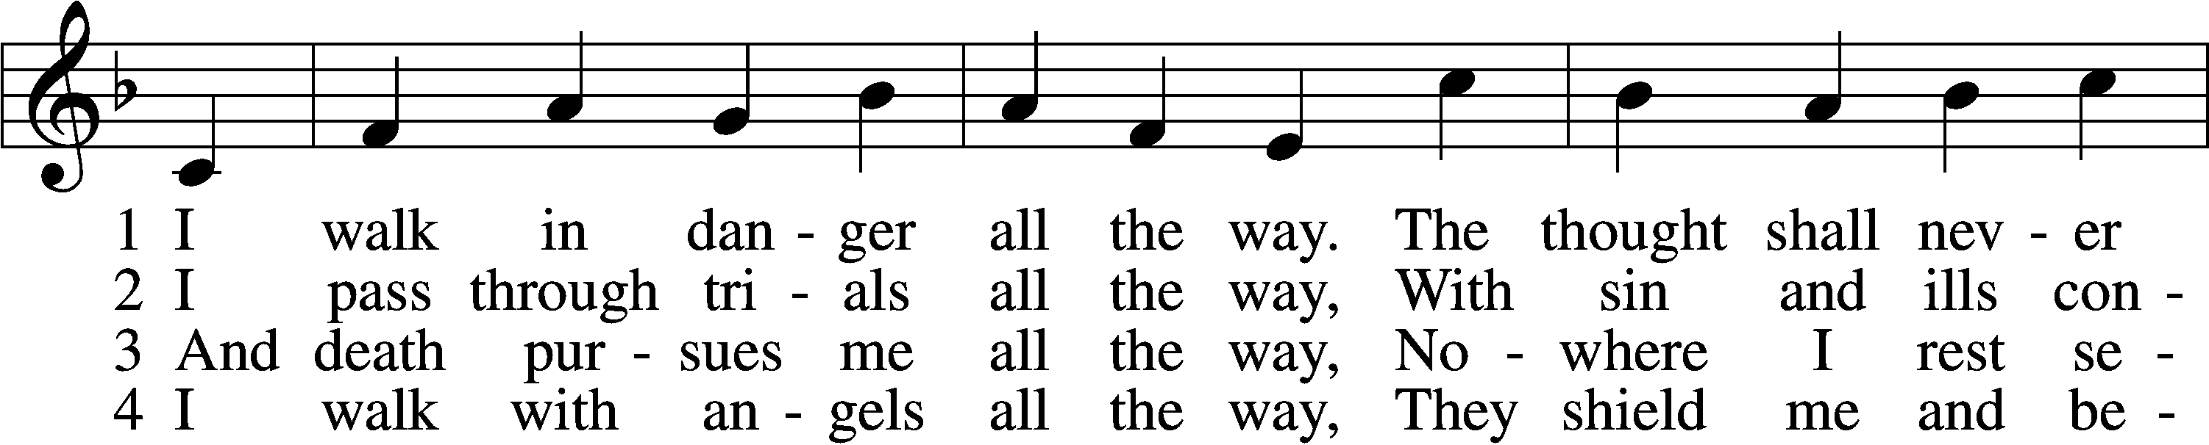

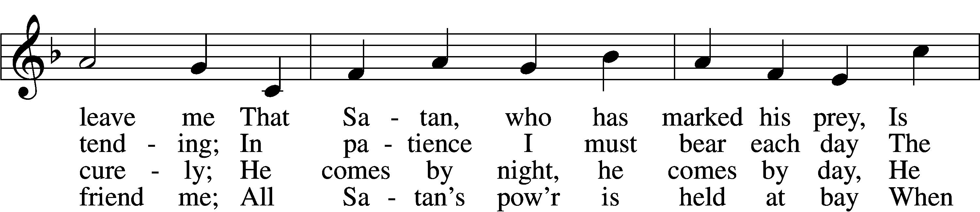

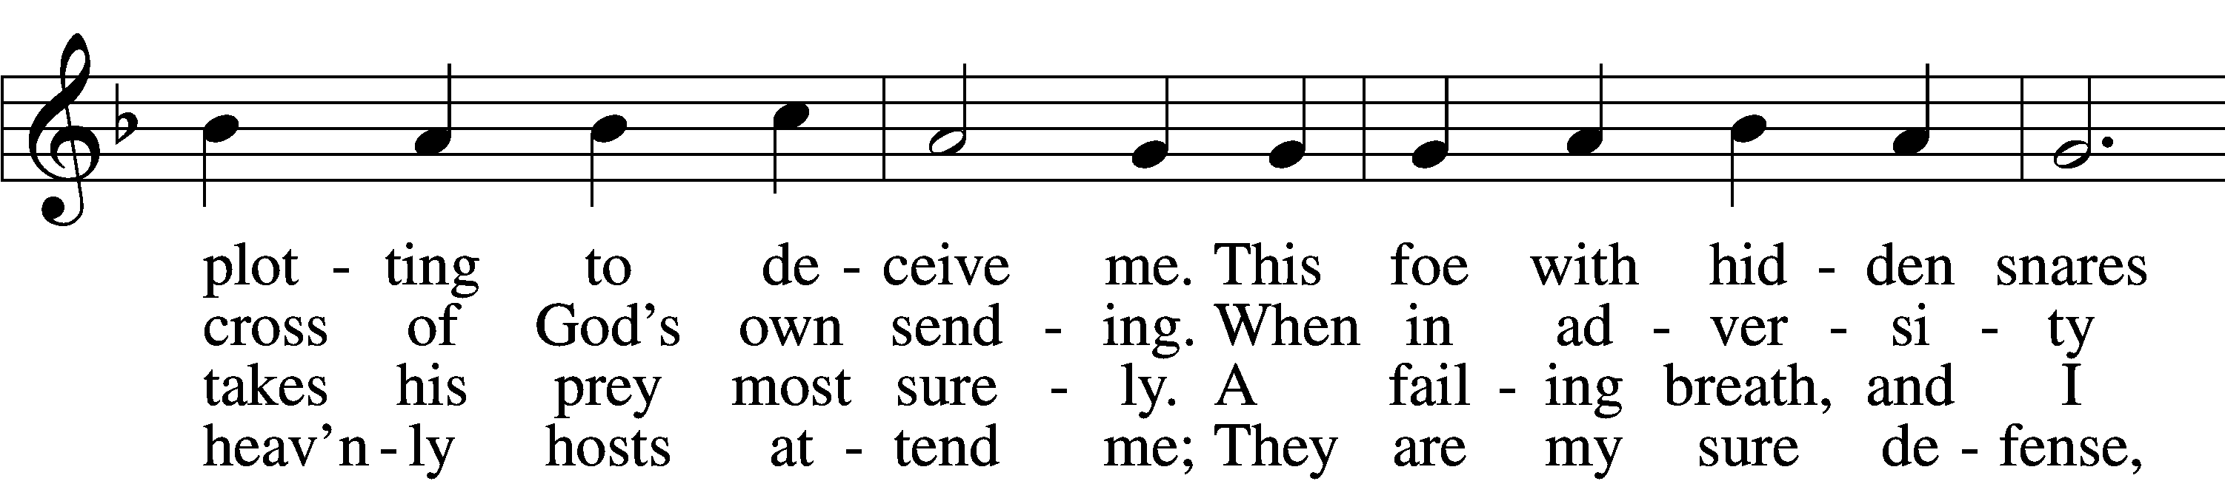

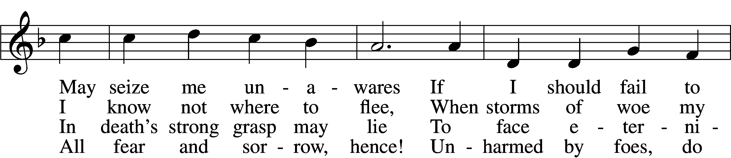

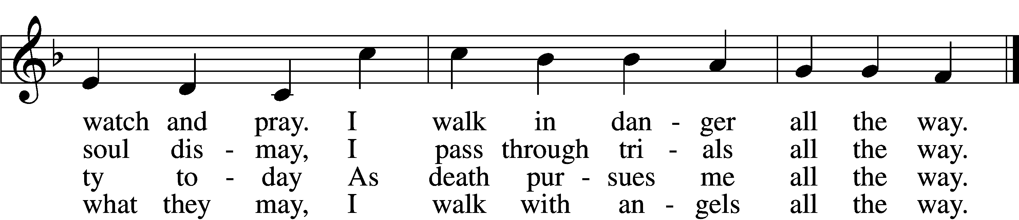

5 I walk with Jesus all the way,  
 His guidance never fails me;  
Within His wounds I find a stay  
 When Satan’s pow’r assails me;  
And by His footsteps led,  
My path I safely tread.  
 No evil leads my soul astray;  
 I walk with Jesus all the way.

6 My walk is heav’nward all the way;  
 Await, my soul, the morrow,  
When God’s good healing shall allay  
 All suff’ring, sin, and sorrow.  
Then, worldly pomp, begone!  
To heav’n I now press on.  
 For all the world I would not stay;  
 My walk is heav’nward all the way.

Text: Hans Adolf Brorson, 1694–1764; tr. Ditlef G. Ristad, 1863–1938, alt.  
Tune: Geist-reiches Gesang-Buch, 1708, 4th ed., Halle, ed. Johann A. Freylinghausen  
Text and tune: Public domain

*Offering*

Stand

*Prayer p.265*

L In peace let us pray to the Lord:

C **Lord, have mercy.**

L For the gift of divine peace and of pardon, with all our heart and with all our mind, let us pray to the Lord:

C **Lord, have mercy.**

L For the holy Christian Church, here and scattered throughout the world, and for the proclamation of the Gospel and the calling of all to faith, let us pray to the Lord:

C **Lord, have mercy.**

L For this nation, for our cities and communities, and for the common welfare of us all, let us pray to the Lord:

C **Lord, have mercy.**

L For seasonable weather and for the fruitfulness of the earth, let us pray to the Lord:

C **Lord, have mercy.**

L For those who labor, for those whose work is difficult or dangerous, and for all who travel, let us pray to the Lord:

C **Lord, have mercy.**

L For all those in need, for the hungry and homeless, for the widowed and orphaned, and for all those in prison, let us pray to the Lord:

C **Lord, have mercy.**

L For the sick and dying and for all those who care for them, let us pray to the Lord:

C **Lord, have mercy.**

L Finally, for these and for all our needs of body and soul, let us pray to the Lord:

C **Lord, have mercy. Christ, have mercy. Lord, have mercy.**

*Collect of the Day*

L Almighty God, our heavenly Father, Your mercies are new every morning; and though we deserve only punishment, You receive us as Your children and provide for all our needs of body and soul. Grant that we may heartily acknowledge Your merciful goodness, give thanks for all Your benefits, and serve You in willing obedience; through Jesus Christ, Your Son, our Lord, who lives and reigns with You and the Holy Spirit, one God, now and forever.

C **Amen.**

*Collect for the Word*

L Blessed Lord, You have caused all Holy Scriptures to be written for our learning. Grant that we may so hear them, read, mark, learn, and take them to heart that, by the patience and comfort of Your holy Word, we may embrace and ever hold fast the blessed hope of everlasting life; through Jesus Christ, Your Son, our Lord, who lives and reigns with You and the Holy Spirit, one God, now and forever.

C **Amen.**

*Evening Prayer p.266*

C **I thank You, my heavenly Father, through Jesus Christ, Your dear Son, that You have graciously kept me this day; and I pray that You would forgive me all my sins where I have done wrong, and graciously keep me this night. For into Your hands I commend myself, my body and soul, and all things. Let Your holy angel be with me, that the evil foe may have no power over me. Amen.**

*Hymn* *“Lamb of God”* # 550

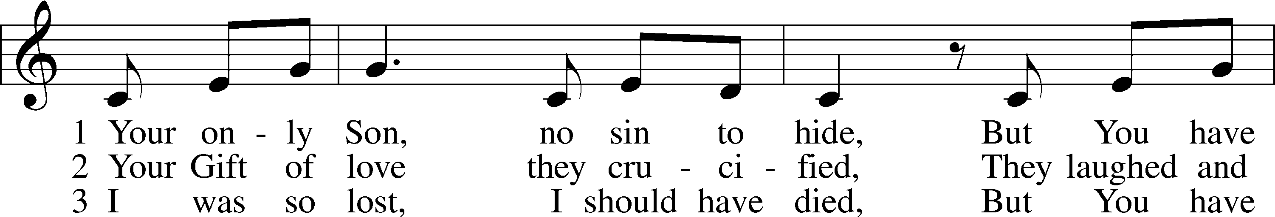

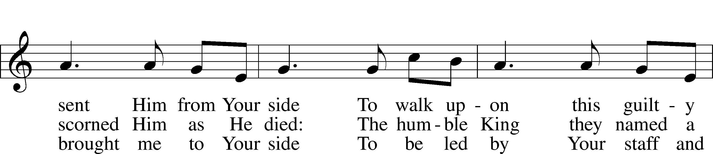

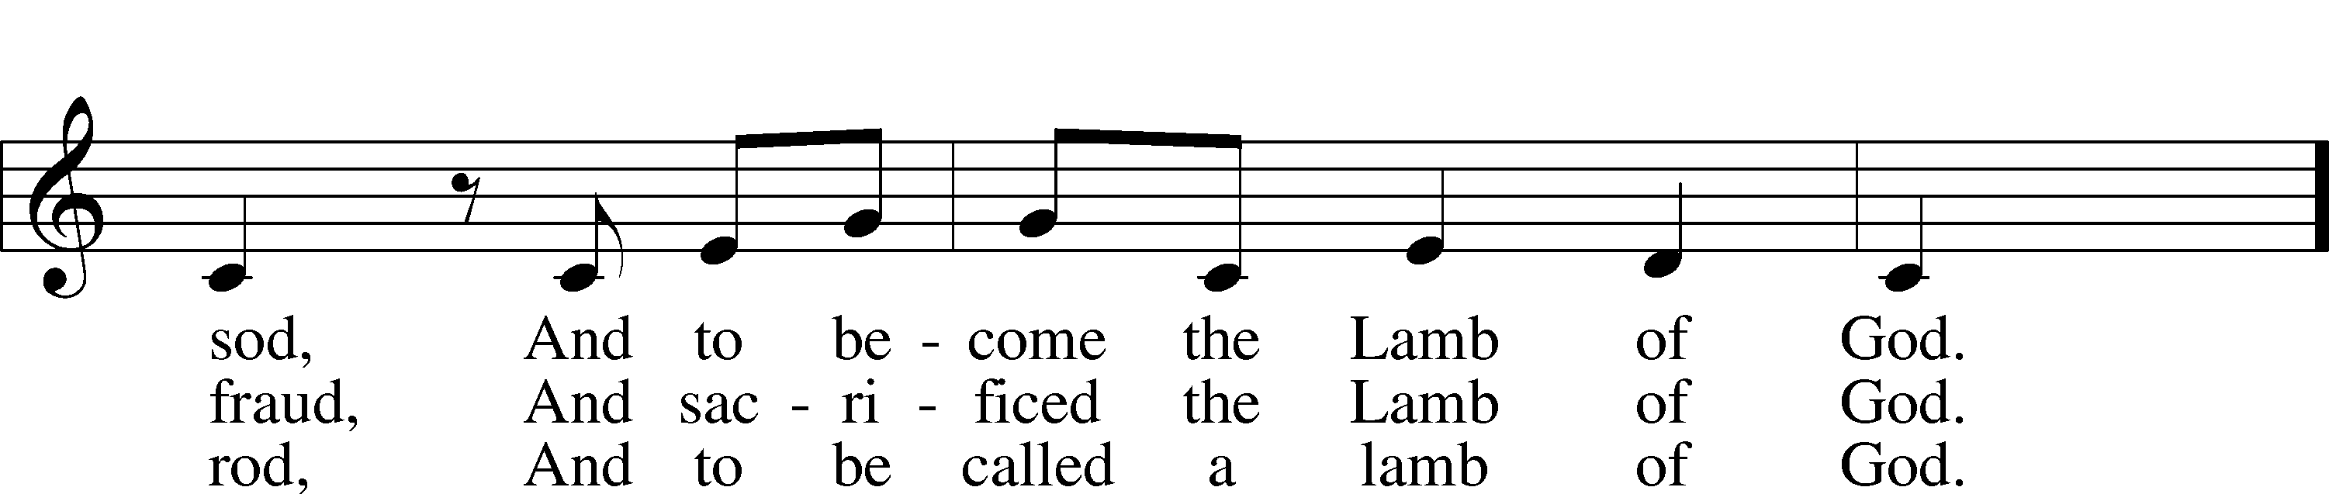

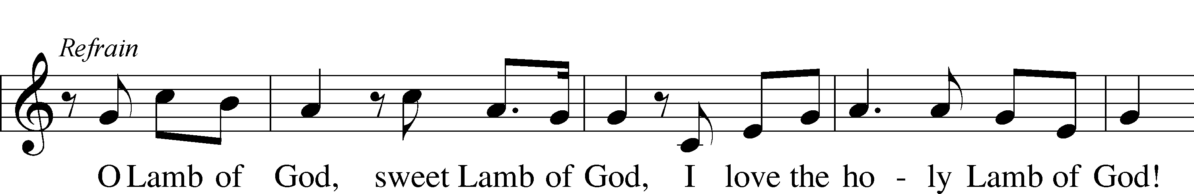

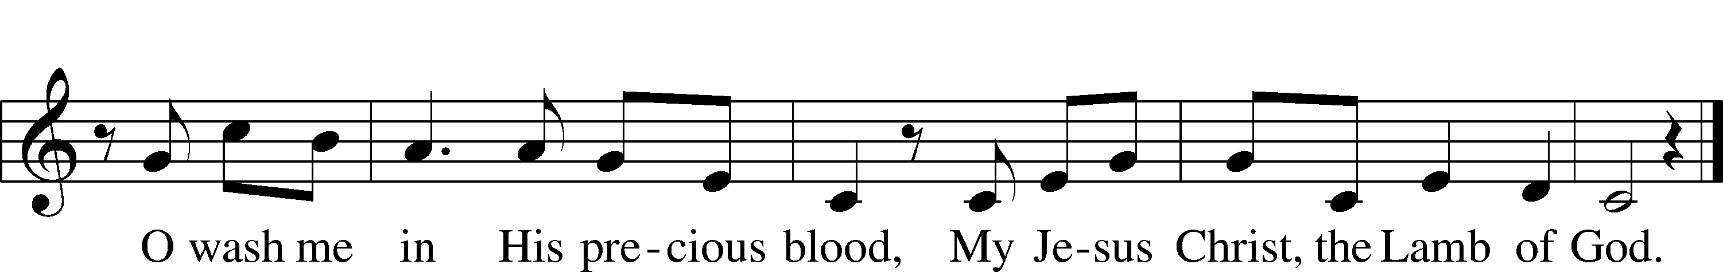

Text and tune: Twila Paris, 1958  
Text and tune: © 1985 Straightway Music, admin. EMI. Used by permission: LSB Hymn License no. 110003344

*Blessing p.267*

L Let us bless the Lord.

C **Thanks be to God.**

L The almighty and merciful Lord, the Father, the T Son, and the Holy Spirit, bless and preserve us.

C **Amen.**

*Hymn* *“Now Rest beneath Night’s Shadow”* # 880

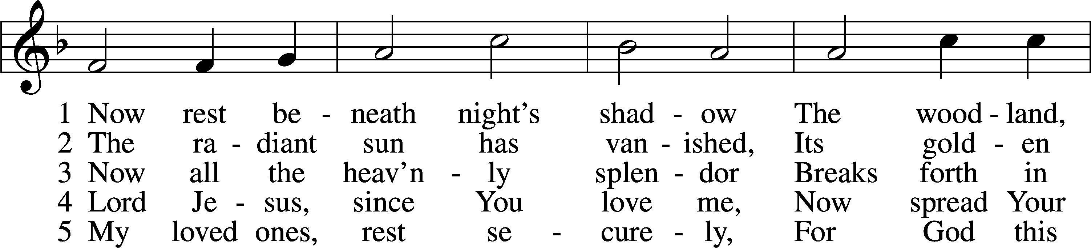

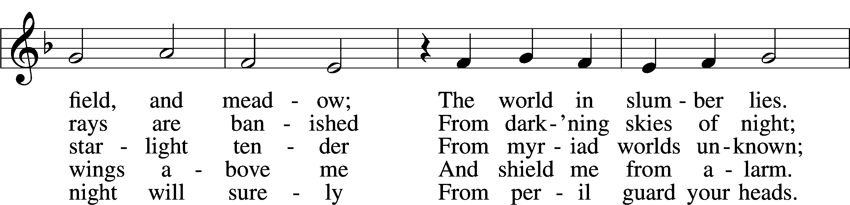

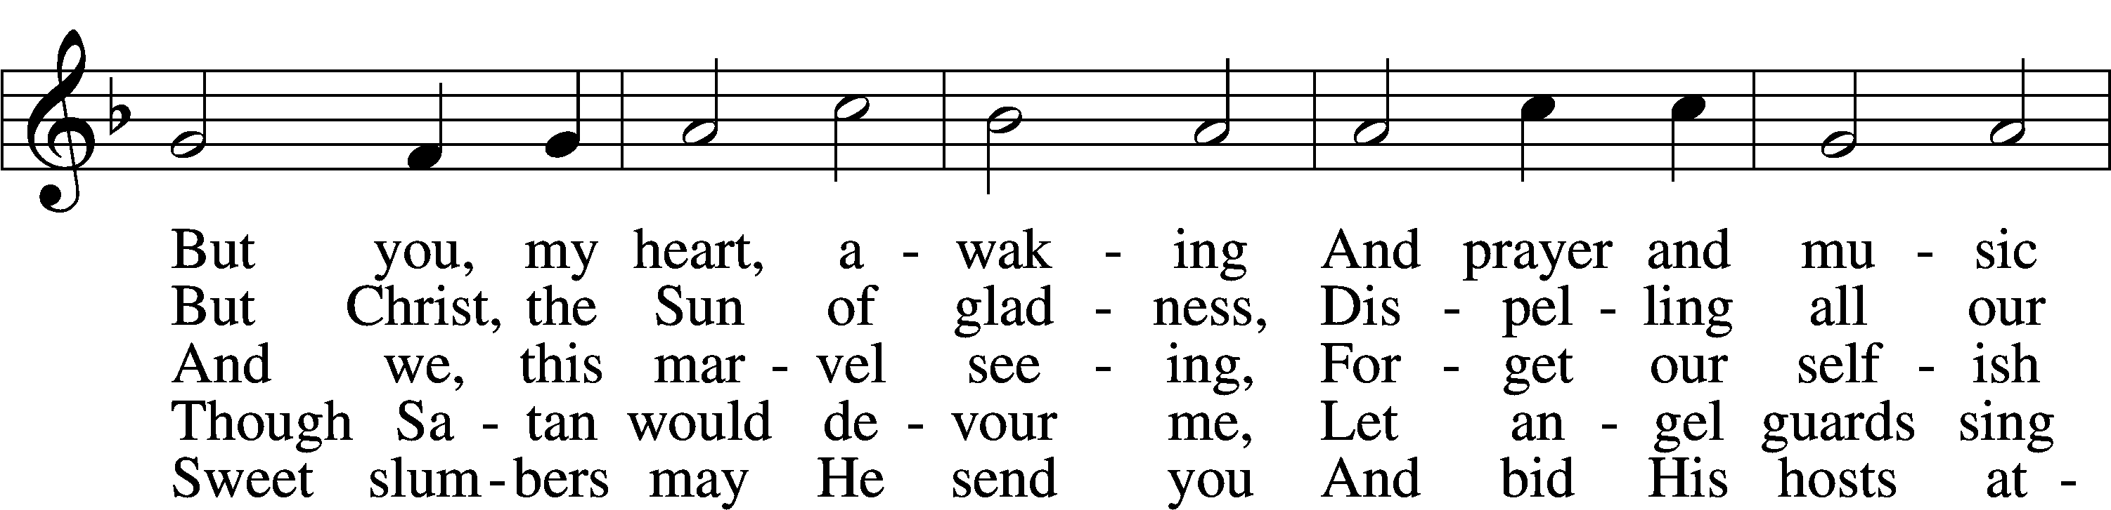

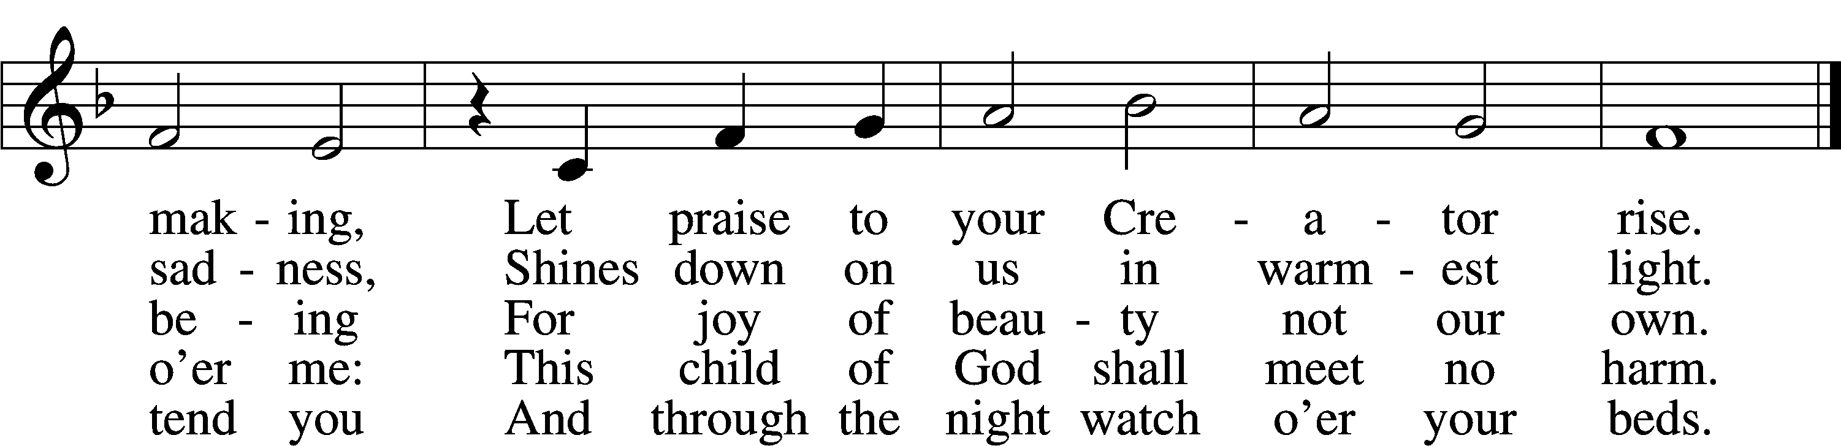

Text: Paul Gerhardt, 1607–76; tr. The Lutheran Hymnal, 1941, alt.  
Tune: Heinrich Isaac, c. 1450–1517  
Text and tune: Public domain

Lenten Theme

+++

You Meant it for Evil,

But God Meant it for Good

2/14 Ash Wednesday

Pastor Roeglin

Blessed Savior Lutheran

2/21 Faith for a Complicated World

Pastor Ruback

Grace Chapel Lutheran

2/28 That Day, and Today

Pastor Roeglin – Blessed Savior Lutheran Church

3/06 He was Numbered Among the Transgressors

Pastor Glenn

Chapel of the Cross

3/13 The Real Battle

Pastor Dressler

Salem Lutheran Church

3/20 When you See such Blind Ignorance, What do you

Think?

Rev. Briggs –Lutheran Senior Services

Acknowledgments

Service of Prayer and Preaching from Lutheran Service Book

Unless otherwise indicated, Scripture quotations are from the ESV® Bible (The Holy Bible, English Standard Version®), copyright © 2001 by Crossway, a publishing ministry of Good News Publishers. Used by permission. All rights reserved.

Created

by Lutheran Service Builder © 2024 Concordia Publishing House.