Blessed Savior Lutheran Church
Florissant, Missouri

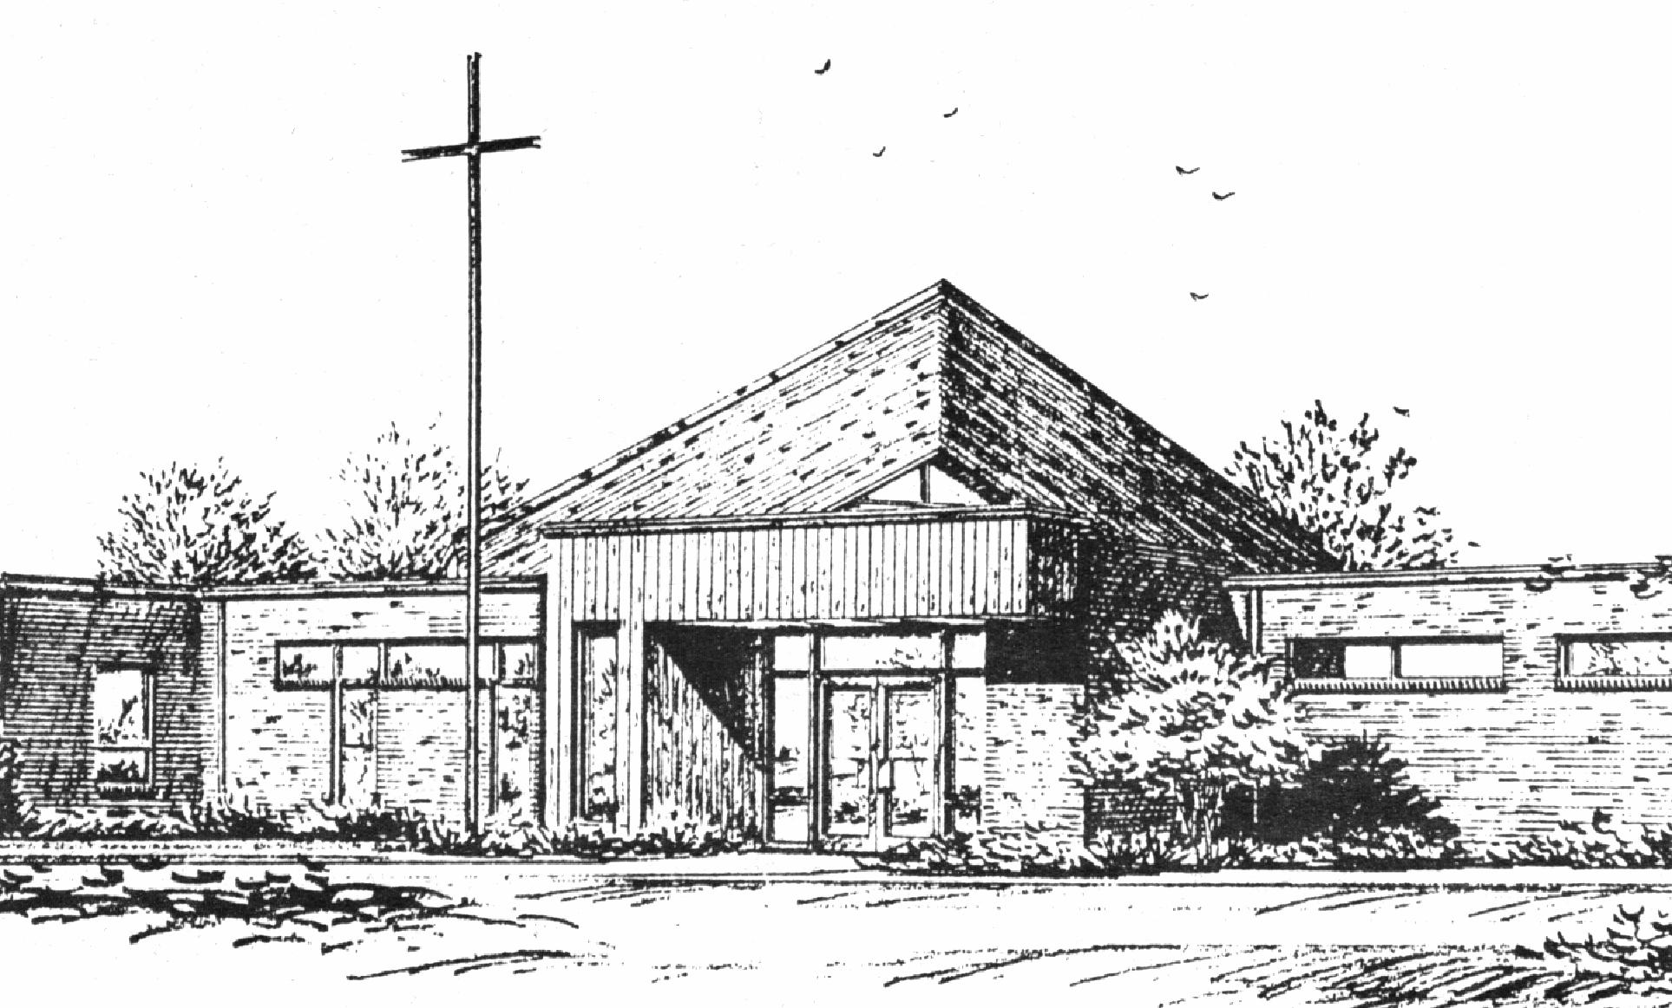
“Empowered by God’s Holy Word,
we joyfully share the love of Jesus with all people;
through worship, teaching, fellowship,
service and witnessing.”

Third Sunday of Easter
April 14, 2024

The Lutheran Church-Missouri Synod

BLESSED SAVIOR LUTHERAN CHURCH
2615 Shackelford Road
Florissant, Missouri 63031-2005
Telephone: 831-1300
www.blessedsavior-lcms.org
Pastor Matthew Roeglin
+ + + + + + + + + + + +
Third Sunday of Easter
Sunday, April 14, 2024

WE WELCOME YOU to our worship service this morning. We pray God’s rich blessings upon you as you hear His Word and praise His holy name. We ask our members and visitors to please use the friendship pad found on the pew. Kindly hand the friendship pad to the person sitting next to you. The Ushers will collect them after the service. Thank You.

THIS WORSHIP FOLDER / CHURCH BULLETIN is prepared for your convenience and contains the entire order of worship with all spoken and sung responses. However, if you are more comfortable using the hymnal, you may use the order of worship found in the front pages of Lutheran Service Book where all the melodies are shown for the sung responses of the congregation.

Divine Service 1 p.151

Greeting of Peace The people may greet one another in the name of the Lord, saying, “Peace be with you,” as a sign of reconciliation and of the unity of the Spirit in the bond of peace. (Matt. 5:22-24; Eph. 4:1-3).

Opening Hymn
“Christ Is Risen, Christ Is Living” # 479

Stand

Stand
Confession and Absolution p.151
The sign of the cross may be made by all in remembrance of their Baptism.

P In the name of the Father and of the T Son and of the Holy Spirit.
C Amen.

P If we say we have no sin, we deceive ourselves, and the truth is not in us.
C But if we confess our sins, God, who is faithful and just, will forgive our sins and cleanse us from all unrighteousness.

Silence for reflection on God’s Word and for self-examination.

P Let us then confess our sins to God our Father.
C Most merciful God, we confess that we are by nature sinful and unclean. We have sinned against You in thought, word, and deed, by what we have done and by what we have left undone. We have not loved You with our whole heart; we have not loved our neighbors as ourselves. We justly deserve Your present and eternal punishment. For the sake of Your Son, Jesus Christ, have mercy on us. Forgive us, renew us, and lead us, so that we may delight in Your will and walk in Your ways to the glory of Your holy name. Amen.

P Almighty God in His mercy has given His Son to die for you and for His sake forgives you all your sins. As a called and ordained servant of Christ, and by His authority, I therefore forgive you all your sins in the name of the Father and of the T Son and of the Holy Spirit.
C Amen.

Stand

Service of the Word
Introit Psalm 30:1–5; antiphon: Psalm 16:11b
In your presence there is full- | ness of joy;*
at your right hand are pleasures for- | evermore.
I will extol you, O Lord, for you have | drawn me up*
and have not let my foes rejoice | over me.
O Lord my God, I cried to | you for help,*
and you have | healed me.
O Lord, you have brought up my soul | from Sheol;*
you restored me to life from among those who go down | to the pit.
Sing praises to the Lord, O | you his saints,*
and give thanks to his | holy name.
For his anger is but for a moment, and his favor is for a | lifetime.*
Weeping may tarry for the night, but joy comes with the | morning.
Glory be to the Father and | to the Son
and to the Holy | Spirit;
as it was in the be- | ginning,
is now, and will be forever. | Amen.
In your presence there is full- | ness of joy;*
at your right hand are pleasures for- | evermore.

Kyrie p. 152
A In peace let us pray to the Lord.
C Lord, have mercy.
A For the peace from above and for our salvation let us pray to the Lord.
C Lord, have mercy.
A For the peace of the whole world, for the well-being of the Church of God, and for the unity of all let us pray to the Lord.
C Lord, have mercy.
A For this holy house and for all who offer here their worship and praise let us pray to the Lord.
C Lord, have mercy.
A Help, save, comfort, and defend us, gracious Lord.
C Amen.

Hymn of Praise “Gloria in Excelsis” p. 154
A Glory to God in the highest, and peace to His people on earth.
C Lord God, heavenly king, almighty God and Father:
We worship You, we give You thanks, we praise You for Your glory.
Lord Jesus Christ, only Son of the Father, Lord God, Lamb of God:
You take away the sin of the world; have mercy on us.
You are seated at the right hand of the Father; receive our prayer.
For You alone are the Holy One, You alone are the Lord,
You alone are the Most High, Jesus Christ, with the Holy Spirit,
in the glory of God the Father. Amen.

Salutation and Collect of the Day
P The Lord be with you.
C And also with you.

P Let us pray.
C O God, through the humiliation of Your Son You raised up the fallen world. Grant to Your faithful people, rescued from the peril of everlasting death, perpetual gladness and eternal joys; through Jesus Christ, our Lord, who lives and reigns with You and the Holy Spirit, one God, now and forever. Amen.

Sit
Old Testament Reading Acts 3:11–21
11While [the lame man who was now healed] clung to Peter and John, all the people ran together to them in the portico called Solomon’s, astounded. 12And when Peter saw it he addressed the people: “Men of Israel, why do you wonder at this, or why do you stare at us, as though by our own power or piety we have made him walk? 13The God of Abraham, the God of Isaac, and the God of Jacob, the God of our fathers, glorified his servant Jesus, whom you delivered over and denied in the presence of Pilate, when he had decided to release him. 14But you denied the Holy and Righteous One, and asked for a murderer to be granted to you, 15and you killed the Author of life, whom God raised from the dead. To this we are witnesses. 16And his name—by faith in his name—has made this man strong whom you see and know, and the faith that is through Jesus has given the man this perfect health in the presence of you all.
17“And now, brothers, I know that you acted in ignorance, as did also your rulers. 18But what God foretold by the mouth of all the prophets, that his Christ would suffer, he thus fulfilled. 19Repent therefore, and turn again, that your sins may be blotted out, 20that times of refreshing may come from the presence of the Lord, and that he may send the Christ appointed for you, Jesus, 21whom heaven must receive until the time for restoring all the things about which God spoke by the mouth of his holy prophets long ago.”

A This is the Word of the Lord.
C Thanks be to God.

Gradual adapt. from Matthew 28:7; Hebrews 2:7; Psalm 8:6
C Christ has risen from the dead. God the Father has crowned him with glory and honor. He has given him dominion over the works of his hands; he has put all things under his feet.

Epistle 1 John 3:1–7
1See what kind of love the Father has given to us, that we should be called children of God; and so we are. The reason why the world does not know us is that it did not know him. 2Beloved, we are God’s children now, and what we will be has not yet appeared; but we know that when he appears we shall be like him, because we shall see him as he is. 3And everyone who thus hopes in him purifies himself as he is pure.
4Everyone who makes a practice of sinning also practices lawlessness; sin is lawlessness. 5You know that he appeared to take away sins, and in him there is no sin. 6No one who abides in him keeps on sinning; no one who keeps on sinning has either seen him or known him. 7Little children, let no one deceive you. Whoever practices righteousness is righteous, as he is righteous.

A This is the Word of the Lord.
C Thanks be to God.

Stand
Alleluia and Verse p. 156
C Alleluia.
Lord, to whom shall we go?
You have the words of eternal life.
Alleluia, alleluia.

Holy Gospel Luke 24:36–49
P The Holy Gospel according to St. Luke, the twenty-fourth chapter.
C Glory to You, O Lord.

36As they were talking about these things, Jesus himself stood among them, and said to them, “Peace to you!” 37But they were startled and frightened and thought they saw a spirit. 38And he said to them, “Why are you troubled, and why do doubts arise in your hearts? 39See my hands and my feet, that it is I myself. Touch me, and see. For a spirit does not have flesh and bones as you see that I have.” 40And when he had said this, he showed them his hands and his feet. 41And while they still disbelieved for joy and were marveling, he said to them, “Have you anything here to eat?” 42They gave him a piece of broiled fish, 43and he took it and ate before them.
44Then he said to them, “These are my words that I spoke to you while I was still with you, that everything written about me in the Law of Moses and the Prophets and the Psalms must be fulfilled.” 45Then he opened their minds to understand the Scriptures, 46and said to them, “Thus it is written, that the Christ should suffer and on the third day rise from the dead, 47and that repentance and forgiveness of sins should be proclaimed in his name to all nations, beginning from Jerusalem. 48You are witnesses of these things. 49And behold, I am sending the promise of my Father upon you. But stay in the city until you are clothed with power from on high.”
P This is the Gospel of the Lord.
C Praise to You, O Christ.

Apostles’ Creed p.159
C I believe in God, the Father Almighty,
maker of heaven and earth.

And in Jesus Christ, His only Son, our Lord,
who was conceived by the Holy Spirit,
born of the virgin Mary,
suffered under Pontius Pilate,
was crucified, died and was buried.
He descended into hell.
The third day He rose again from the dead.
He ascended into heaven
and sits at the right hand of God the Father Almighty.
From thence He will come to judge the living and the dead.

I believe in the Holy Spirit,
the holy Christian Church,
the communion of saints,
the forgiveness of sins,
the resurrection of the body,
and the life T everlasting. Amen.

Sit
Mite Box & TEAM
Children's Message
Sermon Hymn “With High Delight Let Us Unite” # 483
Sermon
Offering
Stand
Offertory p. 159
C What shall I render to the Lord for all His benefits to me? I will offer the sacrifice of thanksgiving and will call on the name of the Lord. I will take the cup of salvation and will call on the name of the Lord. I will pay my vows to the Lord now in the presence of all His people, in the courts of the Lord’s house, in the midst of you, O Jerusalem.

Prayer of the Church
After each petition of the prayers:
P | Lord, In Your mercy.
C | Hear our prayer.
After the final petition:
P | Through Jesus Christ, our Lord.
C | Amen.

Lord’s Prayer p.162
C Our Father who art in heaven,
hallowed be Thy name,
Thy kingdom come,
Thy will be done on earth
as it is in heaven;
give us this day our daily bread;
and forgive us our trespasses
as we forgive those
who trespass against us;
and lead us not into temptation,
but deliver us from evil.
For Thine is the kingdom
and the power and the glory
forever and ever. Amen.

Benediction p. 166
P The Lord bless you and keep you.
The Lord make His face shine on you and be gracious to you.
The Lord look upon you with favor and T give you peace.
C Amen.

Closing Hymn “This Joyful Eastertide” # 482

Acknowledgments
Unless otherwise indicated, Scripture quotations are from the ESV® Bible (The Holy Bible, English Standard Version®), copyright © 2001 by Crossway, a publishing ministry of Good News Publishers. Used by permission. All rights reserved.
Created by Lutheran Service Builder © 2024 Concordia Publishing House.

Sit
Announcements
After the announcements, please stand for the closing Doxology.

Doxology #805
Praise God, from whom all blessings flow;
Praise Him, all creatures here below;
Praise Him above, ye heav’nly host:
Praise Father, Son, and Holy Ghost. Amen.

Go and Serve the Lord
Acknowledgments Unless otherwise indicated, all scripture quotations are from The Holy Bible, English Standard Version, copyright © 2001 by Crossway Bibles, a division of Good News Publishers. Used by permission. All rights reserved. Created by Lutheran Service Builder © 2006 Concordia Publishing House.

The Liturgist & Preacher: Pastor Matthew Roeglin
The Organist: Mrs. Donna Boyd
Altar Flowers – are placed by Terry & Paula Bossaller in celebration of their 47th wedding anniversary and for the many blessings God has bestowed upon them.

Altar Flowers needed for: April 21 & 28, May 5, 12 & 26

BLESSED SAVIOR’S CALENDAR
April 14 – April 21, 2024

TODAY:
Sunday 8:15 a.m. Bible Class (McKenna)
9:30 a.m. Worship Service
Mite Box & TEAM
Apr. 14 10:45 a.m. Bible Class & Sunday School

MONDAY: 6:30 p.m. Outreach Meeting
Apr. 15

TUESDAY:
Apr. 16

WEDNESDAY: 2:30 p.m. Pastor’s Adult Bible Study
Apr. 17 6:00 p.m. Bible Study (McKenna)

THURSDAY:
Apr. 18

FRIDAY: Pastor - Day with family
Apr. 19

SATURDAY:
Apr. 20

NEXT 8:15 a.m. Adult Bible Study (McKenna)
SUNDAY 9:30 a.m. Worship Service w/Holy Communion
10:45 a.m. Adult Bible Class (Pastor)
Apr. 21 10:45 a.m. Sunday School & High School

April 14 3rd Sunday of Easter 1 John 3:2 “Beloved, we are God's children now, and what we will be has not yet appeared; but we know that when he appears we shall be like him, because we shall see him as he is.” This is the essence of our sanctification: becoming like our Lord. As St. John notes, this will only be completed in the Resurrection, but in the meantime, we strive toward that goal because we want to walk in the footsteps of our Lord. By His grace we share His destiny in eternal life, and therefore we desire to share His life of service now.

Our Response to God’s Love – April 7, 2024
Sunday (9:30)………. 41
Sem Students/family......
Visitors…………..…
Communed….29
Total……………... 41
Sunday School…………
Sun. School/Bible Staff...
Bible Study/Youth……...
Bible Study/Y.Adults….
Bible Study I ………….
Bible Study II ………..
Adult/Confirm…….
Wednesday Morning …...

General Offerings…. $ 3,451.00
Misc. $ 0.00
Total response for week of: March 31 $ 3,451.00
Weekly Budget Needed $- 3,800.00
Deficit $- 349.00

Blessings Upon Blessings
Anniversary Campaign- Update
Wk of 4/7 YTD
Debt Reduction $ 0.00 $ 4,210.00
Improvement/Banners $ 10.00 $ 1,625.00
$ 10.00 $ 5,835.00

Our Special Prayers and Intercessions
Jim Laughlin – open heart surgery
Kim – cancer
Mary S. – cancer
Jeannie Firoved – health issues
Sara – health
Tiffany Connor – health issues
Connor Stretch – Health issues
Mike – Liver failure
Andrew – Guidance
Wanda Johnston – recovering from hip
Surgery
David Hogenmiller – health
Rev. Gary Shack – health
Jim Grimes – health issues
Cheryl Ehrhard – recovering- knee surgery
JoAnn Roellig - hospice
Martha Oth – health
Lindsay Jaco – car accident
Debbie Bacon – hospitalized
Allan Joellenbeck – health
Dan Boyd - health

Kyle – renewal of faith
Heather – strengthening of faith
Pastor Struve- hospitalized
Marge Struve – health issues
Pastor Eric Carlson – Leukemia
Anneliese Wenger – health issues
Charlotte Taggert – health issues
Jessica Parish – MS
Rita Kirk – health issues
Mary Peacock – health
Debbie – home recovering
Lindsay – health
Wendy DeSanto – health issues
Patti Henneman – health issues
Laurie Moore – health issues
William – health issues
Doris Boyd – health issues
David Kuhl – health
Mike Wilder – cancer
Tom Murphy – health
Kelly - health
Retha Taylor – health
Caitlyn – health
Steve Haynes – heart issues
Nancy Stocker – health issues
Ted Stocker- health issues

Serving in our Armed Forces – Andrew Mack, Paul Hackett, Jay Warren, Michael Rice, Caleb McElyea, Jeff Throgmorton, Adam Guercio, Chance Glover, Cody Guercio, Danny Chung, Zayne Glatz, Alanna Kreppert, James Adelhardt, Sean Bentrup, Wesley Peach, Jordan Rolf, Anne Heintzelman, Austin Dreckshage, Ken Leppert II, Shelby Croghan & Richard Vengels.

*Please note: Those who are named in our special prayers and intercessions list are placed there by members of our congregation. St. Paul tells us in 1Timothy 2:1-2: “I urge, then, first of all, that requests, prayers, intercessions and thanksgivings be made for everyone – for kings and all those in authority, that we may live peaceful and quiet lives in all godliness and holiness. This is good, and pleases God our Savior.” Those named remain joyfully in our prayers until the person who requested our prayers removes them or until the Lord resolves their need. Therefore, as St. Paul tells us in Philippians 4:6 “Do not be anxious about anything, but in everything, by prayer and petition, with thanksgiving, present your request to God.

