Opening Hymn “The Lord’s My Shepherd, I’ll Not Want” # 710
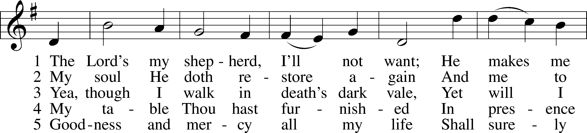
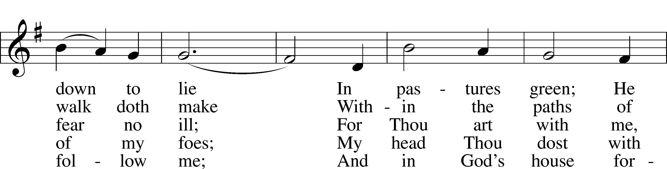
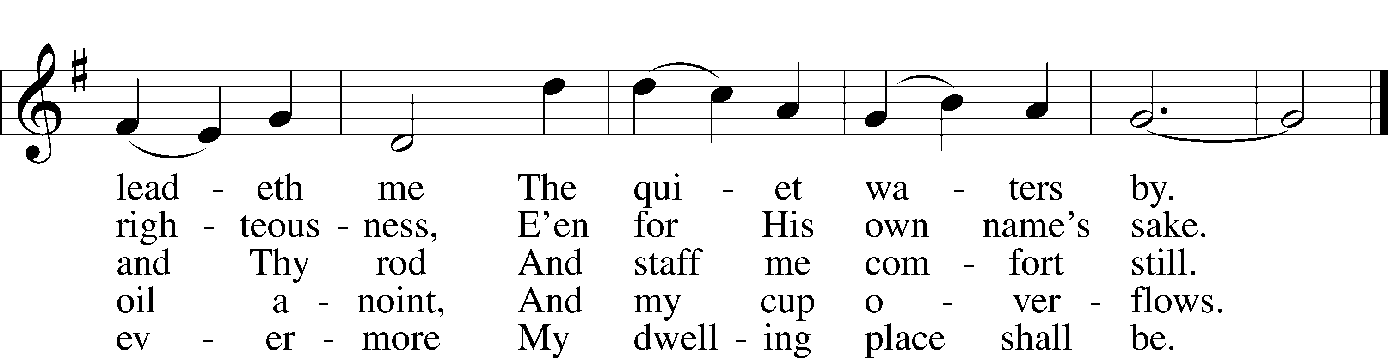
Text: The Psalms of David in Meeter, 1650, Edinburgh
Tune: William Gardiner, 1770–1853
Text and tune: Public domain
Sermon Hymn “The King of Love My Shepherd Is” # 709
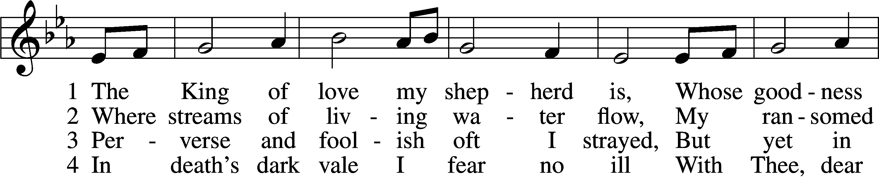
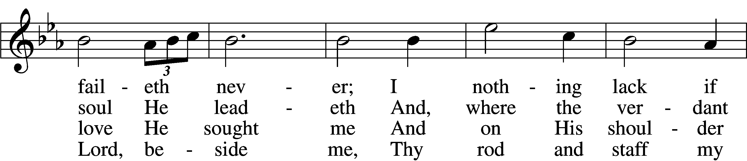
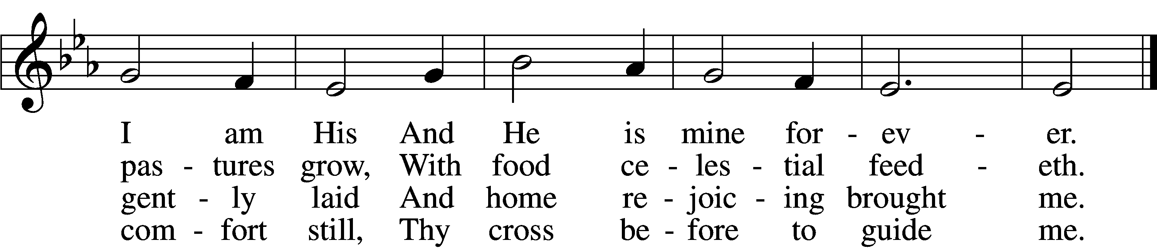

5 Thou spreadst a table in my sight;
Thine unction grace bestoweth;
And, oh, what transport of delight
From Thy pure chalice floweth!

6 And so through all the length of days
Thy goodness faileth never;
Good Shepherd, may I sing Thy praise
Within Thy house forever!
Text: Henry W. Baker, 1821–77
Tune: Irish, c. 18th cent.
Text and tune: Public domain

Distribution Hymn “Crown Him with Many Crowns” # 525
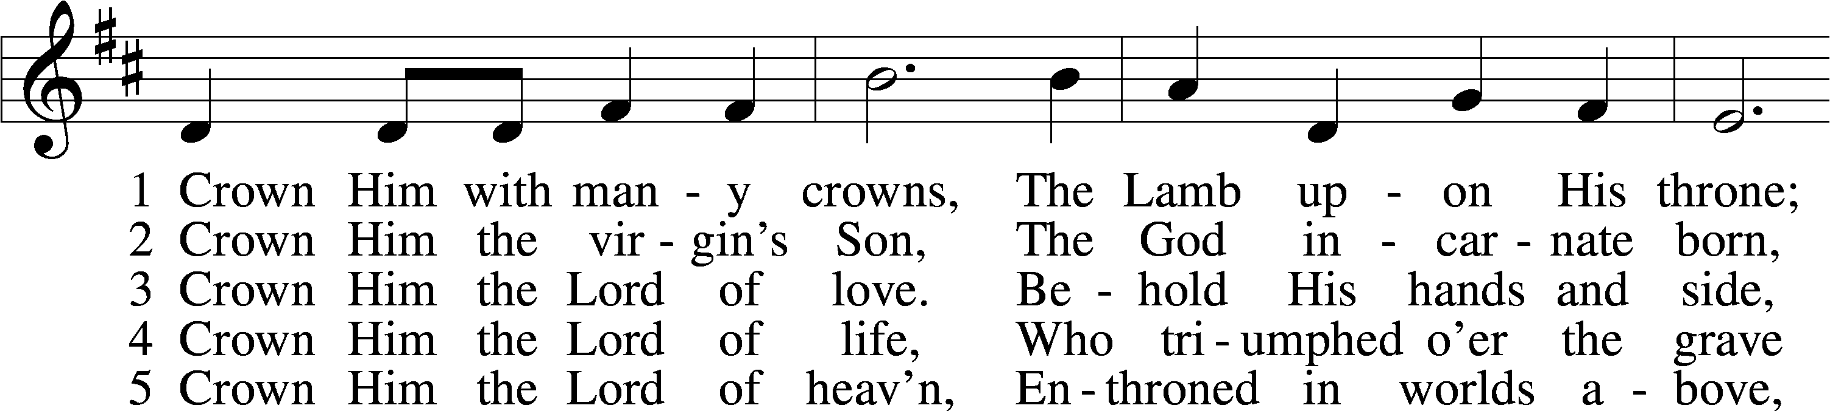
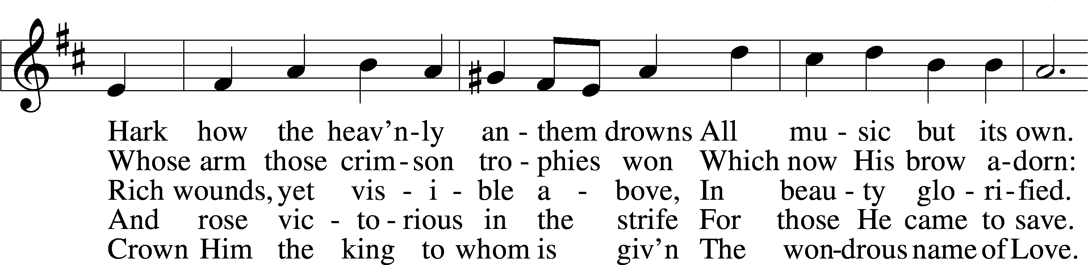
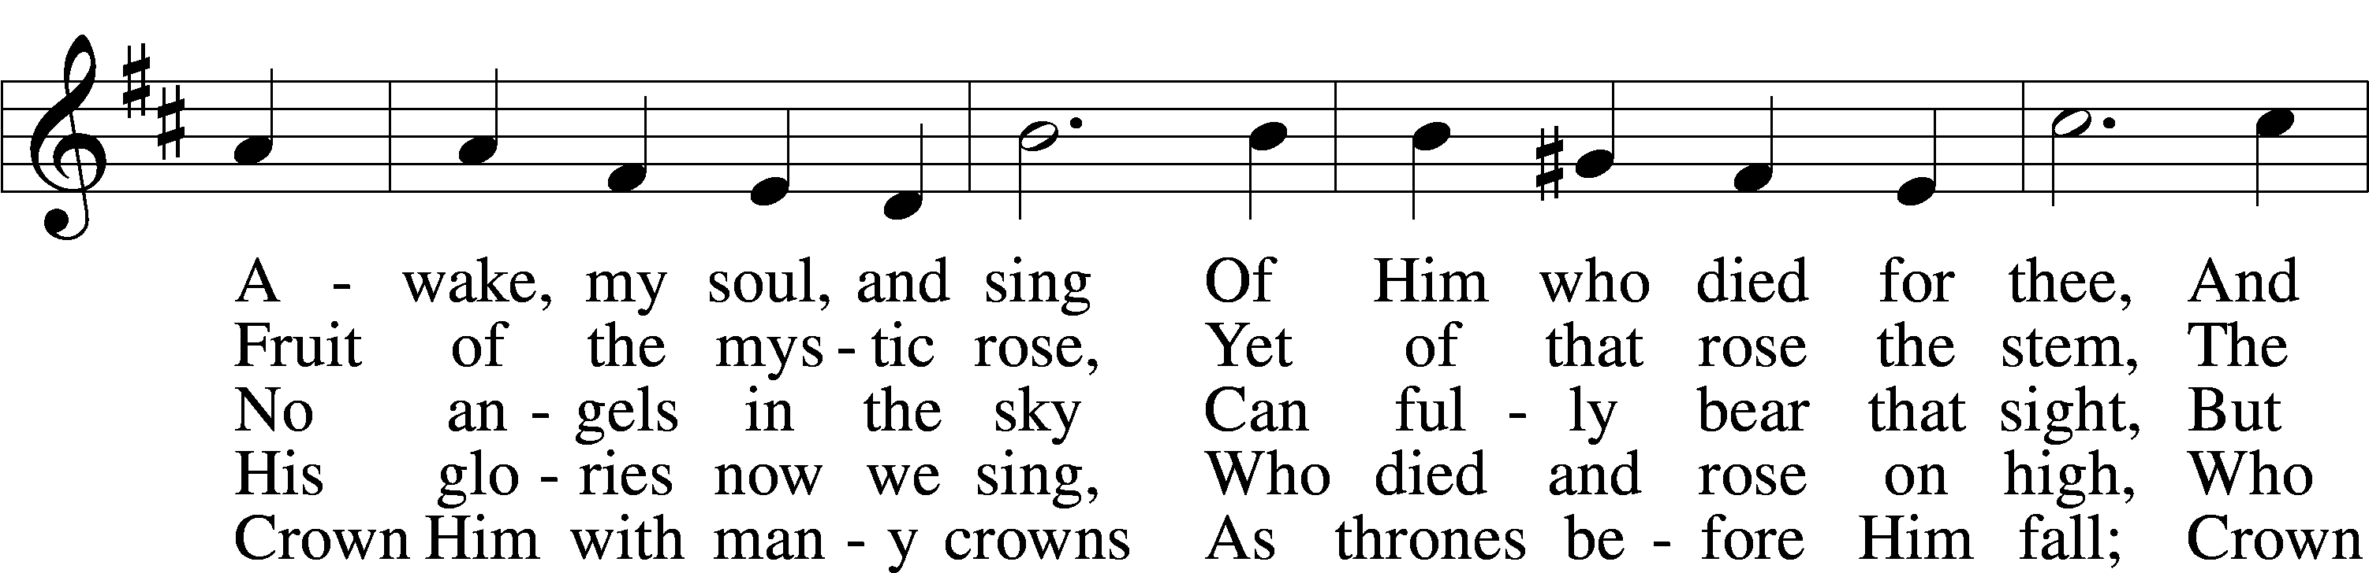
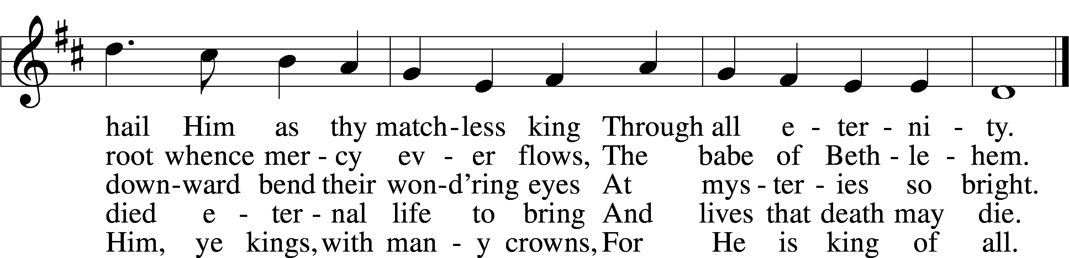
Text (sts. 1–3, 5): Matthew Bridges, 1800–94, alt.; (st. 4): Godfrey Thring, 1823–1903
Tune: George J. Elvey, 1816–93
Text and tune: Public domain
Distribution Hymn “Love Divine, All Loves Excelling” # 700
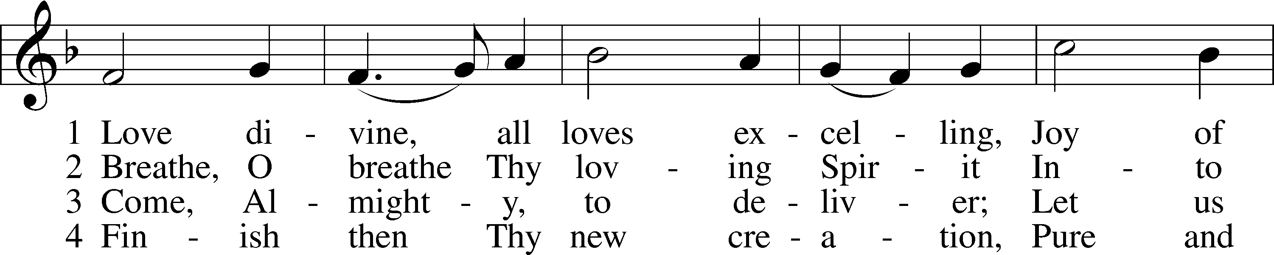
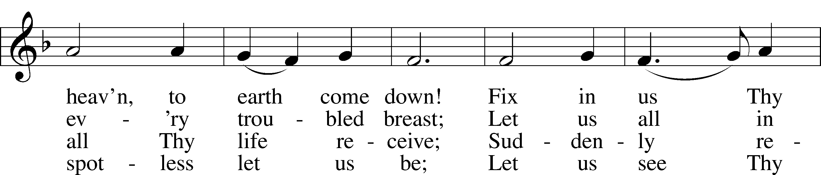
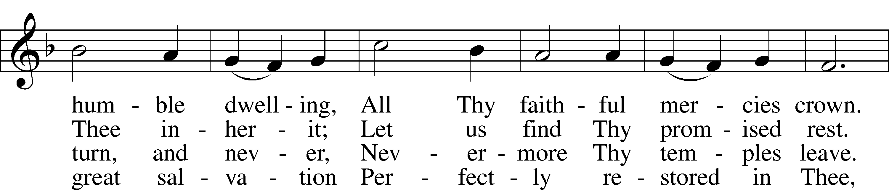
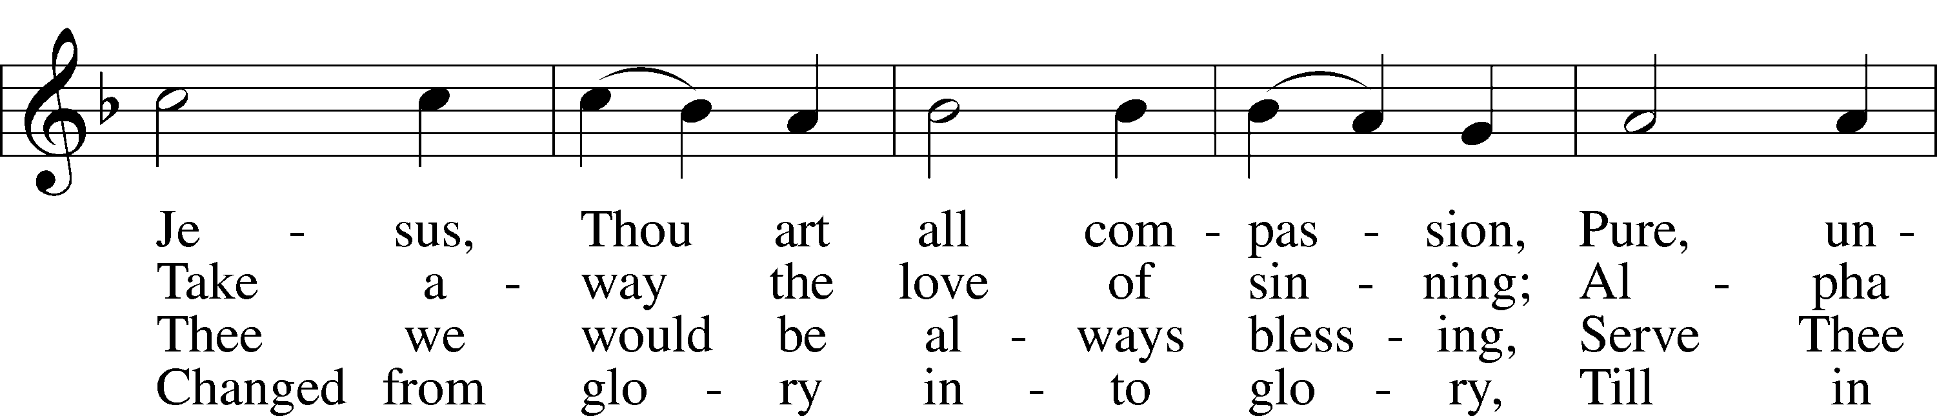
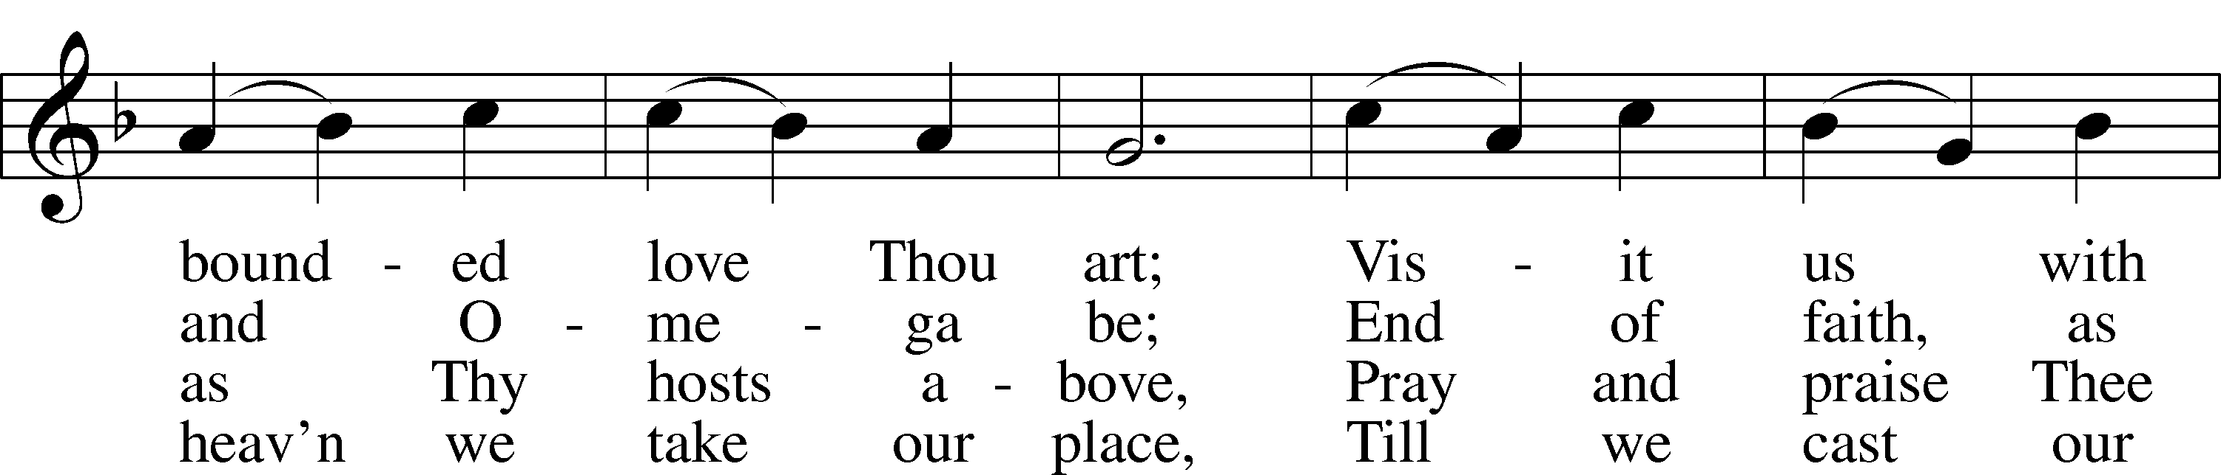
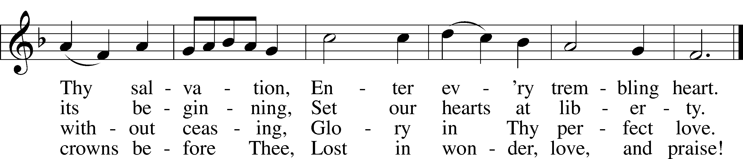

Text: Charles Wesley, 1707–88
Tune: Rowland H. Prichard, 1811–87
Text and tune: Public domain

Distribution Hymn “All Hail the Power of Jesus’ Name” # 549
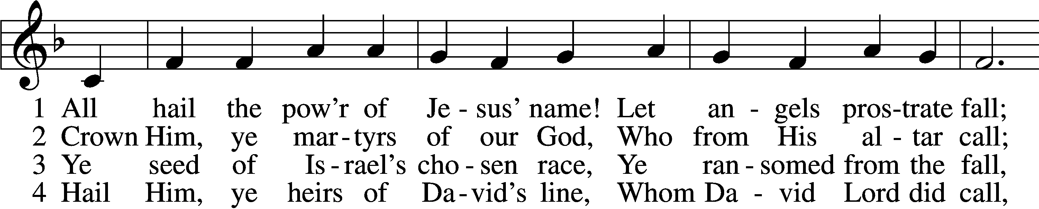
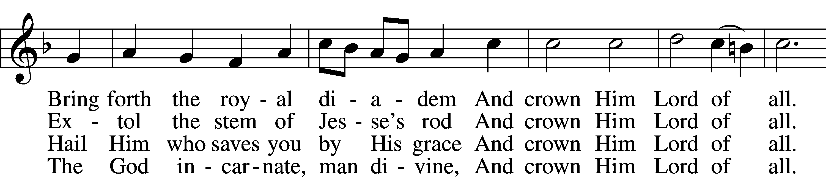
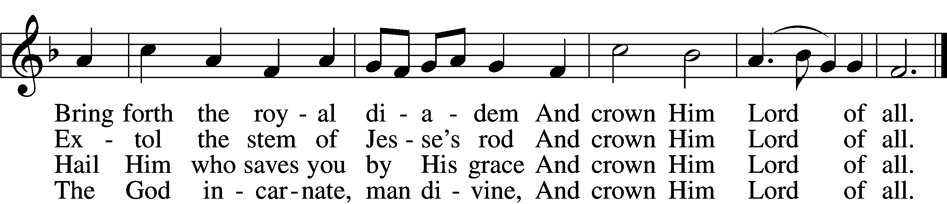

5 Sinners, whose love can ne’er forget
The wormwood and the gall,
Go, spread your trophies at His feet
And crown Him Lord of all.
Go, spread your trophies at His feet
And crown Him Lord of all.

6 Let ev’ry kindred, ev’ry tribe,
On this terrestrial ball
To Him all majesty ascribe
And crown Him Lord of all.
To Him all majesty ascribe
And crown Him Lord of all.

7 Oh, that with yonder sacred throng
We at His feet may fall!
We’ll join the everlasting song
And crown Him Lord of all.
We’ll join the everlasting song
And crown Him Lord of all.
Text (sts. 1–5): Edward Perronet, 1726–92, alt.; (sts. 6–7): A Selection of Hymns, 1787, London, alt.
Tune: Oliver Holden, 1765–1844
Text and tune: Public domain

Hymn to Depart: 740 I Am Jesus’ Little Lamb LSB 740
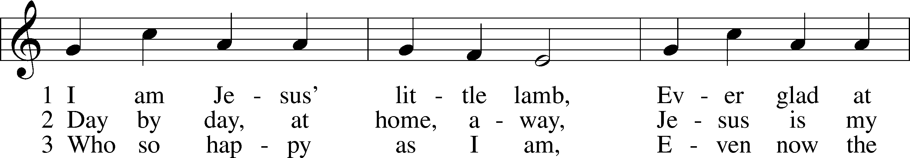
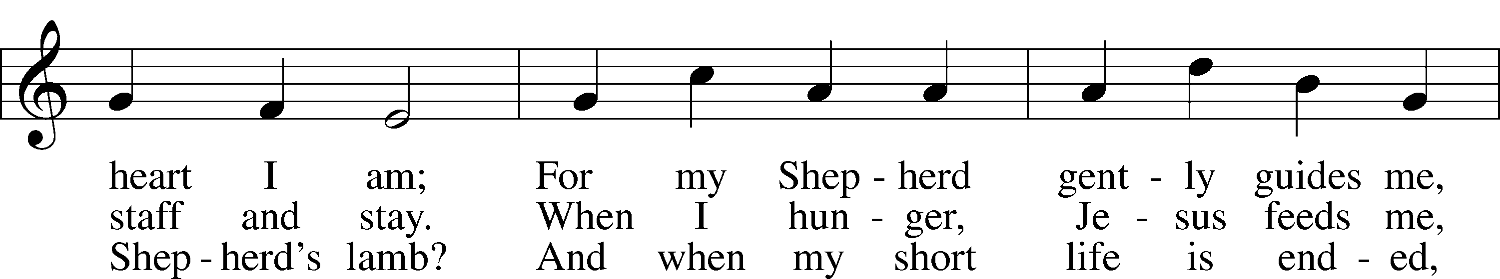
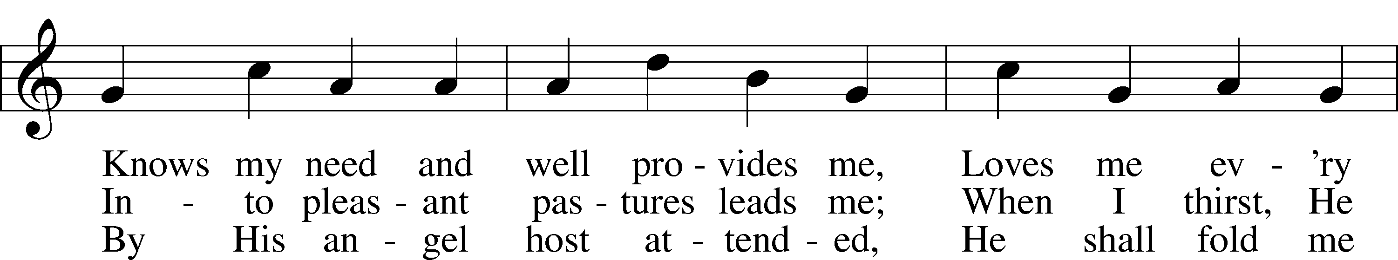
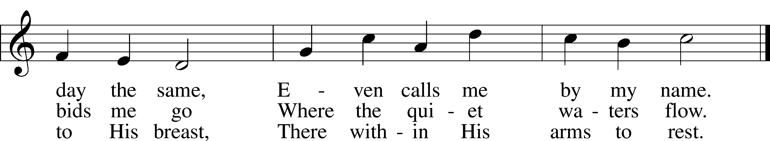
Text: Henrietta L. von Hayn, 1724–82; tr. The Lutheran Hymnal, 1941
Tune: Choral-Buch . . . Brüder-Gemeinen, 1784, Leipzig
Text and tune: Public domain

