Opening Hymn “When Morning Gilds the Skies” # 807
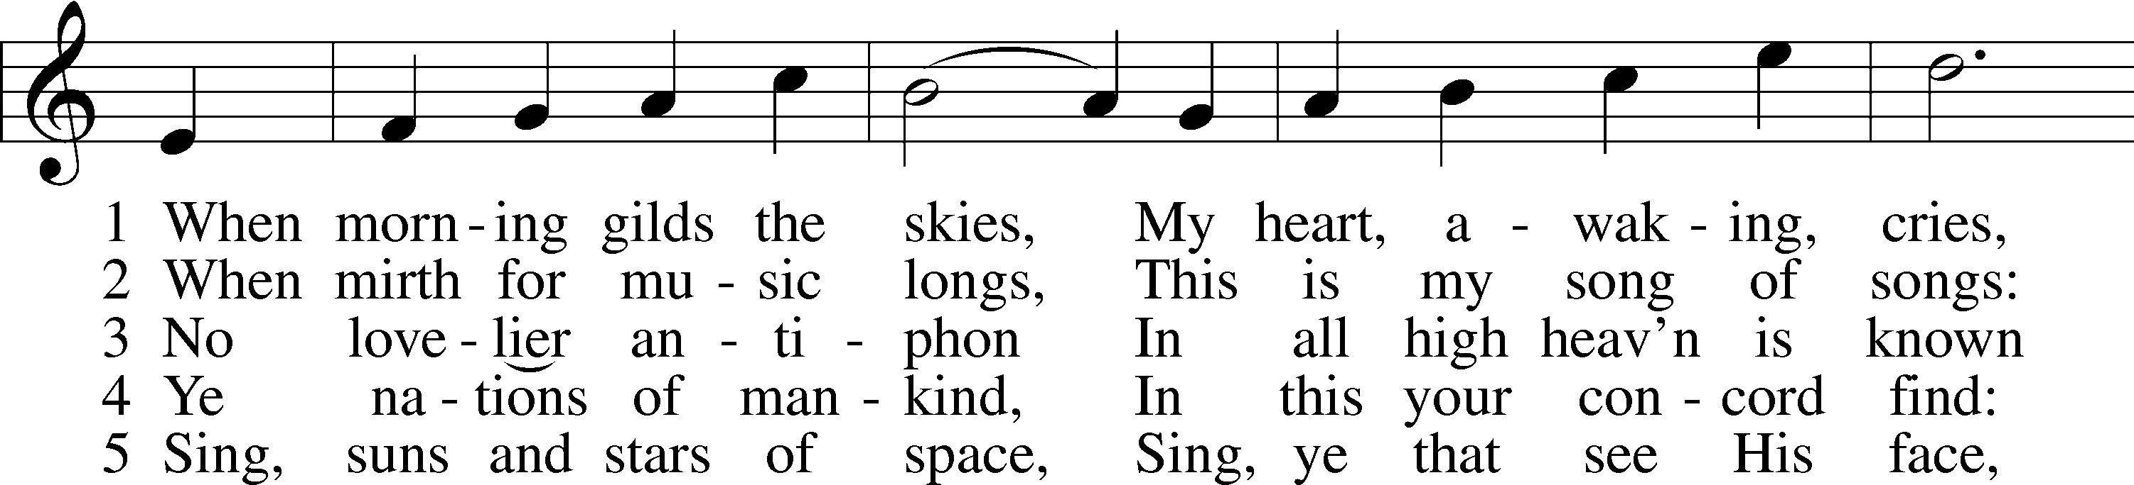
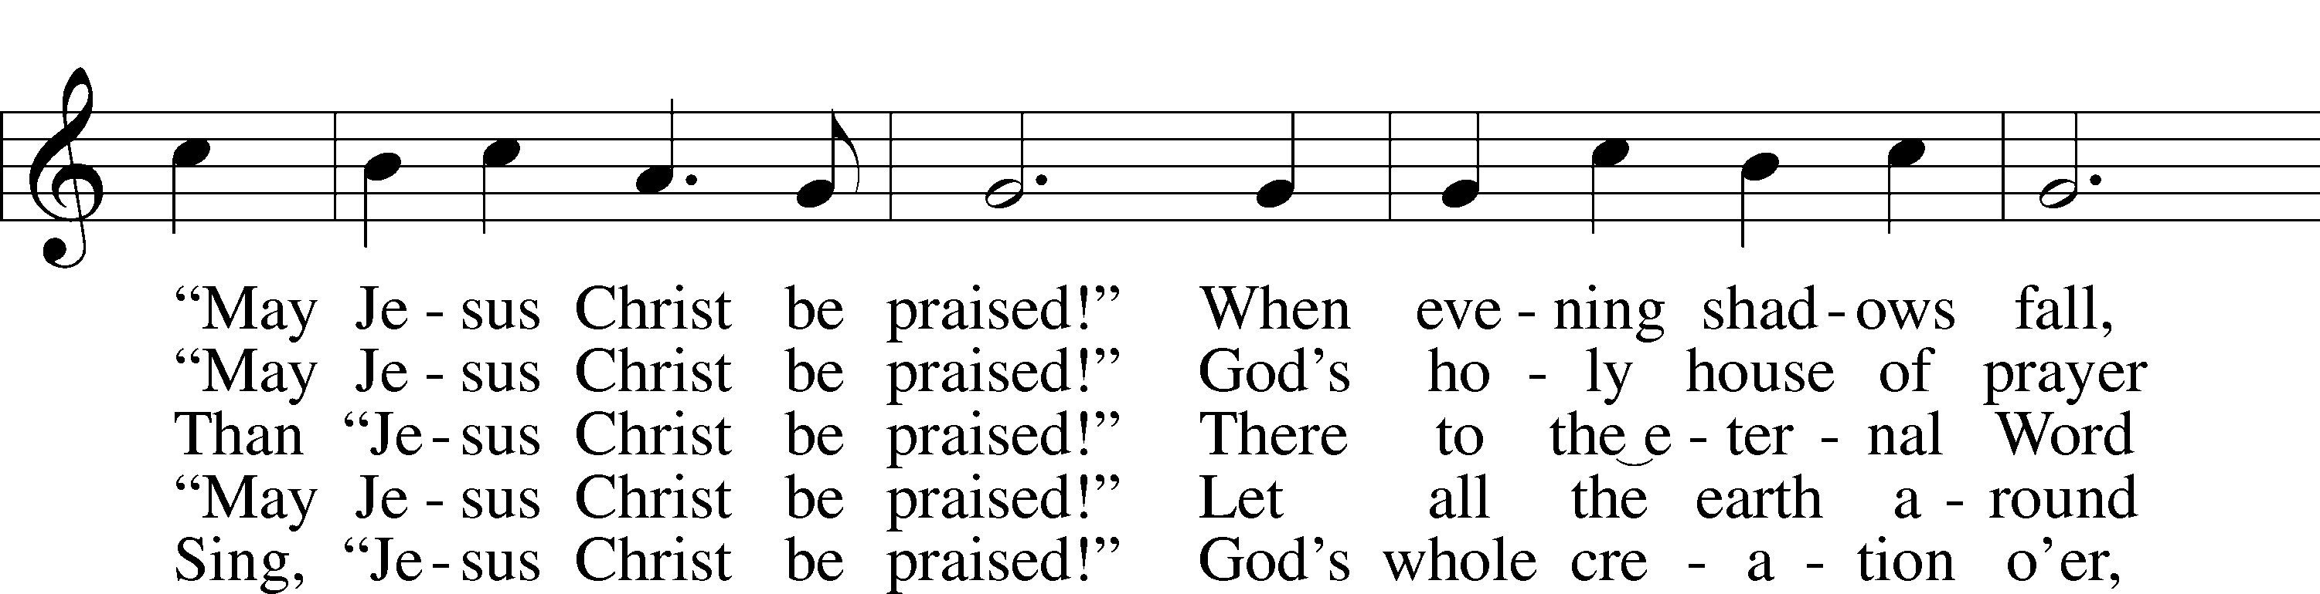
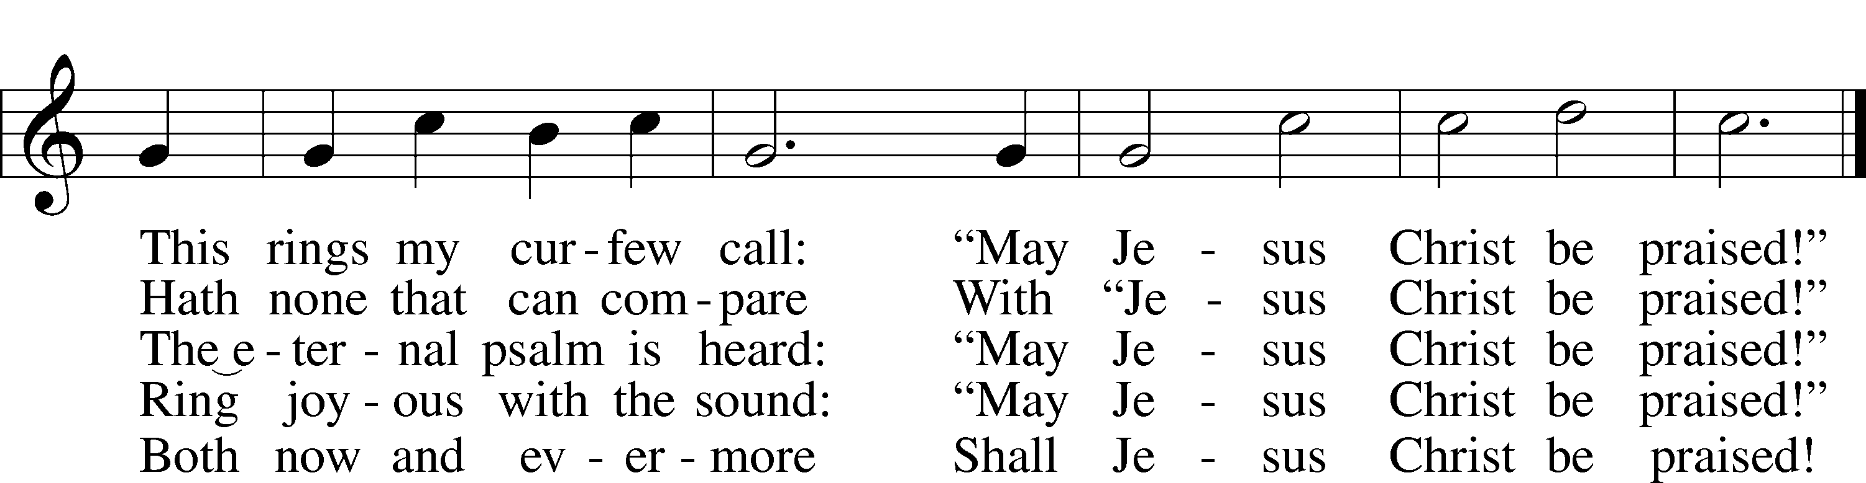
Text: Katholisches Gesangbuch, 1828, Würzburg; tr. Robert S. Bridges, 1844–1930, alt.
Tune: Joseph Barnby, 1838–96
Text and tune: Public domain

Sermon Hymn “Alleluia! Jesus Is Risen” # 474
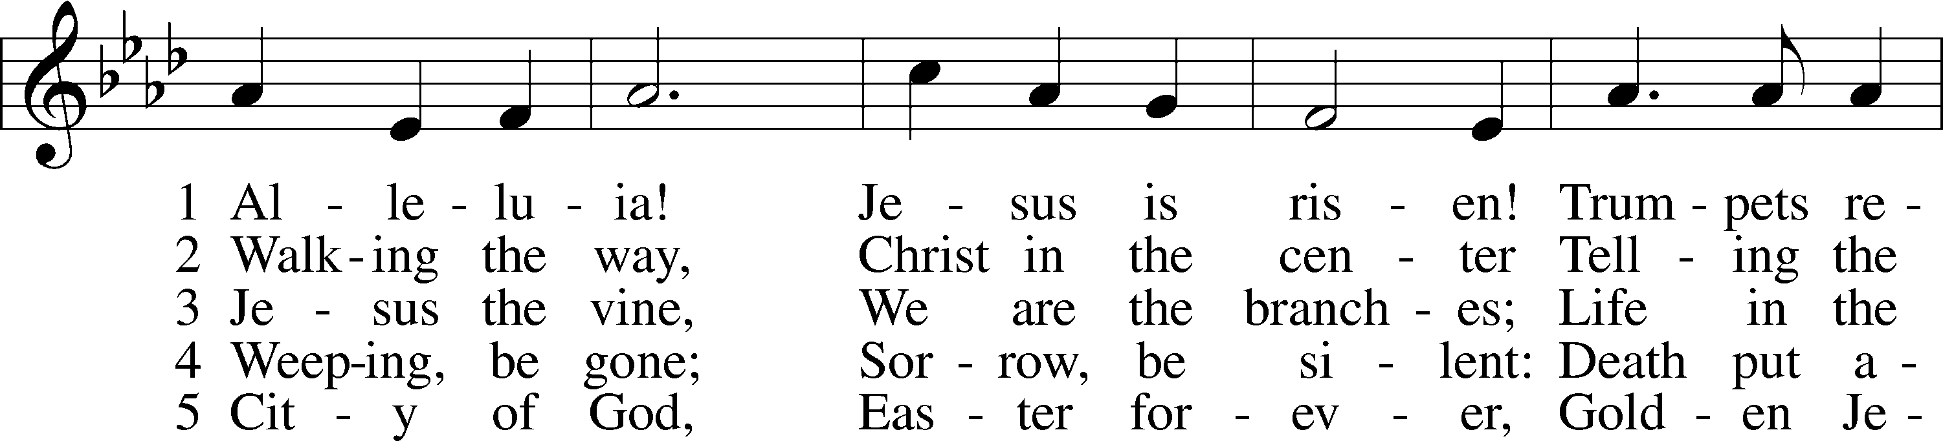
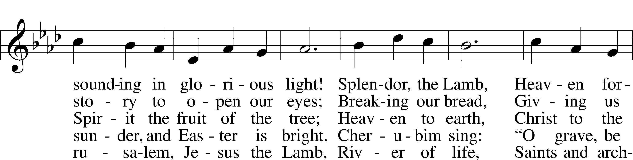
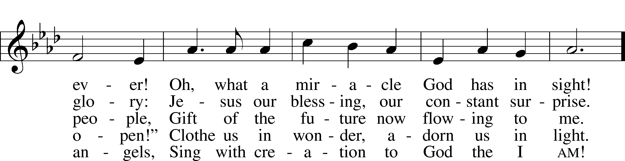
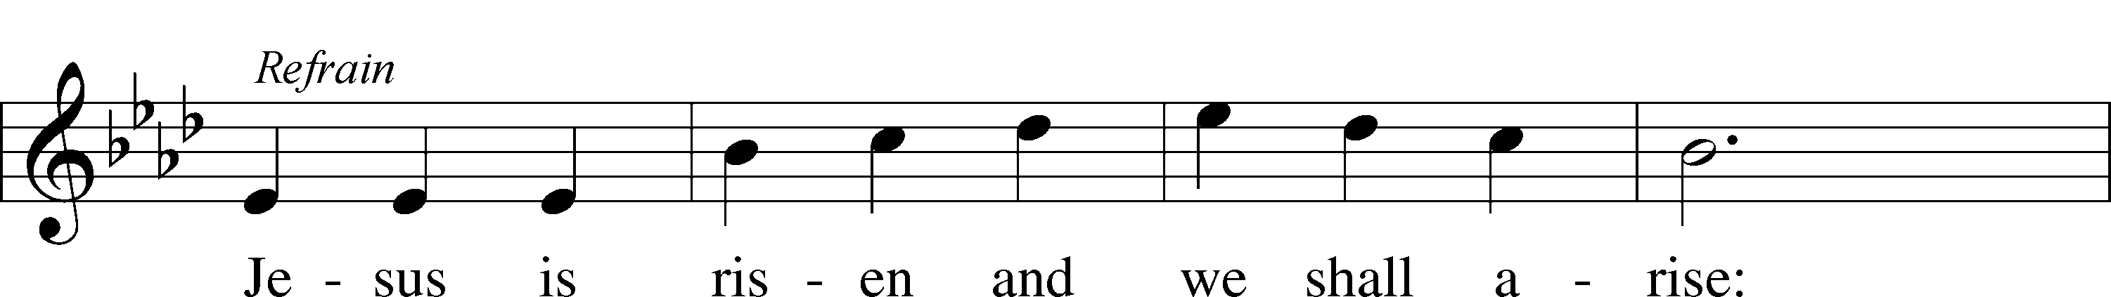
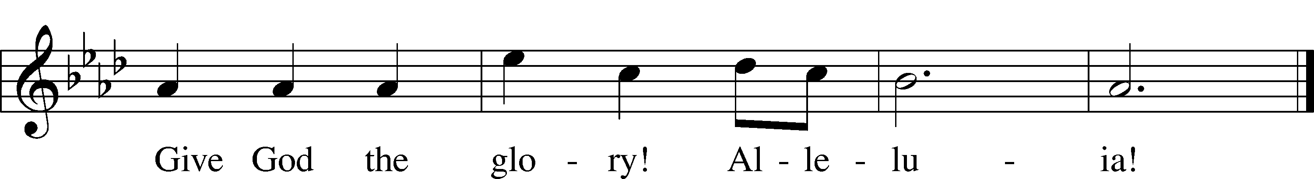
Text: Herbert F. Brokering, 1926–2009
Tune: David N. Johnson, 1922–87
Text: © 1995 Augsburg Fortress. Used by permission: LSB Hymn License no. 110003344
Tune: © 1968 Augsburg Publishing House. Used by permission: LSB Hymn License no. 110003344

Closing Hymn “Where Charity and Love Prevail” # 845
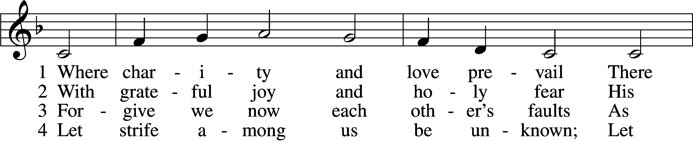
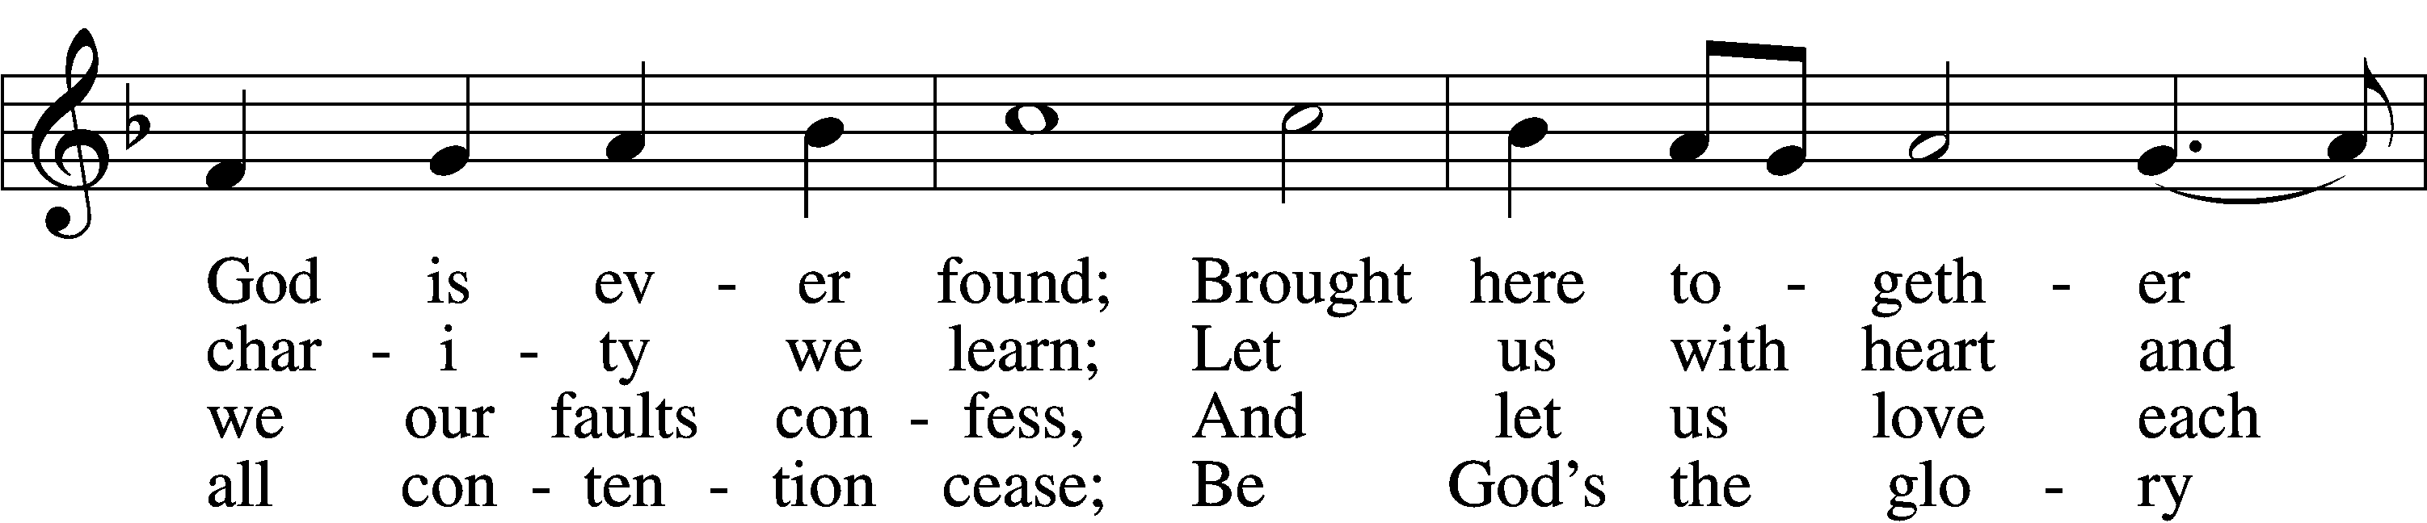
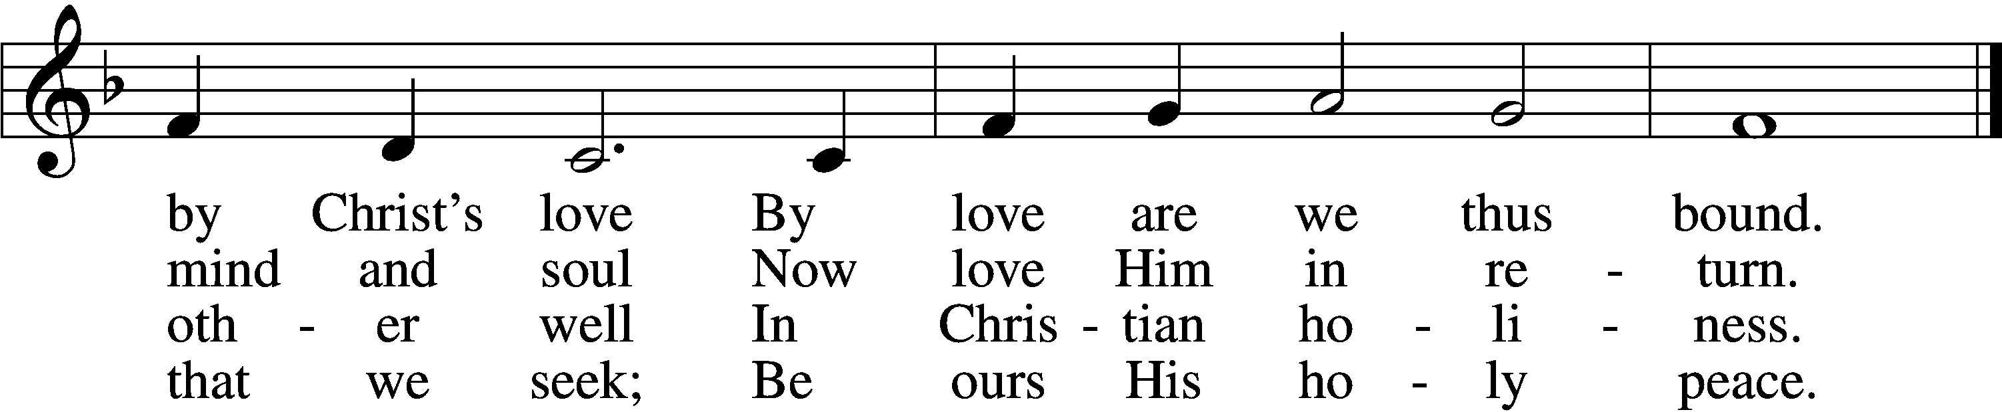

5 Let us recall that in our midst
Dwells Christ, His only Son;
As members of His body joined
We are in Him made one.

6 For love excludes no race or clan
That names the Savior’s name;
His family embraces all
Whose Father is the same.
Text: Latin, c. 9th cent.; tr. Omer E. Westendorf, 1916–97, alt.
Tune: Lucius Chapin, 1760–1842
Text: © 1960 World Library Publications. Used by permission: LSB Hymn License no. 110003344
Tune: Public domain

