Opening Hymn “Christ the Lord Is Risen Today” # 469
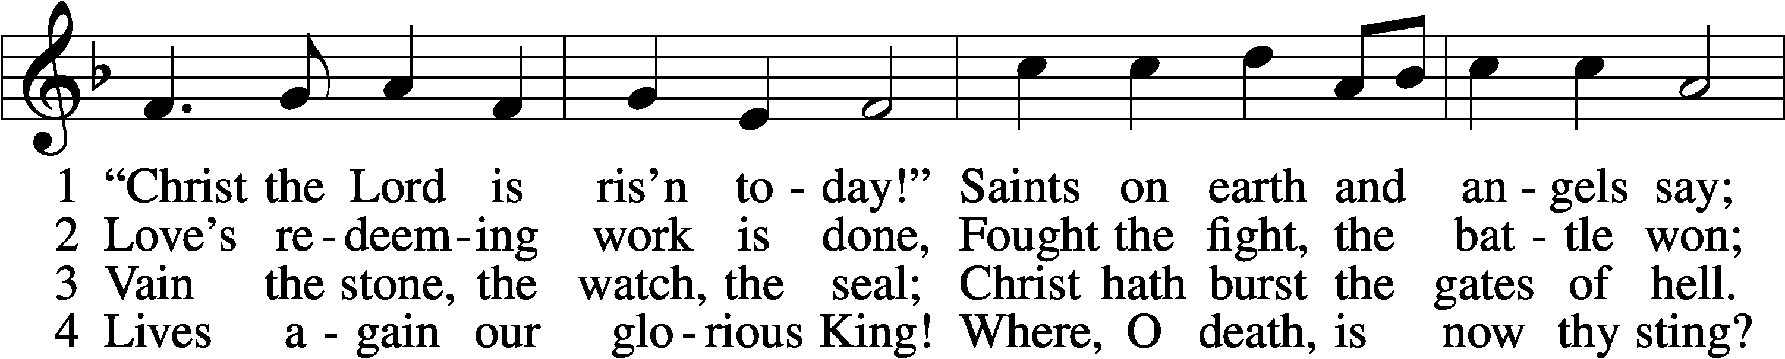
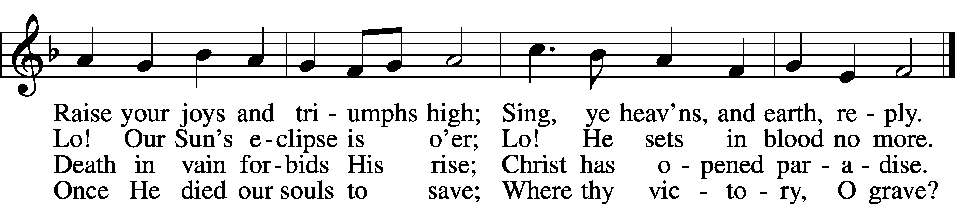

5 Soar we now where Christ has led;
Foll’wing our exalted Head.
Made like Him, like Him we rise;
Ours the cross, the grave, the skies.

6 Hail the Lord of earth and heav’n!
Praise to Thee by both be giv’n!
Thee we greet triumphant now:
Hail, the resurrection, Thou!
Text: Charles Wesley, 1707–88, alt.
Tune: French, 13th cent.
Text and tune: Public domain

Sermon Hymn “Dear Christians, One and All, Rejoice” sts. 1-5 # 556
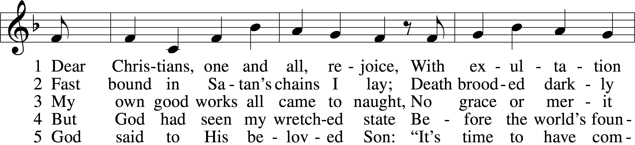
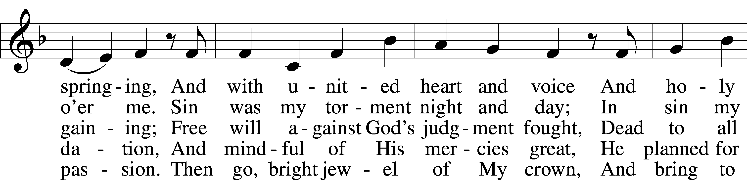
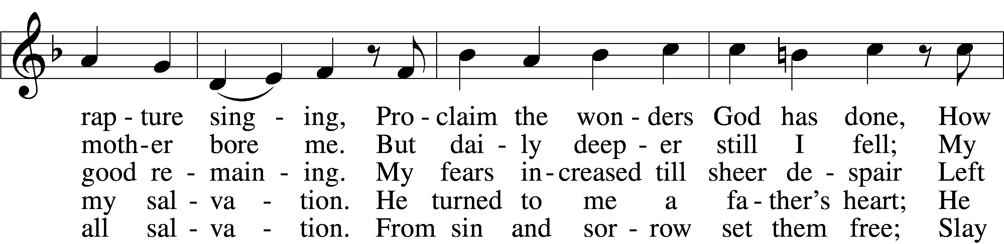
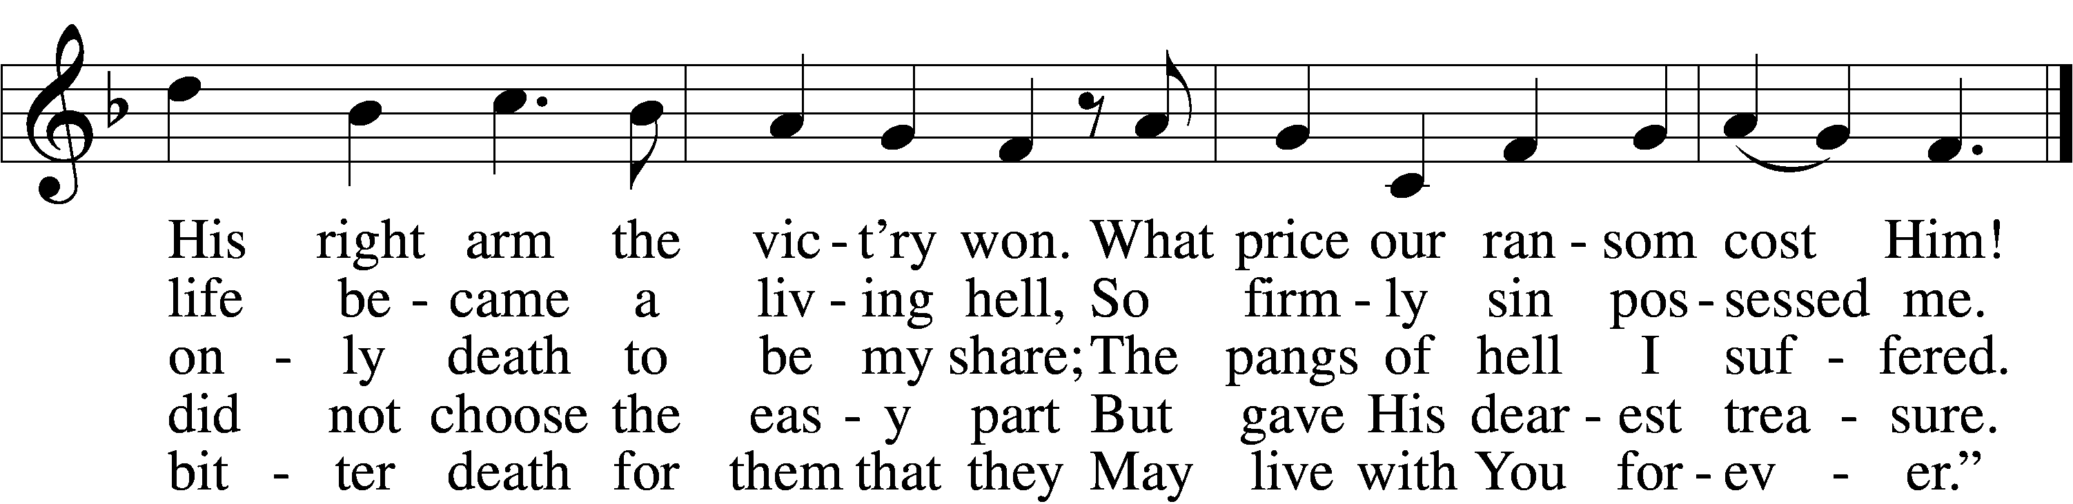
Text: Martin Luther, 1483–1546; tr. Richard Massie, 1800–87, alt.
Tune: Etlich Cristlich lider, 1524, Wittenberg
Text and tune: Public domain

Responsive Hymn “Dear Christians, One and All, Rejoice” sts. 6-10 # 556
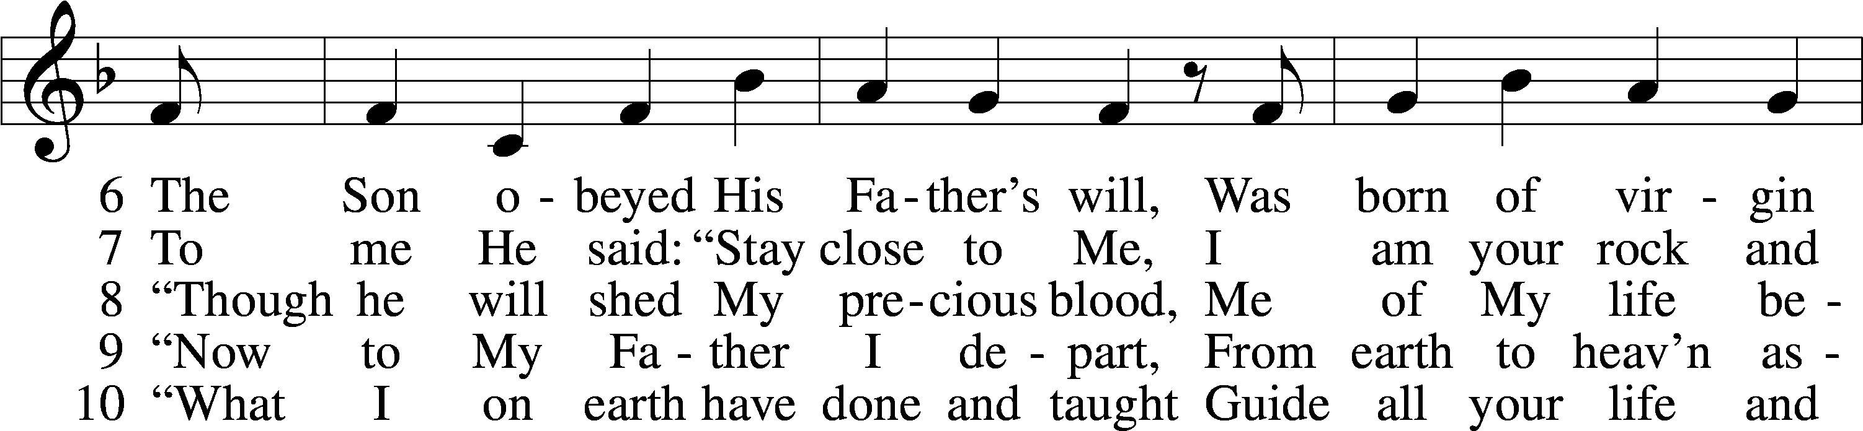

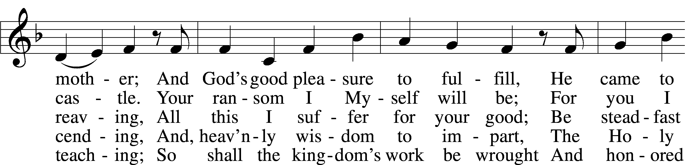

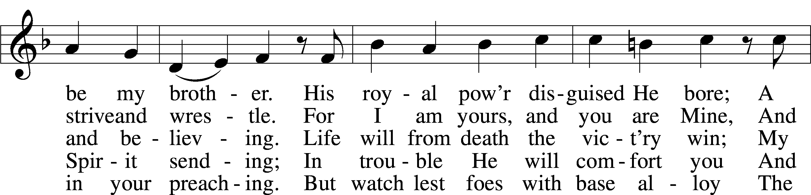

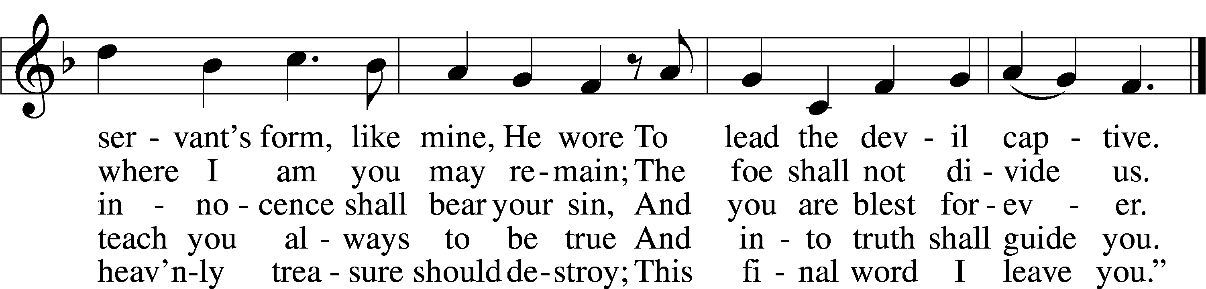

Text: Martin Luther, 1483–1546; tr. Richard Massie, 1800–87, alt.
Tune: Etlich Cristlich lider, 1524, Wittenberg
Text and tune: Public domain

Distribution Hymn “What a Friend We Have in Jesus” # 770
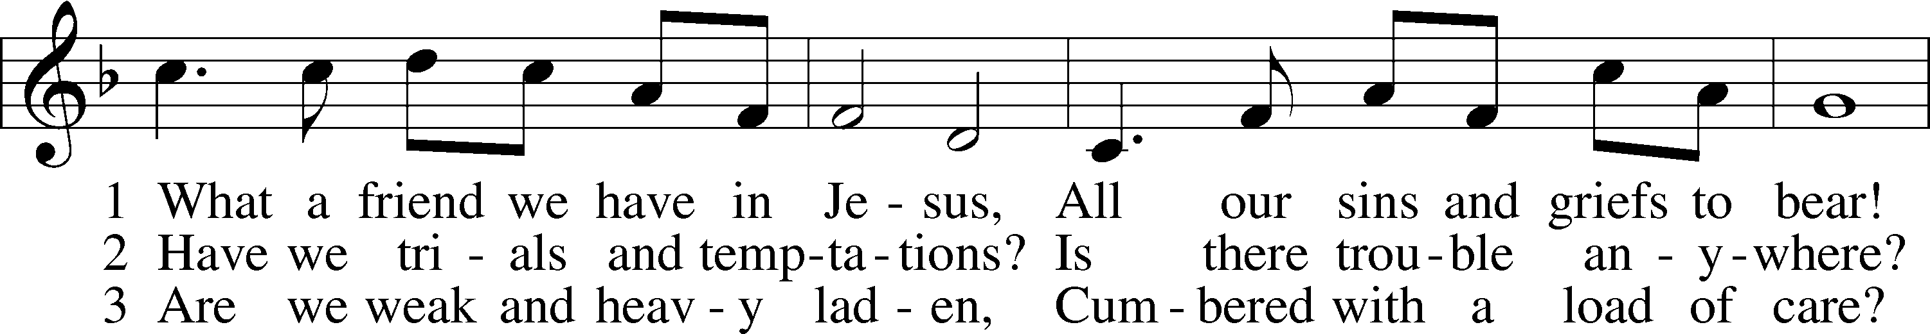
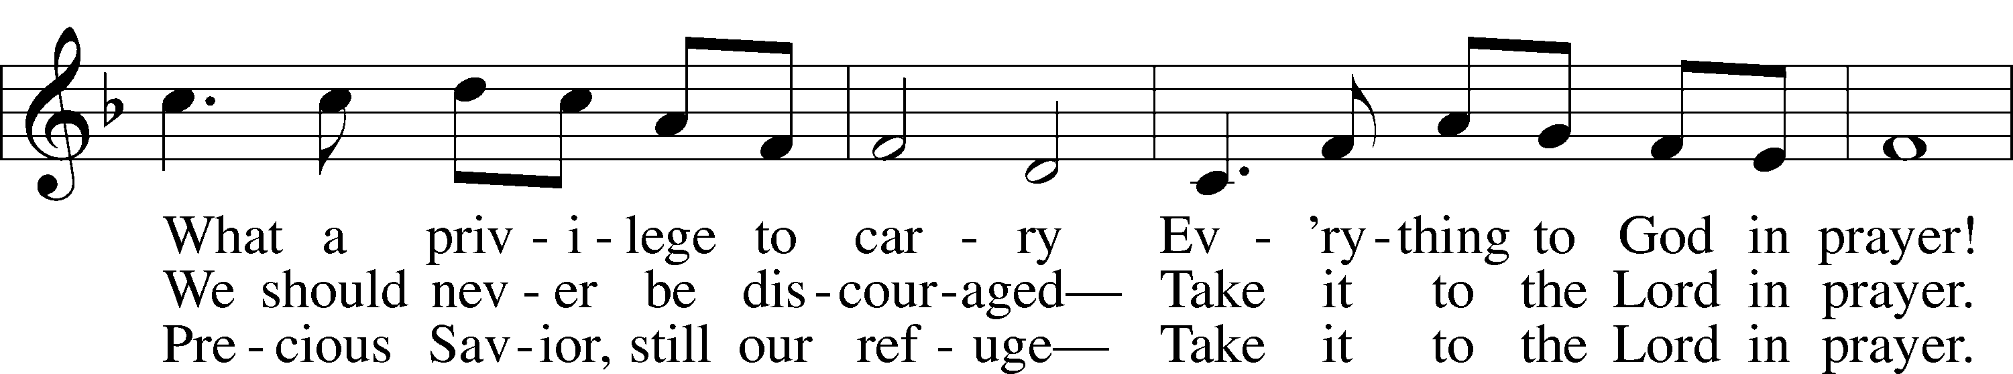
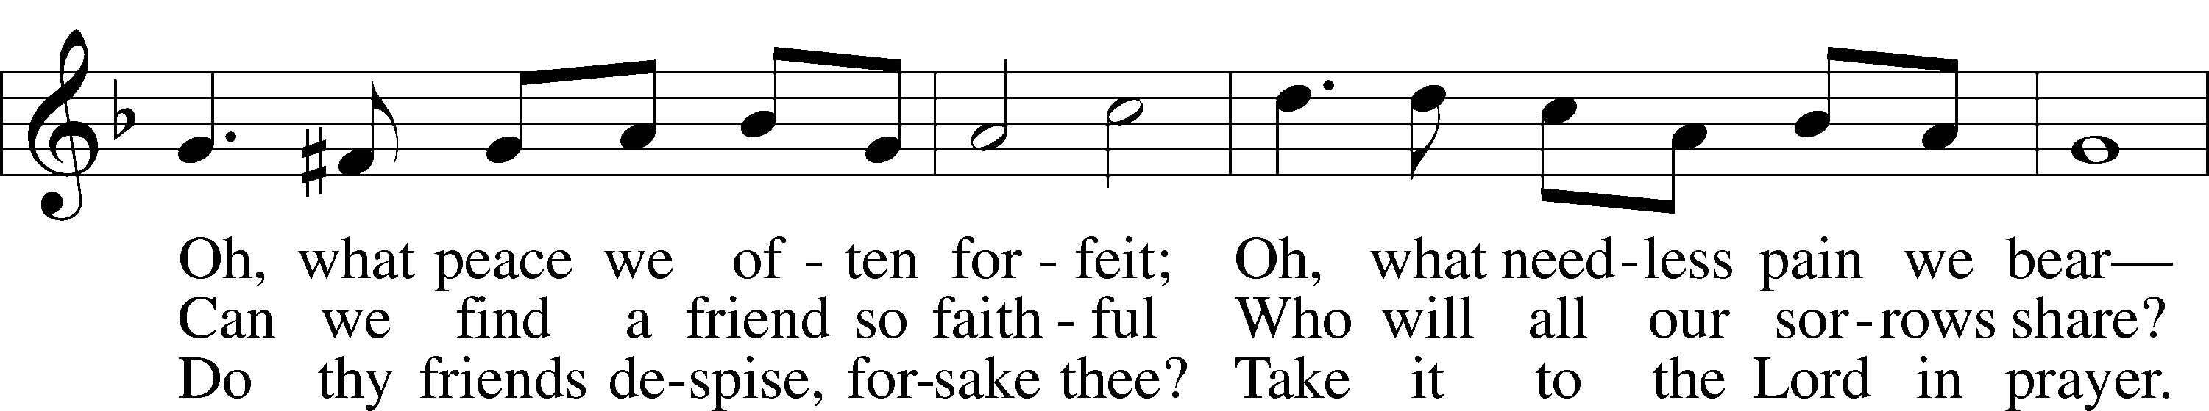
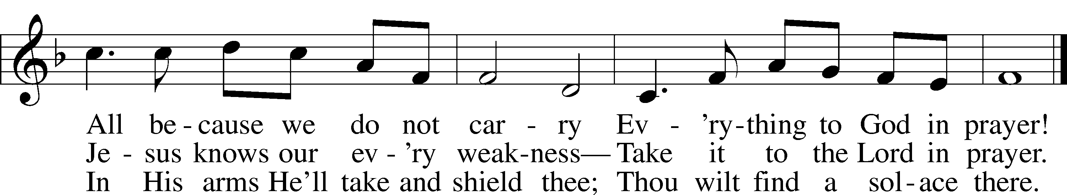

Tune: Charles C. Converse, 1832–1918
Text and tune: Public domain

Distribution Hymn “Lord, Keep Us Steadfast in Your Word” # 655
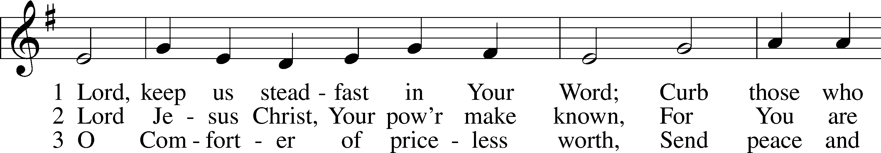
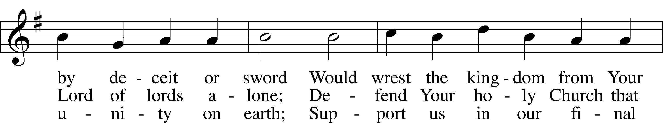
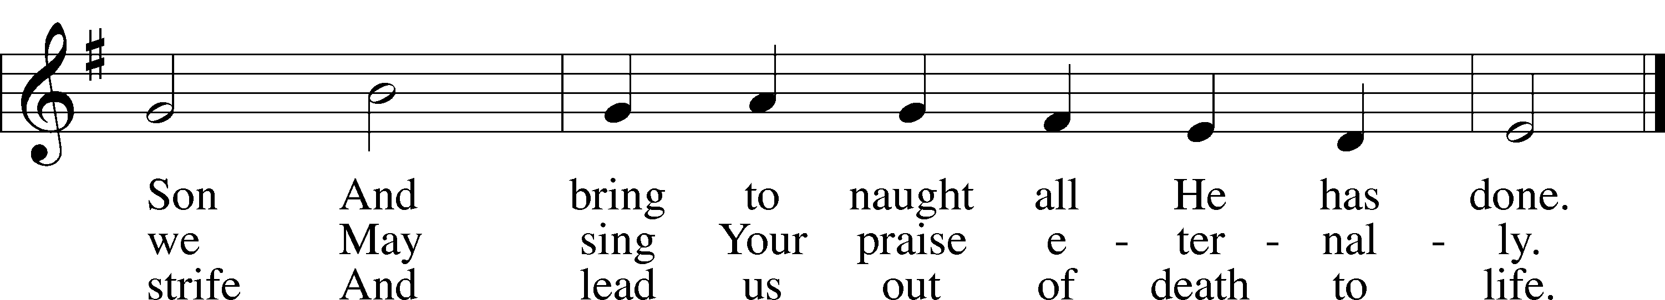

Text: Martin Luther, 1483–1546; tr. Catherine Winkworth, 1827–78, alt.
Tune: Geistliche Lieder auffs new gebessert, 1543, Wittenberg, ed. Joseph Klug
Text and tune: Public domain

Distribution Hymn “Love in Christ Is Strong and Living” # 706
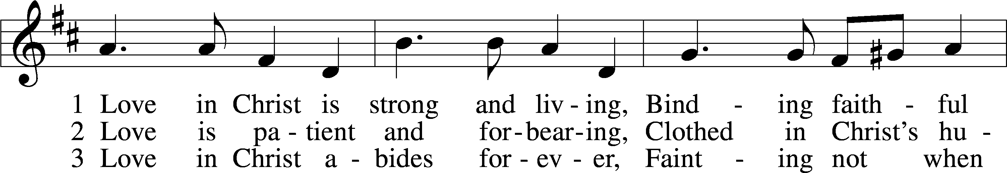
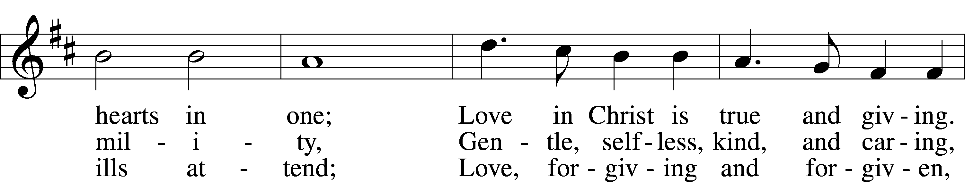
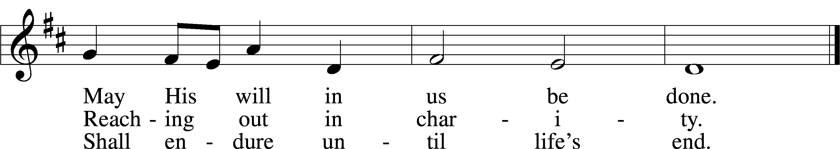

Text: Dorothy R. Schultz, 1934
Tune: Ralph C. Schultz, 1932
Text and tune: © 1979 Concordia Publishing House. Used by permission: LSB Hymn License no. 110003344

Closing Hymn “Jesus Lives! The Victory’s Won” # 490
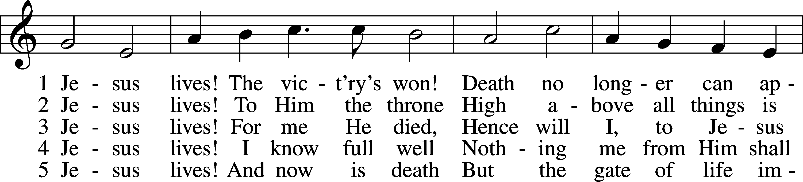
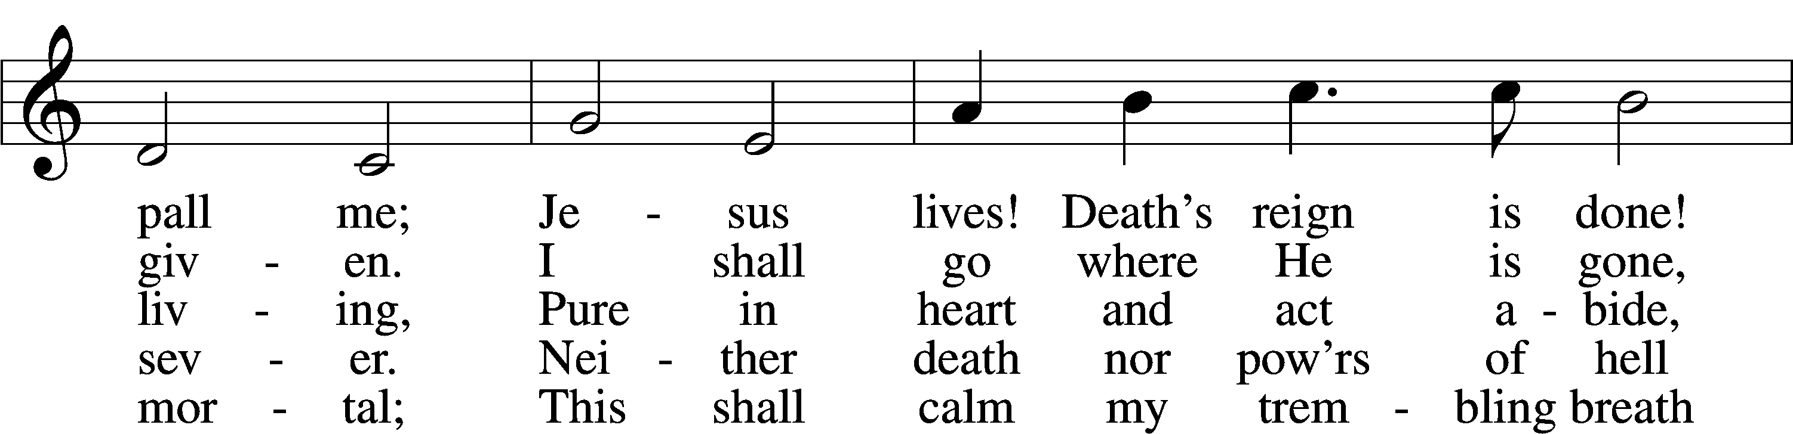
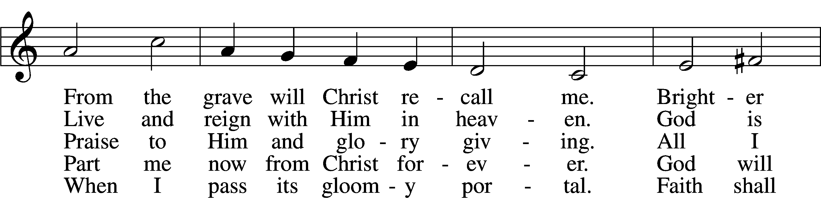
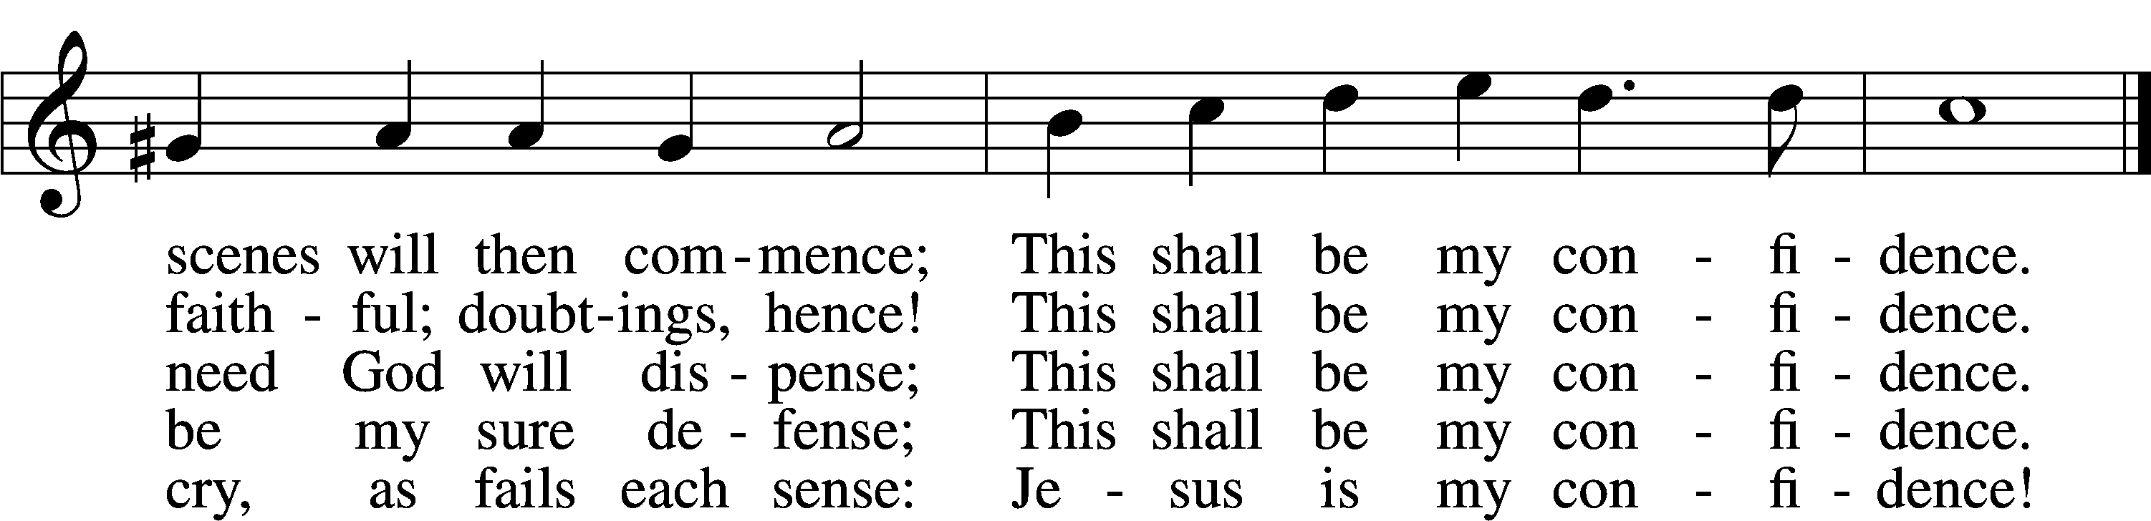
Text: Christian Fürchtegott Gellert, 1715–69; tr. Frances E. Cox, 1812–97, alt.
Tune: Johann Crüger, 1598–1662
Text and tune: Public domain

