Opening Hymn “Hosanna, Loud Hosanna” #443

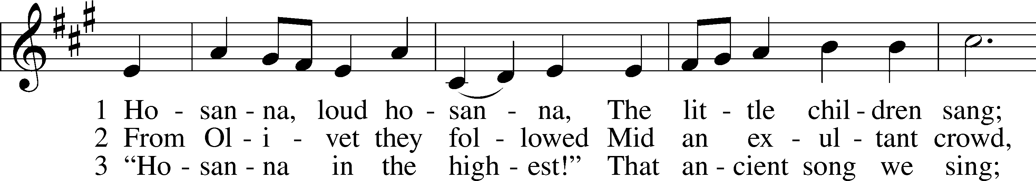
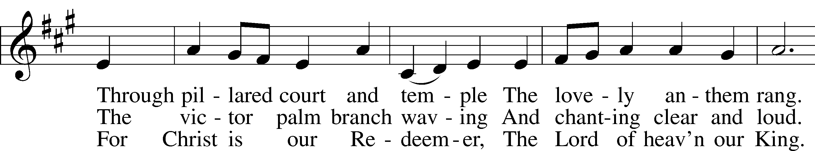
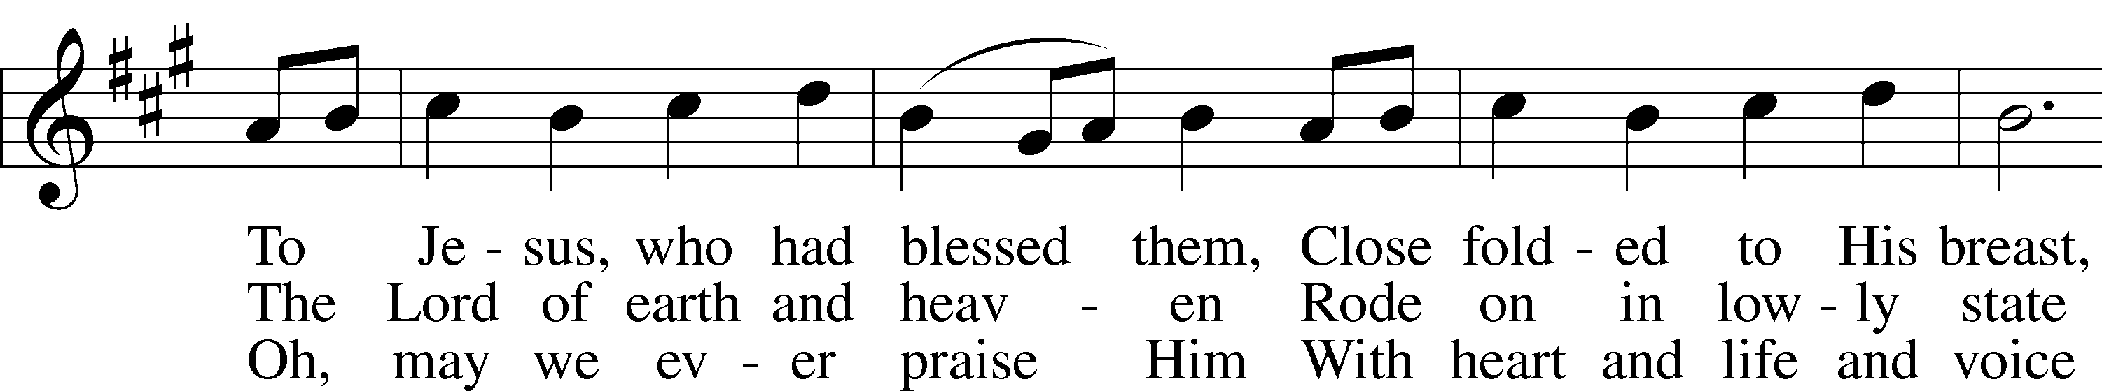
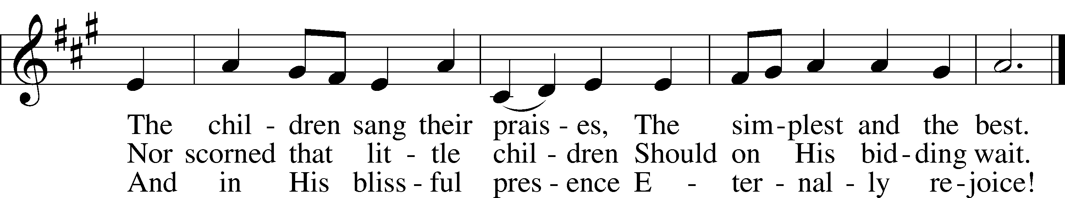

Confirmation Hymn “Lift High the Cross” #837

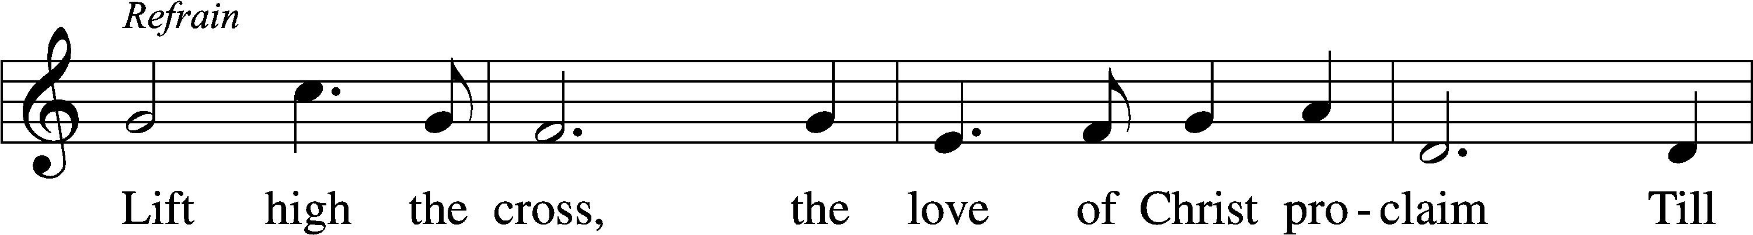
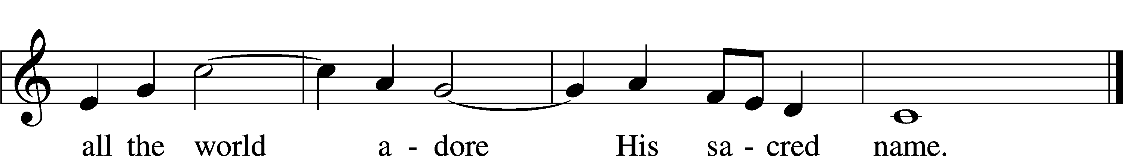
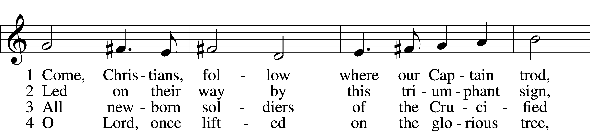
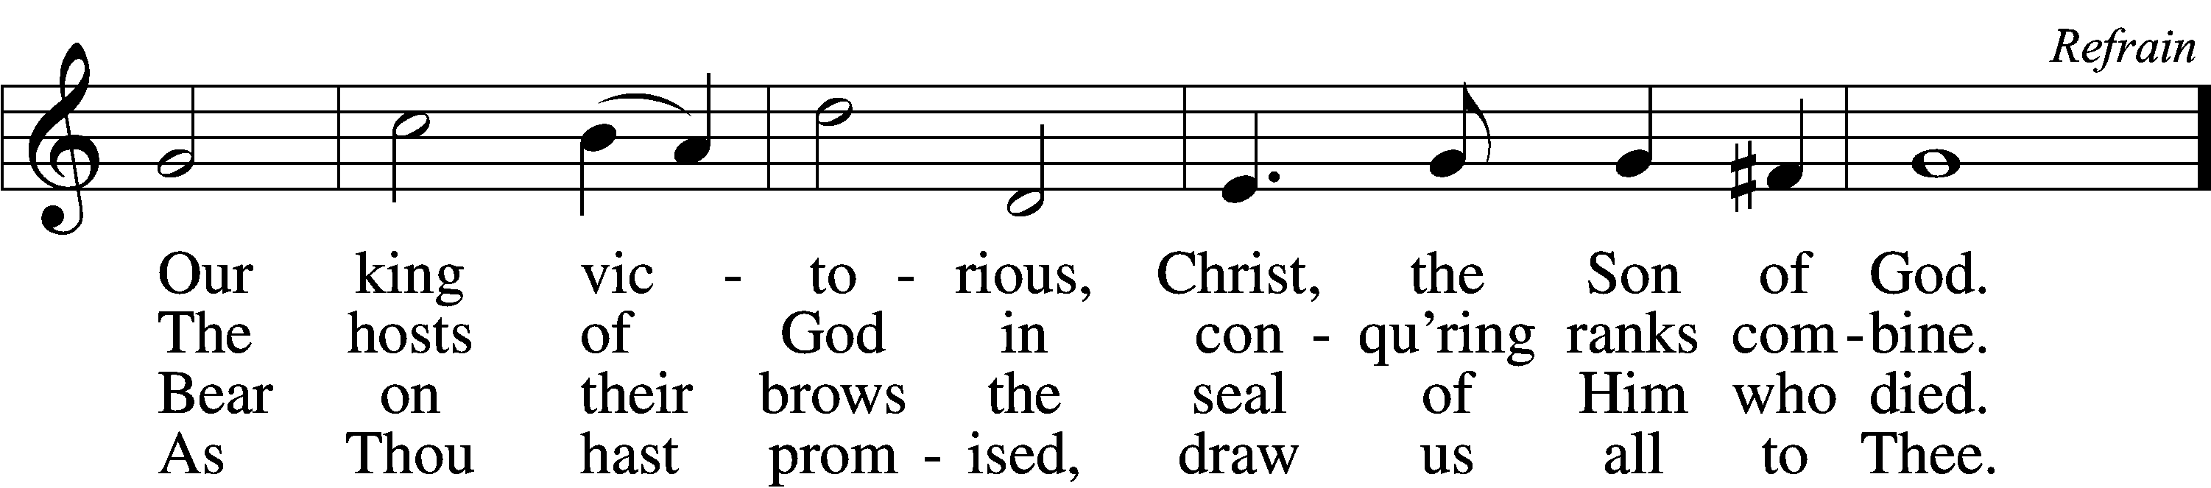

5 Let ev’ry race and ev’ry language tell
Of Him who saves our lives from death and hell. Refrain

6 So shall our song of triumph ever be:
Praise to the Crucified for victory! Refrain
Text and tune: © 1974 Hope Publishing Co. Used by permission: LSB Hymn License no. 110003344

Sermon Hymn “Ride On, Ride On, In Majesty” #441
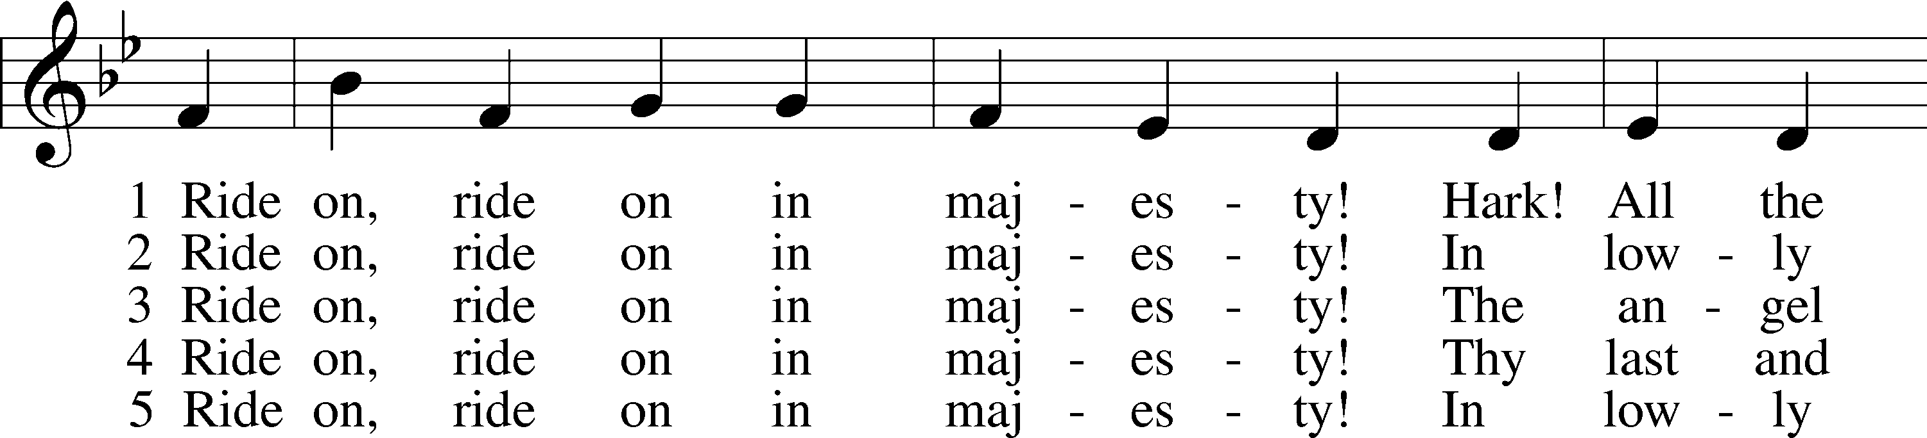
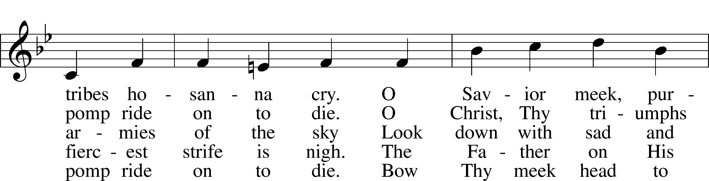
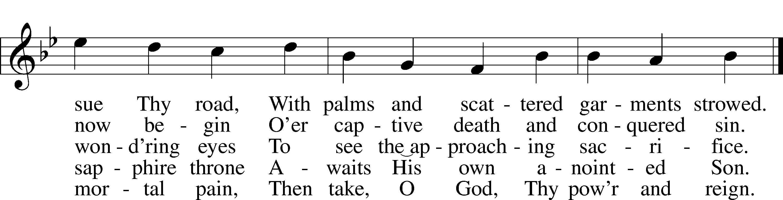
Tune and text: Public domain

Distribution Hymns
“All Glory, Laud, and Honor” #442
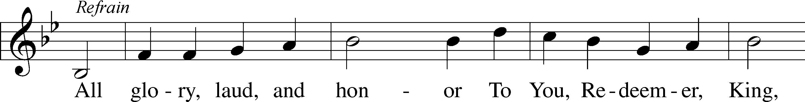
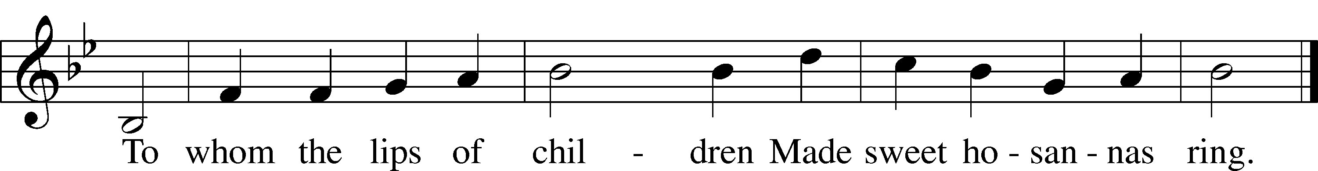
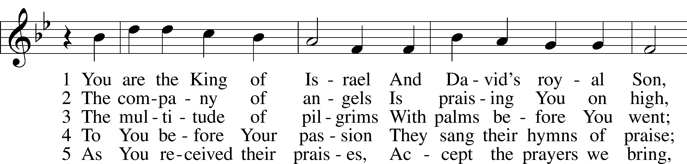
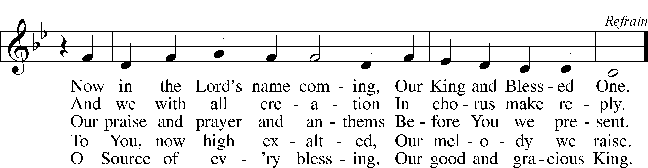

Tune and text: Public domain

Distribution Hymn
“I Come, O Savior, to thy Table” #618
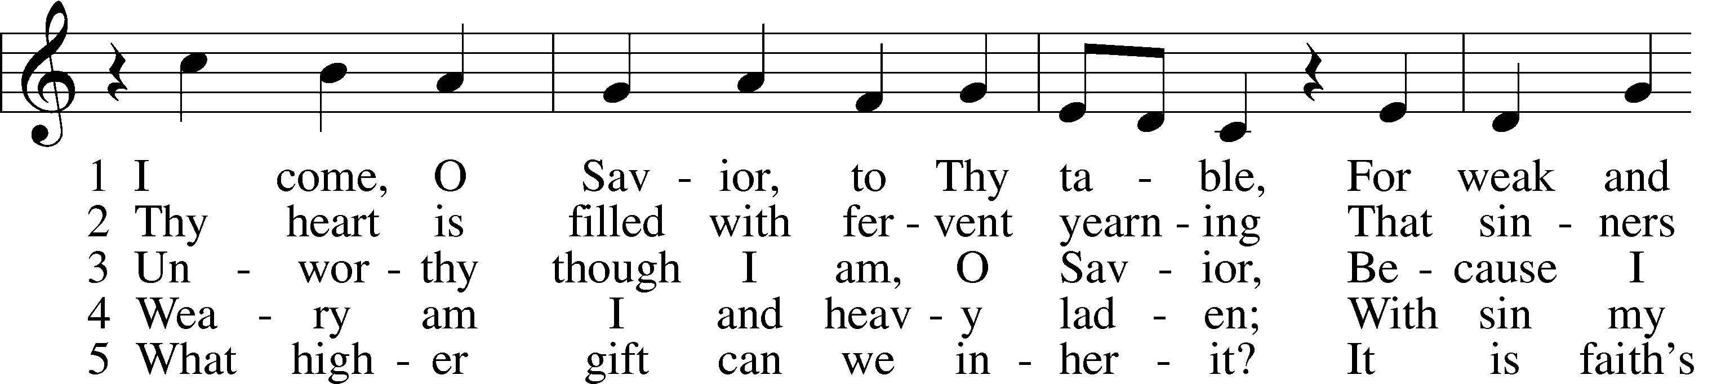
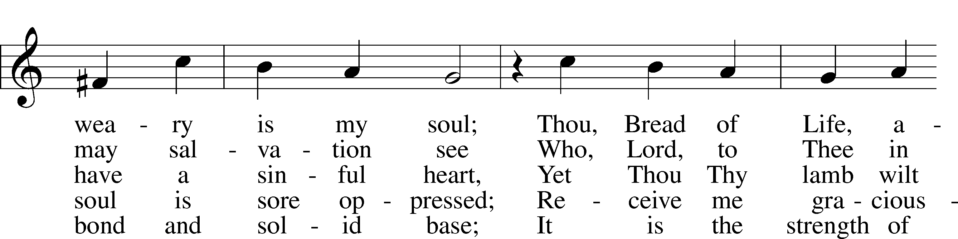
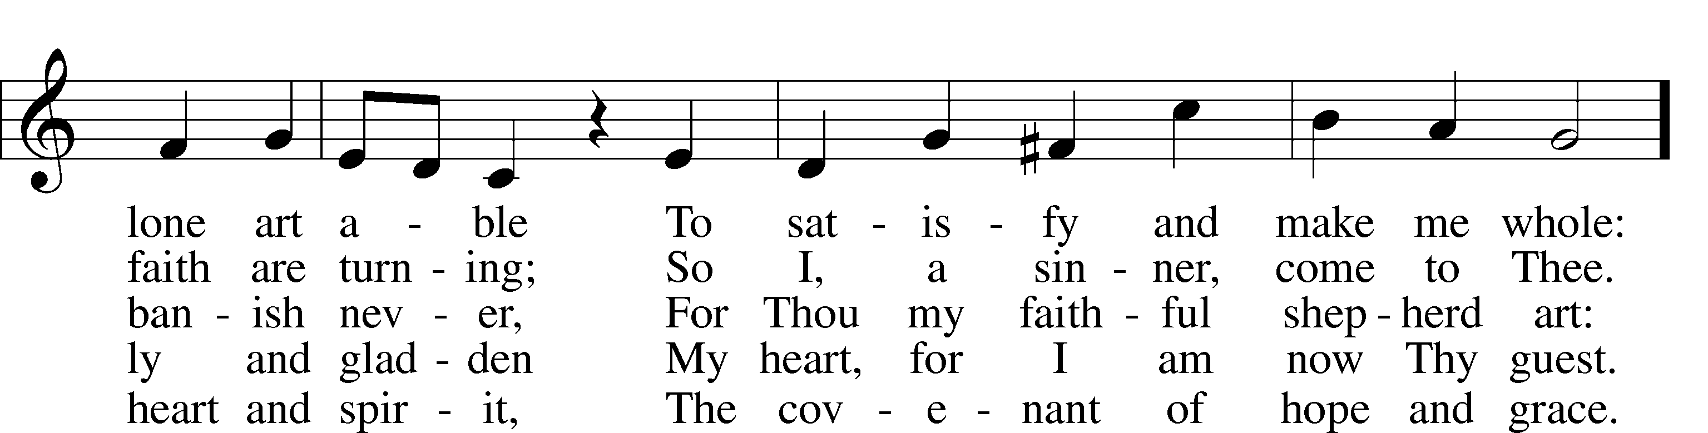
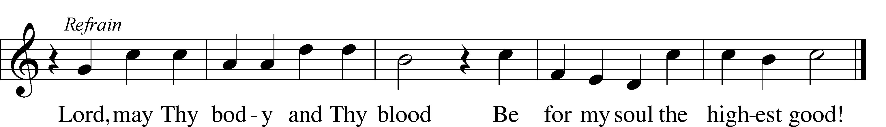
Tune: Public domain
Text: © 1941 Concordia Publishing House. Used by permission: LSB Hymn License no. 110003344

Distribution Hymn
“All Hail the Power of Jesus’ Name” #549

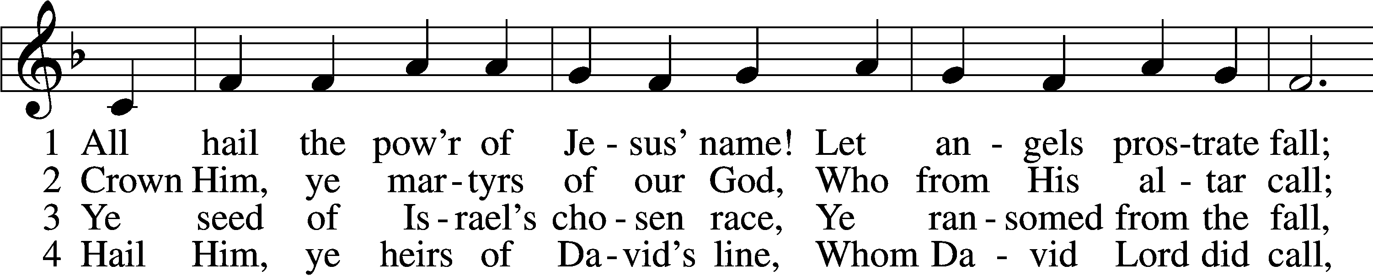
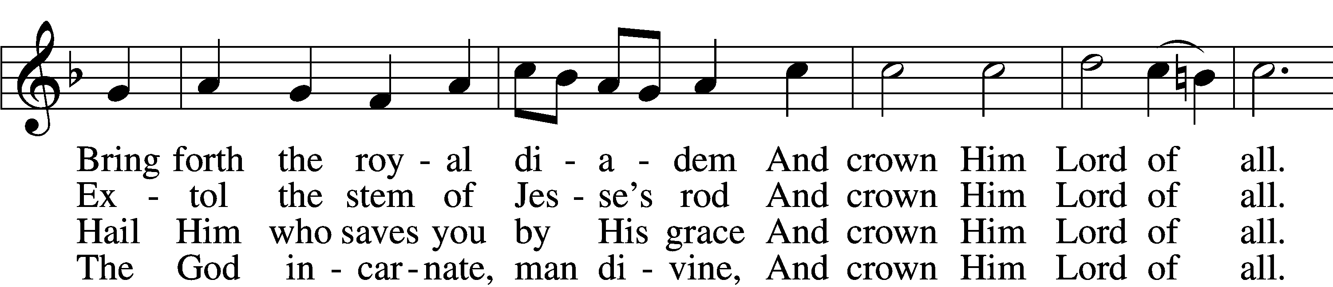
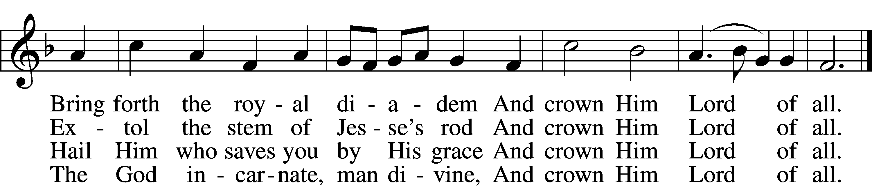

5 Sinners, whose love can ne’er forget
The wormwood and the gall,
Go, spread your trophies at His feet
And crown Him Lord of all.
Go, spread your trophies at His feet
And crown Him Lord of all.

6 Let ev’ry kindred, ev’ry tribe,
On this terrestrial ball
To Him all majesty ascribe
And crown Him Lord of all.
To Him all majesty ascribe
And crown Him Lord of all.

7 Oh, that with yonder sacred throng
We at His feet may fall!
We’ll join the everlasting song
And crown Him Lord of all.
We’ll join the everlasting song
And crown Him Lord of all.
Text and tune: Public domain

Closing Hymn “No, Tramp of Soldiers’ Marching Feet” #444
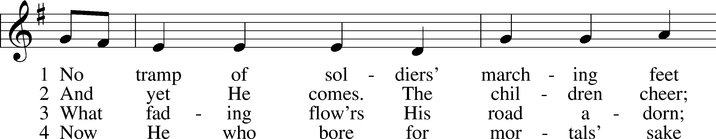
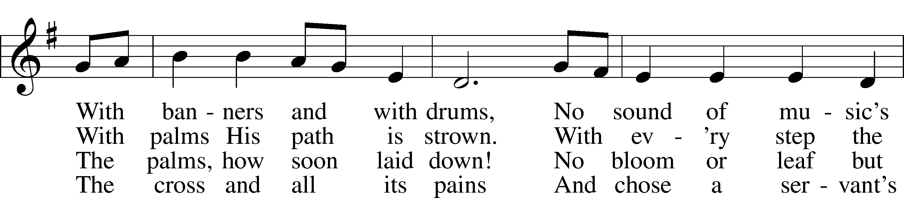
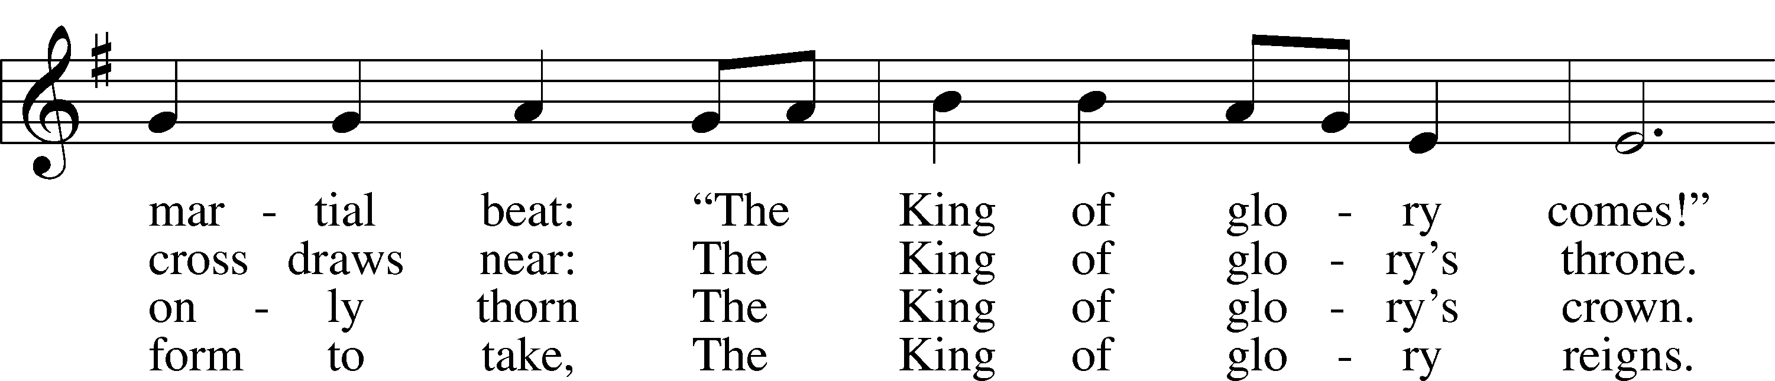
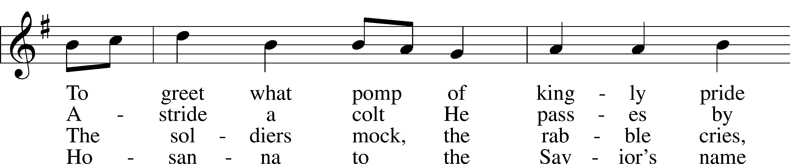
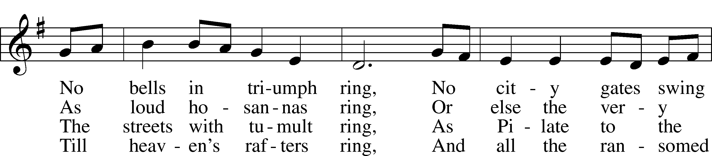
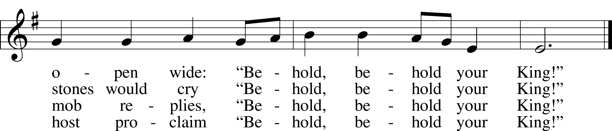
Text: © 1984 Hope Publishing Co. Used by permission: LSB Hymn License no. 110003344
Tune: Public domain

